Практическая работа №3
Обучение диалогическому тематическому высказыванию.
- Role play.
- 1 этап подготовки. Контроль подготовленной речи.
На основе предложенных готовых диалогов составить свой диалог и разыграть его. (диалоги из ОКП для 7 класса УМК «Happy English.ru» Кауфман К.И., Кауфман М.Ю.)
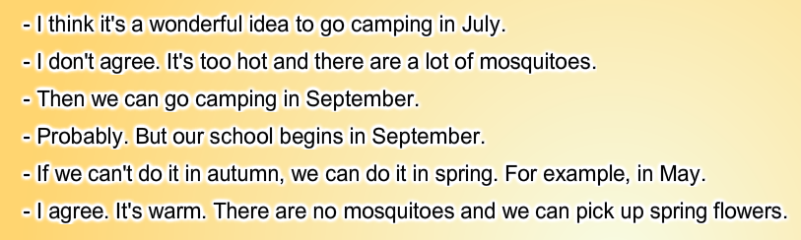
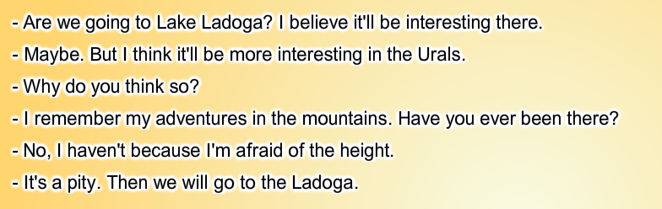
- 2 этап подготовки. Контроль неподготовленной речи.
Pole play “Telephone talk about camping”
Phone your friend and:
- remind him/her about your plans for the weekend
- find out if his/her parents allow him/her to go camping
- agree who of you will take this or that equipment
Remember to:
- Be active and polite
- Ask all the questions
- Come to an agreement

Инициирование разговора | Развитие и завершение разговора
-Hello. It is…calling. Can I speak to…?  - Is that you, …? | Извлечение информации с помощью вопросов. Ответные реплики на запрос информации  - I am calling about…  - Do you remember about…?  - Remember we planned to go hiking?  - I am calling to ask …  - What about your mum/ dad/ parents?  - Is your mum for/ against…?  - Do your parents allow you to…  - Do your parents mind…?  - Of course not. They say …  - My mum says it’s OK to go.  - Unfortunately, they don’t want us to go to the forest without adults.  - Can they go with us?  - Mine, too. / Neither do mine  - So I am taking the tent / sleeping bags/cauldron …., right?  - Do you remember you are taking …?  -And don’t forget to take your…  - Do you think we need to take…?  - And I think … is absolutely necessary.  - I prefer to …  - You remember you are taking …, don’t you?  -And don’t forget to take your…  - So let’s decide to …  - We agreed that…  - So we’ve dacided to…  Выражение одобрения/сожаления по поводу ответной реплики.  - Oh, yes!  - Oh dear!  - Great!  - That’s a pity!  - Oh, wait. What if…  - It’s a good idea.  - Let me see…  - That’ll be fine!  - That’s what we need!  Завершение разговора  Thank you for calling. Not at all. See you. See you tomorrow. See you on Friday.

- Debate: buying equipment for going on a hike.
You and your friend are thinking of buying equipment for a hike. Discuss with him/her what kind of equipment you want to buy and choose only one thing.
Here is a list of options:
a cauldron a picnic table a sleeping bag an air matress
Remember to:
- Discuss all the options
- Take an active part in the conversation and be polite
- Come up with ideas
- Give reasons
- Find out your partner’s opinion and take it into the account
- Invite your partner to come up with suggestions
- Come to an agreement

 | - | +
A cauldron | Not so cheap as you have planned.  It is rather big and you will have to carry it miles and miles | Very useful  For all the campers.  Practical- it will last for a long time not just through a few uses.  The quality is very good.
A picnic table | - It is not so necessary in the forest. You can put the table cloth on the ground instead of it.  - It is a waste of money because it is not the most useful thing  - Rather heavy and you have to walk a lot when you are on a hike. | - It is very comfortable for arranging your meals  - Affordable price.  - It will make your campsite cosy.
A sleeping bag | - Not for every member of your group  - Quite an expensive thing | - Very useful.  - It so pleasant to lie in a warm sleeping bag after walking miles and miles.  - It is not so heavy to carry.
An air matress | - You can easily do without it.  - It is not so cheap.  - The quality leaves much to be desired. | - It is better to sleep on the mattress than on the hard ground.  - It is an air mattress so it is won’t take a lot of room.  - Comfortable and will bring joy to little kids.

Writing “My camping story”
Write a short story for the school newspaper about your most interesting camping adventures.
These questions can help you.
- Where did you go?
- Who did you go camping with?
- Was it fun / boring /interesting? Why? Why not?
- What was the weather like?
- What did you do?
- Did you have any funny/ sad situations? Was everything OK? Did you have any problems?
- What are your feelings and emotions? Did you like it?

