[](http://www.medciencia.com/wp-content/uploads/2013/08/red_list_iucn-680x627.png)[](http://s00.yaplakal.com/pics/pics_original/5/4/2/2376245.jpg)[](http://lahdshaft.ru/images/stories/wwf.jpg)

**Let’s preserve it**

**for future generations**

**Совместный проект**

**учеников 10 класса**

**МБОУ – Кокинская СОШ Брянской области**

[](http://www.dacostadesign.com/contents/uploads/4-portfolio/40_1.identity_6-b.jpg)

**Contents**

1. **Bryansk Forest Nature Reserve - Ulyana Rozhnova**
2. **Lake Baikal - Veronika Mameeva**
3. **Caucasian dolmens - Akif Samedov**
4. **Amur tiger - Kostya Ershov**
5. **Caucasian mountain goat - Anton Grimzin**
6. **Hooded Crane - Nastya Petrakova**
7. **Snow leopard - Ira Nashivan**
8. **Atlantic walrus - Karina Simonova**
9. **Red Wolf - Masha Ishchenko**
10. **Pallas’s cat (manul) - Daniil Andronov**

**The Bryansk Forest Nature Reserve**

**[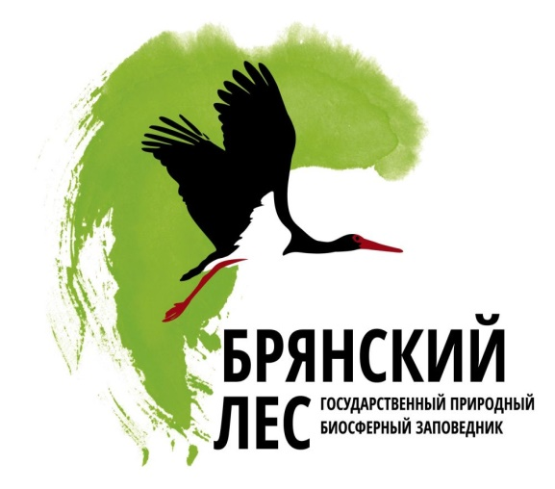](http://go32.ru/uploads/posts/2013-02/1360670282_bl.jpg)The Bryansk Forest Nature Reserve** was created on July 14, 1987 in the Trubchevsk and Suzemka districts of the Bryansk Region in western Russia. This reserve is a unique place. Five species of plants are listed in the Russian Red Book.   Many rare species of animals are protected in the reserve:  Russian desman, brown bear, river otter, lynx, black stork, common crane, and others.  Twenty-five species of animals are listed in the Russian Red Book.

Black stork is very beautiful and mysterious bird. This bird is the symbol of the reserve. The Bryansk Forest was established to preserve black storks.

[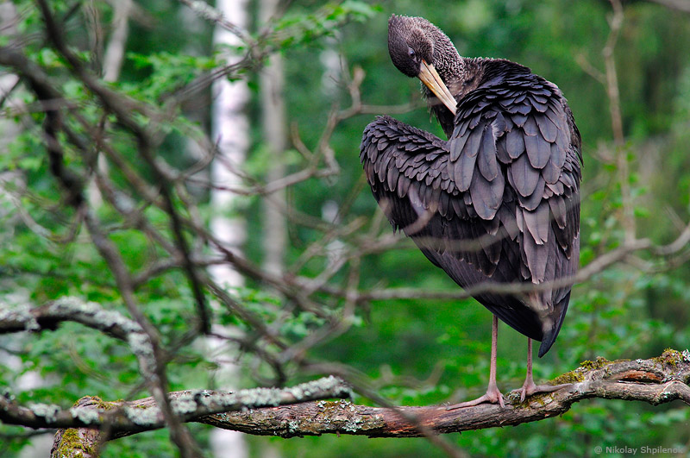](http://img.labirint.ru/images/comments_pic/1418/10_7c9a6e9f0bb40448b09fe0ffa7720d3d_1398678553.jpg) [](http://imgc.allpostersimages.com/images/P-473-488-90/65/6552/C5T4100Z/poster/lynn-m-stone-white-water-lily.jpg) [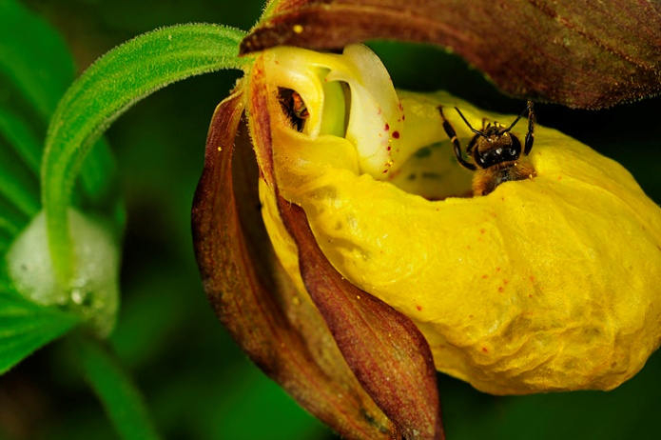](http://www.bryansky-les.ru/upload/information_system_4/0/9/2/item_92/information_items_92.jpg)

[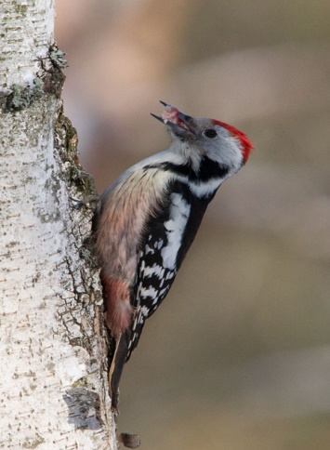](https://im1-tub-ru.yandex.net/i?id=7d2fbe459b1c1406d527b8d562f1dc8b&n=24) The Bryansk Forest Nature Reserve is a home to a lot of beautiful plants. Lady’s slipper and water lily are known to live there.

Interestingly, the Bryansk Forest is the only place in Europe where all 10 species of European woodpecker can be found:  great spotted, middle spotted, Syrian, white-backed, green, and others.

I think this place is really unique and we must preserve it for future generations.

[**http://en.bryansky-les.ru/**](http://en.bryansky-les.ru/)

**Lake Baikal**

[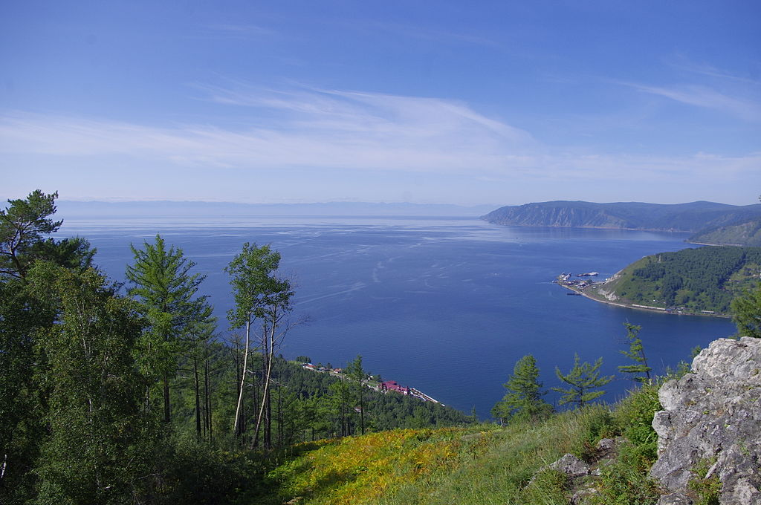](http://upload.wikimedia.org/wikipedia/commons/thumb/a/a4/Jezioro_Bajka%C5%82_2.jpg/1024px-Jezioro_Bajka%C5%82_2.jpg)

One of the most famous nature wonders is Lake Baikal. It is the oldest lake in the world. It’s old about 25-30 million years. More than 1500 life forms live in and around this lake. It occupies the territory of 12000 m2 and 400 km long. About 30 uninhabited isles are scattered throughout the lake. It’s the largest reservoir of drinking water. It is the cleanest lake in the world.

*Several organizations are carrying out natural research projects on Lake Baikal. Most of them are governmental or associated with governmental organizations. The Baikal Research Centre is an independent research organization carrying out environmental educational and research projects at Lake Baikal.*

*In July 2008, Russia sent two small submersibles, Mir-1 and Mir-2, to descend 1,592 m (5,223 ft) to the bottom of Lake Baikal to conduct geological and biological tests on its unique ecosystem.*

*Russian scientist and federal politician Artur Chilingarov, the leader of the mission, took part in the Mir dives as did Russian leader Vladimir Putin.*

I think we must save this beautiful place and preserve it for future generations.

[**http://en.wikipedia.org/wiki/Lake_Baikal**](http://en.wikipedia.org/wiki/Lake_Baikal)

**Caucasian dolmens**

**Dolmens** are usually found on flat ground, or on the tops of ridges sunny slopes. The vast majority of dolmens oriented down the sunny slopes. Inside of the dolmens are decorated with carved ornaments. The most famous dolmens in the territory of Adygeya are on the river Kizimke. It was found about 600 dolmens, most of them destroyed. Most notable among surviving - Guzeriplsky dolmen Kozhzhohskoy group, according to conservative estimates, it is not less than 5000 years.

As a kind of tombs, dolmens Western Caucasus are on a par with a lot of similar structures of all time. Identified the most ancient burials in the dolmens left is their builders. Although known for a number of ground burial dolmen culture, their number is quite insufficient for now a known quantity of a fairly large settlements.

Of course, the construction and function of the sanctuary was carried out, is likely to family or generic: this, for example, suggests the find of the stone altar in the reconstruction of the dolmen complex at Jean (located in Gelendzhik Local History Museum). The newly reconstructed complex on the River Janet and Mount Nexis (both near Gelendzhik), as well as many dolmens with "yards" can imagine taking place once there is a ceremony.

**The problem of protection**

Before the Caucasian War dolmens and menhirs accompanying them are not subjected to destruction. Only with the settlement of the mountains Cossacks these buildings were used as a quarry. And now, almost all of them are not protected, are affected by the Vandals (loggers, black diggers, truckers and other developers [3], hikers and sightseers, sectarian , business tenants), and the collapse of natural causes. Some dolmens dolmens cork or stolen for personal use.

[**http://en.wikipedia.org/wiki/Dolmens_of_North_Caucasus**](http://en.wikipedia.org/wiki/Dolmens_of_North_Caucasus)

[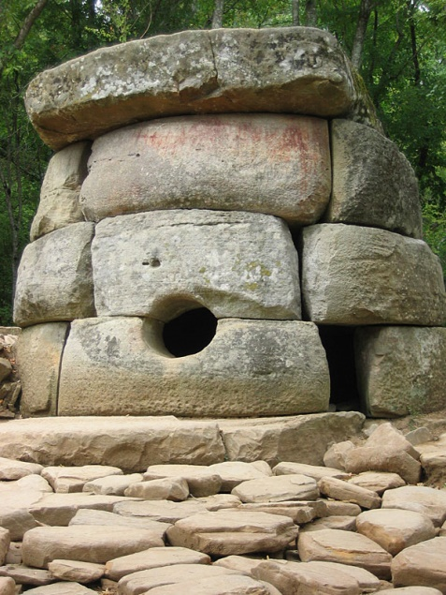](http://upload.wikimedia.org/wikipedia/commons/thumb/c/c6/Dolmen_Russia_Kavkaz_Jane_1.jpg/220px-Dolmen_Russia_Kavkaz_Jane_1.jpg)

**Amur tiger**

**Amur tiger**("Siberian Tiger") is one of the smallest tiger subspecies, the most northern tiger. The Amur tiger belongs to the largest subspecies, its wool is thicker than that of tigers living in warm areas, and its colour is lighter. The ground colour of Siberian tigers' pelage is often very pale, especially in winter coat.

In 1992, the *Siberian Tiger Project* was founded. The project consists of the following components.

* monitoring patrol routes and law enforcement results with the patrol monitoring system MIST which is based on GIS-technique
* support for patrol teams (fuel, spare parts, maintenance for vehicles and ranger outfits)
* bonuses for patrol teams that perform well.

[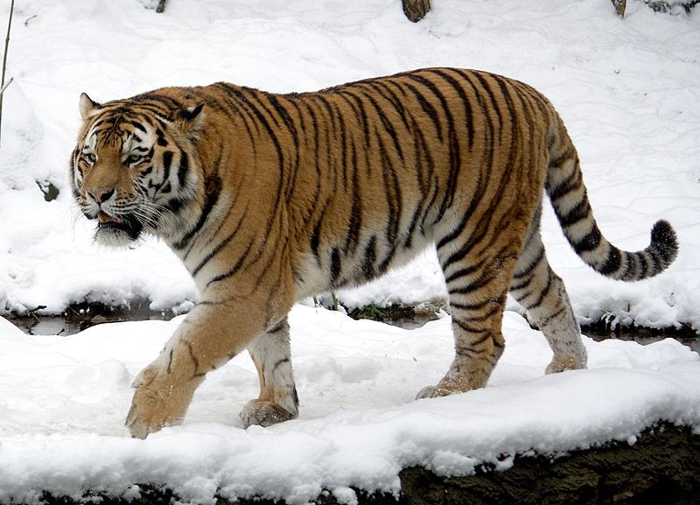](http://upload.wikimedia.org/wikipedia/commons/thumb/b/b9/P.t.altaica_Tomak_Male.jpg/800px-P.t.altaica_Tomak_Male.jpg)

This tiger is listed in the Red Book of Russia. In April 2007 experts from the World Wildlife Fund (WWF) announced that the Amur tiger population has reached a maximum and a century that the tiger is no longer on the verge of extinction.

In 2008-2009, a multidisciplinary expedition staff IEE RAS in the framework of the "Siberian Tiger" in the Ussuri Reserve in the Far Eastern Branch of the Russian Primorye Territory Russia's Far East found out that this area is inhabited by six species of Amur tigers. With the help of satellite collars scientists monitored their routes and marked for the first female tiger for a year managed to get 1,222 locations . According to published research animal uses an area of ​​almost 900 square kilometers - despite the fact that the area of ​​the reserve is only 400 square kilometers. This means that the tigers are far beyond the protected area, undergoing high-risk . These data, according to the publication, give grounds to speak about the need for a buffer zone of the reserve and the need to regulate human activities beyond the protected area.

[**http://www.worldwildlife.org/species/amur-tiger**](http://www.worldwildlife.org/species/amur-tiger)

**Caucasian mountain goat**

**[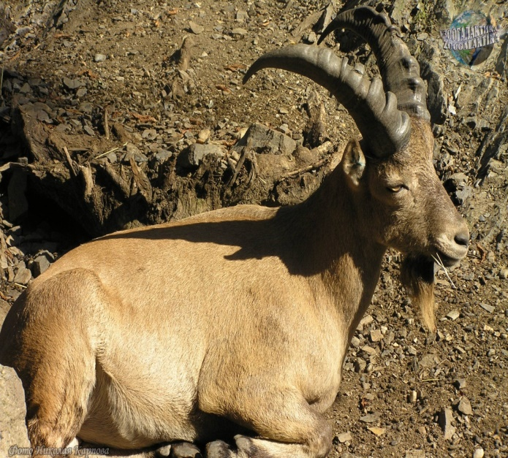](http://zoogalaktika.ru/assets/images/mammals/artiodactyla/ruminantia/caprinae/capra-caucasica/capra-caucasica_03.jpg)West Caucasian round**, or Caucasian mountain goat is rather short, strong and quite curved horns reaching 75-centimeter length, very short tail, a short and wide beard. Rounds generally in the morning and in the evening, in the winter also are active in the afternoon. In the fall and in the winter they gather in herds and are grazed on the southern slopes where there is less than snow; keep one by one or small groups in the summer.

Animals usually leave the places which are often visited by people. If they aren't disturbed, they lead quite inactive life, carrying out almost all the time behind pasturage or on thighs. In habitats of mountain goats there are tracks going along a slope or down to watering places along crests or feet of rocks. During bad weather goats gather in niches and superficial caves under rocks, it is obligatory with the good review. Rounds eat grassy plants, foliage of trees and bushes, fruits, in the winter — a dry grass and escapes.

**[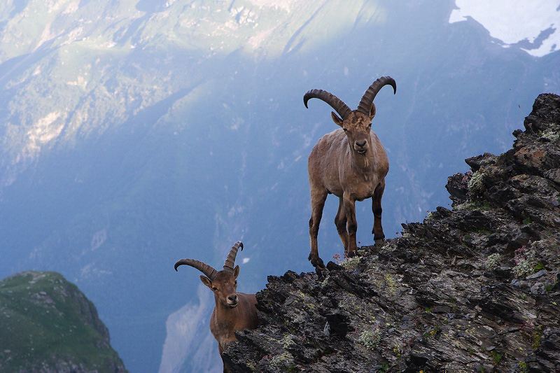](http://www.vitalfoto.kiev.ua/fotobank/Kavkaz/images/07-07_IMG_7592.jpg)**

[**http://en.wikipedia.org/wiki/West_Caucasian_tur**](http://en.wikipedia.org/wiki/West_Caucasian_tur)

**Hooded Crane**

**Hooded Crane** is a small, dark crane. It has a grey body. The top of the neck and head is white, exept for a patch of bare red skin above the eye.

It is one of the smallest cranes, but it still a fairly large bird, at 1m long, a weight of 3,7kg and a wingspan of 1,87m

The Hooded Crane breeds in south-central and south-eastern Siberia. Breeding is also suspected to occur in Mongolia.

Over 80% of its population winters at southern Japan, South Korea and China.

The Hooded Crane is evaluated as Vulnerable on the IUCN Red List of Threatened Species. You can see the Hooded Cranes in "Norsky reserve" or in "Hingansky reserve" in the Amur region.

[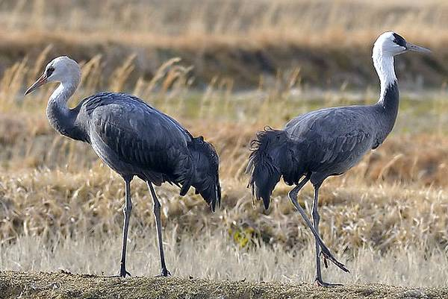](http://upload.wikimedia.org/wikipedia/commons/thumb/c/c2/Grus_monacha_-Kyushu,_Japan_-three-8.jpg/1024px-Grus_monacha_-Kyushu,_Japan_-three-8.jpg)

[**http://en.wikipedia.org/wiki/Hooded_crane**](http://en.wikipedia.org/wiki/Hooded_crane)

**Snow leopard**

**[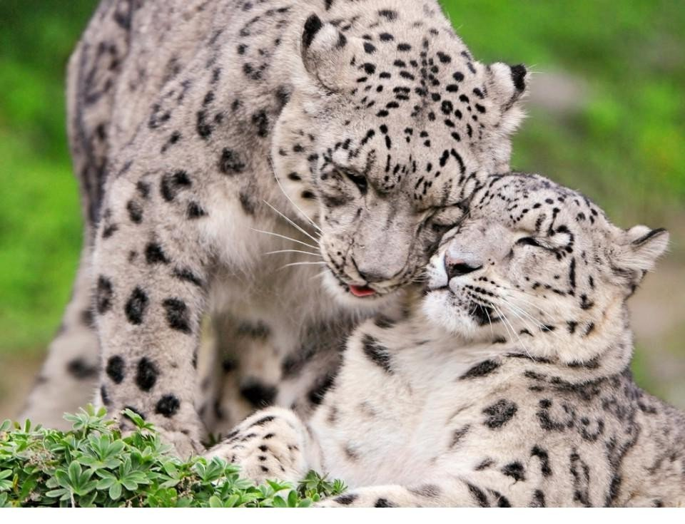](http://www.wallpapers1920.ru/img/picture/Feb/04/9609e8ce9a51f8d1aafe29f771b1d189/4.jpg)Snow leopard** is listed in the Red Data Book as "endangered." It occupies an intermediate position between large and small cats. Given this similarity, and those with other cats, leopards are sometimes called "middle-cats." The length of it to 130 cm, and a very thick tail is a little shorter. Its wool is high, very thick and soft, its length on the back is 55 mm. It provides protection from the cold, harsh environmental conditions . The main coat color on the back and upper sides is light-grey or greyish, almost white, with a touch of smoky. Snow Leopard, unlike other big cats can not roar. Irbis belongs to the poorly studied species. It lives in 13 countries: Afghanistan, India, Kazakhstan, Kyrgyzstan, China, Mongolia, Russia and others. He lives in the dense bush and mountain plains, where there is almost no vegetation. Here, among the mountain of ice and snow, his fur perfectly conceals him from the enemies, and from the victims. It is active at dusk, but sometimes during the day. Snow leopards hunt alone in most cases before sunset and in the morning at sunrise. He feeds all living in his birthplace of mammals - from mice to mountain goats and sheep. Among the big cats snow leopard is the only permanent inhabitant of the highlands. The survival of this rare cat in highly disturbed mountain ecosystems is extremely difficult or impossible; respectively maintenance of viable populations of snow leopards is inevitably associated with the effective protection of its habitat as a whole. Also in the mountains there is an active poaching and hunting for skins of freshwater animals. Currently, the number of snow leopards catastrophically lows.

[**http://en.wikipedia.org/wiki/Snow_leopard**](http://en.wikipedia.org/wiki/Snow_leopard)

**Atlantic walrus**

[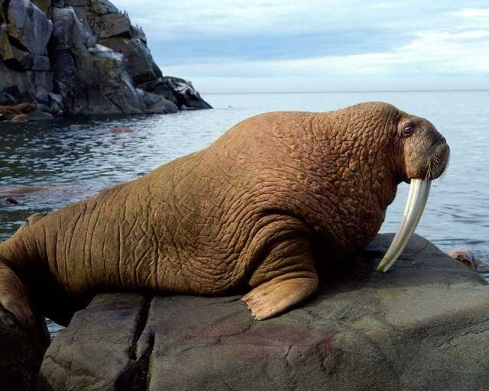](http://4.bp.blogspot.com/_BdoPZq9TBg4/TOzgaihnrII/AAAAAAAAADw/lIMwkf_hFLQ/s1600/morsa.jpg)

**Atlantic walrus** lives in the Barents and Kara seas and feeds on molluscs and crustaceans. Long adult specimens can reach 4 meters, and the weight of the Atlantic walrus may be about 1.5 tons.

The walrus has played a prominent role in the cultures of many indigenous Arctic peoples, who have hunted the walrus for its meat, fat, skin, tusks, and bone. During the 19th century and the early 20th century, walruses were widely hunted and killed for their blubber, walrus ivory, and meat. The population of walruses dropped rapidly all around the Arctic region. Their population has rebounded somewhat since then, though the populations of Atlantic and Laptev walruses remain fragmented and at low levels compared with the time before human interference.

By the mid-twentieth century, this species was almost completely wiped out due to poaching, melting ice and oil spills. Today, they are strictly protected by the state, so there is a slight increase of the population of walruses.

[**http://en.wikipedia.org/wiki/Walrus**](http://en.wikipedia.org/wiki/Walrus)

*Red Wolf*

**[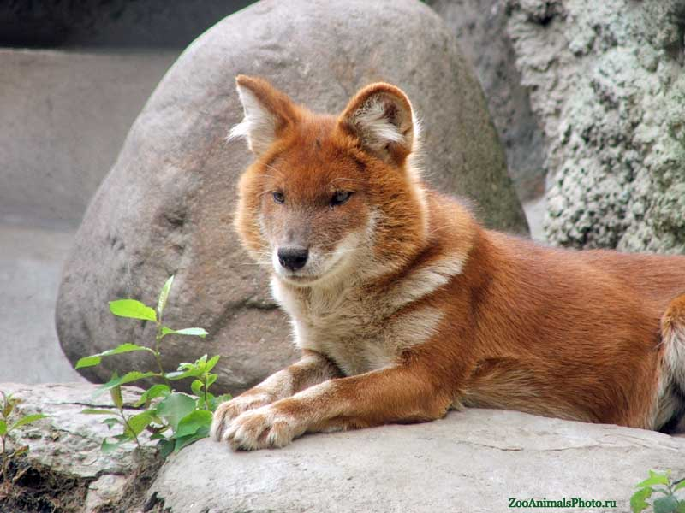](http://zooanimalsphoto.ru/gallery/moscowzoo/wolf_red_0482.jpg)Red Wolf** is a typical inhabitant of mountains rising up to 4000 meters above sea level. On the open plains do not settles, but in search of food to make long seasonal migrations, sometimes appearing in unusual landscapes - steppes and even deserts. He lives and hunts the red wolf packs of 5-12 individuals (sometimes more), apparently uniting several generations of animals.

Relations within the pack is usually non-aggressive. He hunts mostly during the day, long pursuit of prey. Red Wolf sanctuaries usually are crevices of rocks, caves and niches in the slopes; They do not dig burrows.

[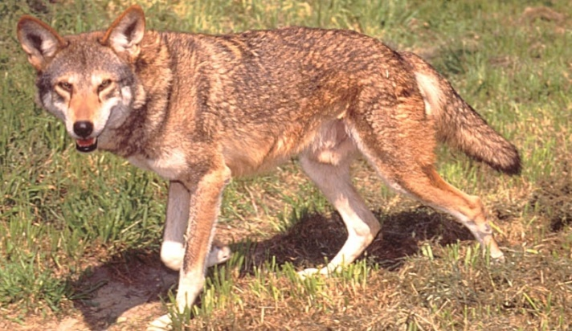](http://funkman.org/animal/mammal/redwolf.jpg) Have developed hearing, good swim and jump great - able to overcome long distance up to 6 m. People avoid red wolves; captive breeding, but not tamed. Biology of reproduction is not well understood. Red Wolf - strict monogamous; males are involved in the protection and education of the young. In zoos, the animals mate in January - February; they born pups in April after 60-62 days of gestation, bringing of 5-9 pups. In India, the puppies are all year round, but most in January - February.

Newborn puppies are covered with short dark brown and resemble ordinary wool. Their eyes open at 13-14 days. At the age of six months reach adult weight.

They reach sexual maturity at 1-2 years old. Red Wolf listed in the Red Book of the IUCN endangered species status, as well as in the Red Book of Russia.

[**http://en.wikipedia.org/wiki/Red_wolf**](http://en.wikipedia.org/wiki/Red_wolf)

*Pallas’s cat (manul)*

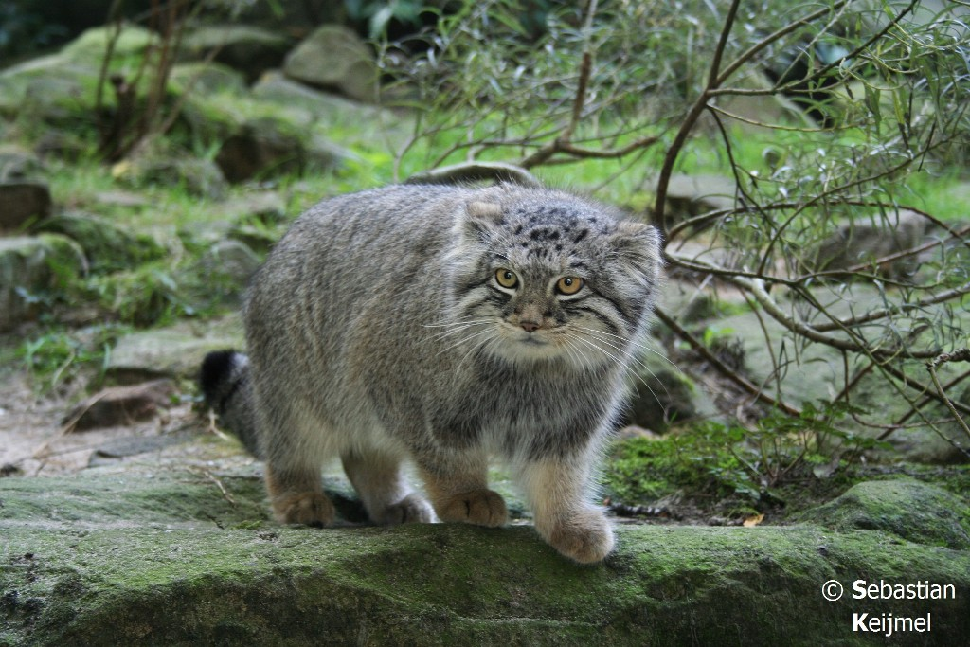

**Pallas’s cat** is a cat that lives on the Earth millions of years.  
Would you ever take a trip back in time and see that were the animals millions of years ago? In the case of cats do not need to, as there Pallas - about 12 million years ago, it was one of the first versions of those cats, and from which came the modern cats.  
Pallas’s is the only wild cat similar in size to domestic cats, but it has very sharp teeth. It may seem a little high only because of its very thick fur. Despite the fact that it looks a little awkward, it is very graceful, agile and fast.  
This cat lives in high deserts, steppes and treeless rocky mountainsides, and may be found at elevations as high as 13 000 feet. The Pallas’s cat is found from the Caspian Sea and Iran, to Southeastern Siberia, Mongolia and China.  
These cats are believed to eat marmots, small mammals, hares, birds.  
Manul is very rear animal and it should be preserved.

[**http://en.wikipedia.org/wiki/Pallas's_cat**](http://en.wikipedia.org/wiki/Pallas's_cat)