Методическая разработка
открытого урока по английскому языку
по теме
«Достопримечательности Лондона»

Цели урока:
Образовательные:
1.Совершенствовать лексические навыки по теме: «Достопримечательности Лондона».
2.Развивать уровень свободного высказывания монологической и диалогической речи.
3.Развивать навыки аудирования.
Развивающие :
- Развивать способности осуществить продуктивные речевые действия у обучающихся.
Воспитательные:
- Воспитать уважительное отношение обучающихся к иноязычной культуре.
Оборудование: ноутбук, экран, проектор, документ-камера, картинки с достопримечательностями Лондона.
Ход урока
I.Организационный момент
1.Приветствие обучающихся
Teacher: -Good afternoon boys and girls! I am glad to see you.
2.Проверка отсутствующих
- Who is on duty today? Who is absent? OK
Вступление
- Let`s begin our lesson.
(музыкальное вступление: группа «Кармен»- песня «London, goodbye!»)
The subject of our lesson is sights of London. And I’d like to start our lesson with the words: «Who doesn’t like London like life itself»
Today we have an unusual lesson.
At our lesson we`ll make a trip to London. We’ll see many attractive places, you’ll know many important facts about history and other useful things. But before we start our travelling, I want to introduce the interpreter to you. Greet, please. Her name is Ulia.
Interpreter:- Good afternoon! I`m glad to meet you. I`ll be your interpreter today.
- Добрый вечер, я очень рада приветствовать вас, сегодня я буду вашим переводчиком.
- Now we are on board of liner, flying from Krasnodar to London. Fasten your belts and enjoy your holidays.
- Мы находимся на борту самолета, Краснодар-Лондон.
Звук самолета.
Stewardess: Good-afternoon, ladies and gentlemen. We are glad to welcome you on board of our liner. We are flying to London. It will take us 45 minutes. Please, watch the electric sign flashes in the plane. When the ‘Fasten Seat Belts’ sign goes on, do it immediately. The crew of the plane wish you good flight!
II. Повторение по теме: «Великобритания»
Now let`s revise your knowledge about Great Britain using computers.
(на экране высвечиваются тестовые вопросы по теме «Великобритания», а обучающиеся заполняют листы-приложения с вопросами)
Тест
1. What is the full name of Great Britain?
a) Great Britain
b) England
c) The United Kingdom of Great Britain and Northern Ireland.
2. Where is Great Britain situated?
a) on the British Isles
b) in South Africa
c) on the Scottish Isles
3. How many parts does the Island of Great Britain consist of?
a) 6
b) 4
c) 3
4. What is the climate like in Great Britain?
a) mild
b) snowy
c) hot
5. What kind of state is the United Kingdom of Great Britain?
a) a parliamentary republic
b) a limited monarchy
c) a constitutional monarchy
6. What is the name of the British national flag?
a) The Saint Andrew’s Cross
b) The Union Jack
c) The Saint David Cross
7. What is the emblem of England?
a) A shamrock
b) A red rose
c) A leek

III. Повторение изученного материала по теме: «Достопримечательности Лондона» (ролевая игра)
Stewardess: -Ladies and gentlemen. Our plane is landing. Fasten your safety belts, please. We are landing in London Airport. Welcome to London.
Звук самолета
Teacher: We are in London for the first time and we’ll want to see the most famous sights of London, therefore we have a guide, it is Andrew.
Чтобы посмотреть достопримечательности Лондона, нам нужен гид и сегодня им будет Андрей.
Guide: - Hi everybody. Welcome to London. I work as guide in London Travelling Bureau. Today I`m going to show you one of the oldest cities in the world, you`ll see the most interesting places of London. It’s one of the best cities of the world. Tell me please, what do you know about London?
Pupil 1.-London is the capital of the United Kingdom of Great Britain and Northern Ireland. It is situated on both sides of the river Thames. It’s a political, financial, commercial, industrial and cultural center of Great Britain.
Pupil 2. -London is more than two thousand years old. About 8 million people live in London. It is divided into four parts: the City, the West End, the East End and Westminster Abbey. There are many interesting sights in London.
Guide- Now you have an opportunity to visit some of them. Now we are crossing the Tower Bridge over the river Thames.
From here you can see the Tower of London. It is situated in the City. English kings lived there many years ago. It was a fortress, a Royal palace and a prison, but now it’s a museum. The Crown Jewels, the royal regalia are kept here now.
Teacher.-I want to tell you the legend about several ravens that live here. There is a superstition that the British Empire will come to an end if the ravens leave the Tower. So their winds are clipped and they are fed twice a day.
Guide. Now we are coming to the place known to almost every person in the world. It is the famous Houses of Parliament. It is in front of you. It is the place where the British Parliament sits. There are two chambers in the British Parliament: the House of Lords and the House of Commons.
- Now we can see the famous clock tower Big Ben.
Pupil 3-Why it is called Big Ben?
Pupil 4: -I know. It was named in honour of Sir Benjamin Hall, Ben for short. This man was very tall and his friends called him Big Ben. The Clock has 4 dials, each 22 feet in diameter. The minute hands are 14 feet long, the hour hands are 9 feet long.
Guide. –Now we are coming to the place known to everybody. This is Trafalgar Square. It is the geographical centre of London. Trafalgar Square was named in the memory of Admiral Nelson`s victory in the battle of Trafalgar in 1805. The tall Nelson`s Column stands in the middle of the square.
Pupil 5. Excuse me. What do the four lions at the base symbolize?
Interpreter. They symbolize Nelson`s four great naval victories.
Guide. Now we are at Buckingham Palace. It was built in 1703. It is the official residence of the English Queen. When the flag is flying on the top, she is at home.
Pupil 6. How many rooms are there in the Palace?
Guide. There are 600 rooms.
Now we pass famous London parks. Entrance to the parks is free and you can walk on the grass, lie down to rest on it.
Pupil 7. I want to tell you about Hyde park. It has an area of 361 acres and is joined on the west by Kensington Gardens. It became the first public garden. It is known for its “Orators` Corner”, where everyone can stand up and say what he wants.
IV. Закрепление по теме «Достопримечательности Лондона», игра «Что есть что».
На экране появляются картинки с достопримечательностями города, обучающиеся должны выбрать правильные названия к ним.
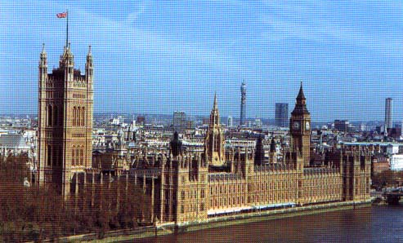
And now let’s play a game «What is wrong, what is right» and check up yourself.
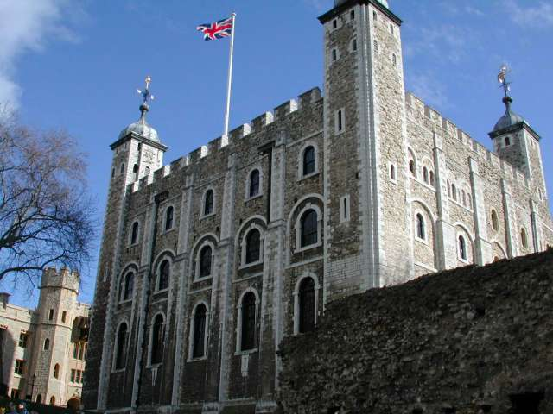
1. The British Parliament
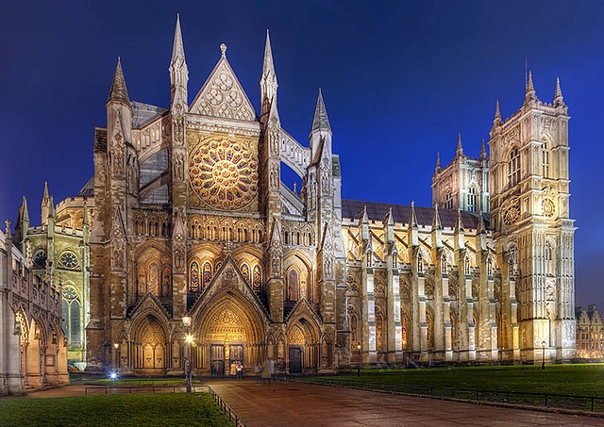
2. The White Tower

3. The Westminster Abbey
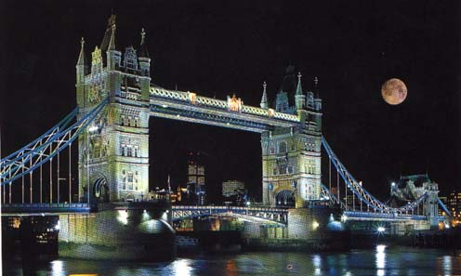

4. Tower Bridge

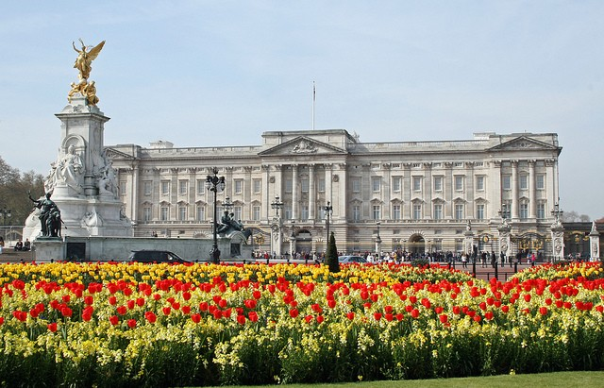

4. Buckingham Palace
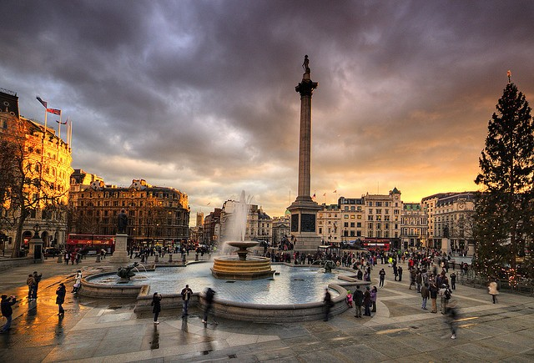

5. Trafalgar Square

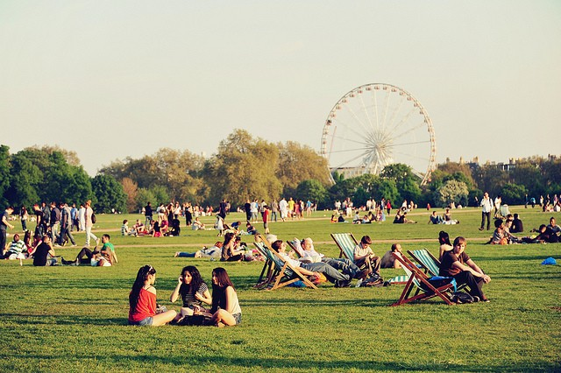
6. Hyde Park

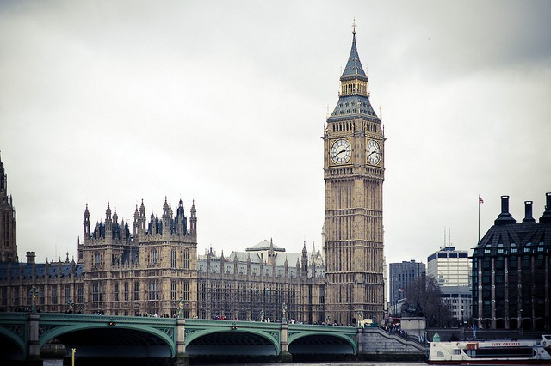
7. Big Ben

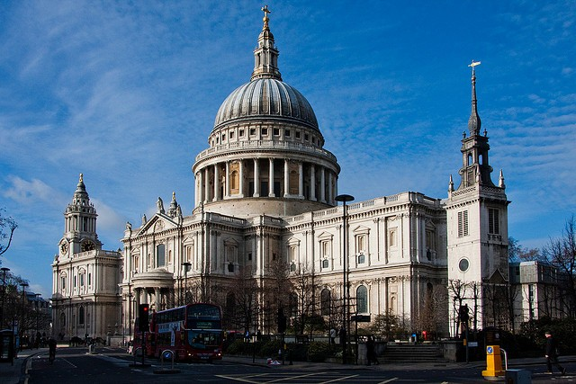

8. St. Paul`s Cathedral

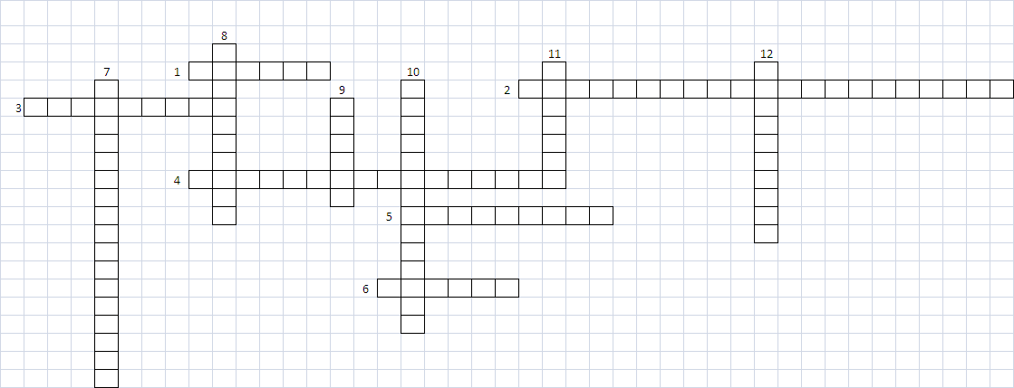
V. Homework-Your home task is to do the crossword

- What is the Tower of London now?
- By whom was the Tower built?
- Which London park is famous for its Speakers` Corner where you can make any speech you like?
- Who designed St. Paul`s Cathedral?
- What square is situated in geographical center of London?
- What birds are the national symbol of London?
- Where are the British monarchs crowned?
- In what Palace does the Queen live?
- In Trafalgar Square there is a monument to Admiral…
- What museum is famous for its wax effigies of famous people?
- What is the most famous clock in Great Britain?
- What are the famous guards of the Tower of London called?

Ф.И.О. УЧАСТНИКА | ТЕСТ | РОЛЕВАЯ ИГРА | ОТВЕТЫ С МЕСТА | ИГРА «ЧТО ЕСТЬ ЧЕГО НЕТ» | ИТОГ
Игнатенко Анна
Колмакова Марина
Цулан Юлия
Станбольян Татьяна
Белов Михаил
Липатова Кристина
Дьяченко Дарья
Кирпань Андрей
Гребенюк Ирина
Зима Мария
Пехтерева Елена
Чугунова Алена
VI. Итоги урока (анализ работы обучающихся, объявление оценок)

Teacher. Our tour has finished. We have been in London and we have learned a lot of interesting facts and information about its sights. I hope that you have enjoyed our tour to London. You have worked very well today. I give you… (marks) for the lesson.
Our lesson is over, thank you. Good bye.

Приложение № 1
Тест
1. What is the full name of Great Britain?
a) Great Britain
b) England
c) The United Kingdom of Great Britain and Northern Ireland.
2. Where is Great Britain situated?
a) on the British Isles
b) in South Africa
c) on the Scottish Isles
3. How many parts does the Island of Great Britain consist of?
a) 6
b) 4
c) 3
4. What is the climate like in Great Britain?
a) mild
b) snowy
c) hot
5. What kind of state is the United Kingdom of Great Britain?
a) a parliamentary republic
b) a limited monarchy
c) a constitutional monarchy
6. What is the name of the British national flag?
a) The Saint Andrew’s Cross
b) The Union Jack
c) The Saint David Cross
7. What is the emblem of England?
a) A shamrock
b) A red rose
c) A leek

эталон ответов:
1. с
2.а
3.в
4. а
5. с
6. в
7. в

Приложение № 2
Кроссворд по теме «Достопримечательности Лондона»
