"THE BRIGHT PAGES OF MY SUMMER DIARY"

Автор: Шкитина Людмила Витальевна, учитель английского языка

Школа: Государственное бюджетное образовательное учреждение города Москвы средняя общеобразовательная школа с углубленным изучением английского языка № 1378

Населенный пункт, регион: город Москва

Электронный адрес: ludmila9@mail.ru

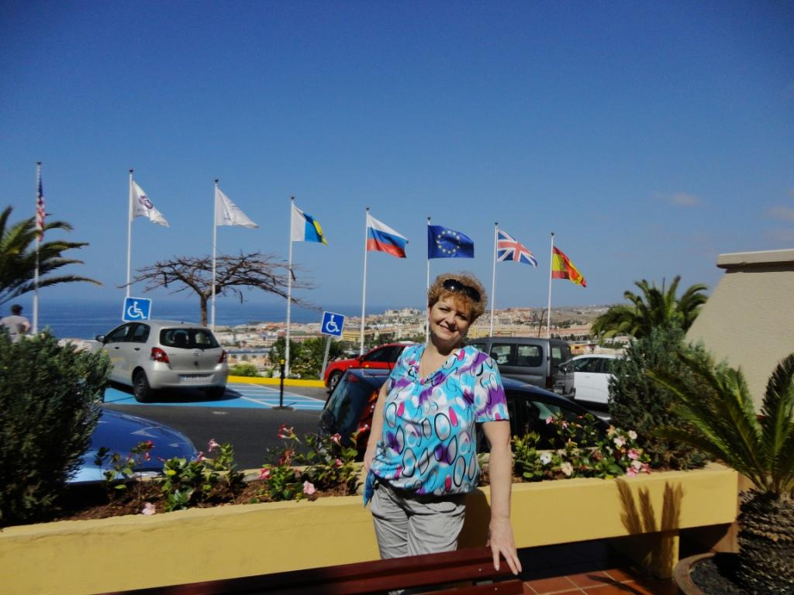

Well, it’s time to open the first page of my SUMMER DIARY called
“My 10 Days of delight”

The sky was cramped 14 July, 2013

I feel like I spent the whole year just waiting for a unique chance to arrive in the Canaries. I'm so grateful that my family joyfully agreed to fly so far. I was afraid my daughter Kate could easily reject the idea due to her attitudes to flights. She scares them… It was such a generous gift to the world called “MOTHER”… I think this is the common thread that runs through the SHKITINS, - I mean our great love to travel.
So now we are in the Canaries! It’s our first day here! These are all people and the island that are worthy of your full attention and top admiration. Thanks a lot, my honeys, for always being interested in the special places that make our little world go round!
Be sure, everybody staying in the canaries will fall in love with its people, nature, climate and cuisine forever LIKE ME.

“Space” exploration 16 July, 2013

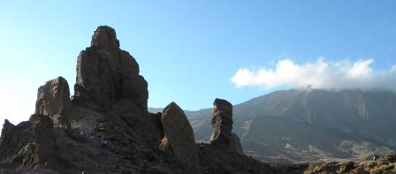
I had never even expected I would travel to Tenerife and see the beauty of the island with its space-like landscape. Today we decided to join a group of tourists to explore the island and visit its sights, exhibitions or attractions. After two-day lying on the beach everybody of us was ready to change this activity for the more active one. So the coach brought us to the heart of the island - to the factory of Tenerife Pearl. Our journey started at the most beautiful visitor’s center where we could do some shopping too. I am crazy about the jewelry, that’s why much money was spent for Tenerife pearls.

Taking the sun is so relaxing 17-19 July, 2013
Nothing special has happened this time: relaxing, relaxing, relaxing …after hard work at school is really cool!
Making new friends 20 July, 2013
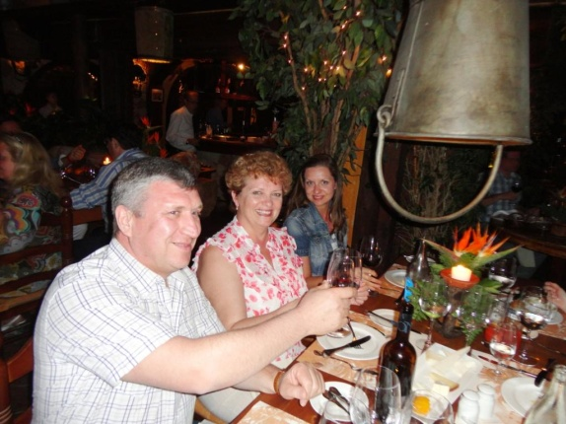
This late afternoon we all needed of a good feed. I’m sure, we didn’t go wrong with Teide Restaurant. A romantic atmosphere, attentive service and a varied menu including seafood, vegetarian dishes, chicken dishes and a range of international dishes are always offered here. It has become our favorite Restaurant. Very pleasant people from Suzdal were having late dinner there. Our joint party was full of chatting, dancing and jokes.

A day at Siam Park 21 July, 2013
Waking up early in the morning isn’t typical for the holiday makers, neither is for my family but today we are going to Siam Park to try all aqua attractions. We could hardly miss a brilliant chance to spend there the whole day.
We were greatly surprised with “the working hours” of the park staff. Till five o’clock! The end of the working day! Nothing can make Tenerife local people stay longer at work. Trade Unions care their members.

One day before the departure 22 July, 2013

The morning was bright. The sun was shining. It was just 20 minutes past 7 when we reached the slipway to the beach. The last day before departure was a little sad. I was sitting on the sand and watching the children making sand castles, as small hands busied themselves with their buckets and spades.
The sea was bright-blue, the small waves were running to the seaside… like small sheep.
This early hour I could see lots of holidaymakers strolling past the sand dunes. Farewell to the Canaries, farewell to the sea, the sun… Ready to come back to Moscow…

Использованные источники

- Фото из архива автора, фотоальбом «Отдых на Тенерифе»

