"THE BRIGHT PAGES OF MY SUMMER DIARY"

Автор: Фазлахметова Елена Дмитриевна, учитель
Школа: МБОУ СОШ № 4 НГО
Населенный пункт, регион: Приморский край, г. Находка, ул. Школьный переулок, 1
Электронный адрес: www.V0lek@mail.ru

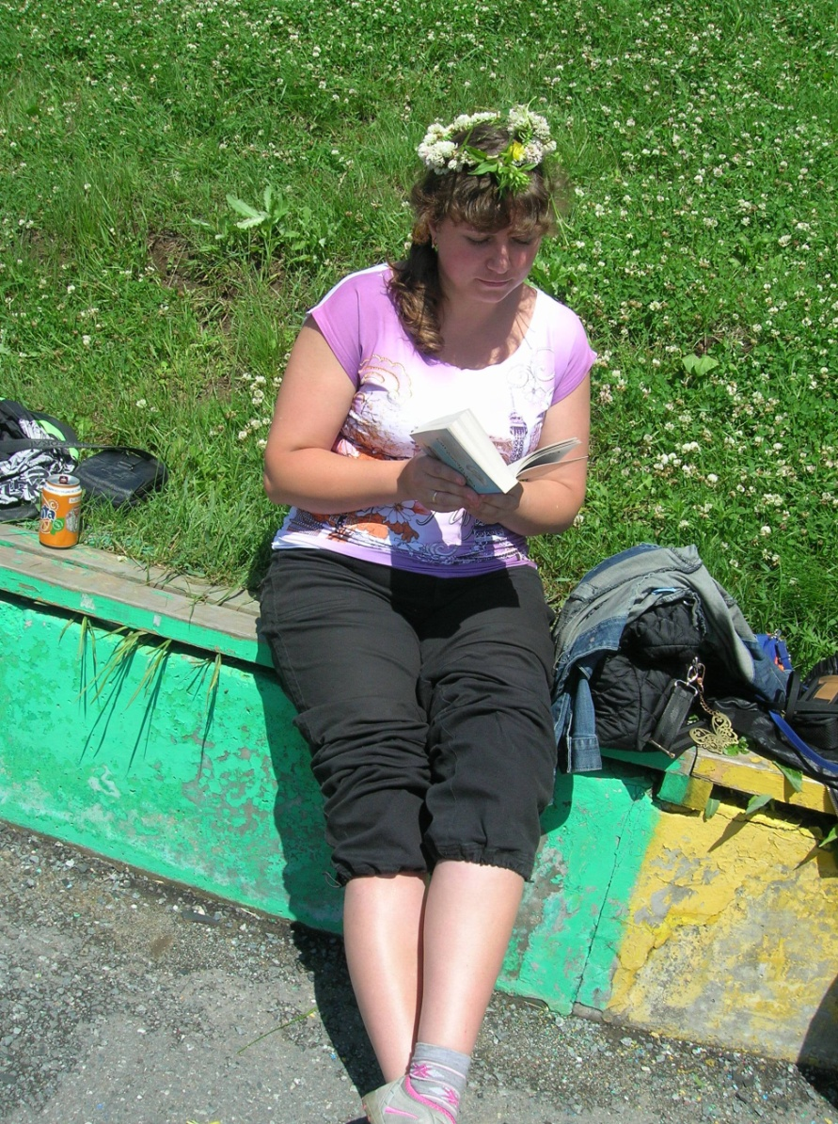

S
June
ummer came at last. All people like and wait summer. It’s warm and hot. You wear light clothes. Mostly only teachers have holidays in summer. But in this month they continue working: take exams. Pupils from 1 to 8 and 10 grades are happy. They start to have a good time.
I worked in this month too. I went from my school to another one to take USE exams. There I met different teachers and changed my experience. In my free days I helped other teachers with children from summer school camp.
The life in the school camp was wonderful. Every day was different. When the weather was fine we spent a lot of time outdoors in the playground “Chunga-Changa” and visited the museum, cinema, theatre and art gallery. All children liked these activities. When the weather was bad we watched cartoons and played various games in the classroom.
Today is the end of June. I went on holiday. Hooray! In first day I slept. The weather was nice and then my son and I went to the sea. We swam, lay in the sun, sat on the sand and made a sandcastle. I liked to sit in the water and look at the sea. (фото из архива автора)
The godmother of my son asked us to help her and her family to work in the country cottage in Priiskovy country where we grow vegetables and fruit in the kitchen garden; water the flowers and other plants.
We also dig the ground and sow the seeds. In this day I tried to plant the seeds of watermelon from Japan. But without success. There weren’t any shoots. Today we pulled out the weeds, picked up the strawberries and mowed the long grass. My son and his godmother worked with the rake gathering the grass. We breathed fresh air a lot and went home completely tired.
Thus, the first month of the summer was over.

Фото из архива автора

Here is the gold middle of summer. It is time to repair my classroom. With the help of my pupil I painted the walls, floor, desks and chairs. It was very difficult for me because I had never done it before.
July
This month made us happy by nice and bad weather. When there were heavy showers my five-year old son and I visited exhibition “Mammoths” in the city museum, saw the rare species of butterflies in the art gallery which is near our house.
In summer we have an opportunity to go to the circus when it comes to town and ride a horse and even a camel. But most of all my son and I prefer riding a bicycle. We spend a lot of time on the beach.
One day we went to the Safari Park. There we saw many different kinds of birds: owls, eagles, kites and others. And we saw the tigers, Amur and Taiga. They are allowed to play and walk in the big open-air cage. During our excursion two boars followed us, and then the dears. We fed all the animals except the lions. Most of all we liked the little naughty bears.
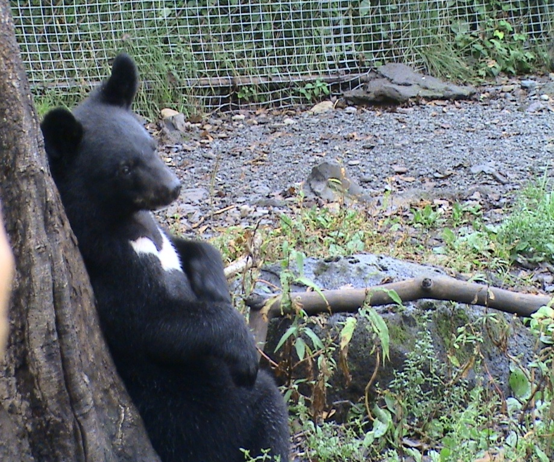
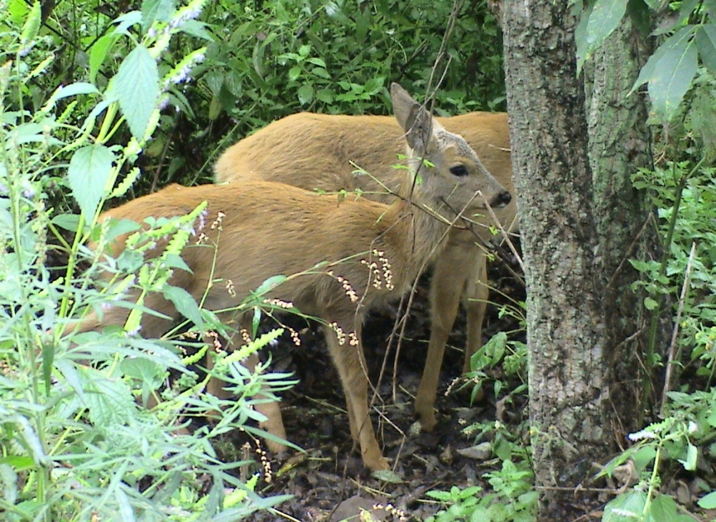
Фото из архива автора
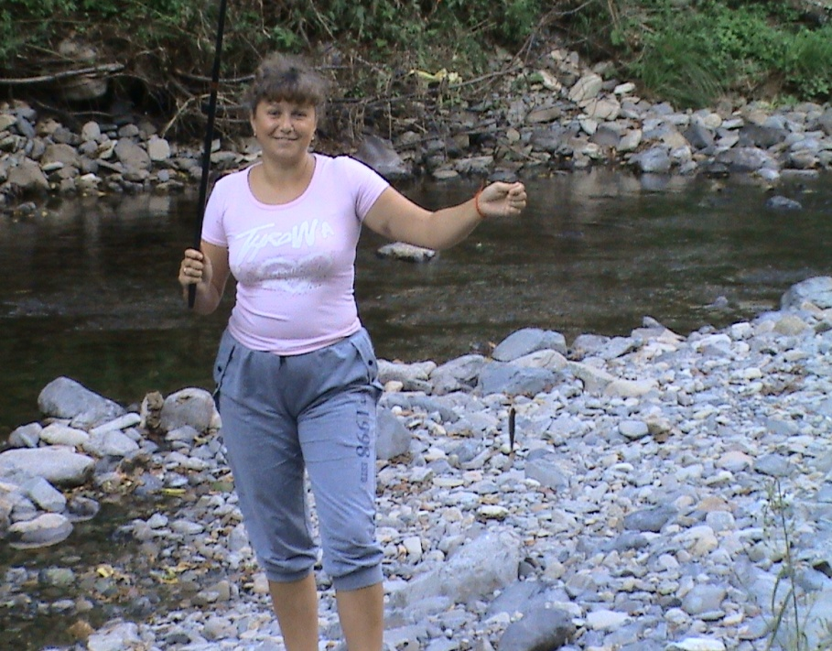
It’s time to crop, fishing, gathering mushrooms, berries and etc. The weather is fine and we, instead of going to the beach, go to the river. Our father, my husband, likes fishing by the river and my friend and I like going boating and talking about wonderful holidays. In this month we go for a walk in the forest, smell flowers and pick up mushrooms and berries but mostly the first. I also visit my friend with her little child; we drink tea and tell funny stories.
August

Sometimes we gather many friend and go somewhere for two maybe three days to make and sit round the fire, enjoy the beauty of the countryside, to take long walks in the forest and river, to catch fish, to tell the jokes and enjoy the weather. After these short holiday we always come home quite tired but happy.

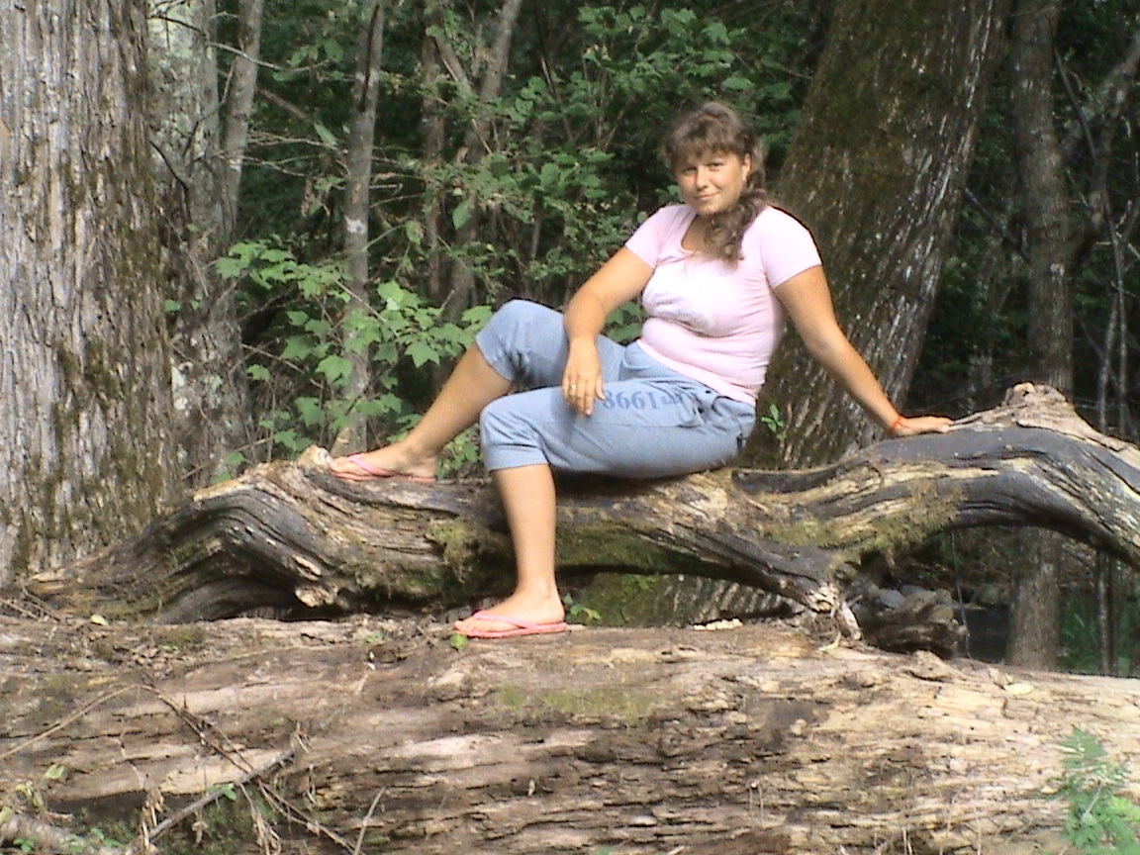

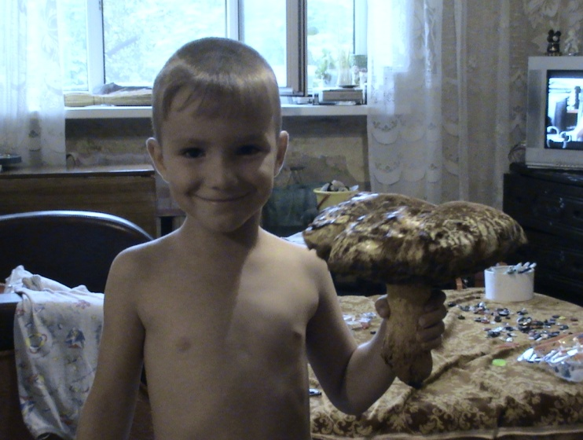

Фото из архива автора

