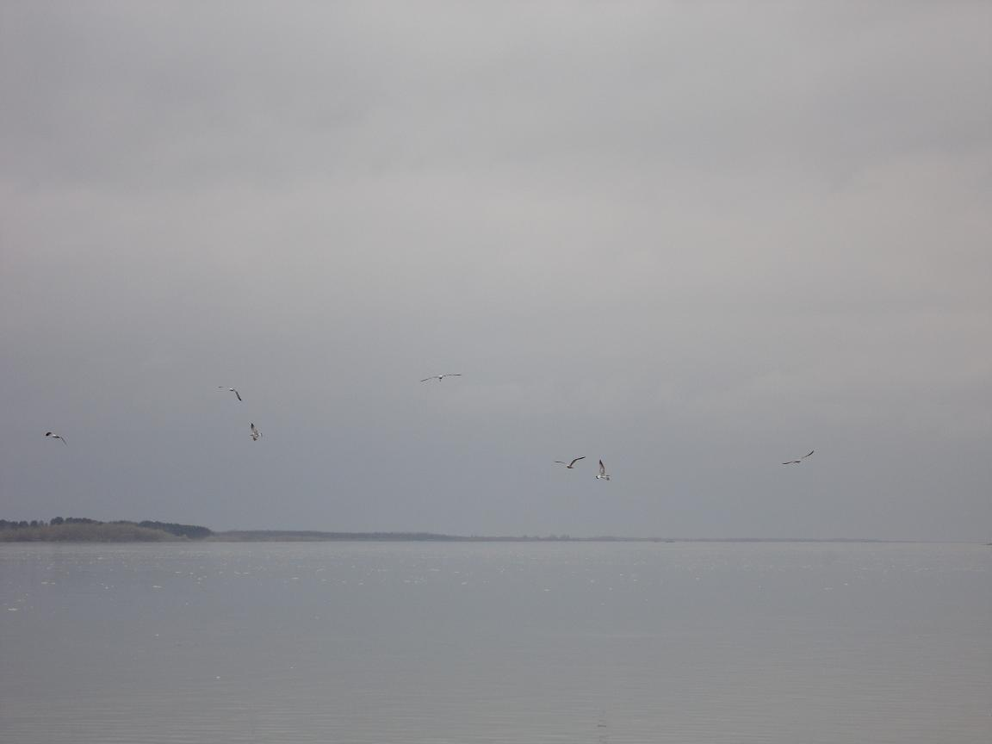

THE BRIGHTEST PAGE OF MY SUMMER DIARY
Автор: Зайцева Светлана Александровна

Школа: Муниципальное бюджетное общеобразовательное учреждение

муниципального образования г. Нягань

«Общеобразовательная средняя школа № 3»

Населенный пункт: г. Нягань ХМАО-Югра

Электронный адрес: light-64@mail.ru

Summer
Bright, hot
Attracts, relaxes, involves.
I adore summer holidays.
Happiness!

Summer is loved by everyone and everything: people, animals, plants. For many people summer is associated with the hot weather, plenty of flowers, fruit, vegetables, seasides and, of course, summer holidays. As for me, I adore summer. I leave my Northern town, visit my parents, son, friends and travel.
Last summer holidays began as usual.
Our school has got a lot of traditions. One of them is burning the school timetable at the end of the academic year. Teachers usually go to the countryside, have a picnic and burn the timetable (a large poster which is on the wall in the school hall).
According this tradition we had a picnic called “burning the timetable” last Sunday of the school year. It was the 2nd of June. The hard school year was over. There were no lessons at all, only exams.
Our trip started early in the morning at 8 o’clock (at the same time when the school began). It was long enough. We went by bus, then by boat for an hour and a half. The weather was nasty and cool. Fortunately, there wasn’t rain but cold wind was blowing. Our boat was small but safe. There was grey water around us and we could see only empty banks of the river Ob far away.
Suddenly we saw a beautiful white-sand shore. The shore was like a sea beach after a storm. There were large stones, sticks and logs. A thick forest was some meters away. It was our place for the picnic.
It is said that many, many years ago the Arctic Ocean was there and the shore has a beautiful landscape, white sand and large boulders now.
The nature was beautiful. There were gentle, tiny leaves on the trees. The fur-trees were fluffy and green. There was a carpet of green grass on the ground. The birds were singing and something was happening in the forest – we could hear sounds and noise.
First, we collected wood and made a fire. We sat around it and got warm. I looked at the fire, the boiling water in the bowler and felt peaceful and relaxed.
Then some of us went fishing. An hour later we cooked fish soup. It was delicious. Also we barbecued. It was a fantastic meal.
After that we made a big fire and put the timetable in it. The large piece of paper was getting brown, large holes appeared and the fire was filtering through the holes. It was burning, burning. Some minutes later there was nothing, only the fire. The school year was over. Our troubles, problems were over too. We shouted “Hurrah!”
Then we had sport competitions. We ran, jumped and … swam. To tell the truth only two brave men could swim in cold water of the Ob. They were Physics and Physical Education teachers. We applauded them. Also we made a funny performance and played games. There was the competition “the best sandcastle”. The castles were wonderful but our hands were cold because of icy water. In the evening we sat on the shore waiting our boat. We were quite and tired. It was an amazing day. We had a great time and took a lot of pictures. Look at them, please. They are interesting, aren’t they?
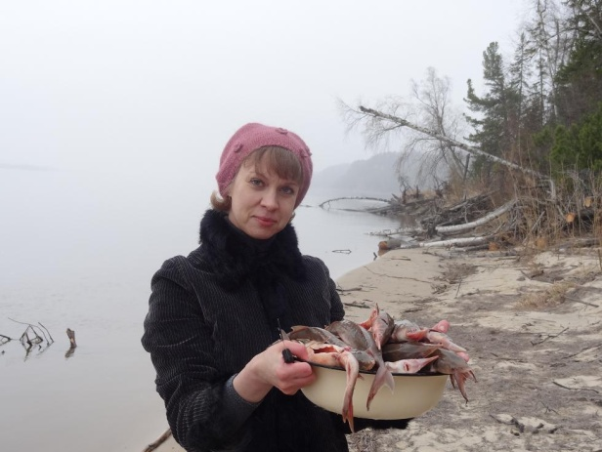
(Все фотографии взяты из личного архива автора, включая фотографию на подложке)
