"THE BRIGHT PAGES OF MY SUMMER DIARY"

Автор: Тупенова Гульжан Маратовна

Школа: Бюджетное общеобразовательное учреждение г. Омска «Средняя общеобразовательная школа №68»

Населенный пункт, регион: г. Омск, Омская область

Электронный адрес: happy7899@mail.ru

THE BRIGHT PAGES OF MY SUMMER DIARY
There were ninety-two of them, – bright, unforgettable. They differed from one another in shapes, colours, sounds, odours, details, memories, connections, meanings, impressions but they all had one thing in common – the belonging to the last summer. They resembled leaves of a tree, the pages of the little life called my summer adventure. The ninety-two pages from my summer diary are all dear to me but I have chosen only three of them to tell you about, one from each season.
The first page is from June, the seventh of June. It was light green tinged with shining drops of sky-blue, like the colour of the rain on that day. It sounded adorable echoing to the thunder that followed flashes of lightning and the music of the falling rain. I was in high moods though nothing special had happened but the exam which Zhenya, the only student of mine who had taken it, had passed successfully. In spite of the fact that after the examination I had to clean my classroom to prepare it for decorating the whole world seemed to me to be painted in pink. The heavy rain coming down in torrents could not make me feel blue, it merely washed away the dust so that everything became beaming with cleanliness and everyone’s faces were sparkling with inner joy and delight. The purity and freshness of that day has remained deep in my heart as a pearl of wonderful June.
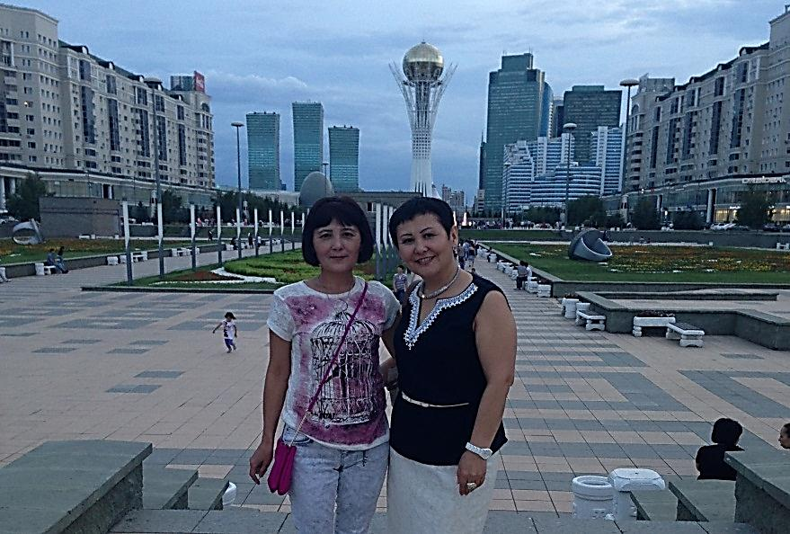
The second page comes from July. Then I visited Astana almost for the first time in my life. The capital of Kazakhstan fascinated me with numerous places of interest and I was greatly impressed on its modern stylish outlook and fine architecture combining European comfort and multi-functionality and Asian refinedness and luxury. My sister and my niece served me as guides and showed me all possible attractions which may be of any interest to a newcomer. We visited various shopping malls like Khan Shatyr, Keruen, enjoyed wonderful views of unique monuments and amazing squares and avenues, went to the cinema, took a lot of fantastic pictures as a keepsake and had delicious lunches in cafes and bistros.
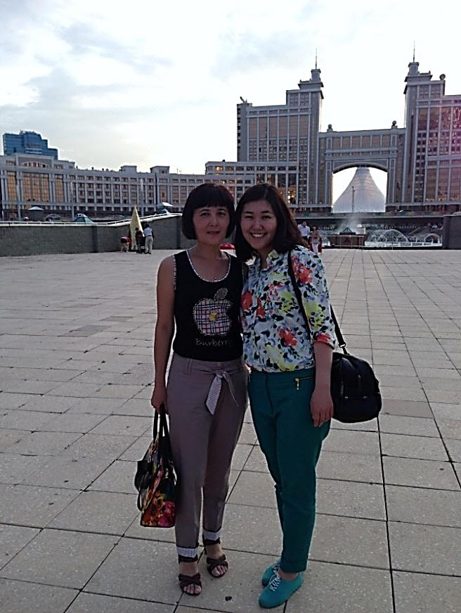
During my visit of that wonderful city, the youngest and the most quickly growing capital on the planet, I was happy to change my garments every part of the day which were as many-coloured as life in Astana itself. And now on looking back at the sunny days I spent there with my relatives I realize that I began missing Astana immediately as soon as I left it, its various amazing buildings, its convenient wide roads and its friendly cheerful atmosphere. In my mind that city remains as a subtle diamond flower in the heart of Kazakhstan. I promise myself to return to that splendid place should an opportunity arrive.

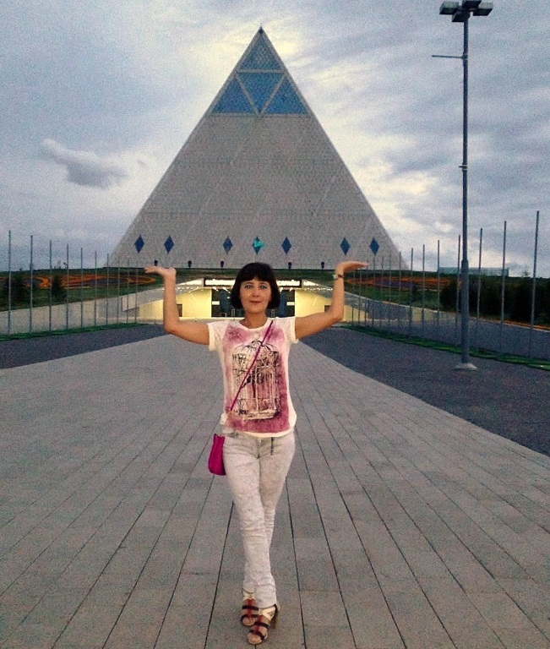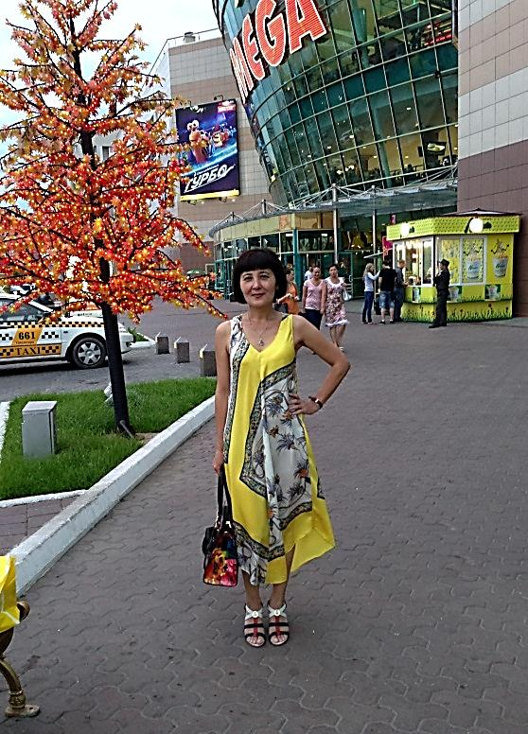
Фото из личного архива

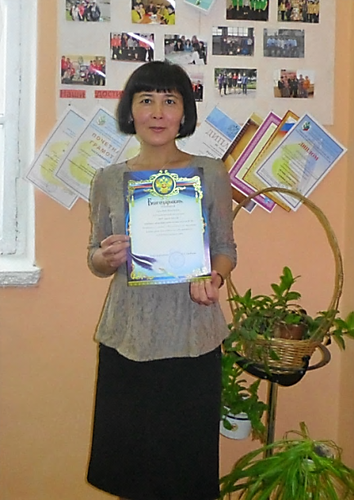
The last page that I would like to describe you is from August. It would have been an ordinary working day if I hadn’t got a message of thanks signed by the principal. That was the first official document in the school I had ever had and I was the only one to be handed it that time. It says that I was an active participant of distance projects and competitions for teachers and students during the last school year. I can add to those words that almost all of them resulted in diplomas of winners. That was a great moment for me and a nice incentive not to stop and give up but to move forward to higher goals. I strongly believe that it was a turning-point on my way to the golden height of success.
So, I keep those days in my memory as a collection of precious stones, the bright pages of my summer diary. I go over them in my mind over and over again. I wish they had never passed.
The brightest pages of my summer leave
Turned into orange, red and yellow leaves.
Their role is small,
To float and fall
Remaining in my dreams.

They do remind me of hot summer weather
Where days and nights were full of fun and ever
I will recall
Them with the fall
Of leaves in sunlight beams.

Though with the mournful cold rain surrendered
I’ll keep on being careful and tender
As golden rays
Of sunny days,
Reviving every page

Of gone away and early faded summer
One more time ended with an autumn drama.
And in the rain
I’ll stay again
And autumn’s on the stage.
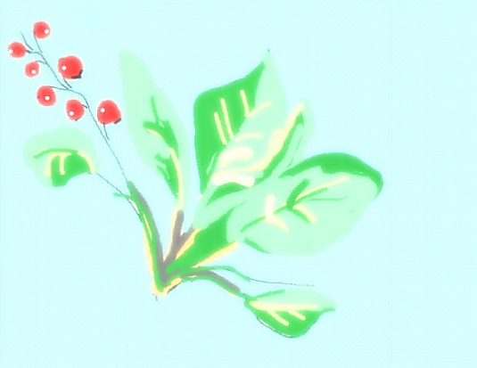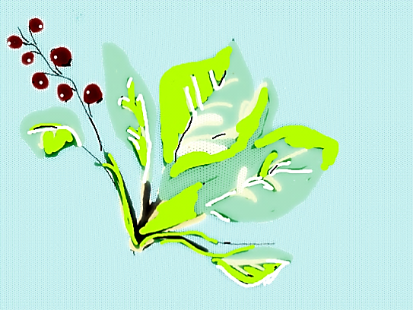

Фото из личного архива
Рисунки автора
Картинка для подложки взята на сайте: http://images.yandex.ru

