"THE BRIGHT PAGES OF MY SUMMER DIARY"

Автор: Панкратова Любовь Ивановна, учитель английского языка
Школа: муниципальное бюджетное общеобразовательное учреждение
«Ремзаводская средняя общеобразовательная школа»
Населенный пункт, регион: село Павловск Алтайского края
Электронный адрес автора работы lipankratova@mail.ru

I believe that summer is the best season as to fill one’s life with bright events as to meet new people and to make friends with some of them.

June. My Heart’s in the Highlands…
I live in Altai Krai. It’s the country of magic highland lakes and beautiful waterfalls, cool bubbling rivers and high mountains covered with thick forests which attracts tourists all over the world.
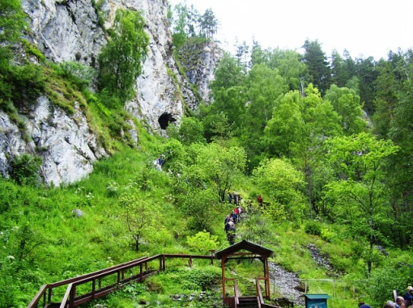
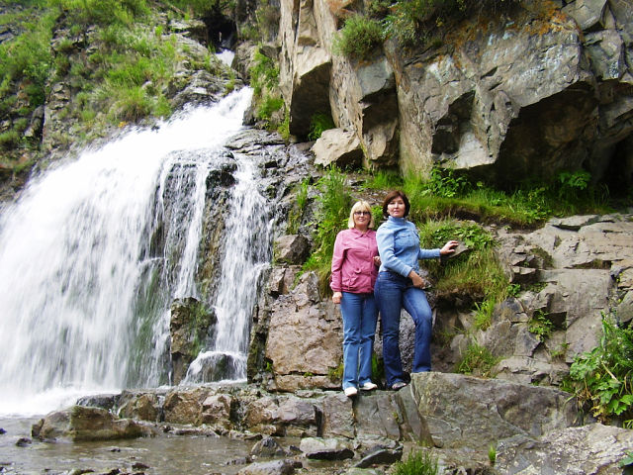
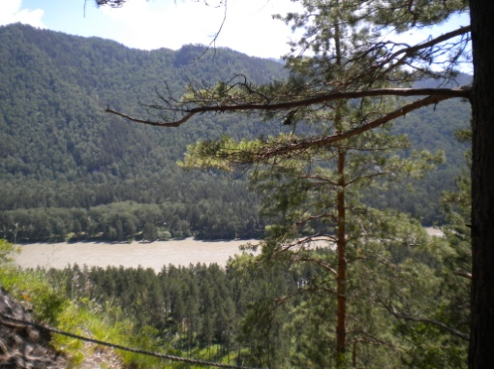
My love to that country was the reason for me to go to the Altai Mountains with a group of the tenformers in June. We lived in the tents on the bank of the Katun River and cooked food on the fire. It was much different from the everyday life of a town inhabitant but funny.

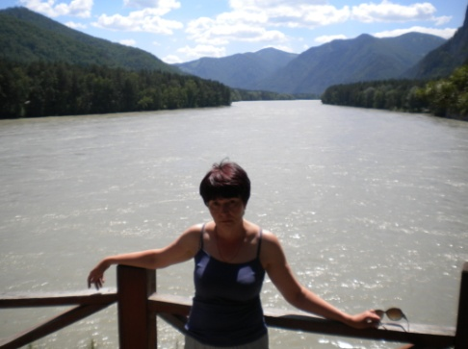
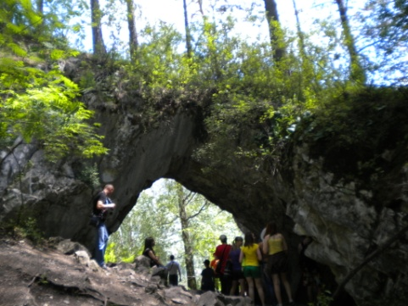
I was greatly impressed by the visit to the Tavdinsky Caves. One should walk high up the mountain to reach the entrance into them. The mountain is completely permeated with the caves, so it’s easy to be lost without an experienced guide. I and my students learned some local legends about magic events connected with the caves and some mysterious stories about ghosts wandering there during the excursion along the narrow tunnels.
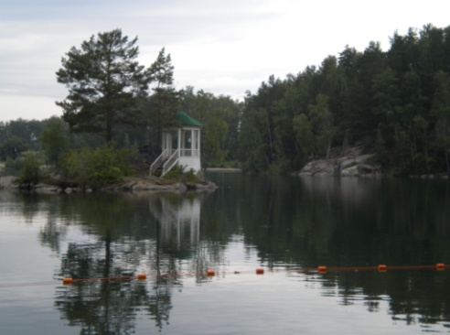
It is said if one hasn’t visited the highland natural lake of Aya means he hasn’t been to the Altai Mountains at all. It’s true! We were really fascinated by its marvelous beauty with the miracle in the middle – the Snakes’ Island. We had to overcome 200 stairs up but it was worth visiting.
If one comes to the Altai Mountains once, he will be back one more time for sure. It’s better to quote the poem of the well-known Scottish poet to express my feelings towards this land:
Wherever I wander, wherever I rove,
The hills of the Highlands for ever I love. (R.Burns)
July. Happy Birthday to You!..
It was nothing special about July except my birthday because I celebrated it in the unusual way. No guests. No party. Just me and my husband. He is a man of peculiar imagination and could fill all the day with various surprises to make my birthday bright and unforgettable. The following day we went on a trip to Italy.

August. Russia is the World Champion!
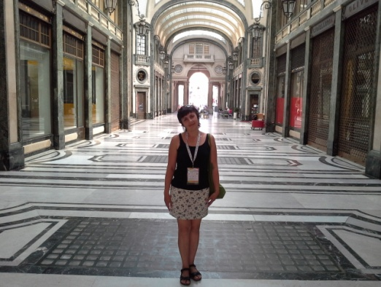
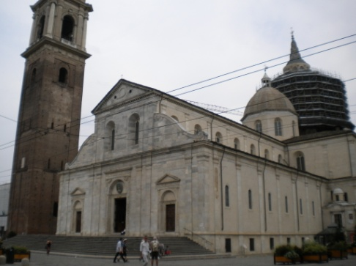
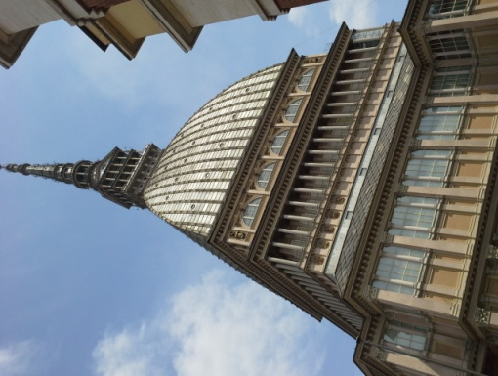
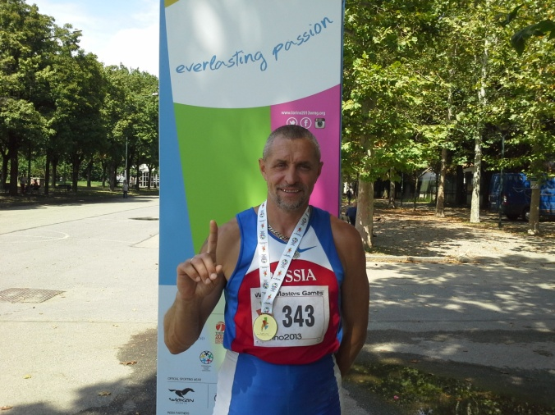
This summer I have been to Italy for the third time in my life. I love this country because it always brings pleasure and joy to me and good luck to my husband. It’s important to mention that my husband is a sport master in athletics and the member of Russian national veterans’ team. In August he competed with other sportsmen from over 130 countries of the world in the World Masters Games in Torino. The brightest event of our visit was his success in the competition. He became the World Champion in triple jump. I felt more than the pride for my husband and for Altai Krai and for Russia when I together with other people at the Primo Nebiolo Olympic stadium were listening the national anthem of the Russian Federation. I liked Torino with its ancient palaces and houses, squares and cathedrals, bridges and parks very much. I couldn’t help visiting Mole Antonelliana Tower with the cinema museum inside which is the symbol of the city. The Royal Palace, Madama Palace and a great number of decorated galleries overwhelmed me with their splendor. Torino, like many other old European towns and cities, has lots of churches and cathedrals. I visited two of the well-known ones. The Duomo di San Giovanni cathedral keeps carefully the shroud of Christ into which his body was wrapped after had been taken from the cross and on that the imprint of his image was left. Another sight of the city is Chiesa Gran Madre di Dio cathedral known for its external similarity with the Parthenon in Rome. The visit to the Egyptian museum is one of the brightest pages in my summer diary. It took my breath away when I was exploring its exhibits. It was fantastic!
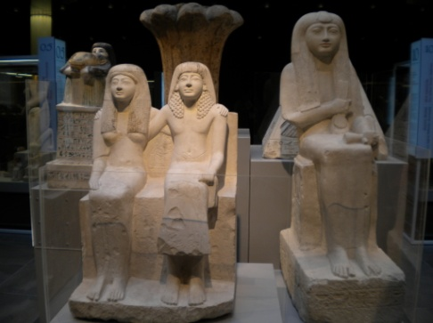
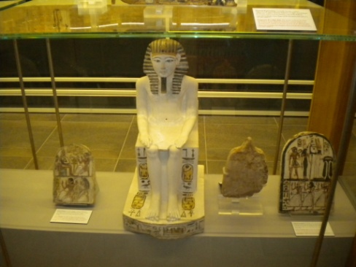
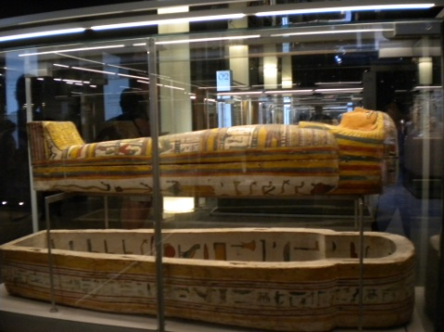
One more interesting fact about Torino is that it has the youngest underground in the world built for Winter Olympic Games in 2006. It isn’t so busy as Moscow one. It was amazing to go by train without a train-driver.
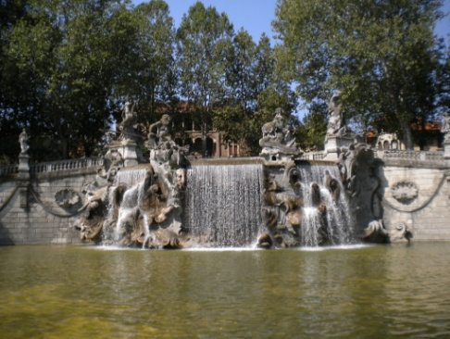
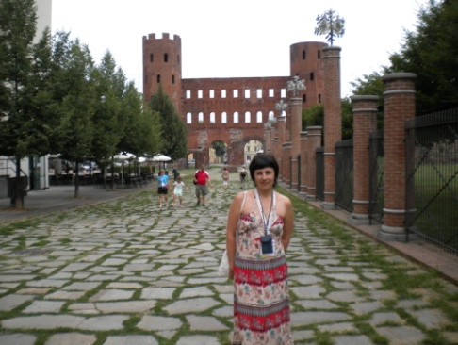
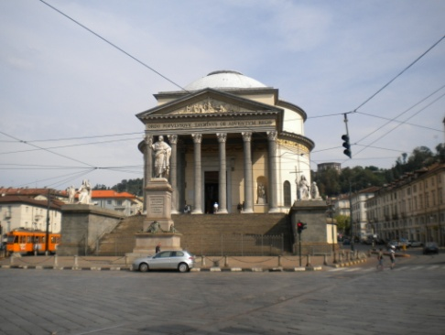
The possibility to practice my English made that trip useful. I conversed with the English-speaking competitors and fans from the USA, Australia and Canada. I couldn’t miss the chance to talk to the members of the Canadian volleyball team who lived at the same hotel. I found them friendly and smiling people.

It was the last page of my summer diary. I will be eager to wait for the next summer to start a new diary.

(все фото взяты из личного архива автора)

