« THE BRIGHT PAGES OF MY SUMMER DIARY »

Автор: Костылева Елена Васильевна, учитель английского языка
Школа: муниципальное автономное общеобразовательное учреждение
средняя общеобразовательная школа №6
Населённый пункт, регион: городской округ Красноуральск Свердловской области
Электронный адрес автора работы: elena-kostyleva88@rambler.ru
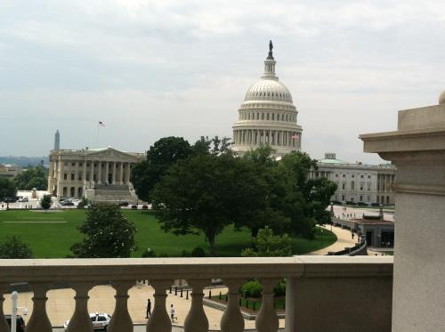
The bright pages of my summer diary

Every summer I visit my daughter living in Georgia, the USA. She usually plans a lot of activities for our vacation. During my previous trips we went to many places and learned a lot about American people and their traditions. This summer we had a lot of fun riding on roller coasters at the Six Flags over Georgia Park and splashing in the waves of the White Water Park but the most exciting was a trip to Washington D.C. My dreams came true this summer. My daughter’s family, my grandson and I left for a trip on June 24. We went by car across South and North Carolina, stopping for a night in Richmond, Virginia. Finally we reached Washington D.C. on June 25. Here is my diary of a three-day stay in the capital of the USA.

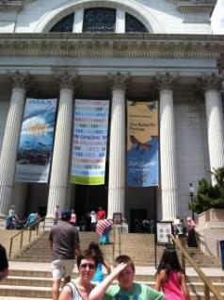
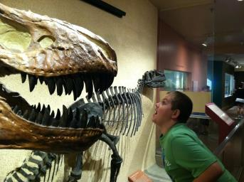
June 25
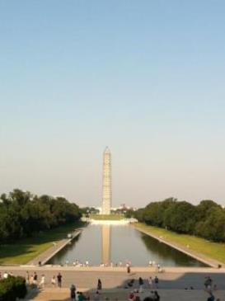
We checked in at the L’Enfant Plaza Hotel in the afternoon and couldn’t wait to do the sightseeing. First, we decided to visit the National Museum of Natural History. The Butterfly Pavilion caught our eye right away. We were able to look at the butterflies in their natural environment. It was fun and exciting to see them land on our hair and clothes. We also walked through various exhibits, such as Bones and Mummies, Dinosaurs, Diamonds, Gemstones and Minerals, Elephants, and Oceans. I admired the Hope Diamond, blue in color and weighing a whopping 45.52 carat or 9.10 grams. It took my breath away. The collection of rocks in the Gemstones and Minerals exhibit was also worth taking a look. We enjoyed walking through the Oceans exhibit, examining with interest different species from the ocean. The Dinosaur Hall was our favorite exhibit by far. We were mesmerized by the real size of the prehistoric dinosaurs and felt like we were actually there.
Next we went to the stunning Washington Monument which is currently under construction due to a recent earthquake. At the moment it isn’t available for public viewing, so we walked around it, admiring it from far.
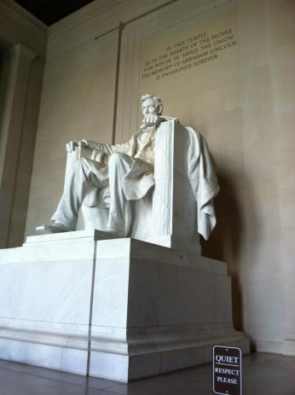
We continued walking along the Reflecting Pool to the Lincoln Memorial. It was packed with tourists but we still had a fantastic time, taking lots of pictures and sitting on the steps of the memorial. The Lincoln statue was amazing because of its size. It is one of my favorite things we saw in Washington. I couldn’t believe I was looking at the greatest monuments in D.C. which I only taught the students about. Being exhausted, we caught a taxi cab back to the hotel, passing the magnificent Jefferson Memorial and ordered a lot of food from a pizzeria. It was a day well-spent!

June 26
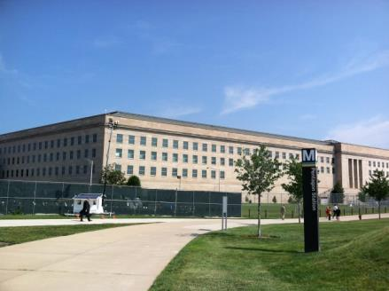
Early in the morning we headed for the Department of Defense, the Pentagon. It is a large building in the shape of a pentagon with five sides and five corners. First we went through strict security screening. The guide led us through many corridors of this five story gigantic building. We walked about 1.5 miles while the guide talked to us about different branches of the military and their accomplishments. There was a lot of different memorabilia, proudly displayed on the walls. It was interesting to learn that Pentagon never closes, being opened 24 hours a day. Pentagon also has 19 escalators, 284 restrooms and various shops, banks, cafes. The last part of the tour was bittersweet, a walk through the 9/11 Memorial for the victims who perished when the plane crashed into the Pentagon in 2001. We were able to sign a book in honor of the victims.
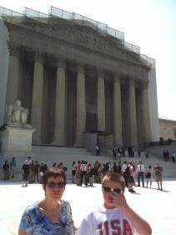
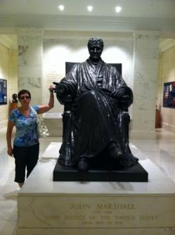
Our next stop was the Supreme Court of the United States of America. There was a lot of press and people in front of the Court because of the Supreme Court ruling on June 26th for federal recognition of the same-sex marriages. Inside this grand marbled building we watched a movie about what happens at the Supreme Court and how judges make decisions. On the ground floor we toured the exhibits, highlighting the Court’s history. We glanced at the John Marshall’s statue, the longest serving Chief Justice, who served for 34 years.
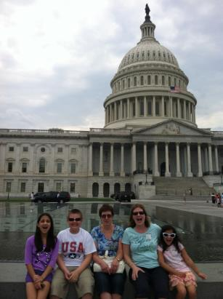
After the Supreme Court we went to the Capitol, a majestic building that houses the Senate and the House of the Representatives. It is one of the most splendid buildings I have ever seen. There is a statue called Freedom on the top of the dome. There are beautiful paintings inside the dome and on the walls, depicting American history. There are statues of the important people who helped shape America. We took a walking tour of the Capitol building and listened through the headphones to the tour guide, enjoying the beautiful architecture and art. The guide was very knowledgeable.
The tunnel led us to the Library of Congress where we did a self-guided tour. I was impressed with the Thomas Jefferson Library. He wanted the congress to have his extensive collection of books when the national library was burned to the ground.
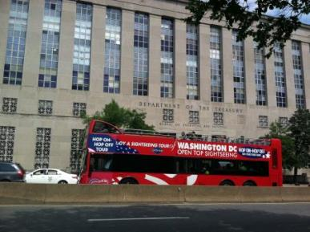
At last we visited the Bureau of Engraving and Printing. It’s a great place to learn all about the U.S. paper currency. We could see millions of dollars being printed as we walked along the gallery overlooking the production process. We got to see how money was being made. We were able to observe the machines and learned the steps in currency printing as the workers waved to us, while handling the money. We learned that 95% of printed money was used to replace old bills and that the design of the bills changed every seven years. We were able to view the new 100 dollar bill before it would be released to the public in October of 2013.
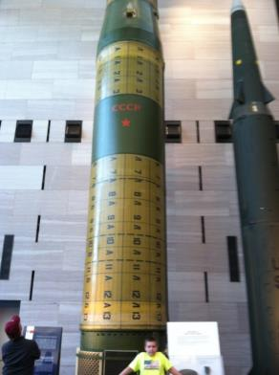
June 27
Our kids couldn’t wait to visit the Air and Space Museum. First we visited the interactive “How Things Fly” exhibit where kids experimented with the laws of physics, especially gravity. The most amazing thing about this museum was the display of real rockets, satellites and spaceships. We were even able to go inside the space capsule. Now we know how astronauts took a shower back then. There was a lot of information about the “race to space” during the Cold War period between the Soviet Union and the US. Astronauts’ suits and memorabilia were displayed in the museum as well. We had a fantastic time exploring the various aspects of space and history.
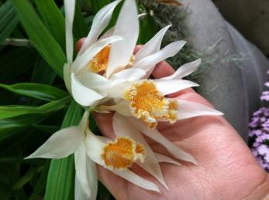
Next we went to the United States Botanic Garden. The beauty and the diversity of plants impressed us. We felt like we were in a magical world. We were immersed into deserts, jungles, Hawaiian flora, orchids and medicinal plants. All of us were fascinated by the jungle area, where the canopy walk allowed us to get a bird’s eye view of towering palms and exotic plants. My granddaughters’ favorite was the dazzling display of orchids. There were so many variations and colours of these mythic plants. They were gorgeous!
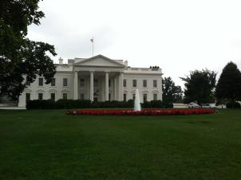
It started raining, so we decided to take a taxi to the White House. Currently it is closed for public viewing. We walked around this massive structure imagining what the president might be doing right now. The White House was guarded by a large team of security guards. There were people from all other the world taking pictures of this seemingly normal house that happened to be white in color.
The National Aquarium is located close to the White House and was next on our list to visit. As soon as we walked in we saw baby alligators, drawing lots of attention from the crowd. Inside there were displays of a variety of colorful fish, eels, sharks, rays and turtles. Kids found piranha the most exciting of all. The National Aquarium was smaller than we expected, but definitely worth visiting.

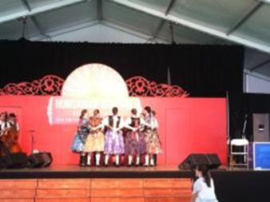
On our way back to the hotel we were lucky to stumble on the Hungarian Festival. We got to watch Hungarian folk dancers and singers performing in front of the audience opposite the Smithsonian Institution. We really enjoyed listening to the violinists. It was a great day!

Unfortunately our Washington trip came to an end. Three days flew by very quickly and they turned out to be the brightest days of my summer. It should definitely be noted that all Washington museums are free of charge to the public, making our visit to the city more affordable and enjoyable. This trip could not have been better. Goodbye Washington!!!

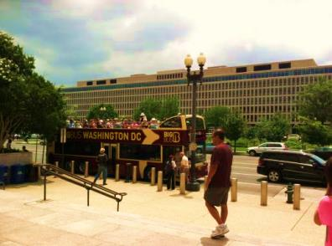
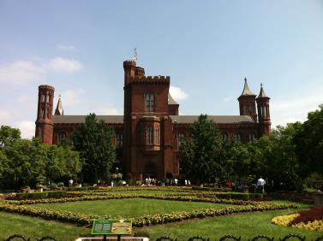

.

Фото из личного архива автора

