Государственное Бюджетное Общеобразовательное Учреждение
Средняя Общеобразовательная Школа № 180
с углублённым изучением английского языка

Театрализованное представление:
“The World of William Shakespeare”
(учащиеся 7-х классов)

Учитель английского языка
Васильева Е.В.

Санкт-Петербург
2013-2014 уч. год
Тема: Страна изучаемого языка.
Сюжет: Мир Вильяма Шекспира.
Цель: Поставить на сцене театрализованное представление по пьесам Вильяма Шекспира.
Задачи:
1) Общеобразовательные:
• Выучить необходимый лексический материал;
• Закрепить знание лексического материала на репетициях;
• Контролировать правильное произношение учащихся;
• Развивать речевые навыки учащихся;
- в монологической речи;
- в диалогической речи;
- в полилоге;
• Развивать навыки аудирования:
- тренировать навык понимания иноязычной речи (английский язык).
2) Развивающие:
• Ознакомить учащихся с биографией Вильяма Шекспира.
• Ознакомить учащихся с Творчеством Вильяма Шекспира:
Сонеты, «Король Лир», «Гамлет», «Ромео и Джульетта».
• Познакомить учащихся с европейской музыкой XV – XVI веков.
• Ознакомить учащихся с некоторыми аспектами истории и быта европейцев эпохи Шекспира.
• Развивать способности учащихся выступать на публике.
3) Воспитательные:
• Развивать умения учащихся работать в коллективе.
• Прививать учащимся ценности добра, любви, семьи.
Всего задействовано в театрализованном представлении 24 учащихся (?-е классы)
1 ведущий;
4 человека читают биографию Шекспира;
4 человека участвуют в сцене из биографии Шекспира;
9 человек участвуют в сцене из трагедии «Король Лир»;
1 человек читает сонет;
2 человека участвуют в сцене из трагедии «Ромео и Джульетта»;
2 человека участвуют в сцене из трагедии «Гамлет»;
2 человека - помощники оформления сцены.
Сценарий представления:
Звучит музыка. Появляется на экране 1слайд.
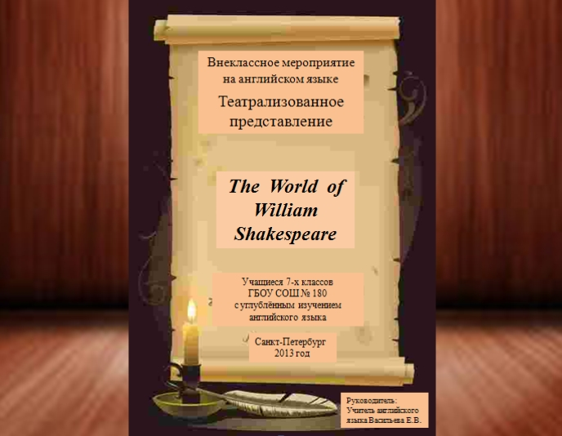
Ведущий:
Good afternoon, ladies and gentlemen! Our dear teachers and friends! We are very glad to meet everyone of you here. Welcome to the performance “The World of William Shakespeare”. Our meeting is dedicated to the greatest writer. People all over the world admire his sonnets, comedies, plays and tragedies, read them, go to the theatres, watch films to enjoy his works again and again. Today you will watch several scenes about love and this is our present to you, as spring time is coming, the time of love is coming
Звучит музыка.Появляется на экране 2 слайд.
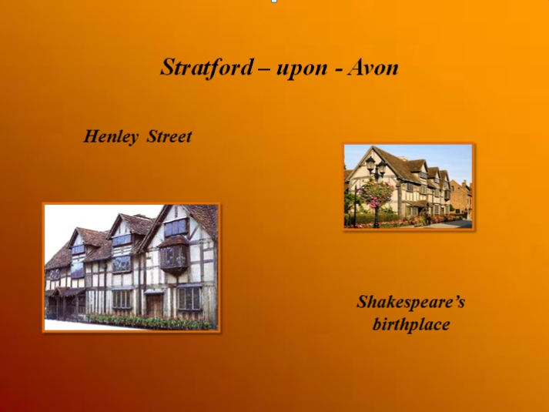
Учащиеся рассказывают присутствующим краткую биографию Вильяма Шекспира.
1-й ученик:
On April 23, 1564 a son, William, was born to John and Mary Shakespeare in Stratford – upon – Avon. His mother was the daughter of a farmer. His father was a glove-maker.
Появляется 3-й слайд
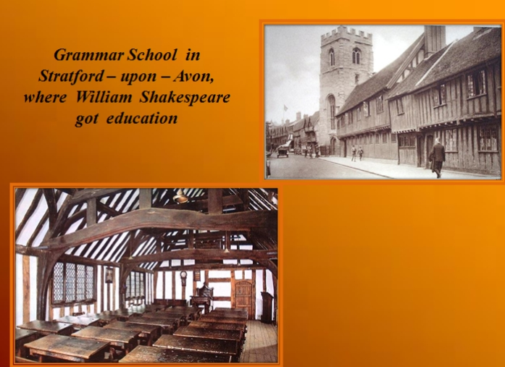
William went to a grammar school in Stratford and had a good education. There he learned to love reading.

2-ученик:
Появляется 4-й слайд
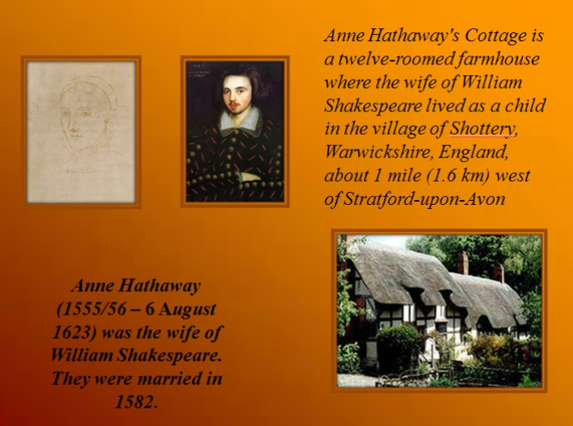

While still a teenager, William married Anne Hathaway, a farmer’s daughter some years older than himself. We don’t know how he earned his living during these early years, perhaps he helped his father in the family business. During these years his three children were born: Susannah, the eldest, then twins, a son Hamnet and another girl Judith.

3-й ученик:
In 1587 Shakespeare went to work in London, leaving Anne and the children at home. We don’t know exactly why he did it. Some people say that the reason was his love of poetry and the theatre. But there is another story, which says that he had to run away from law because he killed some deer belonging to a rich man.

4 – й ученик:
Появляется 5-й слайд
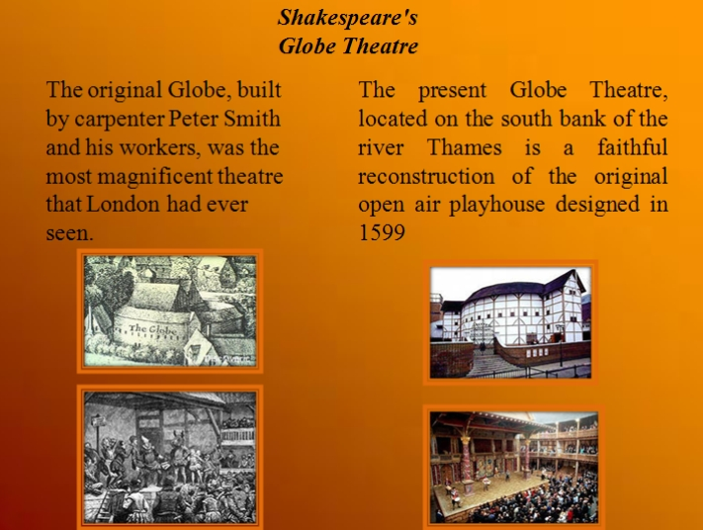
In London Shakespeare began to act and to write plays and soon became an important member of a well-known acting company. Most of his plays were performed in the new Globe Theatre built on the bank of the River Thames. In 1613 he stopped writing and went to live in Stratford where he died in 1616.
Появляется 6-й слайд
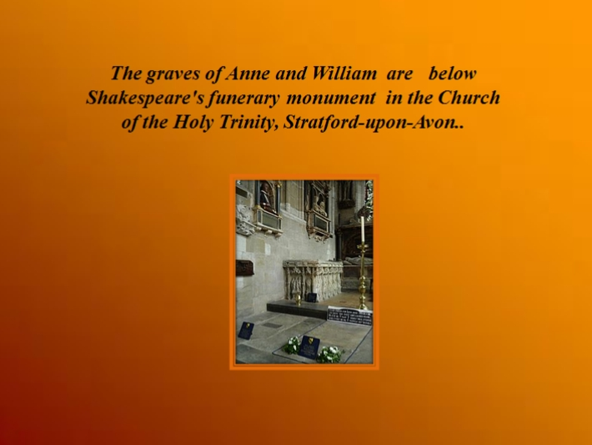
Ведущий:
And this is almost all that we know about Shakespeare’s life. But we tried to imagine the time when William was young, when he loved his future wife Anne Hathaway and dreamt to go to London and to become famous.
Звучит музыка. Готовят сцену для представления сценки из биографии Шекспира.
Will:
Father, mother. I was hired to a London company of actors for 5 shillings a week. We’ll depart to London in a few days. You know my dream, will you let me go?
Father:
Is this what you really want, William? Never learn a trade? Never call yourself a master of your craft?
Will:
Acting is a craft, Father. And not only acting. I may write poetry as well.
Father:
Ah. That may be only in future. Now you’ll be only a common player. That is not what we hoped for you.
Mother:
What we hoped for our son has gone long since. If this is what he wants to do, he’d better do it.
Will:
You mean … . You mean, you wouldn’t mind. I CAN go?
Mother:
Yes, my dear. We want you to be happy.
Will:
Oh, mummy. Thank you!
Father:
Bless you my son. I hope you’ll become rich and successful, and excellent in profession you have chosen.
Will:
Thank you, father.
Will:
I should find Anna Hathaway to say good-bye to her.
Will:
Hello, Anna!
Anna:
Oh, William! Hi! Why are you so serious on this lovely day?
Will:
I’ll go to London, Anna.
Anna:
To London?
Will:
I’ve joined a company of players. I’ll leave in a few days.
Anna:
Then I shan’t see you again.

Will:
I shall be back soon.
Anna:
Oh, you say that now. But when you get to London, You’ll forget all about us here.
Will:
Do you think, I should forget you?
Anna:
Yes, I do. I think that when you see the London ladies in all their silks and jewels … . You’ll soon forget us.
Will:
I never shall. Anna, you know I haven’t any money now, but … .If I come back rich will you marry me?
Anna:
If I loved you … .
Will:
Anna, how can I make you believe me? Here and now. Will you say you’ll marry me?
Anna:
What about my father’s permission?
Will:
I’m poor, he’ll never agree. But, please, tell me that you’ll merry me.
Anna:
Umm. William let me go home … .
Will:
I never will.
Anna:
Ok. I, Anna Hathaway, take you, William Shakespeare, to be my lawful wedded husband.
Появляется 7-й слайд
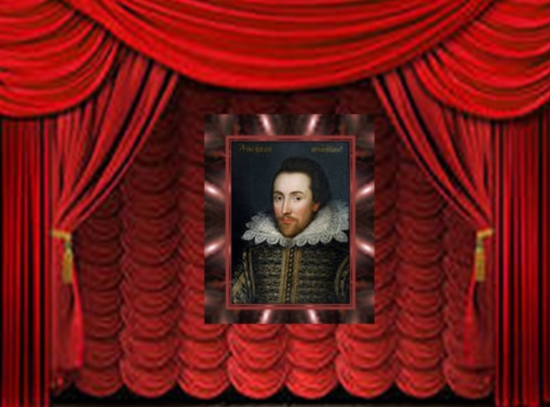

Ведущий:
Shakespeare was not for age, he was for all time, as Benjamin Jonson said about him. What made him famous? Of course, his works, in which he showed the deep true love, love between parents and children. We will tell you the story about King Lear.
Появляется 8-й слайд
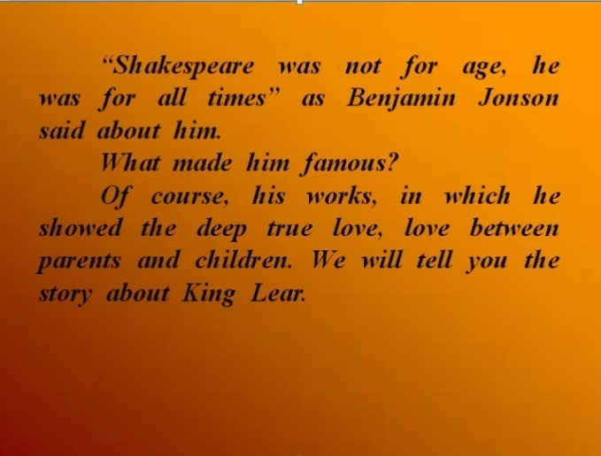
Звучит музыка, сцену готовят для сценки из трагедии «Король Лир»

Появляется 9-й слайд

Ведущий:
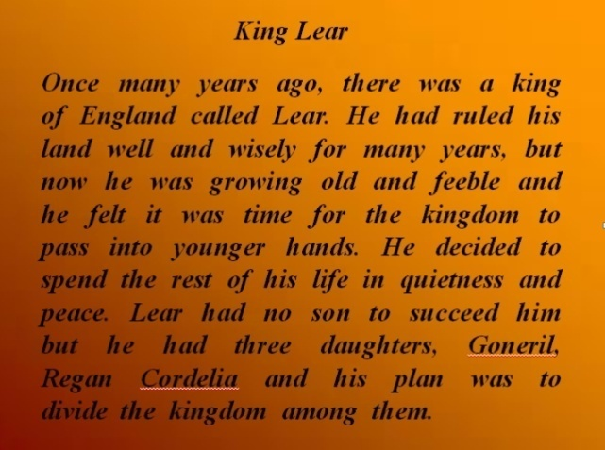
Once many years ago, there was a king of England called King Lear. He had ruled his land well and wisely for many years, but now he was growing old and feeble and he felt it was time for the kingdom to pass into younger hands. He decided to spend the rest of his life in quietness and peace. King Lear had no son to succeed him but he had three daughters, Goneril, Regan and Cordelia and his plan was to divide the kingdom among them.
Появляется 10-й слайд
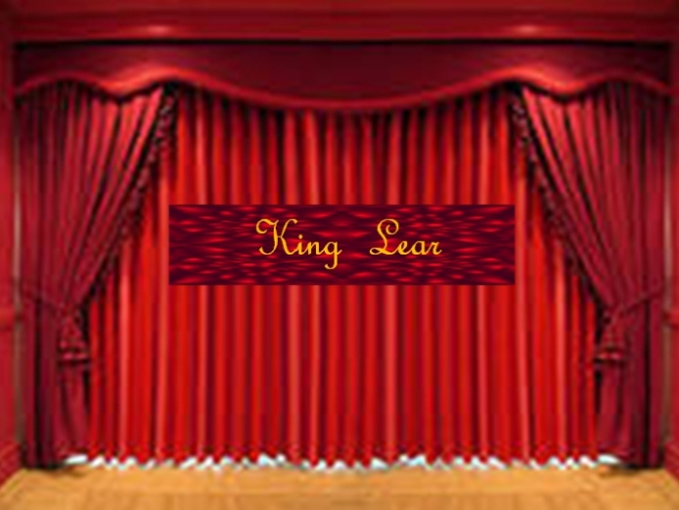

King Lear:
My dear daughters, I gathered you and your husbands here to tell you that I’ve made my decision to divide the Kingdom among you. But before that I’d like to know how deep is your love for me. Goneril, you are my first child, what do you say to your father?
Goneril:
Sir, I love you more that words can say. You are dearer to me that eyesight, life or liberty. No child has ever loved her father more than I love you.

King Lear:
Of all these bound, from this line to this, I make you ruler. Your and Albany’s children will be your heirs.
What does our second daughter, our dearest Regan say? Speak.

Regan:
My feelings are the same as my sister’s, but she has not expressed half the love I feel for you. I am only happy when I am able to serve you.
King Lear:
My dear Regan, I also give you the third of my kingdom.
And now, my dearly loved youngest daughter Cordelia, what can you say to deserve your share?
Cordelia:
I love you as I should: neither more nor less.
King Lear:
You’d better mend your speech, Cordelia, or you may lose your fortune.
Cordelia:
My lord, you are my father. You have cared for me, fed me, and loved me: for these reasons I love you and greatly honour you. But if I have a husband half my love and duty will belong to him.
King Lear:
Do you mean this with all your heart? So young and so untender! You will get nothing from me. I disown you forever.You are no longer a daughter of mine.
And now, the King of France and the duke of Burgundy, do you still wish to masrry poor Cordelia?
The Duke of Burgundy:
My lord, I’ll marry her only if you give her one third of your kingdom.
Cordelia:
Peace with Burgundy! And since it is my fortune that he loves, and not myself, I shall not be his wife.
The King of France:
Fairest Cordelia, you are most rich, being poor. I love you for your virtues and your beauty.
Your poor daughter, King, thrown to my chance, is queen of us and ours, and our fair France.
King Lear:
Take her. Let he be yours, for she is no daughter of mine, and I shall never see her face again. Be gone, without my love or blessing.

Играет музыка. Подготовка сцены для сценки из трагедии Шекспира «Гамлет»
Появляется 11-й слайд.
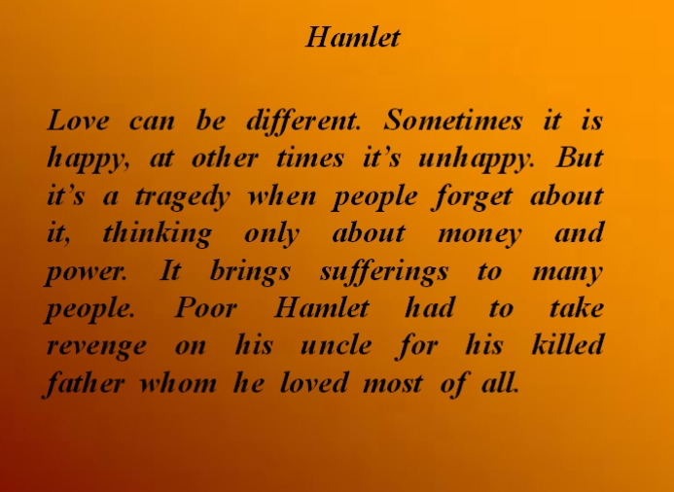
Ведущий:
Love can be different. Sometimes it is happy, at other times it’s unhappy. But it’s a tragedy when people forget about it, thinking only about money and power. It brings sufferings to many people. Poor Hamlet had to take revenge on his uncle for his killed father whom he loved most of all.
Появляется 12-й слайд.
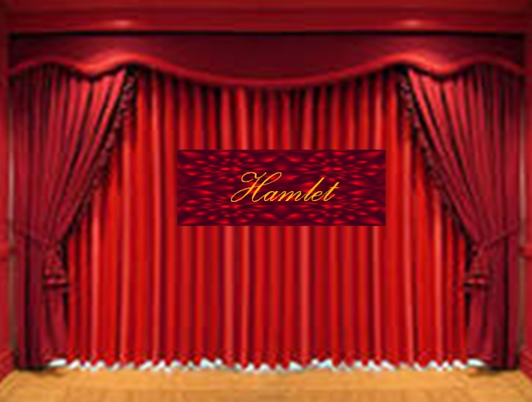

Hamlet:
It’s night again and the new Danish King is feasting tonight, all the trumpets and cannons in the fortress announce it to the people of Denmark. I don’t like this custom. Besides my father died not so long ago. And so I’m here alone, not with them.
Oh, Here it comes again! A spirit again! Hey! Oh, please, answer me!
Ghost:
My hour has almost come and I must go back again to that flame from which I came … .
Hamlet:
Alas, poor ghost!
Ghost:
Pity me not but listen to what I shall say. I’m your father’s spirit, doomed for some time to walk in the night and during the day to burn in flame until all my sins are burnt away.
But I came to ask you to revenge for the most unnatural murder of your father.
Hamlet:
A murder?

Ghost:
The most unnatural murder.
Hamlet:
Tell me about it.
Ghost:
I will be brief. It was my custom to sleep in the orchard after dinner. Your uncle knew that … .
Hamlet:
My uncle? The present king of Denmark?
Ghost:
Yes, your uncle, he stole into the orchard with a poisonous juice and poured it into my ear.
Hamlet:
Oh, horrible! Horrible!
Ghost:
He took my life, my crown, and my wife – your mother … . Don’t let them be happy together, revenge for me, my son. Farewell and remember this moment!
Hamlet:
Remember you? Oh, poor ghost, yes! Since now I will forget all my life, I will remember only this sacred command together with the hatred for my uncle. I promise to revenge.
Hamlet:
To be or not to be: that is the question:
Whether it is nobler in the mind to suffer
The slings and arrows of outrageous fortune,
Or to take arms against a sea of troubles,
And by opposing end them? To die; to sleep;
No more; and by a sleep to say we end
The heart – ache and the thousand natural shocks
That flesh is to heir to, it is a consummation
Devotedly to be wished. To die, to sleep… .

Ведущий:
Yes, love can be unhappy. But no doubt it’s the most wonderful thing in the world. Love is always together with the young hearts. Love and youth are treasures that are given to people only once. William Shakespeare sang about these gifts in his sonnets.
Звучит музыка. Учащийся декламирует сонет Шекспира “Age and Youth”

CRABBED Age and Youth
Cannot live together:
Youth is full of pleasance,
Age is full of care;
Youth like summer morn, | 5
Age like winter weather,
Youth like summer brave,
Age like winter bare;
Youth is full of sport,
Age's breath is short, | 10
Youth is nimble, Age is lame;
Youth is hot and bold,
Age is weak and cold,
Youth is wild, and Age is tame:—
Age, I do abhor thee; | 15
Youth, I do adore thee:
O! my Love, my Love is young!
Age, I do defy thee—
O sweet shepherd, hie thee,
For methinks thou stay'st too long.  Появляется 13 –й слайд | 20
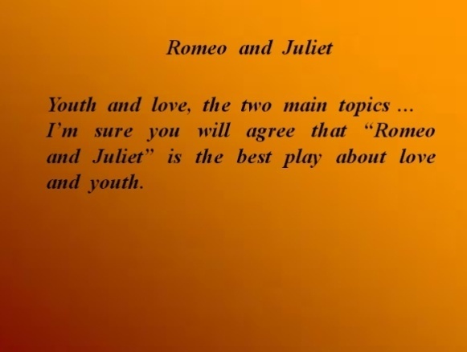

Ведущий:
Youth and love, the two main topics … .
I’m sure you will agree that “Romeo and Juliet” is the best play about love and youth.
Звучит музыка. Подготовка сцены для сценки из трагедии Шекспира «Ромео и Джульетта»
Появляется 14 –й слайд
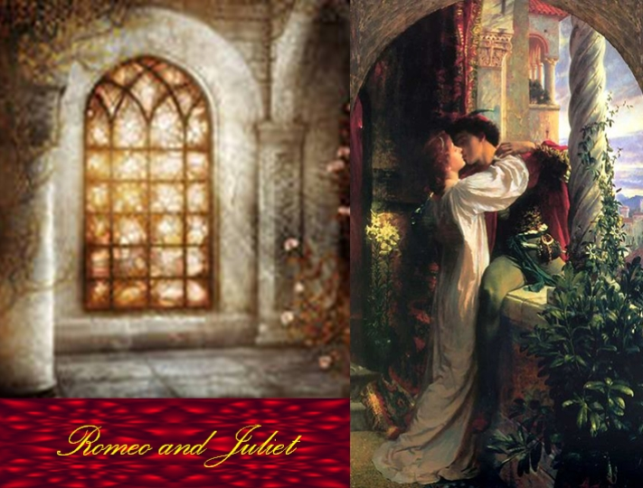

Juliet:
Oh, my! What light through window breaks?
It is the east, and Juliet is the sun.
Arise, fair sun, and kill the envious moon,
It is my lady. Oh, it is my love! Oh, my!
Romeo:
She speaks
O, speak again,bright angel!
Juliet:
O Romeo, Romeo! Why are you Romeo?
Deny your father and refuse your name;
Or, if you do not
I’ll no longer be a Capulet.
Romeo: (aside)
Shall I hear more, or shall I speak at this?
Juliet:
What’s Montague? It is nor hand, nor foot?
Nor arm, nor face, nor any other part
Belonging to a man. O, be some other name!
What’s in a name? What if we call a rose
By any other name, would it be sweet?
Romeo:
Call me but love, and I’ll, be new baptized;
And I will never be Romeo.
I know not how to tell you who I am:
My name, dear saint, is hateful to myself,
Because it is an enemy to you
Juliet:
Oh, don’t say that. Please go, what if my parents saw you here.

Romeo:
I have night’s cloak to hide me from their sight;
And if you love me, let them find me here;
Juliet:
O gentle Romeo,
If you love, pronounce it faithfully,
Or if you think I am too quickly won,
I tell you. I’m not.
Romeo:
Lady, by this blessed moon I swear … .
Juliet:
O, swear not by the moon,
That changes every month.
Romeo:
What shall I swear by?
Juliet:
Do not swear at all;
Or if you want, swear by yourself.
Romeo:
I swear by myself.
Juliet:
It’s so dark and late that I should say good night.
Romeo:
And you will leave me unsatisfied?
Juliet:
What satisfaction can you have to night?
Romeo:
Your vow, that you love me.
Juliet:
My love is deep; the more I give to you,
The more I have
Nurse:
Juliet!
Juliet:
Romeo!
Romeo:
My dear?
Juliet:
At what o’clock tomorrow shall I send to you?
Romeo:
At the hour of nine.
Let me stand here to remember you.
Juliet:
Good night, good night!
Parting is such sweet sorrow.

Появляется 15 слайд
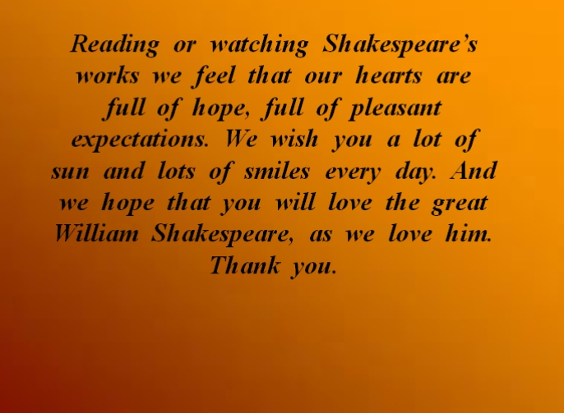

Ведущий:
Reading or watching Shakespeare’s works we feel that our hearts are full of pleasant expectations. We wish you a lot of sun and lots of smiles every day. And we hope that you will love the great William Shakespeare, as we love him.
Thank you.

