

***“MY SUMMER ADVENTURE”***

**Авторы: ученицы 11А класса**

**Рыжакова Лидия**

**Смирнова Екатерина**

**Веселова Екатерина**

**Учитель: Козлова Валентина Анатольевна**

**Школа: МКОУ Островская средняя общеобразовательная**

**школа**

**Населенный пункт: п. Островское**

**Регион: Костромская область**

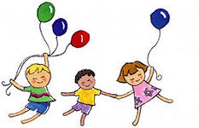



**Our summer holidays were very funny, interesting and unforgettable. The tenth grade was over, the sun was shining and we were waiting for our practice at school camp. Every summer a school camp for small children is organized in June. And the pupils of the tenth grade work there as leaders. We are very interested in a career working with children. So we must be caring persons with good communication skills. We thought our work in a camp would allow us to develop both our key skills and personal qualities. And we looked forward to the first day impatiently. We had found different children’s games, quizzes, sport competitions, songs and plays.**

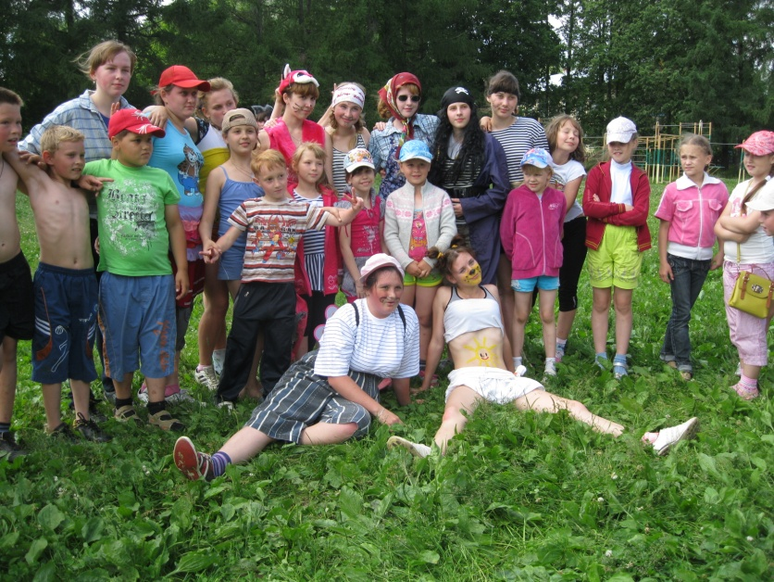**Our practice began on the 1st of June. In the camp there were five detachments. Each detachment had its own song and slogan. The name of our camp was “Sunny City”.**

**Our morning began from the morning exercises. The teachers, the children and we, the leaders were very glad to meet each other because we knew: in front of us there would be a very interesting month.**

**In the dining room each detachment had its own table. The meal was very tasty and healthy. The kids were always thankful to our cooks.**

**We really enjoyed such activity. All day long we were playing different games, dancing, singing songs, listening interesting stories. The leaders organized concerts where children showed their talents. It was amusing because anyone wanted to show his own individual talent. Such concerts were spent in the open air.**

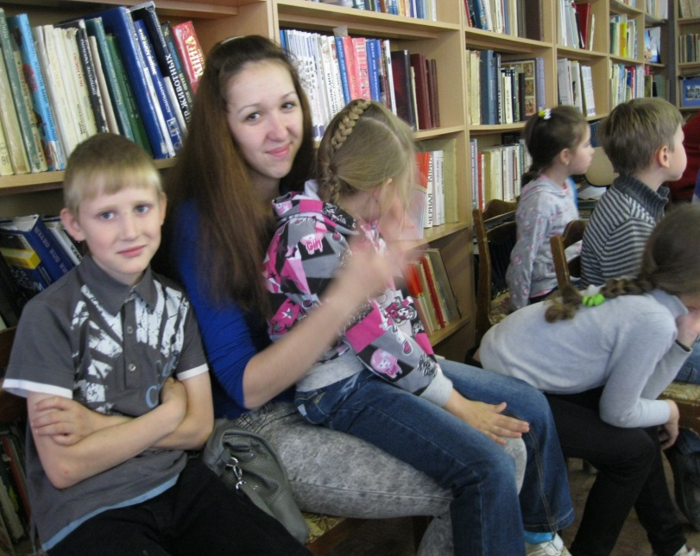

**Twice a week we visited**

**the library. There the children listened to the stories about the Great Patriotic War, Patriotic War of 1812, about the wildlife, forests, about different kinds of mushrooms and berries, sport, Olympic Games. The librarians taught them the rules of street traffic.**

**It was very interesting and cognitive.**

**After dinner we and our kids usually went to the school stadium. We had a small rest at first, read interesting books, drew pictures and lay on the grass. Then the time of games came. Of course, sometimes we were tired and wanted to have a rest, but then we understood that we really liked it. And we would like to do it all summer long.**

**Once we, the leaders, and our children had a remarkable event. It was a “Day of Indians”. On that day we should be in suits of Indians. We made the suits from branches of trees, flowers, feathers and leaves.**

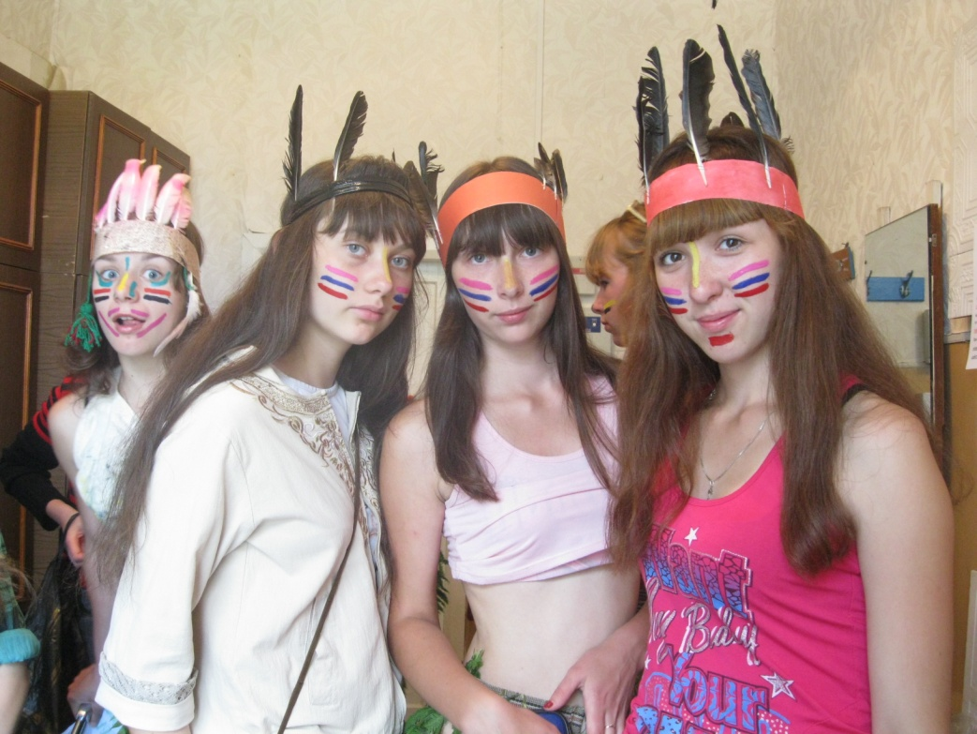



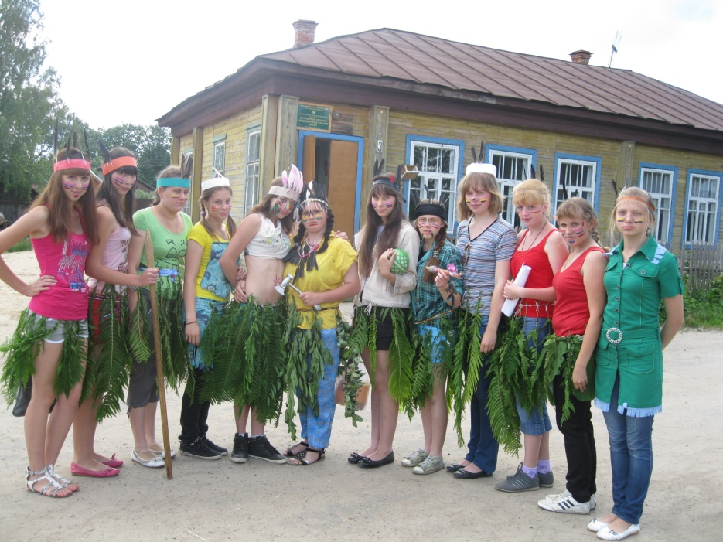**Our faces were also drawn. All leaders were one tribe of Indians. The children organized five tribes. Each tribe had its own colour: red, blue, yellow, green and orange. The tasks for tribes were to prepare a greeting to the leaders, to dance ritual dances and to introduce a tribe. The “Day of Indians” began at ten o’clock in the morning on our school stadium. All tribes gathered for a greeting. Then the competition began. There were five stations: “Sharp-sighted eye”, “Clever brains”, “The fast fallow deer”, “Well-aimed hands” and “The strongest”. At each station the tribes tried to receive the highest marks. They helped each other in difficult situations as the real Indians. And, it is out of the question, that the children handled all tasks successfully.**

**The Indians knew all the answers to all important questions. The tribe with the most points won. Every tribe were rewarded and got different prizes and medals. After the competition the children tired but satisfied had dinner. But the “Day of Indians” was not over. Then we read stories about real Indians about their traditions and customs. It was very interesting for our kids and they asked many many questions. It was the most fantastic and exciting day in our camp “Sunny City”.**

**But soon the last day of our school camp had come. It was a difficult day for all of us. But we tried to spend it funny. It was a great concert.**

**In the morning everything was as usual. The children had their breakfast and then took their seats in the concert hall. We were worried very much. All teachers and children looked at us carefully. And we danced, sang songs, play jokes and play with our audience. The concert was great. And then it was a farewell disco. We were very happy, the music was wonderful, everything was splendid. And how many photos we made!**



**We were very sorry to part with our children because we became the close friends. At the last meeting all children got their diplomas and valuable prizes or a souvenir for his success. The leaders were sad that the time in the camp was over. All good ever ends! But we knew when we would come to school in September we would meet our children again.**

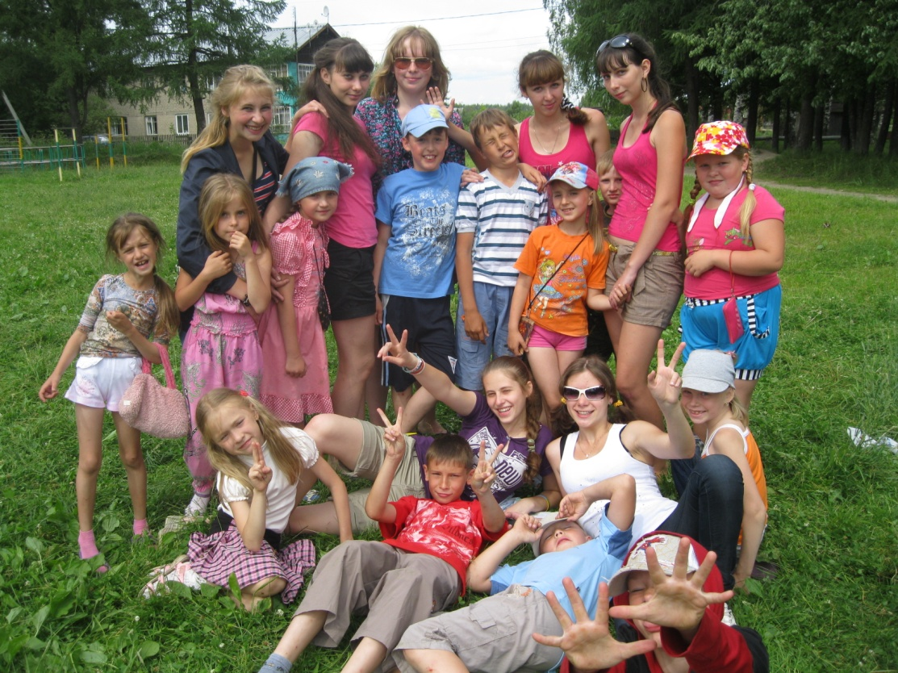

**We think that working at the camp helped us to learn how to be responsible for a lot of different things. We got lots of valuable practical experience that may be useful for the future. And we know that our practice in the school camp was not useless to us.**



**Фотографии из личного архива (фотографии опубликованы с согласия родителей)**

**Ссылка на картинку** [**http://images.yandex.ru/yandsearch?text=%D1%80%D0%B8%D1%81%D0%BE%D0%B2%D0%B0%D0%BD%D0%BD%D1%8B%D0%B5%20%D0%BA%D0%B0%D1%80%D1%82%D0%B8%D0%BD%D0%BA%D0%B8%20%D0%BE%20%D0%BB%D0%B5%D1%82%D0%B5%20%D0%B4%D0%B5%D1%82%D1%81%D0%BA%D0%B8%D0%B5&stype=image&lr=7&noreask=1**](http://images.yandex.ru/yandsearch?text=%D1%80%D0%B8%D1%81%D0%BE%D0%B2%D0%B0%D0%BD%D0%BD%D1%8B%D0%B5%20%D0%BA%D0%B0%D1%80%D1%82%D0%B8%D0%BD%D0%BA%D0%B8%20%D0%BE%20%D0%BB%D0%B5%D1%82%D0%B5%20%D0%B4%D0%B5%D1%82%D1%81%D0%BA%D0%B8%D0%B5&stype=image&lr=7&noreask=1)