“My Summer Adventure”

Aвтор: ученица 6 «А» класса Быкова Маргарита
Учитель: Баркова Татьяна Александровна
Школа: МКОУ «СОШ №1»
Населенный пункт: г.Изобильный
Регион: Ставропольский край

My Summer Adventure.
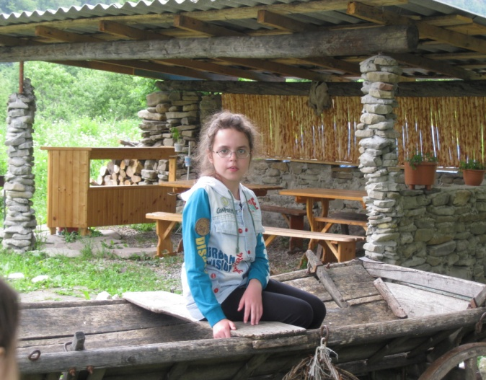
Our family likes travelling. We were in Dombai and Teberda. We also travelled a lot this summer. We spent 3 days in Arkhiz. There are many places to visit here.
The Arkhiz area is a unique “archeological museum”. Traces of an ancient Alan settlement dating back to the 8th century can still be found on the right bank of the river Bolshoi Zelenchuk. Futher down the valley are the ruins of a Christian temple. People here call them Eliad Una, which means houses of Hellenes. We saw the rock painting of Christ here. It was so exciting.
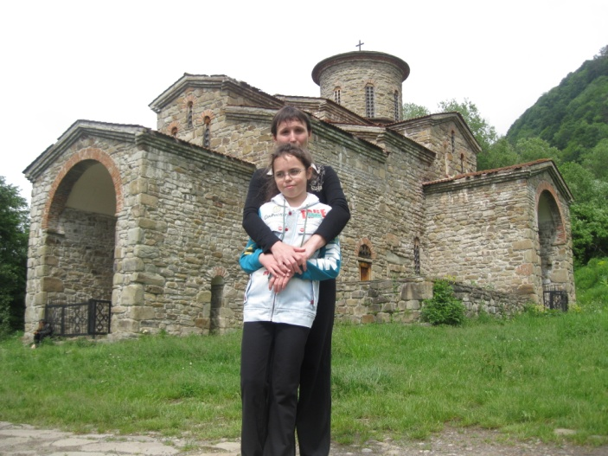
Then we visited Nizhnearkhizckoe gorodishche. I learned about its history. There were 3 churches built in the 10-th – 11-th century. Nizhnearkhizckoe gorodishche was a religious centre of the medieval Alania. Hordes of Mongolian nomads in the 13-th century trampled down fields, destroyed settlement, killed their inhabitans and turned Arkhiz into desert. And only in the 19-th century people came and settled here again. Today it’s one of the major tourist centre in Caucasus. Of course, we were very impressed by that story.
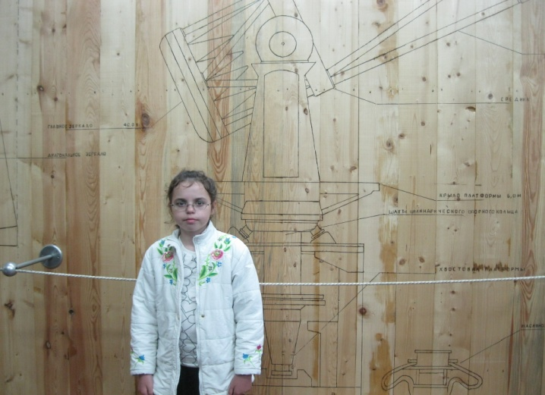
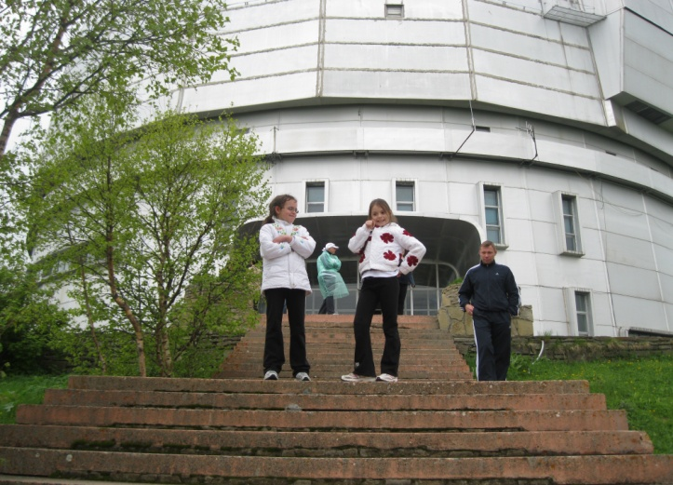
The weather was fine all the time. We spent a lot of time outdoors swimming and fishing. We also enjoyed picking berries and gathering mushrooms. My father took a lot of pictures (You can see some of them). On the way home we also visited Astrophysical Observatory in Zelenchukskaya. We had an interesting excursion and watched stars in the big telescope.
На фотографиях изображена автор сочинения – ученица 6 «А» класса МКОУ «СОШ №1», г. Изобильный Ставропольского края Быкова Маргарита. Фотографии опубликованы из личного архива семьи Быковых с согласия родителей Быковой Маргариты.

