Автор: ученица 8л2 класса - Кулакова Анна
Учитель: Фадеева Елена Геннадьевна
Школа: МОУ «Лицей №26 г.Подольска»
Населенный пункт: г.Подольск
Регион: Московская область

My Summer Adventure
As a rule I spend my summer holidays with my parents somewhere in Moscow region. Very often we go camping to a small hostel near the Oka River or just spend the weekends in our country-house. So, for the last two or three years, much to my regret, I didn’t have a chance to visit my wonderful Granny Ira who lives in Ivanovo. I missed her terribly and was looking forward to seeing her again.
And at last all my dreams came true. I found out about the trip only a week before my departure. It was a big surprise for me.
One summer evening, at the beginning of June, I was having a rest at home and waiting for my Mum from work. I really didn’t suspect anything, I was just looking through a magazine when suddenly she entered the room and informed me joyfully that in a week I would be able to see my dearest Granny! Smiling broadly, Mum passed me the ticket. It was the ticket to the town of my dreams, because Ivanovo for me is not only a beautiful old city, but also the place where I spent a part of my childhood, the place which is full of smells of tasty Granny’s pancakes, herbs and skim milk.
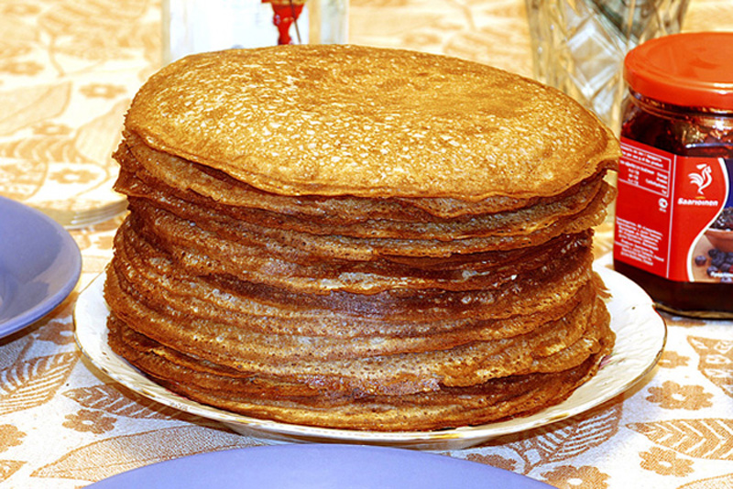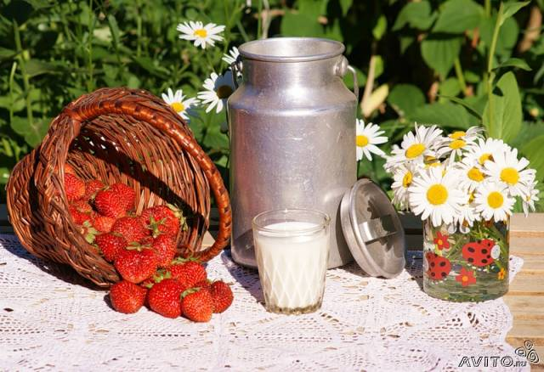
I was very happy, jumped for joy and warmly thanked my Mum for such unforgettable gift. Later, sitting lonely in my room and listening to music I was thinking over things I should take for such a long-awaited trip. But it hadn’t been easy – there were so many things I wanted to take and, besides, I was eager to bring a small present for my Granny – something really nice for a keepsake. But my Mum promised to help me.

I had been really busy for the whole week before the departure. I bought new summer clothes and souvenirs, packed all necessary things, and even organized a going-away party for all my friends and relatives! My Dad also surprised me a lot – he had bought a modern digital camera for me “to be filmed on the road all unforgettable moments of your trip!” – he said gaily! And at last that day came.
In the evening my parents drove me to the railway station in Moscow and helped to get on the train. We all were very excited, a little bit worried, but happy. We said goodbye to each other, and the train set out. In my compartment I met two nice old ladies who were discussing emotionally their fantastic trip to Moscow. They told me about their marvelous visit to the Pushkin Museum and the Cathedral of Christ the Savior. Unfortunately, they couldn’t go to the recently restored Bolshoi Theatre, but nevertheless they were very impressed by our great capital – its buildings, parks and squares, shops and citizens. In turn, I told them about my school life and my friends. From the train window we could see a lot of small towns and villages, settlements with ruined houses and old churches, great Russian forests and lakes. “How huge and splendid our country is!” – I thought proudly.
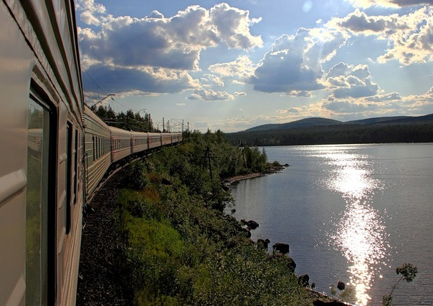

While we were talking, I had no sense of time passing. Morning was beginning. “I’m sorry, it’s my stop,” – I said sadly to my nice fellow travellers. We warmly said goodbye to each other and I got off the train.
Two minutes later I found myself at a small railway station. My two big heavy bags were with me, and I was looking for my uncle Nick, who had to pick me up and drove to my Granny. Suddenly my phone rang. It was my Mum. She told me a horrible thing – uncle Nick had left urgently to get on with his work, so I had to get to the place by myself. “Oh, my God, my God! How can I do this?” - I thought with horror, but quickly brought myself under control and went to the nearest bus stop. Fortunately, I managed to find the right bus, bought the ticket and took the seat. My trip wasn’t very long, but almost all the way I was sitting in silence noticing no one around and thinking my own thoughts. And of course they were about my dearest Granny: “How is she getting on? Is she well? How is our little wooden house? And old apple-trees, which my grandpa had planted many years ago? How are cow Milka and dog Sharik?” And I was … I was really afraid of what she’d think of me.
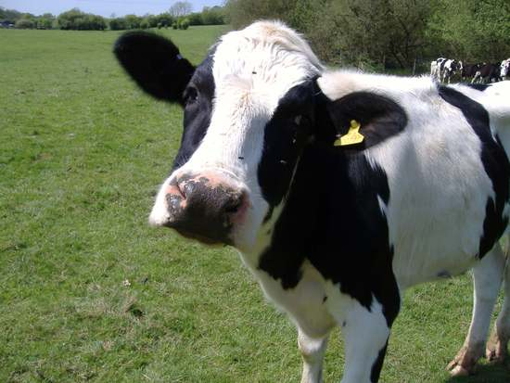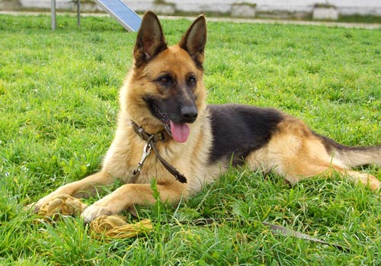
At last the bus stopped and all the passengers started to get off. I also collected my bags and hurried after them. My Granny’s house is not very far from the bus-stop but it seemed to me like an eternity before I saw so familiar gate. My Granny Ira was standing near it, smiling and ready to hug me warmly. And of course after a nourishing and tasty dinner we had a long gabble, and I handed her my present – a big photo of all of us in a lovely wooden frame. “I also have a little surprise for you. Let’s go!” – she said.
In a few minutes we were at a small field and I saw … It was a real horse, a fine black horse. Uncle Nick was holding it by the bridle and cried: “Come on! Try it quickly! This is for you!” Of course, I sometimes go to the manage riding house, but my own horse - it’s beyond my wildest dream!
Two months passed very quickly. I could do a lot – helped Granny in her garden, taught to milk the cow, made some jars of raspberry jam, walked with my new friends along famous Pushkin’s square in Ivanovo and, of course, rode my horse!
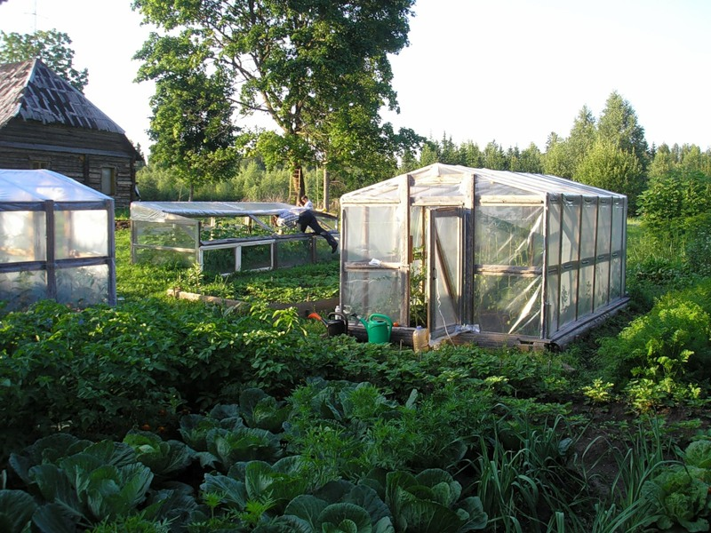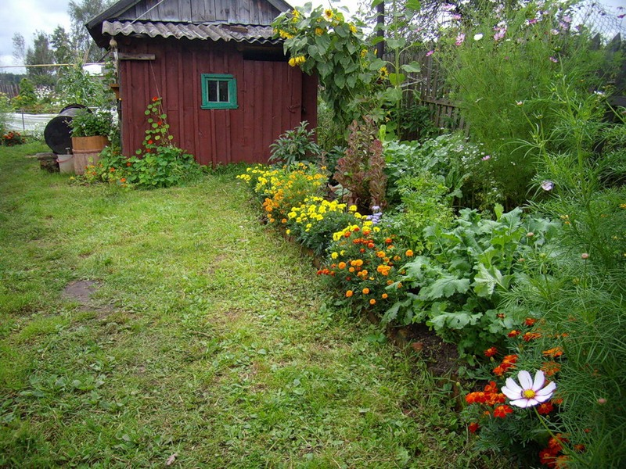
When it was time to leave for Podolsk I could not help tears. But I am sure that these summer holidays were one of the best in my life!

Все фотографии взяты из личного архива.
Фотографии несовершеннолетней публикуются с согласия родителей.

