“My Summer Adventure”

Автор: ученик(ца) __6 класса _____Пархоменко Маша_________(имя и фамилия).
Учитель: ___Винокурова Наталья Эдуардовна ФИО).
Школа: ____МБОУ СОШ№3 Населенный пункт:п. Абан
Регион: _________Красноярский край__________________________________________

“My Summer Adventure”
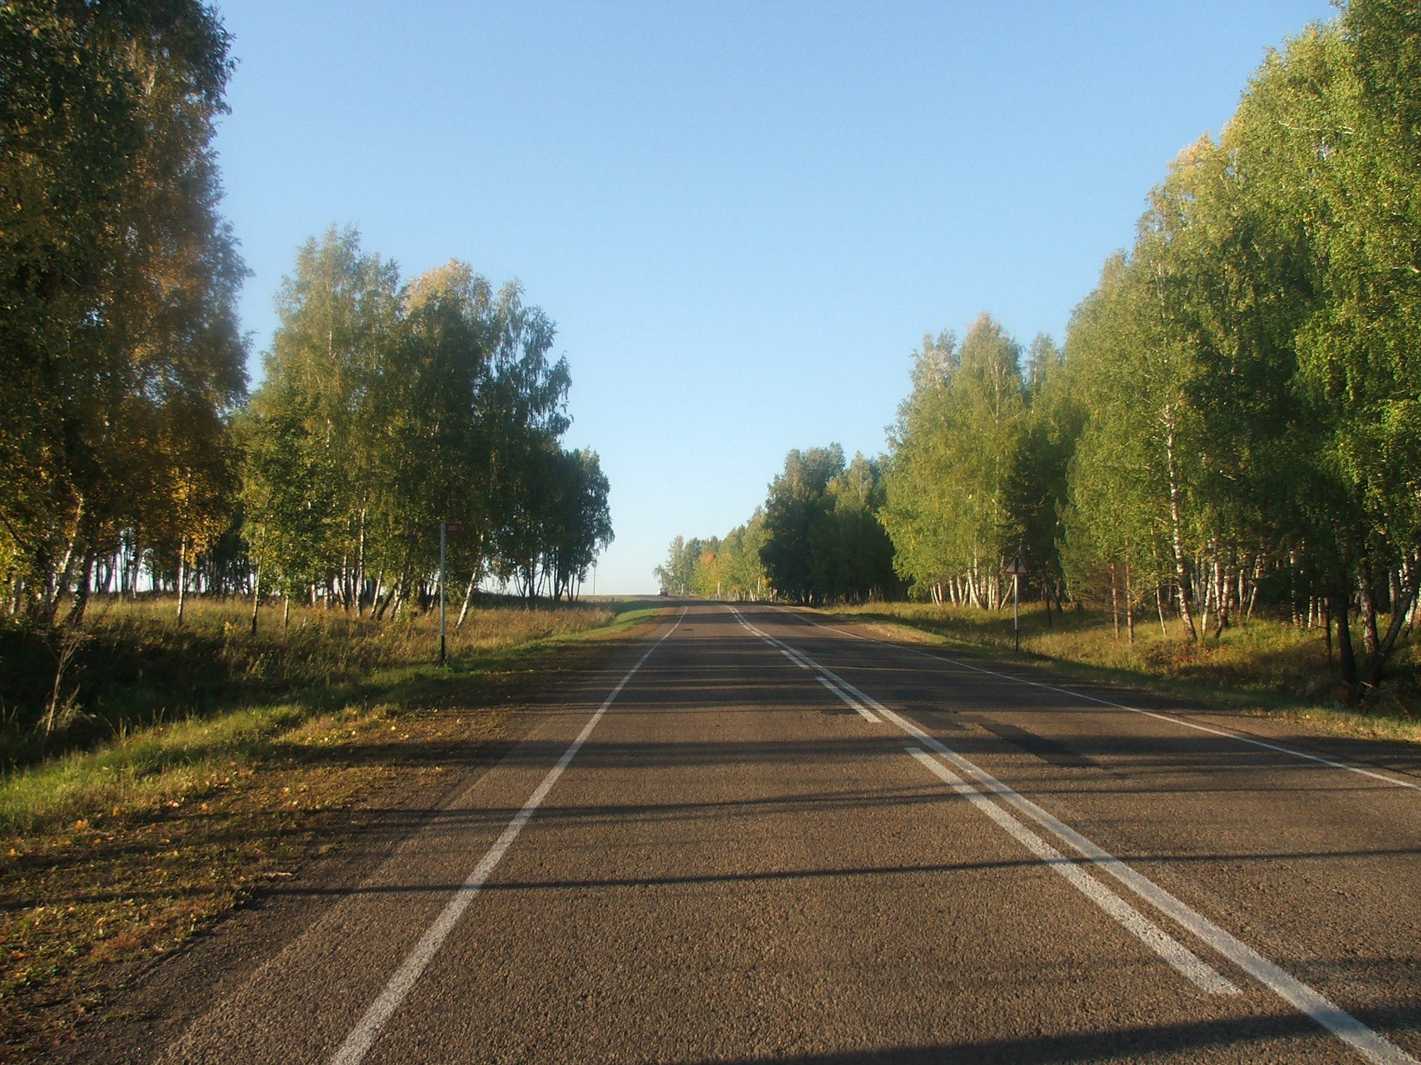Summer holidays are always very nice. You don’t have to do your homework, to wake up early in the morning and you wait for something very pleasant. In June the whole our class went to school to plant and water flowers. Sometimes it was very tiring, sometimes it was very funny. We all were wet, not only the flowers. Then I went to visit my grandmother in the village and in July we went to the city Krasnoyarsk. I had a chance to visit Bobrovy Log. The cable road was a bit scary. Then we went to the Park and had a great time there.
Each summer ends very quickly, but we remember it during the long winters.

Фотография из личного архива Пархоменко Маши, размещена с разрешения родителей.

