“My Summer Adventure”

Автор: ученик(ца) __10_класса Рыжова Анастасия ___ (имя и фамилия).
Учитель: _Брешева Ольга Ивановна _(ФИО).
Школа: _МБОУ ХМР СОШ п. Горноправдинск______________________
Населенный пункт: п. Горноправдинск, _____________
Регион: ХМАО-Югра ___________________________________________

“Summer holidays are gone….”
Last summer my mother and I had a really fantastic adventure in China!
I had dreamed of this moment for years and last summer deserved the chance. I could hardly believed it – I was having a trip to China!
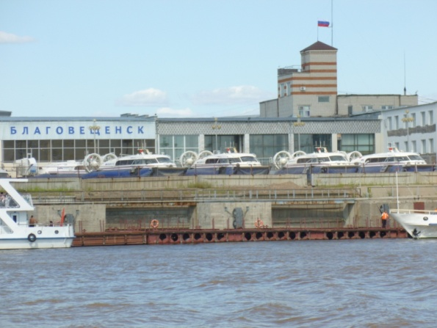
My adventure began from flying by plane to Blagoveshchensk.
Next day our group gathered at the meeting point, then we followed to the security check. It was so dull staying in a queue and waiting our turn in security check and passport control! But when we went out of the hall and saw a beautiful and calm river, white ships and the town on the other side, we forgot about everything.
The first town where we stopped was Hey-he. We had there some spare time and in the evening we walked in the park near the Amur. We were so excited such beautiful illumination on the buildings, bridges and overcrowded town! People walked along the river, danced in the park, the young and the old put away the balloons in the sky. We found out that it was the day of Love. It was really nice!
After that we went to Harbin. The first thing we did was to go sightseeing. Do you know that in Harbin was built the tallest TV Tower in Asia? You can go up to the top floor and look throw the window. Maybe it is clear for you, but we were very surprised when we see small cars and people as if they were toys! And of course, we went to the excursion to okeanarium to look at different amazing fishes!
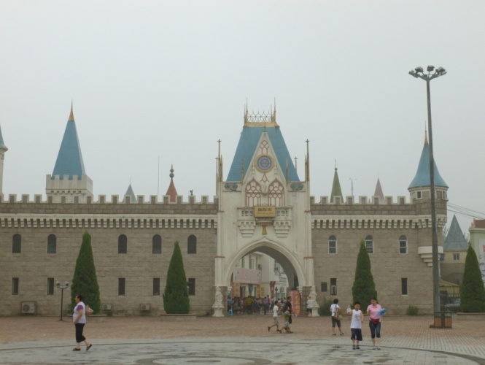
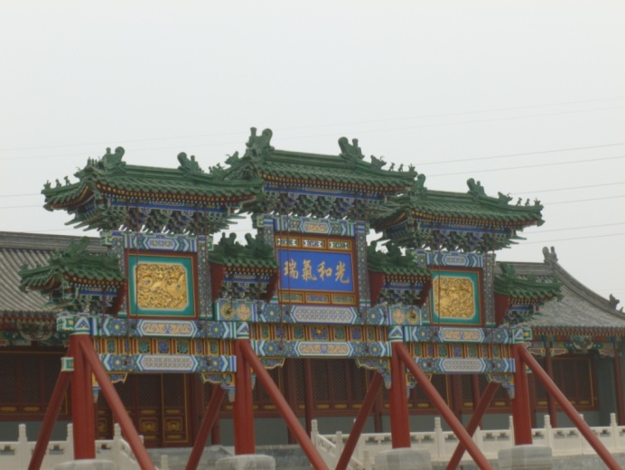
Next day we were in Beijing. As soon as we arrived in the city, we knew that it would be a wonderful trip! Were we lucky with the weather? It was very hot, but very soon we didn’t pay attention for this. We visited the square of Peace and the park of Peace, the Temple, the Olympics stadium and, of course, the Great Wall! It was so interesting to see the most famous sightseeings in one place! We had such unforgettable impression when we saw the Houses of Parliament, the London Bridge, the Statue of Liberty!
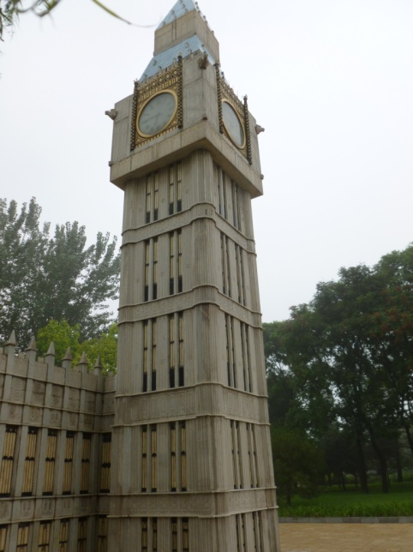
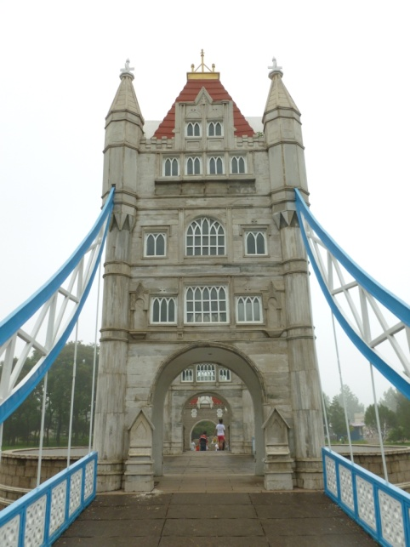
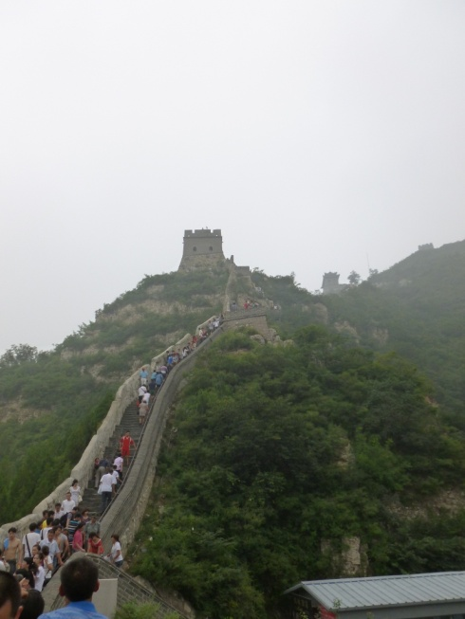
But the most exiting day was when we went to the Great Wall. We got up very early, because the way was too long. The day was foggy and we were upset at first, but then we understand, that we were lucky, it wasn’t so hot as usual. There were many people there, not only tourists, but a lot of Chinese’s. Every person wants to get to the top, it is not very easy, it’s harder and harder to go up by every step. If you watch the people, they look as the ants. But you could see the amusing view from the top and proud for yourself, if you did it! And you could take a personal document that you were on the Great Wall. We returned in a town very tired but excited! We did a lot of pictures and bought some presents for relatives and friends.
I will always remember my trip to China!

Фотографии использованы из личного архива.

