“My Summer Adventure”

Автор: ученик(ца) _8__класса _Малыгина Мария___ (имя и фамилия).
Учитель: ___Брешева Ольга Ивановна ____________ _(ФИО).
Школа: _МБОУ ХМР СОШ п. Горноправдинск__________________
Населенный пункт: п. Горноправдинск , Ханты- Мансийский район
Регион: __ХМАО-Югра_________________

I think, everybody agrees, that summer is a favourite season for all children. So do me. Last summer my mother and I went to the south. That was a cool trip!
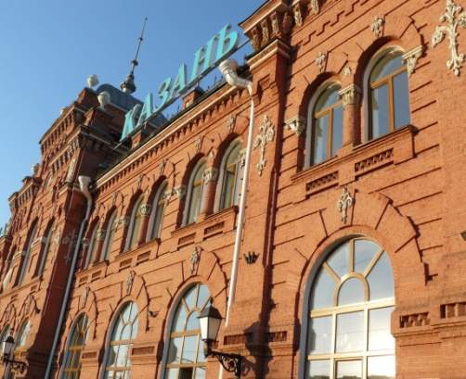
I visited some of the cities. Imagine I saw the Black sea once more!
On the way we visited Kazan. We admired this city. It’s very nice, there are many amazing places and buildings, such as mosque, new metro, different shops and of course there are a lot of beautiful views of nature.
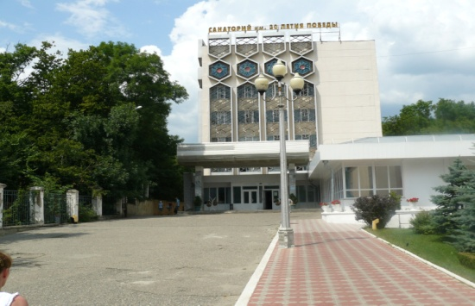
When we arrived to Mineral Waters, we were already waited by my aunt Rita and my sister Nastya.
In this city, there are all conditions for residing. There are a lot of of spa-sanatoriums.
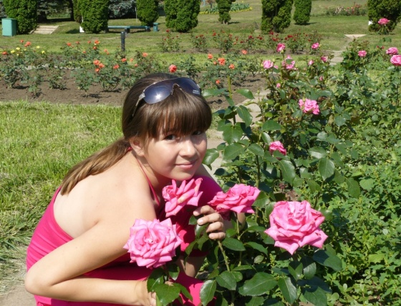
Then we visited Kislovodsk. Kislovodsk is a city of resorts. This city always attracts attention of tourists. The most beautiful place is the valley of roses and the centre of the city. I had never seen so many roses before! They are so beautiful and charming! Every person would try to see them.
After that we visited this Dzhubga, Orhipo-Osipovka and Gelendzhik. When we came there, the sea was absolutely quiet and warm. We lived in a hotel with excellent service. Nearby there was a magnificent restaurant with friendly waiters.
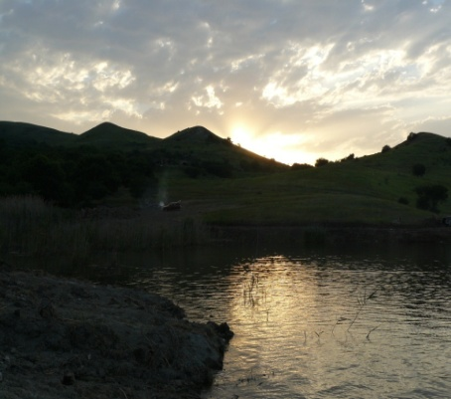
As for me I liked the trip to falls most of all. It is the unforgettable sight! They are such different and attractive! And we heard many interesting legends about falls. During this journey I have made a lot of friends. One of them is Katya, who lives in Khanty-Mansiysk.
When we returned back to Mineral waters, my sister Nastya, showed me all sights of this city. I admired the beautiful mountains, lakes, and, of course, the church.
My holiday passed too quickly. I didn't want to leave my relatives and the beauty of the Caucasus. This place will be in my heart forever and my photos reminded me about my holidays.
I could say that my body is in Gornopravdinsk, and my soul is there.

1.В сочинении использованы фотографии из личного архива.
Фотографии несовершеннолетней публикуются с разрешения родителей.

