“My Summer Adventure”
Автор: ученик 6 класса, Чич Юрий.
Учитель: Синяева Людмила Николаевна.
Школа: ЧОУ Гимназия №1 .
Регион: Краснодарский край.
Населенный пункт: г.Новороссийск.

As you know , summer is the best time for children because we have summer holidays. This summer I went to Kislovodsk. It is a city with the number of health centers in the Caucasian Mineral Water. The main property of Kislovodsk is narzan water. Exactly because of it, many people come to Kislovodsk .There are also a lot of parks in Kislovodsk , where there are more than 320 hectares of trees. Many families stay at sanatoriums. There are a lot of animals in the parks. Especially I like squirrels.They are so nice and funny!I know that the squirrels in Kislovodsk are tame.
One day I was walking with my father in the park. Suddenly I saw a large crowd of people around the tree. I immediately realized that there was a squirre. I had the nuts. Naturally I went to the tree, where the squirrel was. When I approached the tree, I stretched my hand with nuts to squirrel, but it didn’t eat nuts, it jumped on my head, then to the floor and hid in the leaves. All the people looked at me with surprise. I was a little embarrassed .But it was unforgettable.
It was very funny story in my summer holidays. I had a very good summer vacation.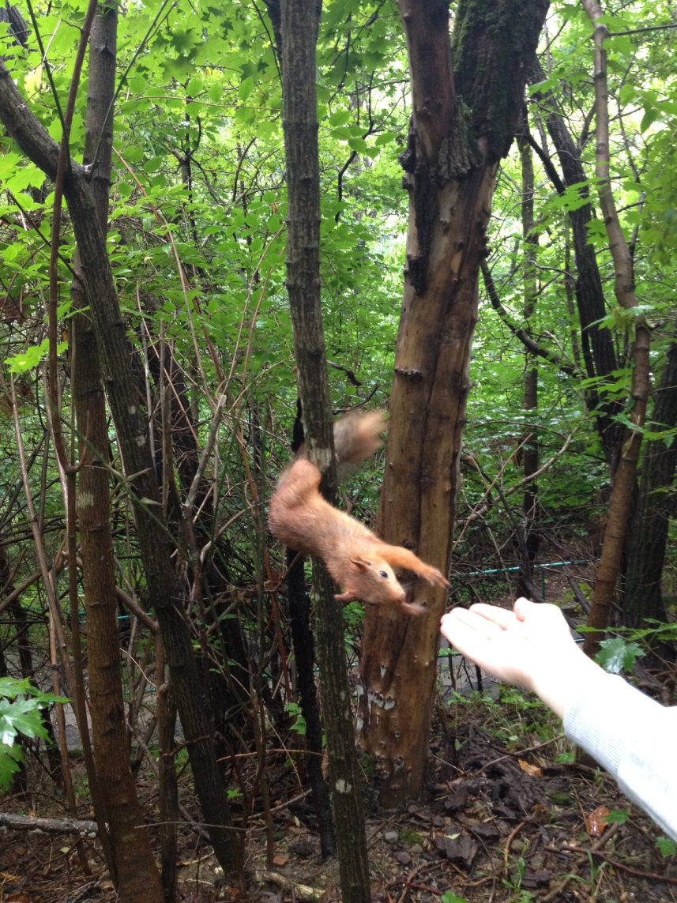
Фотографии взяты из семейного альбома семьи Чич. Фотографии публикуются с разрешения родителей.

