My summer adventure

Автор: ученица 10 класса Зайкова Анна
Учитель: Питухина Ирина Владимировна
Школа: МБОУ «Черевковская средняя общеобразовательная школа»
Населенный пункт: село Черевково, Красноборский район
Регион: Архангельская область
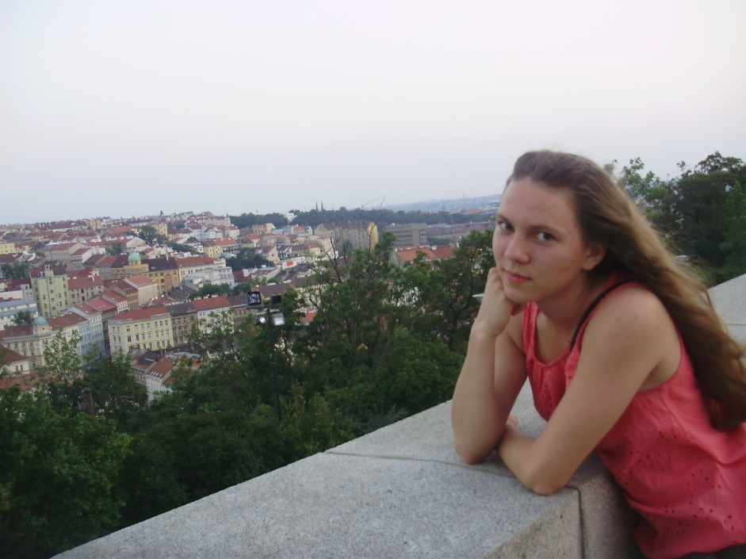

2012 год
Every schoolboy or schoolgirl wants to spend summer holidays as good as possible. Maybe doing something unusual would be enough for it? Most of all leaves their home for travelling because it can not only distract from daily routine, but it may be interesting, informative and useful. So, I couldn’t miss my chance to go abroad this summer.
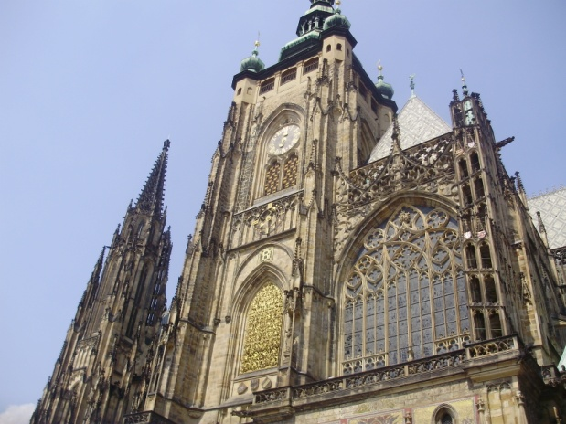
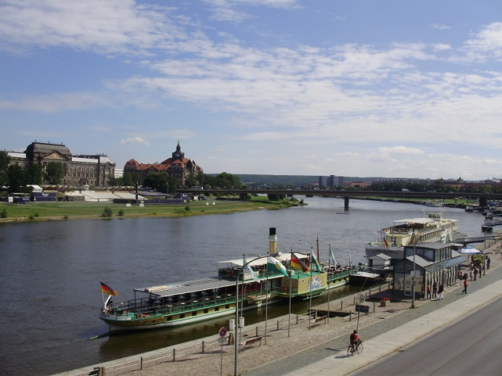
I, my parents and my younger sister went to Dresden, a city with rich and varied historical and cultural roots. Our way from Moscow took only two hours. When we left the airport, I was surprised by cleanness of the streets. Besides, they say Dresden is the most beautiful city of Germany. Now I know they don’t lie. There really were a lot of old buildings, squares, green parks with ponds. Also there was a very picturesque river, Elbe. In Dresden we visited the Old Masters Picture Gallery, the Dresden Armory and the Porcelain Museum. It took a lot of time and our forces, but it was worth it. You wouldn`t believe! I saw the legendary pictures of Raphael and his most famous work the Sistine Madonna!
Further we went to the capital of Czech Republic Prague. If compare it with Moscow, it isn’t a big city. The population of Prague is about 1,5 million. In my opinion it’s good for an old city. I don’t like when there are too many people in the streets and in the transport. I was impressed with the European architecture. You can’t imagine how spectacular it was! Czech Republic is a catholic country, so all temples were constructed in Gothic style. I made a lot of photos of all magnificent temples during our excursions. I think Gothic style is the best architectural style. By the way, now I would like to see the Sagrada Familia in Barcelona. I've heard a lot about it and now I want to see it.
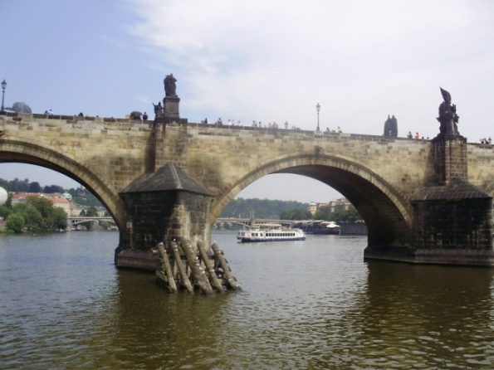
Of course, we wanted and tried to visit as many famous places and sights as we could, but there are too many of them. We couldn`t help paying attention to the Charles Bridge. That beautiful old bridge has many sculptures of different Czech saints. They say if you make a wish and touch the sculpture of John of Nepomuk on the bridge, the wish will surely come true. Of course, I made it and now I am looking forward to its fulfilment. Besides, we went for a walk around Prague every day, when we were there. It’s a magnificent city!
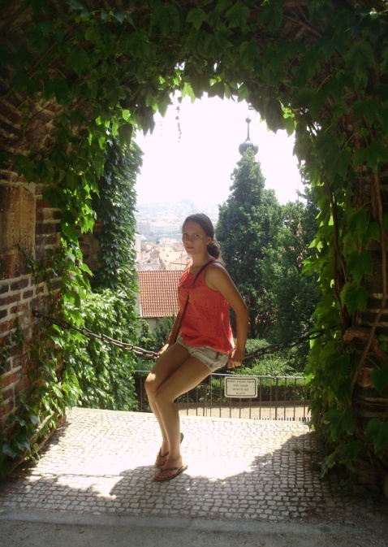
Once I was very tired after the excursion and didn’t want to go anywhere, but my sister persuade me to walk. We were lucky to see the Czech national dances. From a distance we heard the cheerful music and went there. We saw that young people in national costumes were dancing on the square. We stood side by side, enjoying their dances and applauding. Suddenly two of the dancers seized me by the hands and I was among the artists! Of course, I was confused a little, but I like to dance very much! I tried to imitate them and I did it! When I came back to my parents I couldn't help smiling. All tiredness disappeared, my mood abruptly became genial. I am sure that I won’t forget this story, it was so cheerful!
Also we have been in Vienna. Vienna is the capital of Austria. This city is called «the City of music» because many great musicians and composers lived and worked there. They are Mozart, Beethoven, etc. I don’t like history, but learning Austria’s history and watching films about Austrian emperors was not boring, but very interesting. I even would like to watch those films once again.
In seven days my family flew home. We brought a lot of souvenirs and gifts. It will remind me about Prague, Dresden and Vienna. I’ll never forget this amazing trip! It was my best summer adventure which I have ever had. It was so breathtaking, so interesting and so informative! I wish everybody had such a cool summer adventure!

В работе использованы фотографии из личного архива автора.
Все фотографии опубликованы с согласия родителей несовершеннолетнего ребенка.

