“My Summer Adventure”

Автор: ученица 9-а класса Китайчик Виктория Юрьевна
Учитель: Колесова Лилия Александровна(ФИО).
Школа: Коммунальное учреждение «Луганская школа I-III ступеней № 11»
Населенный пункт: г. Луганск
Регион: Украина

“My Summer Adventure”
In July, I went to England. There I took a three-week English course. I studied at the School of English. It's called Ardmore. There are students from many countries, so many fun and energetic teachers ... It was interesting to spend time with.
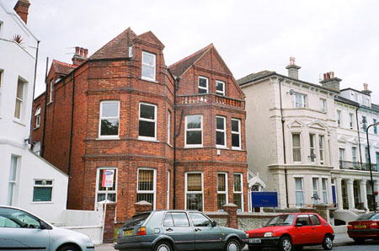
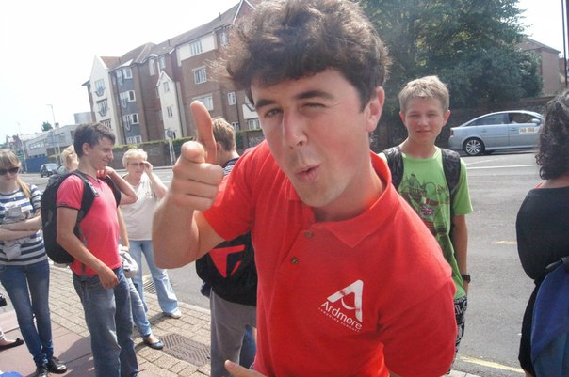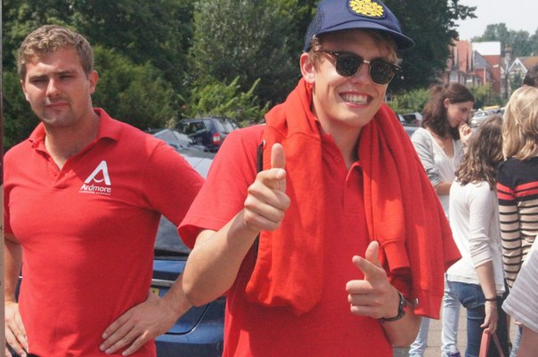
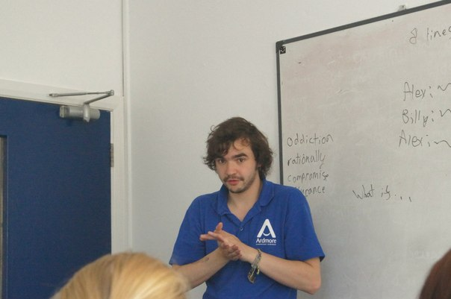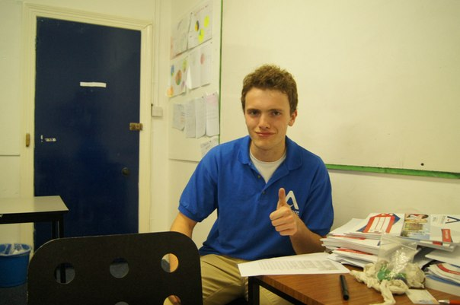
We learned in the first or second half of the day (classes alternated). In the afternoon, we could go on tour, or walk to the park, the boys played football there with other students, and the girls take up tennis or rode horses, we were in an English film and went bowling.
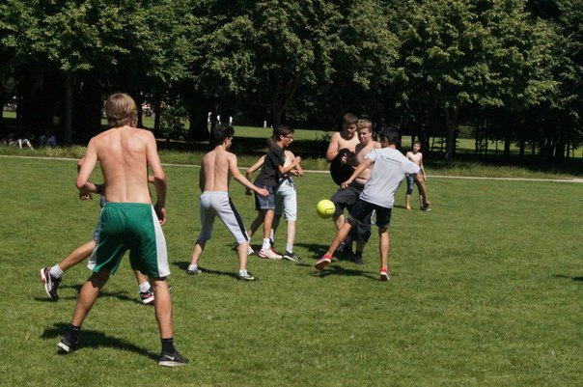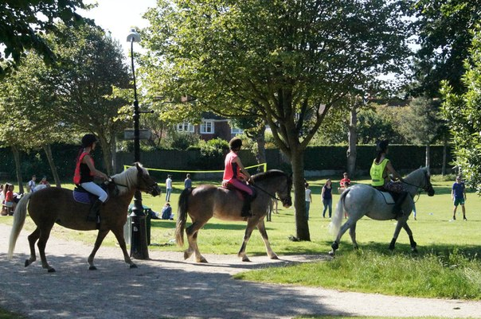
I went with a group, we had fourteen people. We lived and studies in Eastbourne, on the Atlantic coast.
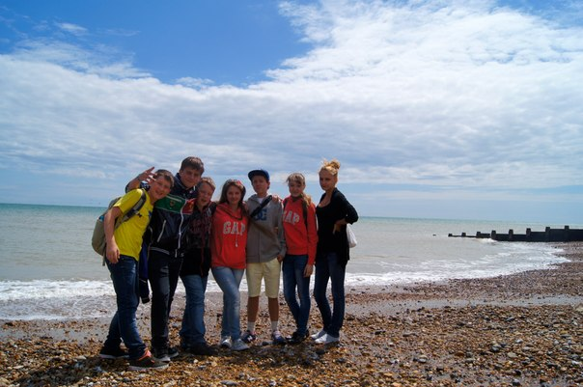
So we trevelled lot on tour. Were in Brighton, Eton, Edenbridge, London, was in the castles of Canterbury, and Javier castle.
Were in Brighton on the wheel, and attended King's Beach.
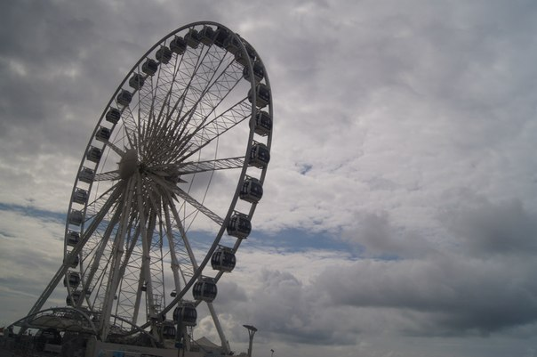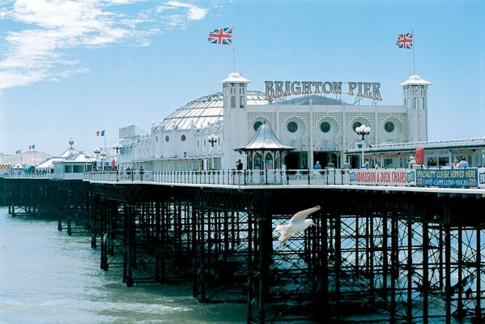
At Eton were in "King's College of Our Lady of Eton" near Windsor. This is a private British school for boys.
We were in a very interesting city of Canterbury. There are rumors that it is a ghost town, and in the evening hours, 7 or 8, you can see the hunters who hunt for them. Canterbury were in the castle. The gothic cathedral. The official name - the Cathedral and the Church of Christ at Canterbury.
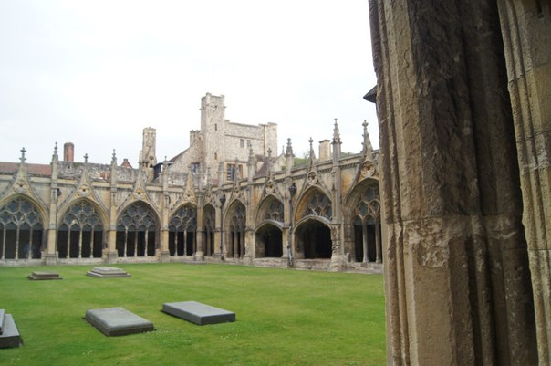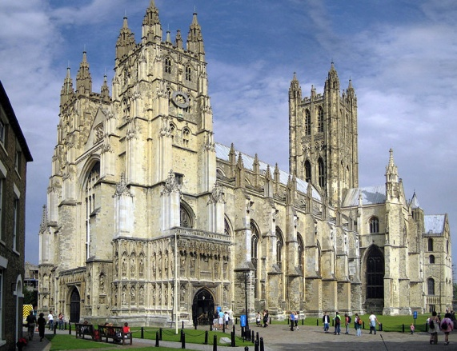
We were in a very interesting city Edenbridge. The city's name is derived from the Old English "Eadhelmsbrigge" ("Bridge Eadhelm" in modern English.) Next to it is the castle of Anne Boleyn is said to Hever Castle. It began as a country house, built in the 13th century. From 1462 to 1539 he was the residence Boleyn. It is surrounded by a moat. If you go through it you can find a lot of interesting things, such as the water maze, and just a very big maze. The most interesting were the gardens. They were very beautiful and scenic.
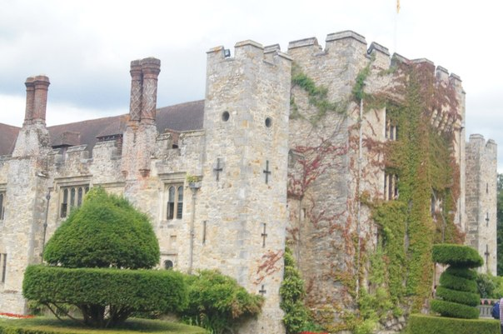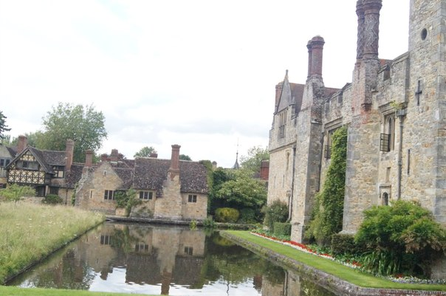
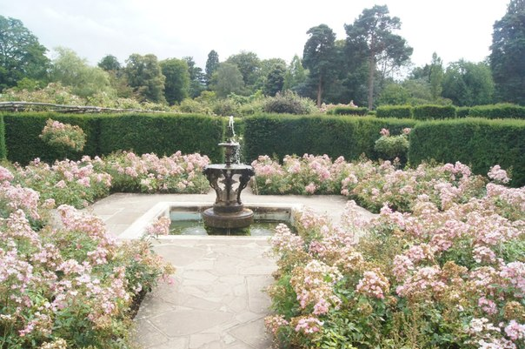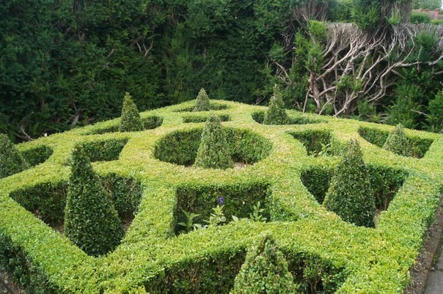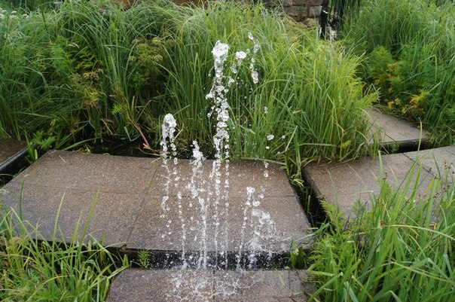
In London, I was on the London Eye (ferris wheel), has been in the British Museum, next to the Big Ben, and a walk in the park opposite Buckingham Palace next to the statue of Queen Victoria.
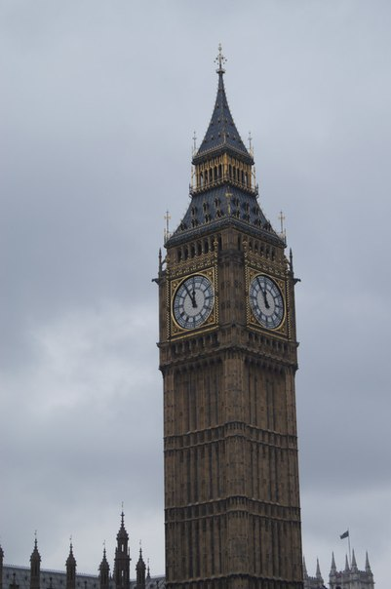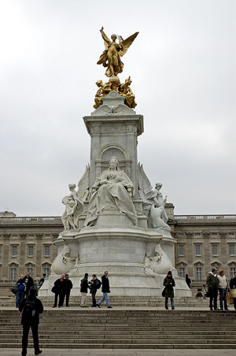
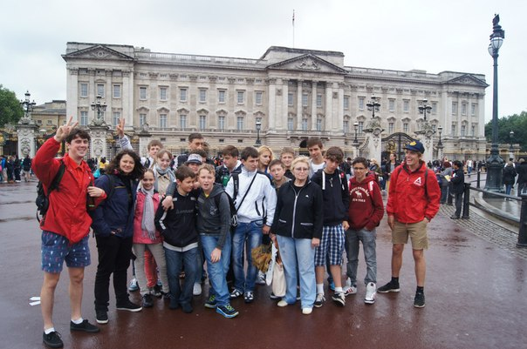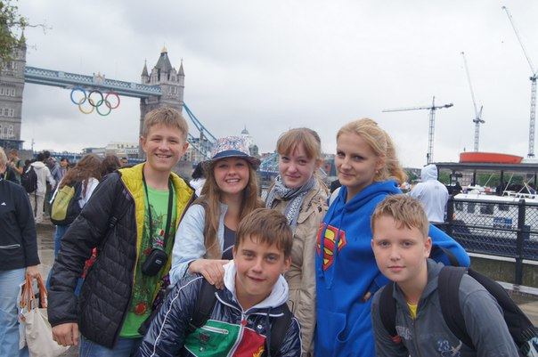
They all lived in their adoptive families. Lived together with students from other countries. I was fortunate to live with two girls from Germany, with 3 girls from France, with a girl from Spain and Israel. All the girls were funny, and interesting, with them it was nice to talk to.
Our family was the foster mother and her two daughters, all of them very good and good.
I like to live and learn. I really want to go back ...
Фотографии из личного архива Китайчик Виктории, размещены с разрешения родителей.

