“My Summer Adventure”

Автор: ученик 5а класса Дмитрий Мостовой
Учитель: Ильина Софья Васильевна
Школа: МБОУ СОШ№6
Населенный пункт: г. Владивосток
Регион: Приморский край

My Summer Adventure

My best summer adventure of 2012 took place in Arseniev. My grandparents live there and I usually visit them every summer.

I lived in a camp as Apache Indian tribesman. I had a lot of fun there with my friends and Chiefs.

On the last day of our camp life we had Funny Games in the Central Park in which the kids could participate together with the parents. I also took part with my Mom and Dad. There was a lot of challenging contests and sports competitions. Our family scored #1 and took the Super prize – an inflatable fishing boat. My interview and photo was published in the local newspaper.
When we returned to Vladivostok we used the boat to surf the waves of Shamora and Mayak beaches, which was also a great fun.

I enjoyed my vacation very much!

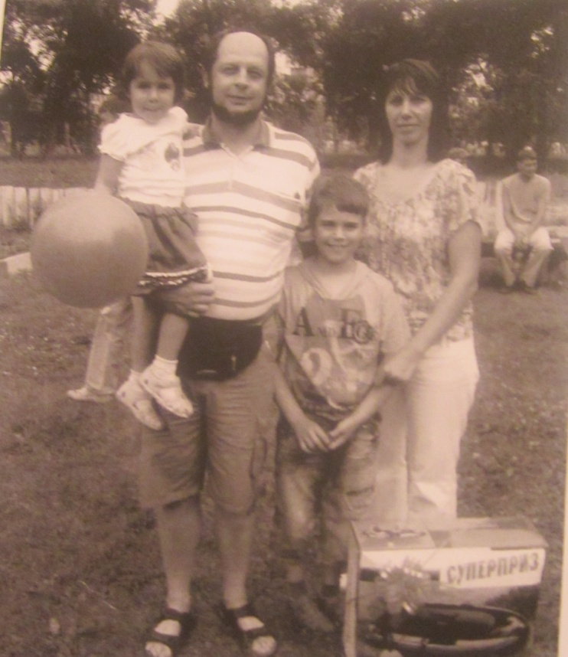
*фото из личного архива семьи с разрешения родителей несовершеннолетнего ученика

