“MY SUMMER ADVENTURE”

Автор: ученица 8 класса Салманова Анастасия.
Учитель: Кишмарова Татьяна Михайловна.
Школа: МОУ Сынковская СОШ.
Населённый пункт: посёлок Сынково, Подольский район.
Регион: Московская область.

Hello! My name is Anastasia and my surname is Salmanova, but my friends call me Jun or Junya. I’m 14 years old and I’m studying in the 8th form.
I like listening to music and dancing. My idol is Ayumi Hamasaki, a Japanese singer.
Now I want to tell you the story that happened to me when I went to a summer camp with my friend Julya. The name of the camp was “Sunny Town”. Why? Because all people there seemed to glow with happiness and joyfulness, and looking at them you felt the warmth as if the sun was shining on your face. In short, everyone was very happy in this “Sunny Town”. There were millions of exciting things to do

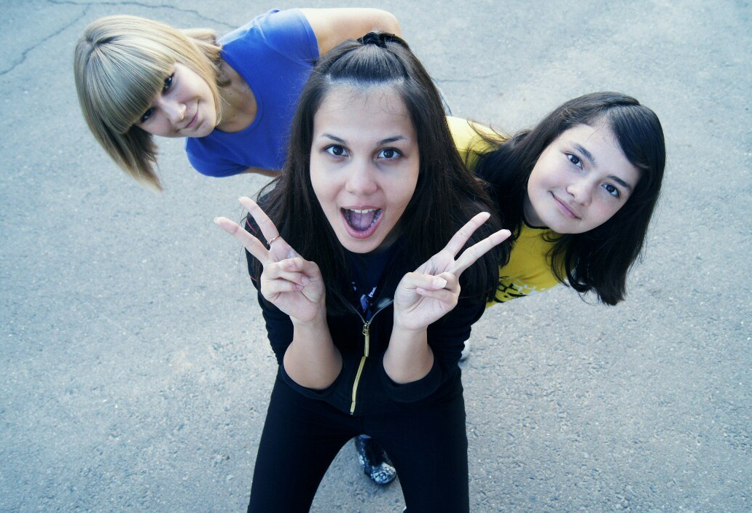

One day my friend and I decided to participate in a concert which was held in our camp. We had to sing the song of Eurythmics “Sweet Dreams”. I was very nervous, but in spite of my emotion and expectation the performance was a great success. The organizers of the concert considered that we were best! I couldn’t believe in our victory. WE WON !!! There was the light of perfect happiness in my face.
The next day I had one more surprise. My friend Julya and I were invited to take part in a karaoke Concert. Julia refused to participate but I decided to accept the offer, even if there were people much older than me.

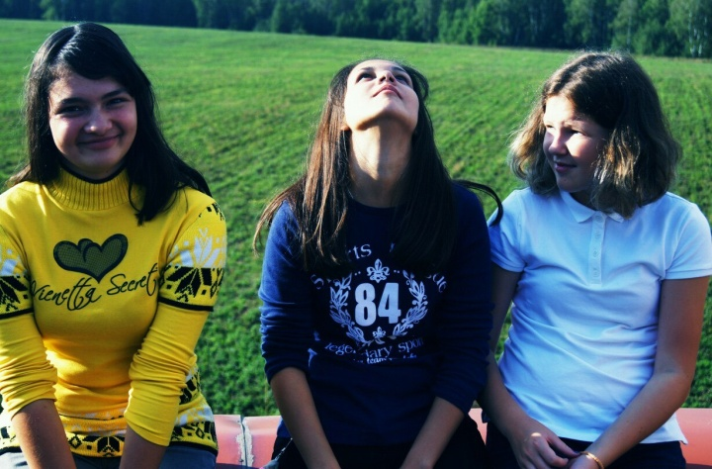
Only 5 days left until the “Friendly Karaoke” concert.
I thought that I would lose my weight during those days because I was very nervous.
However, the fact that I would perform in front of the audience gave me strength. Sometimes I think that I like to feel the adrenaline!
I chose the song by Scorpions “Still Loving You” because I always sang this song for my relatives. My friend appreciated my abilities for this song and agreed with my choice too.
Came the day of the “Friendly Karaoke” concert. All the participants got their numbers for performing. I was number 8. In total, there were 13 participants there. I must confess that it was a quite shock. Little by little each of
us was becoming more excited. A friendly atmosphere around helped us to cope with our emotions. We supported each other as much as possible by giving helpful advice, telling funny stories, silly jokes. There were no losers only friends. That was really great!
So my performance was coming soon. I began to feel stressed. My heart seemed to stop beating when I heard my number. I nearly died of fright. Nevertheless, I managed to collect all my thoughts and began to sing…
When I had finished my singing, there was a silent and then applause broke out. People were clapping, but I didn’t notice anything. I could only feel my trembling.
I think I never forget these happiest moments of my life, the happiest moments of my fame.

Summer, 2012

***
Использованные ресурсы:
- http://www.clipartguide.com/_small/0512-0711-1616-2350.jpg
- http://wwww.acofhc.org/TDE_CMS/database/userfiles/image/Sunshine%20Cheverolet%20-%20Sun%20logo.jpg
- http://images.yandex.ru/yandsearch?p=1&text=%D1%81%D0%BE%D0%BB%D0%BD%D1%8B%D1%88%D0%BA%D0%BE&noreask=1&img_url=cs5766.userapi.com%2Fu100848937%2F-14%2Fx_f860c116.jpg&pos=52&rpt=simage&lr=213
- http://b7.ac-images.myspacecdn.com/02051/77/39/2051599377_l.jpg
- http://604now.com/wp-content/uploads/2011/08/karaoke2.jpg
6. http://www.sauna-pegas.ru/foto/foto_28_b.jpg
- Личный архив автора Салмановой Анастасии с согласия родителей.

