“My Summer Adventure”

Автор: ученик 7А класса Илья Игнатенко.
Учитель: Цветкова-Омеличева Елена Владимировна.
Школа: Санкт-Петербургский Кадетский корпус МО РФ
Населенный пункт: г. Санкт-Петербург
Регион: Ленинградская область

My Summer Adventure

I waited for my summer holidays very much! My mum and I were going to travel to Abkhazia. I had never been there before. I had never seen the Black Sea. Can you imagine how happy I was when I saw it the first time!
We spent two weeks in Abkhazia and everything was wonderful, but one day became really unforgettable. It was full of adventures. So much happened that day!
I got up unusually early. It was a lovely morning, my mum was still sleeping, and I decided to go outside. Walking along the path, I ran into a snake. I almost stepped on it! The snake was looking at me and hissing. I froze in terror. Most of all I wanted to rush away, but I remembered that you shouldn’t move in such situations. I stopped dead and closed my eyes. I don’t know how much time passed… When I opened my eyes, the snake had disappeared. I sighed with relief and ran back to the hotel. I said nothing to my mum about the accident, because I didn’t want to worry her. We had our breakfast and went to the beach.
We decided to have a short voyage. We got on the rubber boat tied to a motorboat with a driver and set off. Our driver was very skillful, and we were sailing at full speed. It was exciting! Some minutes later our boat slowed down and I looked around. I couldn’t see the shore. I was frightened a little bit. I saw only the water around us – the sea water and…fins! Oh! I thought there were sharks, but mum told me: “Don’t worry! These are dolphins. They are very kind and clever animals”. Yes, there were dolphins. They started to jump and play in the sea. I was watching them and waving with my hands. Suddenly, I noticed that a dolphin’s fin was trapped in the fishing nets. I cried and called our driver. He heard me, stopped the boat, dived into the water and swam to the poor dolphin very fast. I saw he cut the net and the dolphin could swim away. It was rescued, we were happy. Our driver came back and said to us: “We must tell the police about this illegal fishing”. He was absolutely right. Dolphins are such friendly and clever animals! People must care about them and other animals and plants. I was very proud and happy that we had helped the dolphin.
Then we came back to the beach and I started walking along the seashore to explore it. I was looking for a new adventure and I found it. I came across a cave in the mountains and I found many interesting things there: a small rubber boat with paddles, some fishing rods and a kite. How lucky I was! I took the kite and went to play with it. The wind was strong enough and the kite flew up very high. It was amazing! Then I took the boat, tied the kite to it and decided to go fishing. It was a wonderful idea. I caught some fish, but I let them go back to the sea, because I was fishing just for pleasure and didn’t want to hurt them.
Suddenly, the wind became stronger, and the sky became dark. My mum called me and I had to go back. I put the boat and the fishing rods in the cave, and we went to the hotel. On our way we were talking about the day we had.
It was such a wonderful day! So many adventures I had! So many exciting moments! I think, I will remember that day forever.
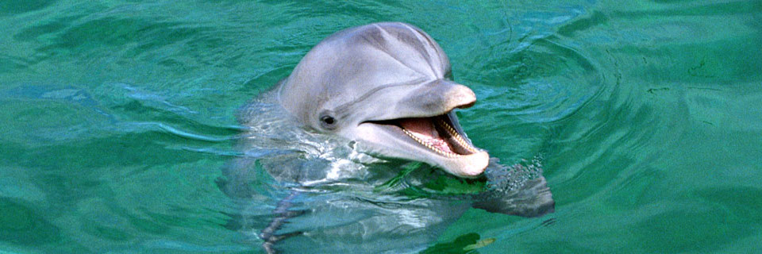
I was very-very tired, but happy at the same time. That night I fell asleep as soon as I went to bed. I was dreaming and saw the sea and the dolphin. It was smiling to me…
Изображение загружено с Интернет ресурса subicresortsguide.com
(http://subicresortsguide.com/wp-content/uploads/2011/12/Subic-Locals.jpg)

