Автор: ученица 6Л класса Харькова Елизавета
Учитель: Шерстяных Татьяна Владимировна
Школа: МБОУ гимназия №11
Населенный пункт: г. Елец
Регион: Липецкая область

I think summer is the best season for travelling. That’s way every year our family travels to different places. This summer wasn’t an exception.
July came and we went to Greece to Crete. Our hotel was on the Mediterranean Sea coast. The water was clear and we could watch crabs and octopuses. We had an excursion to Santorini.
It is a volcanic island in the Southern Aegean Sea. Its beaches are covered with black sand. The houses are white with blue roofs there. We visited the church and we walked along the narrow streets of the island. Let me add, it was better to ride a donkey there. By the way, I couldn’t tear myself from the stand of these animals.

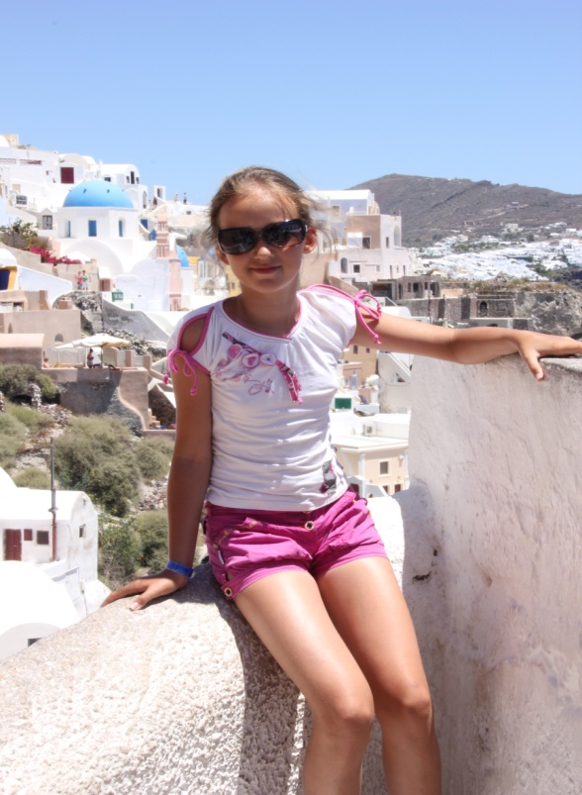
Santorini

Then we went back to Crete. There was a Cretan evening and a traditional holiday organized by the locals. We took part in this holiday. We sang and danced in a ring, danced sirtaki. Then we went to the hotel, we were tired but pleased. As it happened that holiday concurred with the time of our last day at Crete. So, we threw some coins into the sea in the hope to come back here again.
I’m so happy to visit Greece and a little part of my heart is there forever.
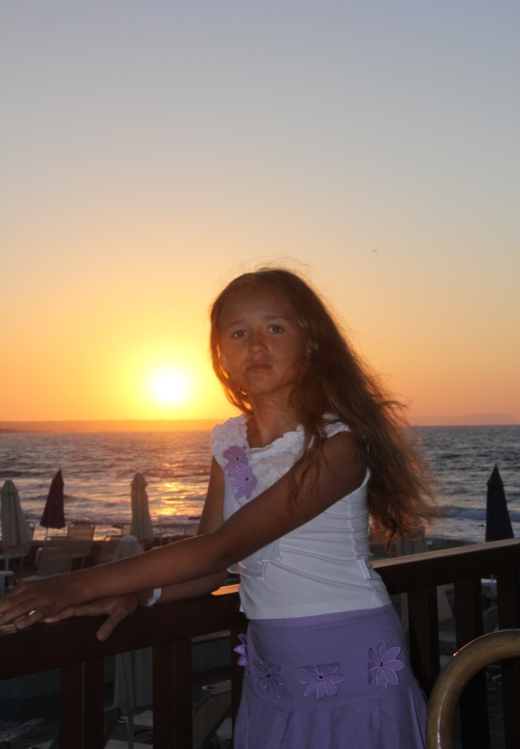

The Cretan evening

Использованные ресурсы:
1. Фотографии взяты из семейного архива автора и размещены с разрешения родителей.

