“My Summer Adventure”

Автор: ученица 9 класса Жукова Александра.
Учитель: Артемьева Ольга Александровна.
Школа: МБОУ «Гимназия №30»
Населенный пункт: г. Магадан
Регион: Магаданская область

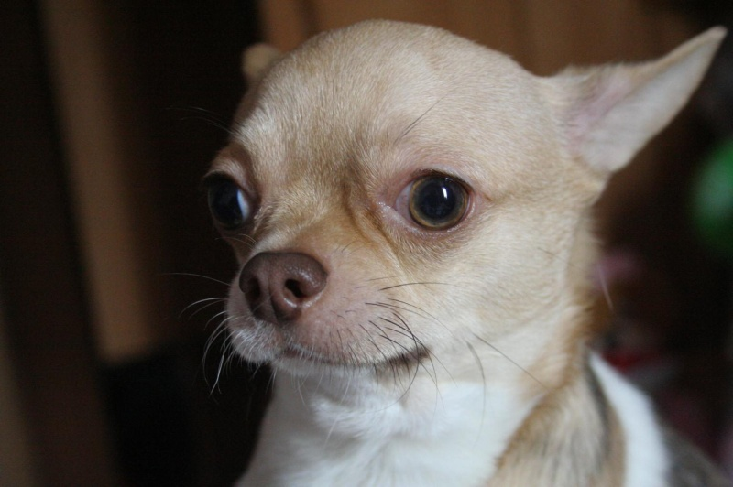
We are a family of 3: my Dad, my Mum and I. For a long we had only 1 dog. It`s a charming girl which was born from mother Pincher and father Chihuahua, her name is Angela, Angy for short. A year ago we took another dog, a Chihuahua boy. We were sure that we would be able to control the situation, but…a week before our going on holiday when my mother was putting Angy in a new dog-bag, she noticed that the dog was very heavy. Mother remembered that Angy had refused to have her meals and guessed that the dog was pregnant. We went to see the vet and he proved mother`s guess, the dog was pregnant.
We couldn’t change anything. All tickets for the plane and the train were bought. The worst thing was that little dogs like our Angela should give birth to their puppies with a vet`s assistance, but there are no vets in the village there we had to go. We were not sure about the date of the birth but my Dad said: «It will happen only when we return home!»
So we set off. It took us 2 hours by plane and 27 hours by train to get to the destination.
Time flies quickly when you are on holiday. We were getting ready to go back.
Everything began 2 days before the departure. Late at night mother found out that there was a puppy in Angy`s box.

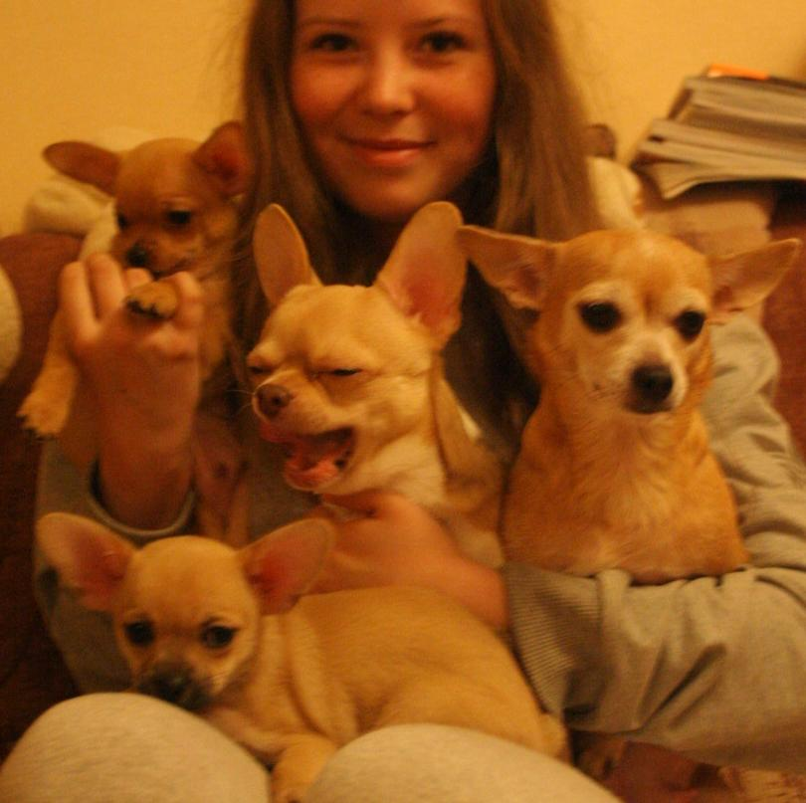
Some minutes later all the members of my family awoke: my aunt, grandmother, grandfather, 5-years-old cousin, my parents and I. We were all watching Angy. The first puppy was already near her but he was silent though all puppies are supposed to squeak loudly after the birth. When the dog was giving a birth to the second puppy, she had some problems. As my mother is a doctor, she helped the puppy to appear. We were so happy!
When the whole family was in the kitchen, drinking tea and talking about the new-born puppies, I went to Angy and her puppies. The first puppy had some problems with his head. There were red bubbles on the place where eyes were supposed to be. Besides, that puppy was lying in the corner of the box and didn`t even try to eat. The second puppy had been eating for 20 minutes already. I worried but my mum advised me to wait till the morning. She said that Angy would help her puppies herself. And in the morning both puppies looked absolutely healthy!
So we had a great problem. If animals travel by train or by plane they must have certificates from a vet. But we didn’t have time to get such certificates for the newborn puppies!
27 hours on the train were hard work for us. We hid puppies in Angy’s dog-bag and did all we could so that nobody noticed two passengers travelling without tickets and certificates.
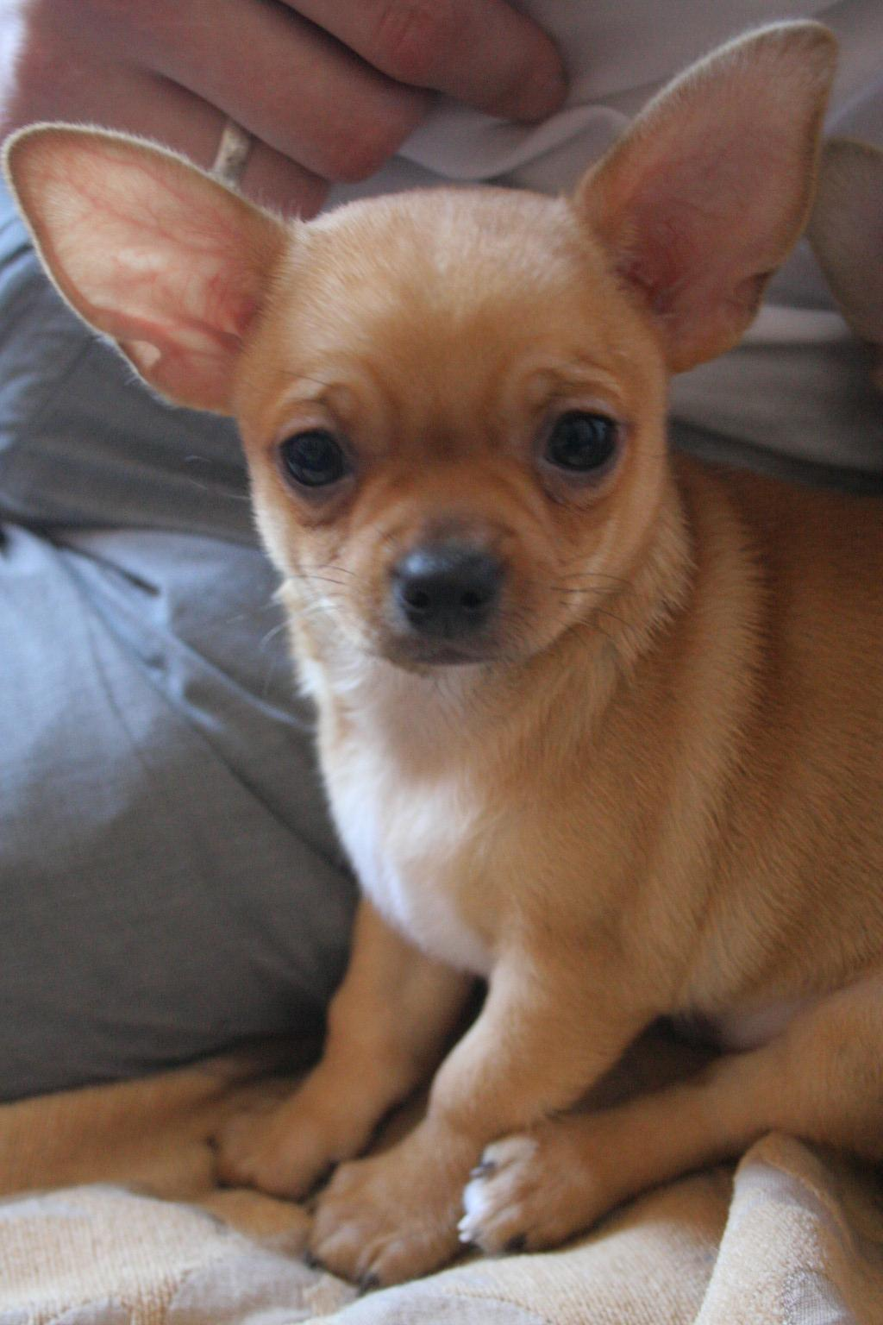
But the worst moments we had in the airport. First of all, we had to pass the chick-in. There we were told that the puppies had to fly in a trunk. We asked if we could take them with us, but the lady said that it was impossible. Then a man standing in the queue behind us started to convince the check-in personal not to take the puppies to the trunk. In few seconds about 10 people were standing for the little dogs with us. Finally, the personal allowed us to take them with us!
But it wasn`t the end. We had to pass screening and boarding. This time my mum tried to hide our puppies. She told me to put them into my pockets and hold in my hands. Of course, the puppies were noticed by the personal. But the two young girls were very delighted by tiny puppies with closed eyes and didn`t check them.

Finally, we were on the plane. 2 hours seemed us 2 minutes and we came back to our city. Now the puppies are still with us and feel fine. They can even jump on the armchair!
My summer adventure has the happy end.

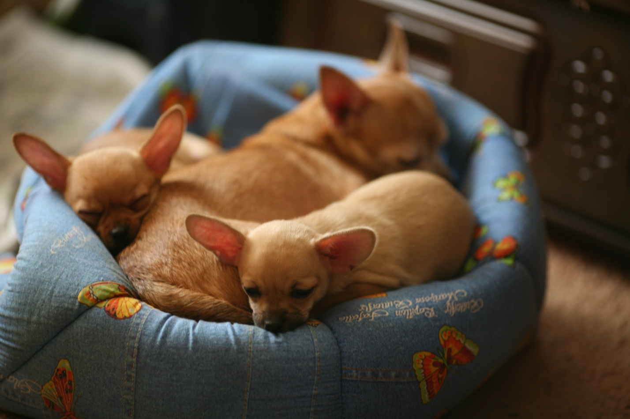

Фотографии из семейного архива Жуковых использованы с разрешения родителей участника конкурса.

