«My summer Adventure»

Автор: ученица 10 «А» класса
Шукралиева Аделина
Учитель: Хайдарова Зухра Набиевна
Школа: «МБОУ СОШ №27»
Населенный пункт: г. Астрахань
Регион: Астраханская область
Hello, my name is Adelina. I am from the town Astrakhan, a student of secondary school № 27. I am a student of the 10 th form. I am 16 years old.
What is summer? Summer is the sun in our eyes, the fresh air, the birds singing in the morning, the smell of wet grass, music, friends, discos and the sea! It is a time, when my family and I spend time and rest together because the whole year each person of our family is busy.
Every year in summer my family and I love to go out of town to relax, to gain strength for the next long year, and get a lot of emotions!
My family and I have been to many cities. I personally visited the resort cities like Anapa, Sochi, Gelendzhik, . Also, Volgograd, Moscow, Elista.
But I would like to tell you how we spent this summer in Kislovodsk.
In Kislovodsk, we were for the first time, this year 2012, in August.
Two months of summer we were at home, in our town.
There were the hottest months in our town. I went to visit relatives, spending time with friends, visiting museums and exhibitions of the town, went to the cottage in the village Rastopulovka, read fiction books.
Some time later, my parents and my sister Amina told that they bought tickets to Kislovodsk, and it was surprising for me! One day we were in the way to Kislovodsk,we have never been to this town! I've heard a lot of good things about this city, but as mentioned before, never been there.
And now it is the date of our departure to Kislovodsk. We come to the station and get into a great comfortable bus. Our trip took one day.
We arrived in Kislovodsk early in the morning.
The first impression was the fresh air , the beautiful landscape, unusuall view of mountains.
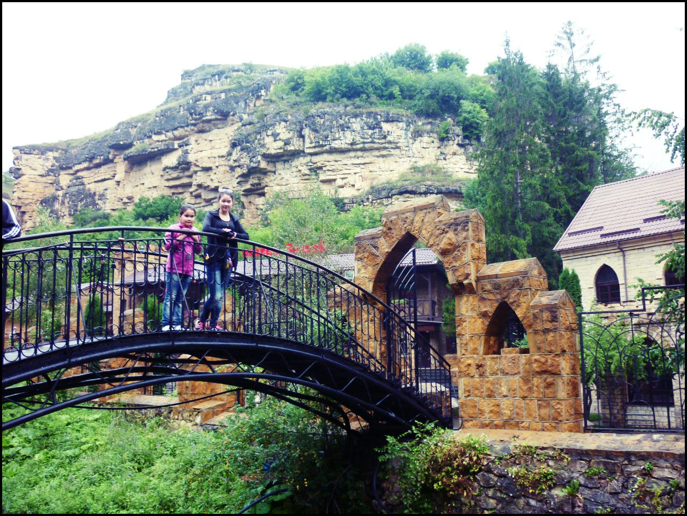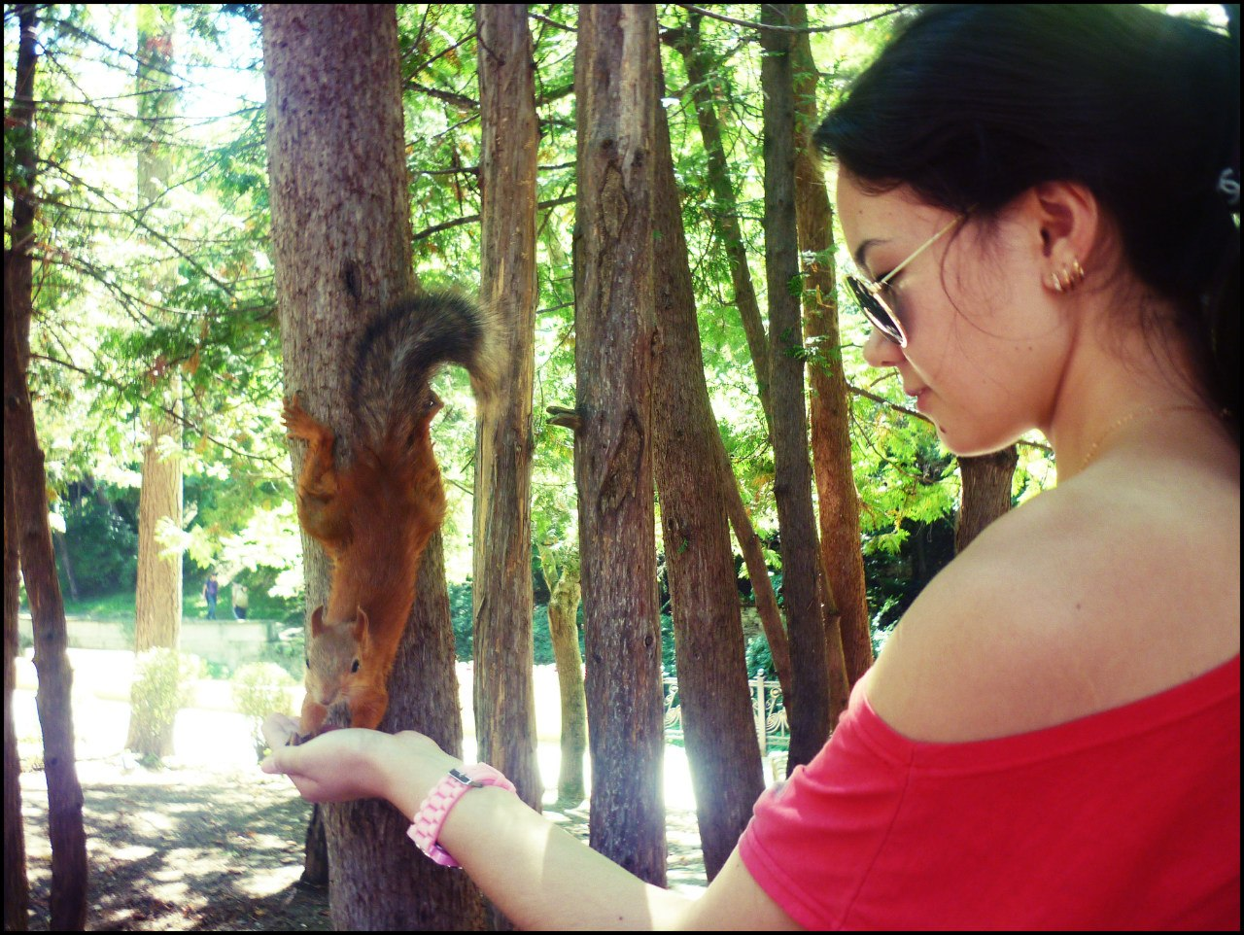

We had sightseeing tour in the town the fist day. There were a lot of entertainments. My sister and I visited delphinarium, we liked seal there. It carried out nicely all commands of the trainer.
Besides we improved our health: drank mineral water “Narzan”, made various procedures.
Best of all we impressed of “Honey Waterfall”. Everybody thinks that honey will be fall from mountains. We were very impressed of five various waterfalls, they different from each other with their sizes and as it is not strange with their colour of water. It was terrible when we went from one waterfall to another by little wooden narrow bridges. We were afraid that we fall down.
Why have these waterfalls such sweet name? I reveal the secret: the honey is not pouring. Honey is brought here from bee apiary and is sold. People come here not for excursion but for eating this honey. This honey is naturel, it contains alive bees.
If you see how magnificent it is there: surprising view of mountains, the fresh air!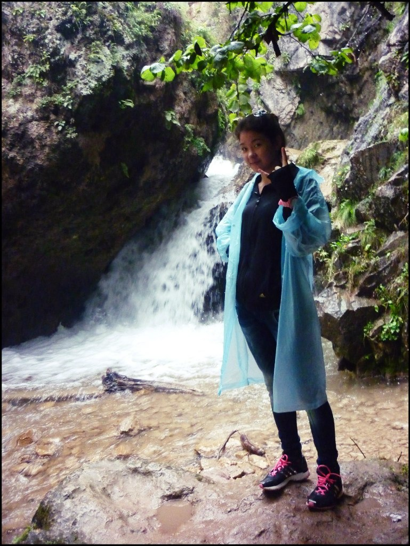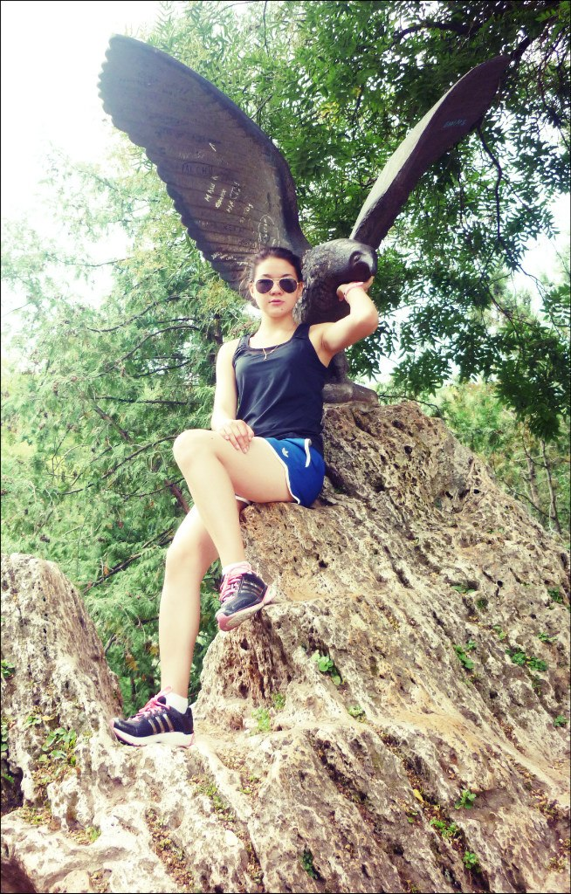

Indescrible beauty! I can say that I spent my summer excellent, unforgettable! My family is satisfied of our tour! After our visit this town I have such assosiation: the fresh air, height ,“noise of the water” and unforgettable marvelous nature!
I advice you to visit this remarkable town!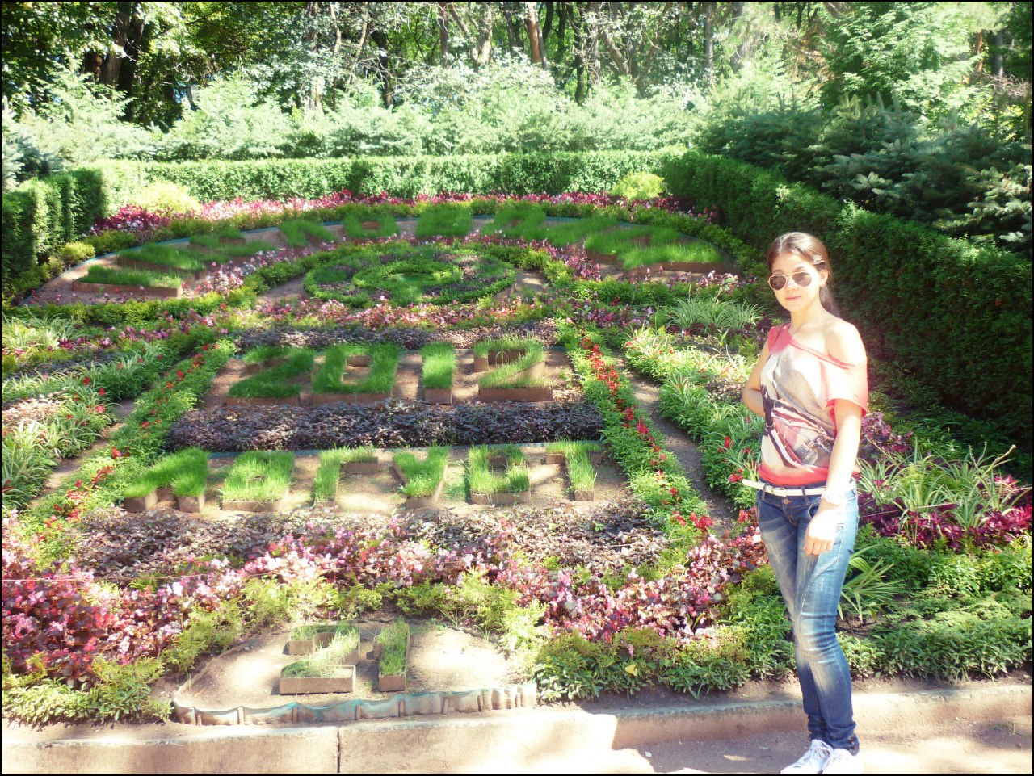
Thank for your attention!
Фото из личного архива автора: Шукралиевой Аделины.
Все фотографии несовершеннолетней опубликованы с согласия ее родителей.

