“My Summer Adventure”

Автор: ученица 9 класса Вебер Анастасия
Учитель: Тарасевич Лариса Васильевна
Школа: Абанская СОШ № 3
Населенный пункт:
п.Абан
Регион: Красноярский край
В работе использовались фото из личного архива автора – Вебер Насти.
Фотографии публикуются с разрешения родителей.

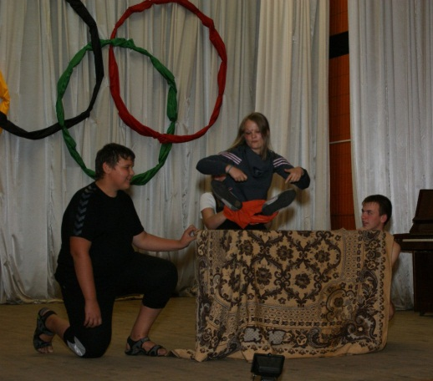
This summer was one of the most interesting and exciting. Time passed quickly because those days were full of exciting events, new meetings and positive emotions.
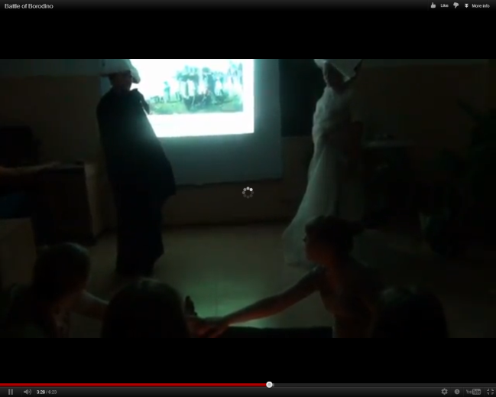
I trained in the sport camp «Bereska» in June. I played, ran, jumped very much. I learned to play football and tennis. When the weather was fine we swam in the lake. But when it was cloudy and rainy we stayed in tents. Even this fact didn’t spoil our mood because we spent a great time with friends.
Moreover, in June I and my classmates made a film «The Battle of Borodino» with our English teachers. I and my friend Polina acted the parts of the spirits of the great captains.
We were the main characters. It was as fantastic as in fairy tale! We turned off the light and put candles. All the students sat around the candles and began to call the spirits of Napoleon and Kutuzov. We laughed very much while we were making the video! The film was sent to the contest “Long Live Victory”
In August I went to the Intensive school «Perspective». It was held in the camp «Grenada».
The topic of our school was «Marine adventure. The lost treasure». «Perspective» consisted of 5 crews. I was in the second cab. I made a lot of friends. They are cool, positive and clever.
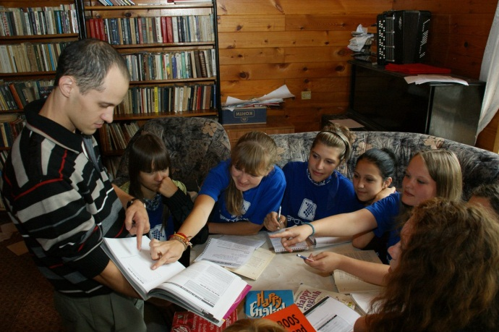
All the teams had names such as «Storm», «Our wave» and so on. The name of our cab was «Bananas»! Every morning we got up with music. But it wasn’t a quiet and nice music. It was heavy metal! I’d prefer to get up with a quiet music.
Than we had been studying, listening lectures. I studied English.
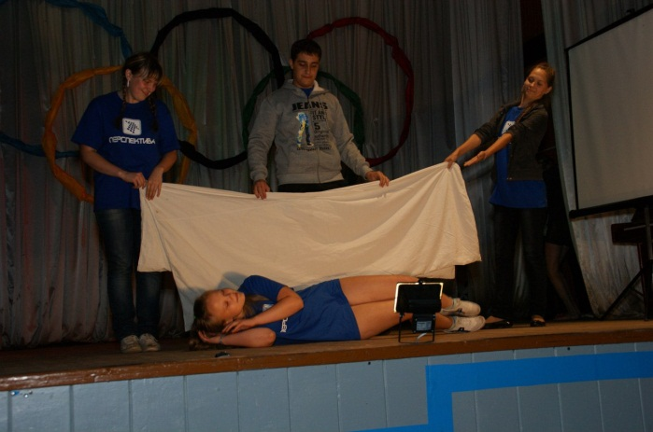
After that we played volleyball, football and basketball. We could join various stations like sport, dance, games, theatre or journalism.

After the dinner we had discos. At 11 o’clock we sat and sang songs, played the guitar, sent letter or saw the news «Perspective».
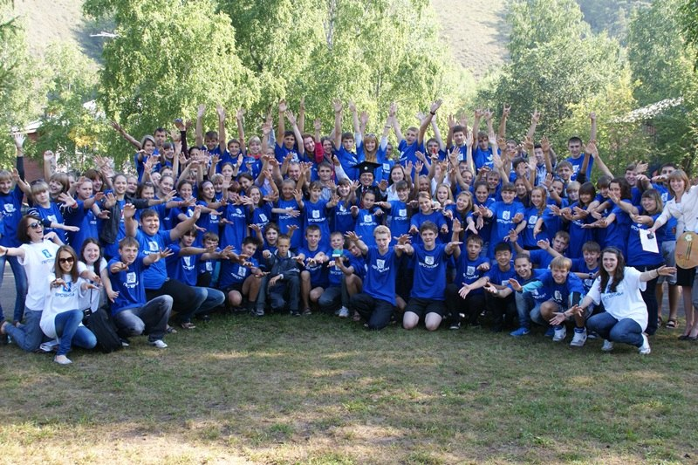
To sum up, I spent this summer very cool! And I’m going to visit «Perspective» again!

