My Summer Adventure”

Автор: ученица 6 класса Тарасевич Вероника
Учитель: Тарасевич Лариса Васильевна
Школа: Абанская СОШ № 3
Населенный пункт:
п.Абан
Регион: Красноярский край

В работе использованы фотографии из личного архива автора – Тарасевич Вероники
Я – Тарасевич Лариса Васильевна, мама Вероники, разрешаю публикацию фото на сайте сообщества.
.

14.07.2012
Hi Dairy!
I have left You at home …and I missed you very much…
I have come back from China. The weather was sunny and hot. I went to China with my dad. Every day we went to the sea, it was warm and beautiful!
We ate in China’s café. The food was delicious. We went to excursions.
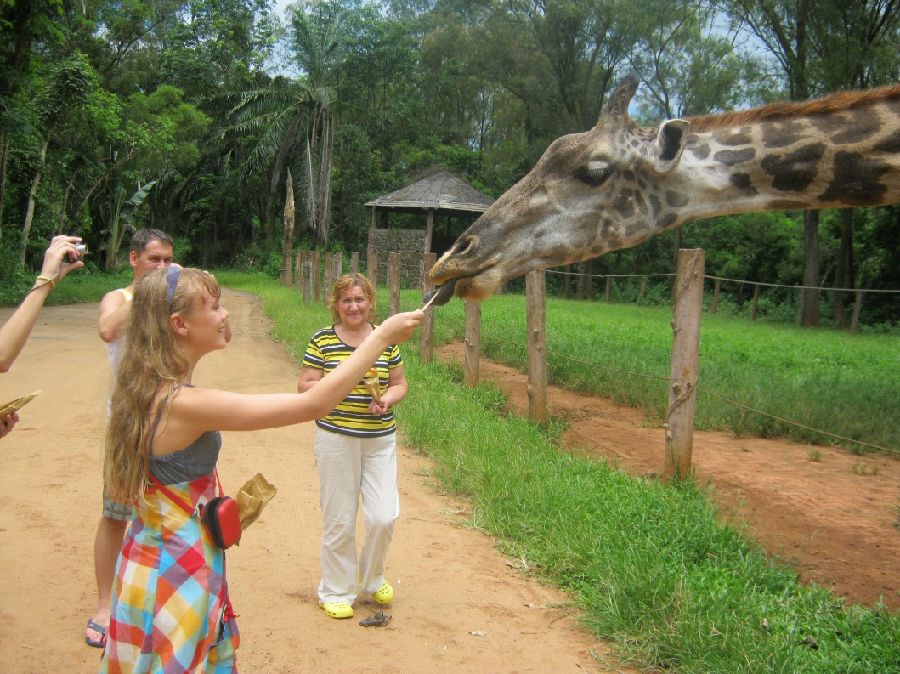
We went to the «Safari» zoo it was fascinating! It was the most exciting excursion I have ever had! We fed animals: elephants, giraffe Zhorick, monkeys, tigers and hippo Dusya. When I fed giraffe it licked my fingers. It was so cute and funny. I couldn’t help admiring watching that gracious animal.

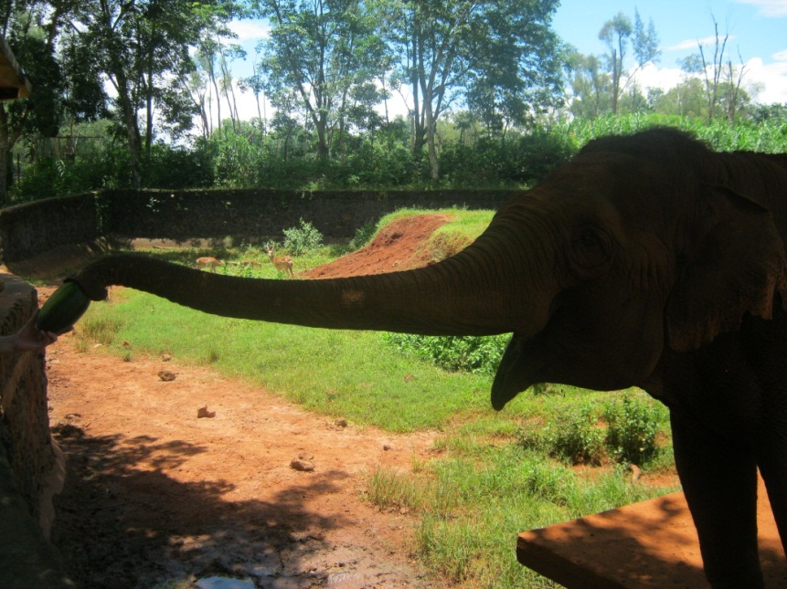

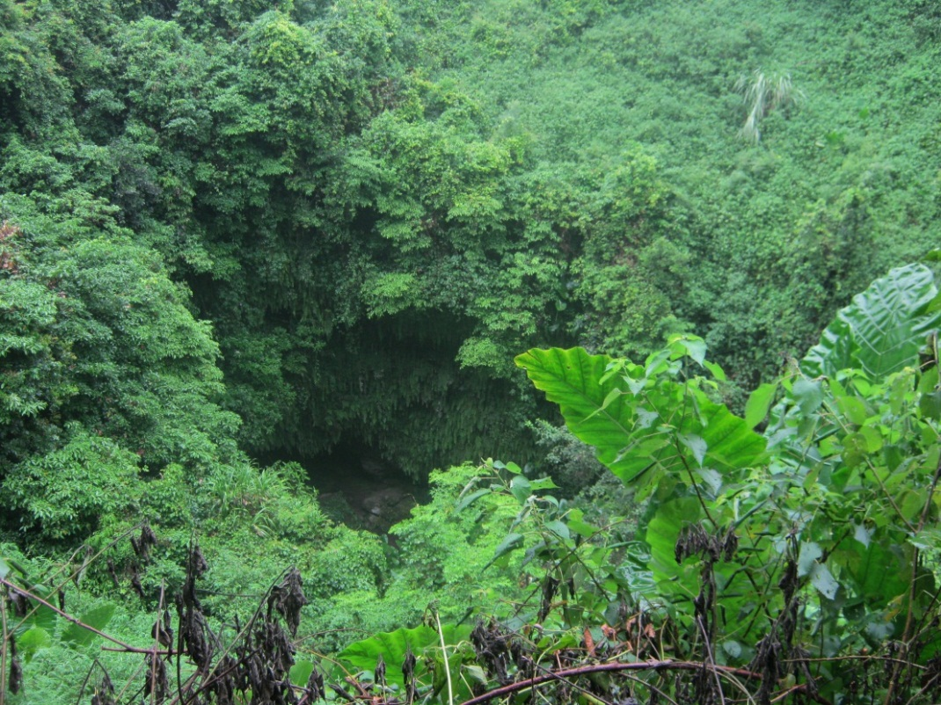
Then we went to volcano and climbed to the top of the volcano. It was an overwhelming view!

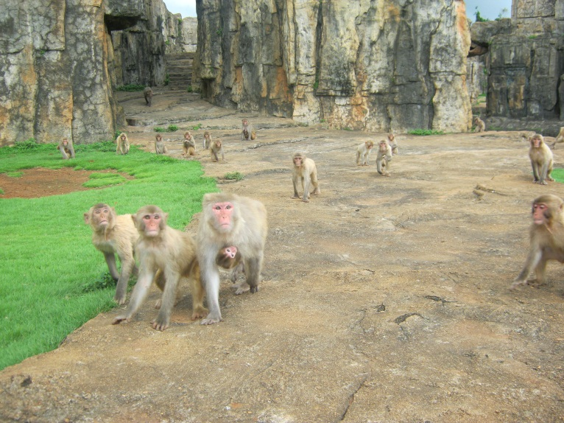
We also visited the monkeys’ island.

I saw a monkey with one eye.

We watched monkeys’ show. Monkeys rode bikes, danced, made tricks.
Monkeys are very clever animals.
It’s a pity to learn that there is a prison for monkeys. Some naughty monkeys live there for short time to be disciplined then.
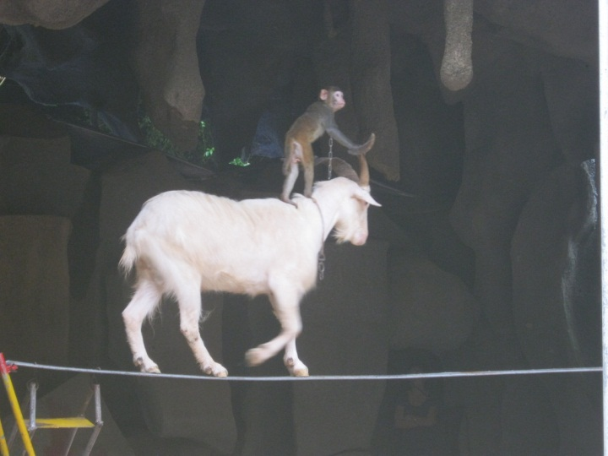
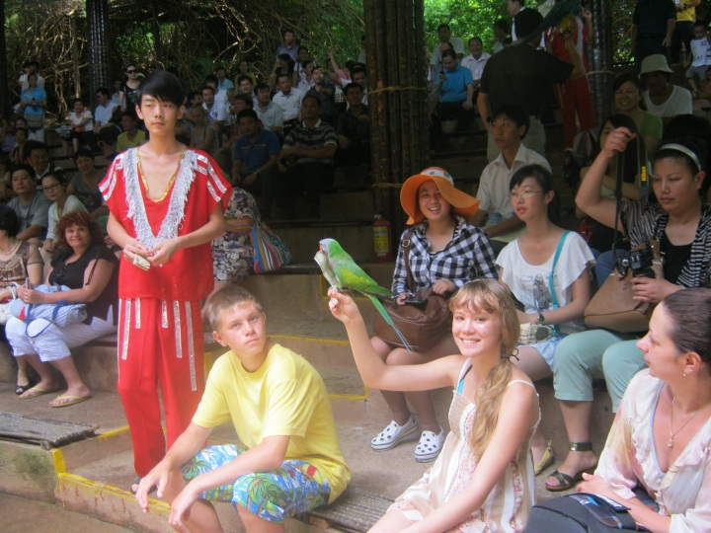

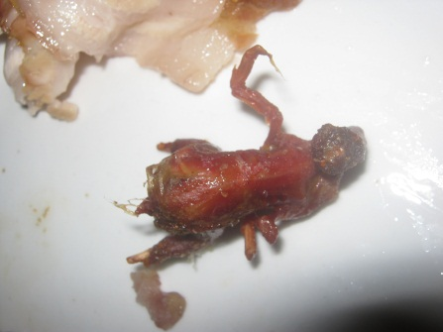
The food was very delicious, we ate fruits: mango, papaya. The funniest dish was roasted sparrow.

I like this adventurous unforgettable holidays!
I have to go to help my mum in the garden. See you soon.
Nica.

