“My Summer Adventure”

Автор: ученица 10 В класса Трубицына Маргарита
Учитель: Шаламова Ирина Николаевна
Школа: МБОУ гимназия №11
Населенный пункт: г. Елец
Регион: Липецкая область

“My Summer Adventure”
I always look forward to my summer holidays, because I can do what I want, I usually have parties with my friends, travel with my family or train for sports competition and always have a nice time.
The sun, the sea and the beach are traditional spending summer for a lot of people. But it isn’t typical for me.
My last summer was really adventurous. It was very interesting and saturation of travellings and events.
My summer started with examinations. I was very tried after a long school year, but I passed all the exams excellently. We (I mean my family and I) were very glad. Successful passing of examinations and my brother’s birthday were a good beginning of my summer
holidays.
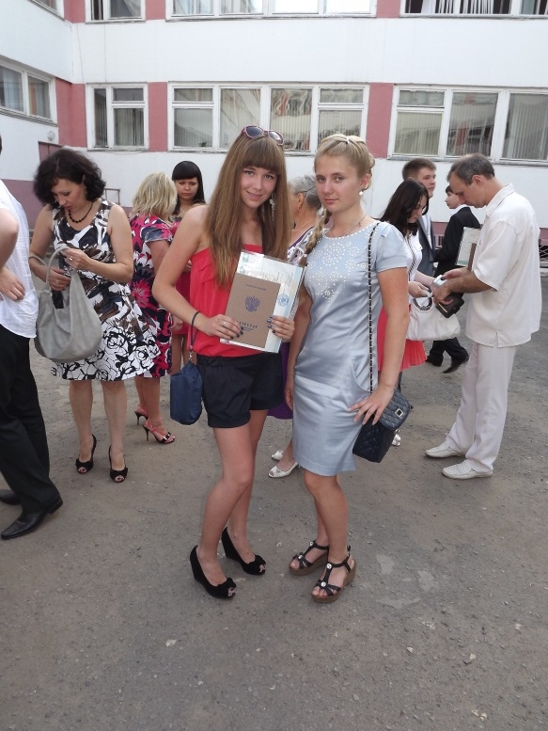

It’s me.

Right after examinations I, my brother, a trainer (by the way, I’m fond of boxing) and my friends went to a camp. It was very funny. We trained hard. I consider it is very important and good when you try to improve your body and character by means of sports. This camp was in the forest. We had already been there earlier. And it was pleasant to us too. Boys were very surprised that I played football well. We took part in all sports competitions and events and usually won the games; we sunbathed a lot and had a rest lying on the grass near the pool. There was a pond nearby our camp. To keep fit we run seven kilometers to it every day. Sometimes we went fishing and cooked our catch on the fire. It was tasty and unforgettable. It was exciting and useful for me.
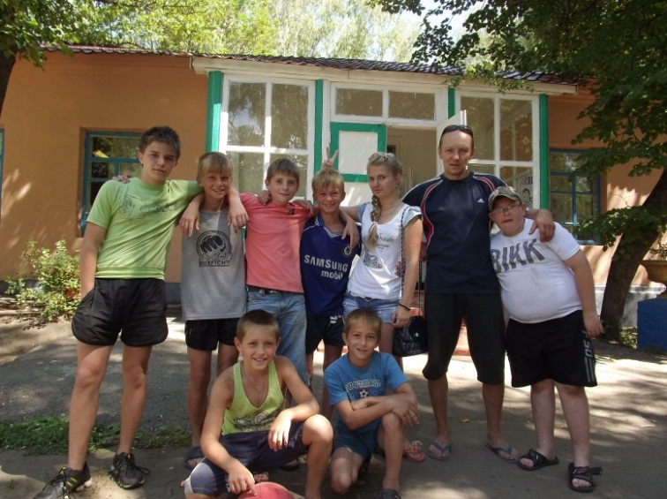
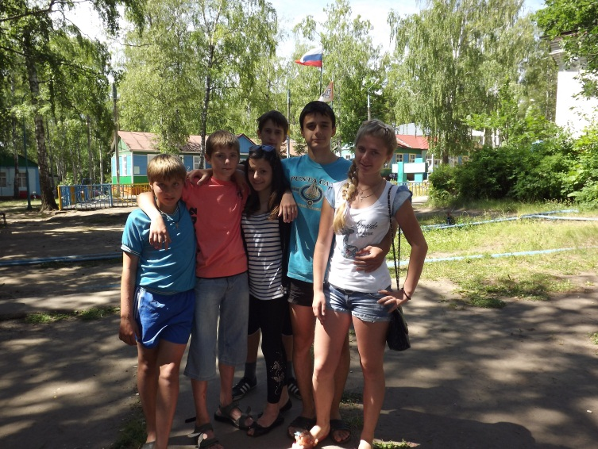
Then I visited Moscow. It was for the first time. It was fantastic! Moscow shocked me by its scope, greatness and beauty. My family and I were in the Kremlin and Red Square. There was a motor-show “Red bull” on Red Square. It was incredible. The metro shocked me with the speed of movement and depth. All around were moving: people, excalators and trains. Our capital is a very big and beautiful city, and I advise everyone to visit it. In spite of Moscow is a noisy bussiness centre, there are also some quiet areas there.
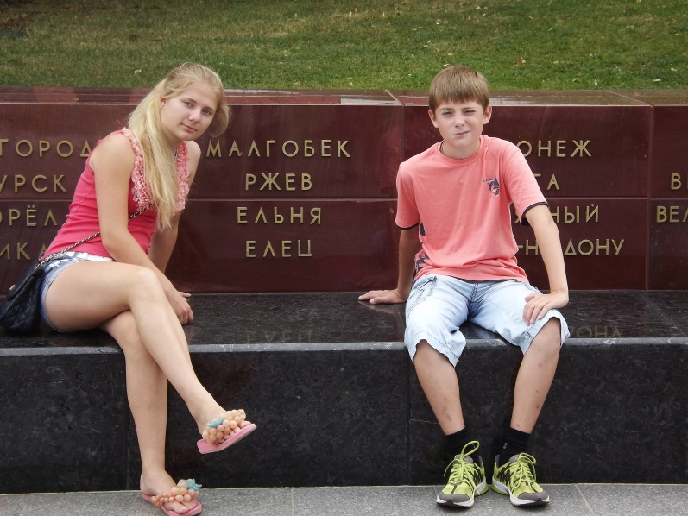
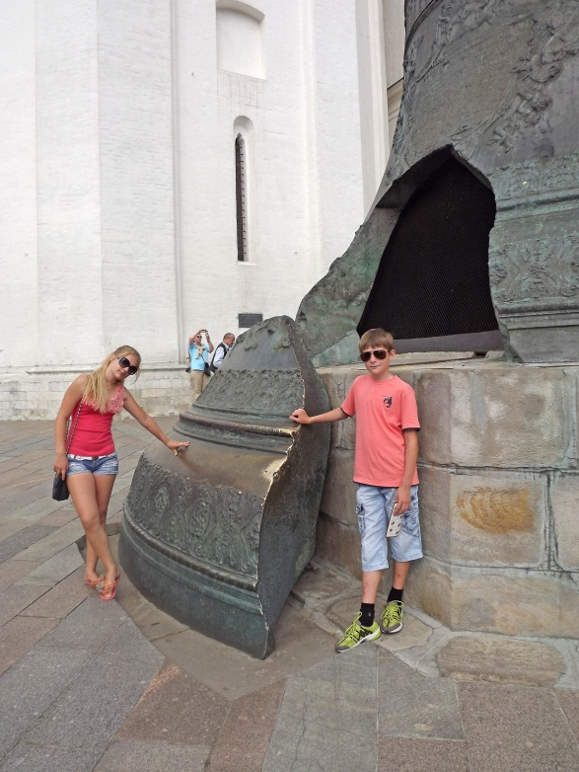
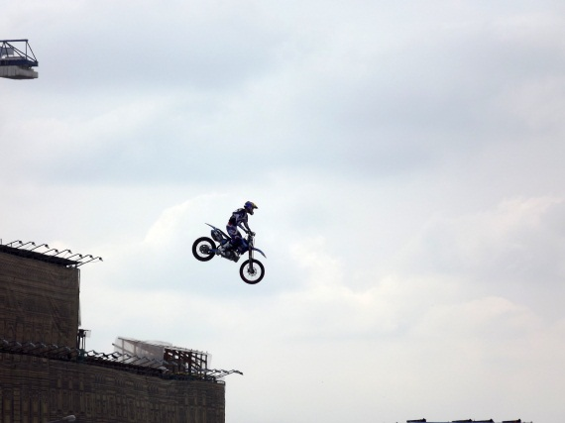
Travelling for a long distance tires persons. So after it we (my family and I) went to Zadonsk. It is not far from my native town Elets. It is small too. We visited Zadonsk’s monastery convent and bathed in a font. I consider that Religion is very important for every person. Then we continued our travelling and went to Voronezh. We skated in the entertaiment centre “Grad”, my brother learnt me to play billiards. It was new for me. I had never played billiards before. I found out the rules of the game and now I can say I play it rather good. I and my brother went to an aquapark. It was terrible and unpleasant for me. “One could is enough to eclipce the sun”, - the proverb says.

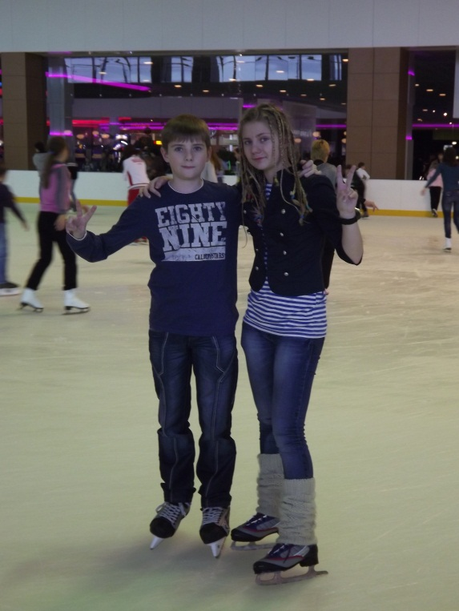
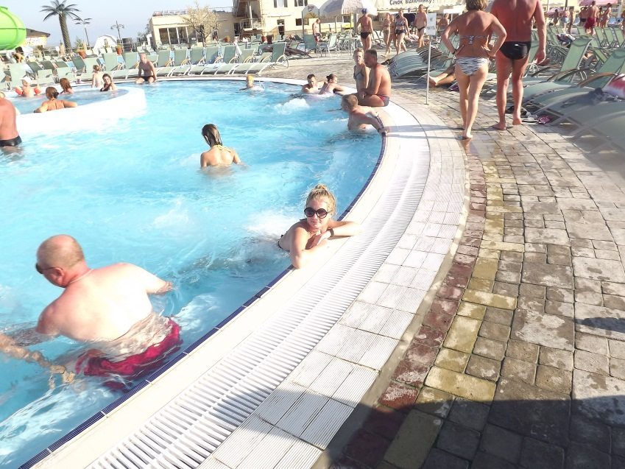

Sports is a big part of my life. I think sports and summer holiday are undivided. So my brother, I and our sports team went on a boxers' meeting. Ten days we lived in the natural conditional near the river Sosna. It was near Livny (it is a small provincial town in Orlovskaya region). All this time only boxers were our society. I consider that boxing educates a charater and trains it. It also makes people friendly. A lot of sportsmen (practically all) are very sociable and communicated people. For ten days we became a real family. At that time we only trained, bathed in the river and spoke much about everything.
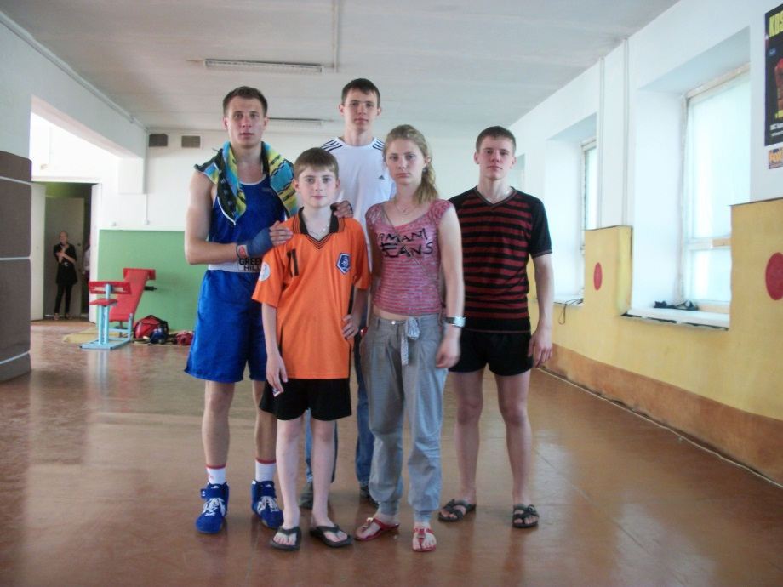
In a week after our trip my brother and our friends took part in a boxing competition in Elets, but not I, unfortunately. I worried about my brother but he won the first prize and got a gold medal. So did our friends.
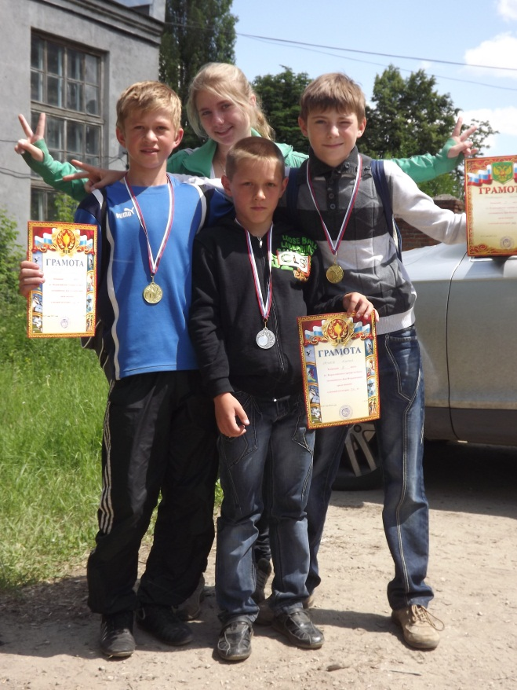
I also visited the North capital of our country. It is a city of bridges and palaces. We visited Tsar’s village, Petergof, Isakievskiy Cathedral, the Hermitage. Riches and luxury impressed us. It wasn’t my the first visit to St. Petersburg. I had visited it earlier, but it never stopped me surprise by its beauty.
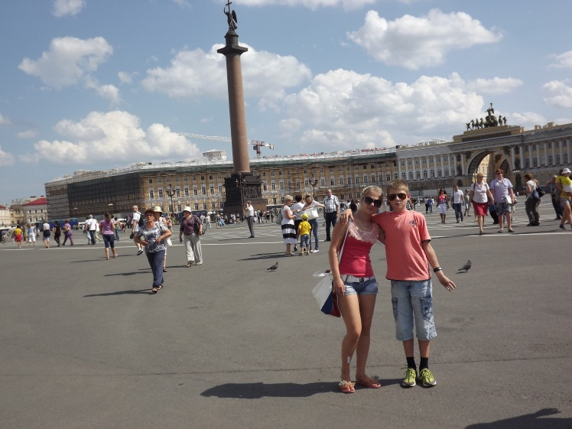
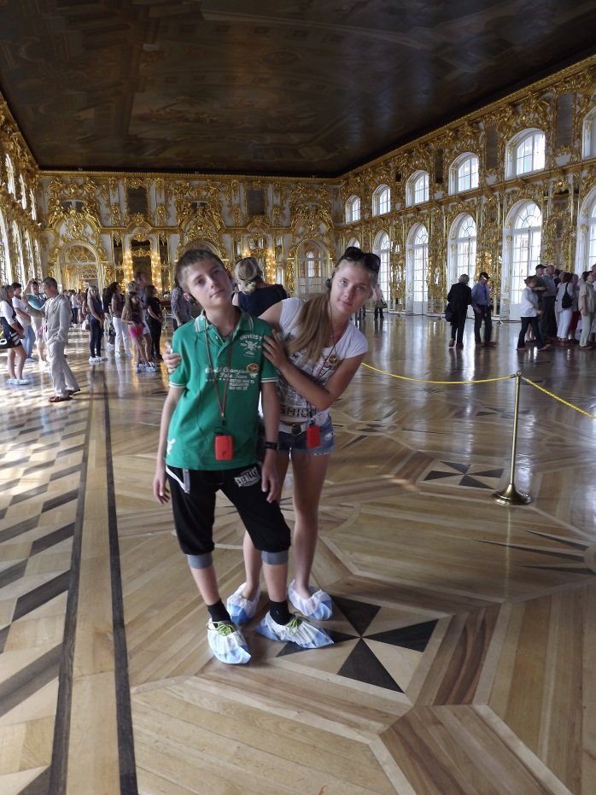
Of course, during my summer holidays I spent a little time at home. But I didn’t just stay at home. My friends and I rode a bike around the town and its nearest suburbs. As the weather was very hot, we gathered together near the fountain (sometimes we even bathed in it) or went to the river to swim. It was very refreshing and cheerful. My friends addicted skate boarding and riding BMX (It is a special bicycle for Bicycle Moto Cross). And I consider that it looks unusual and beautiful and I tried my chance to do it. It was worth trying.
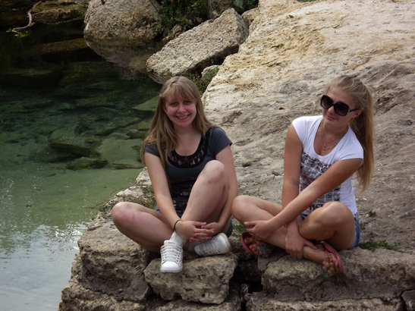

A trip to the sea was my last adventure for this summer, but it was pleasant and comfortable. We went to the Crimea. My family used to travel by car. We though what place to choose. After a discussion we saw a mountainous place and stopped there. As for me I could take a lot of good photos. For three days we had a rest in Koktebel, we enjoyed the sea air and the weather was with us, but suddently the storm changed our plans and we decided to move to another place Nikolaevka. Mobility to move from one place to another is the main advantage of travelling by car. Also we had an excursion to Sevastopol. It is a city of war glory and navy.
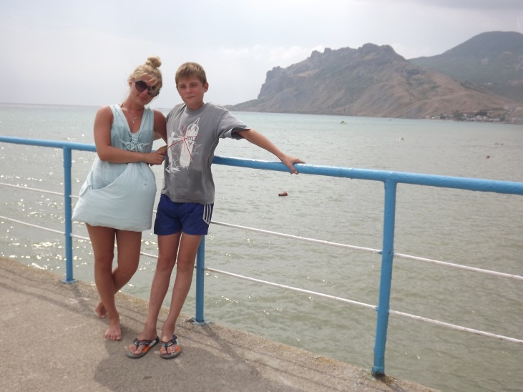
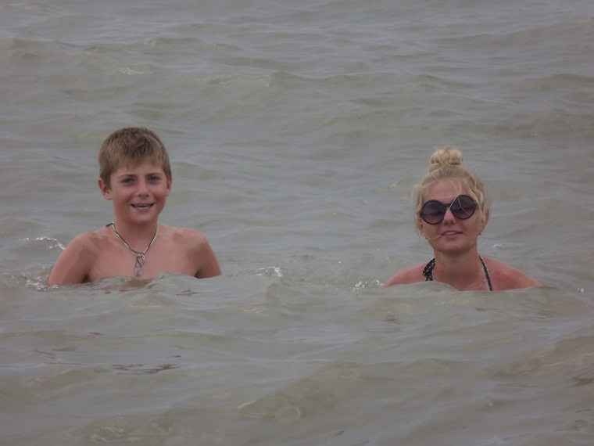

All my plans about summer became true. At last I could stt down on the twine.
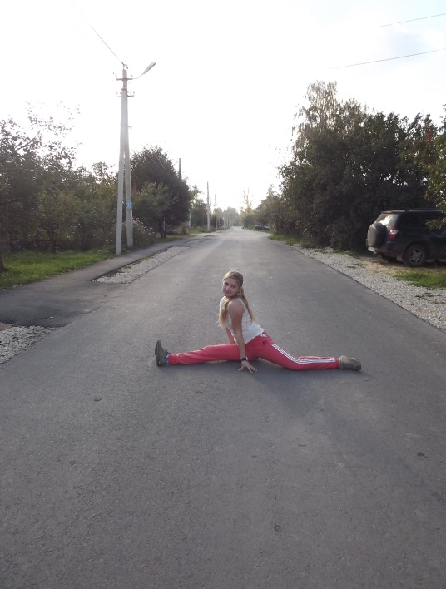
My last summer adventures were great and I think nobody spent summer holidays so interesting and fun as I did.

В работе использованы фотографии из личного архива семьи Трубицыных.
Все фотографии размещены с разрешения родителей.

