Автор: ученик(ца) 9 a класса Фоменкова Софья.
Учитель: Семенова Татьяна Ревокатовна .
Школа: МАОУ «Гимназия №24».
Населенный пункт: город Магадан.
Регион: Магаданская область.

Children always look forward to summer holidays and I am not an exception. I was waiting for them all spring long, because I was going to have a good fun in summer.
So, the first summer month I spent in a summer camp not far from Magadan with my sisters and my friend. I had already been there a summer before and it was really fantastic. But this summer we were disappointed. The only good thing was that the weather was warmer than in Magadan and we didn’ t have to wear warm jackets. There was really nothing to write home about.
We returned back to Magadan in the middle of July.
The rest of July I spent going out with my friends and looking forward to my future journey. I was to go to Khabarovsk to visit my aunt and her family. It hoped it would be an impressive journey.
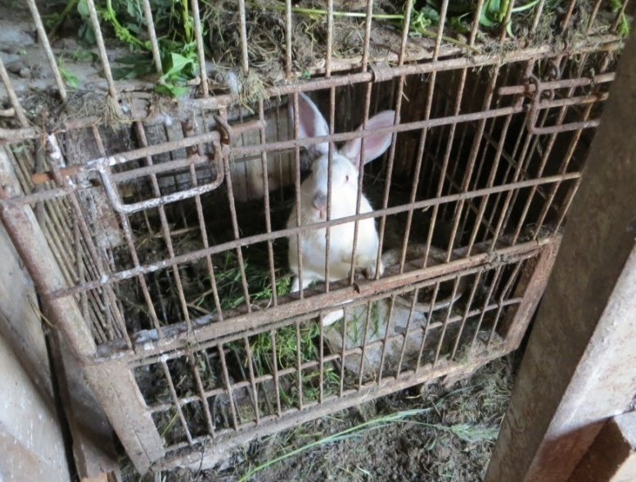
By the way, my aunt and her husband have extraordinary living conditions. They have a farm. There are many different kinds of animals and various plants, vegetables and berries. They always have fresh milk, meat and things like that and sometimes they send us their frozen products.
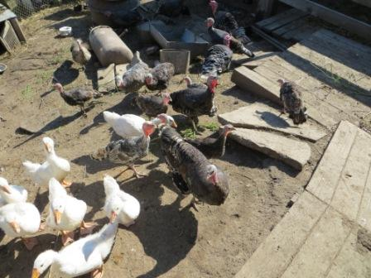

I worried very much because I had to fly without my family for the first time in my life. I was afraid of doing something wrong at the airport, but there was nothing unexpected there. The flight was quiet and very short. It took me just two hours to get to Khabarovsk. I was met by my grandma, my aunt and her youngest son. They were very glad to see me.
In fact, I had already visited them before, but we didn’t stay there long and I don’t remember much about that time.
I came to the city in the evening, but the weather was about thirty degrees above zero and I enjoyed it, because average summer temperature in Magadan is about 15 degrees above zero and it drives me crazy sometimes.
We came home and I was met very cheerfully by my cousins and my aunt’s husband. The first evening was excellent.
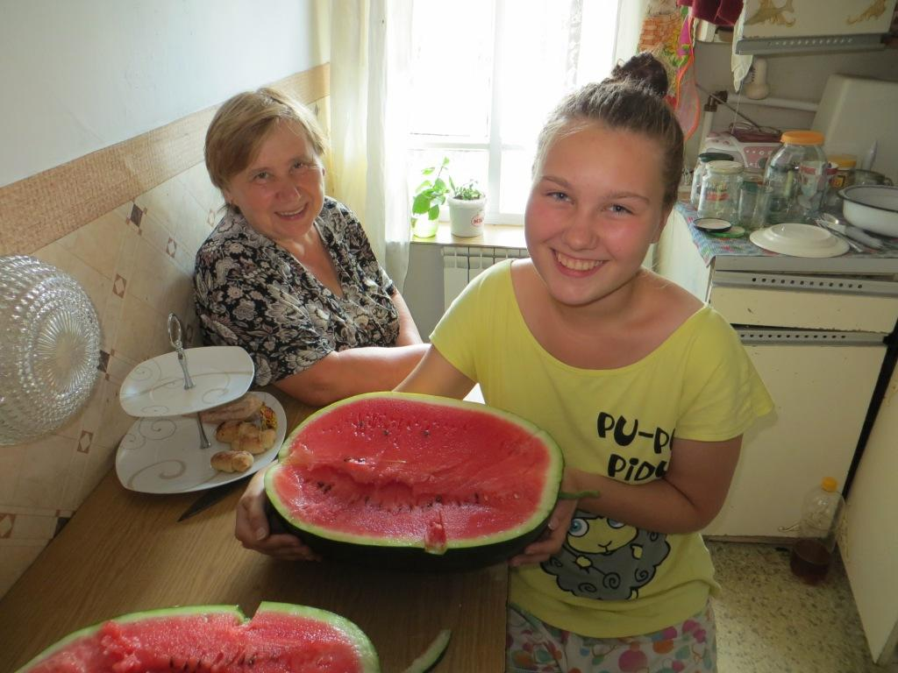

Next day we woke up early in the morning, had breakfast and went to the Platinum Arena which is the main hockey centre in Khabarovsk.
I have three cousins and they all play hockey.
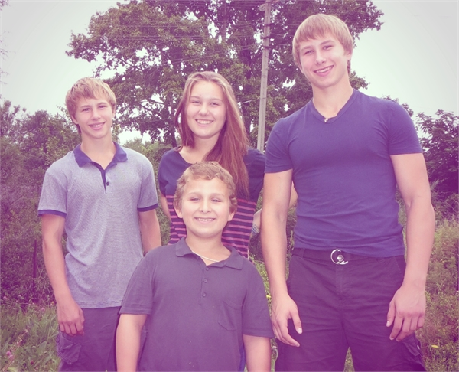

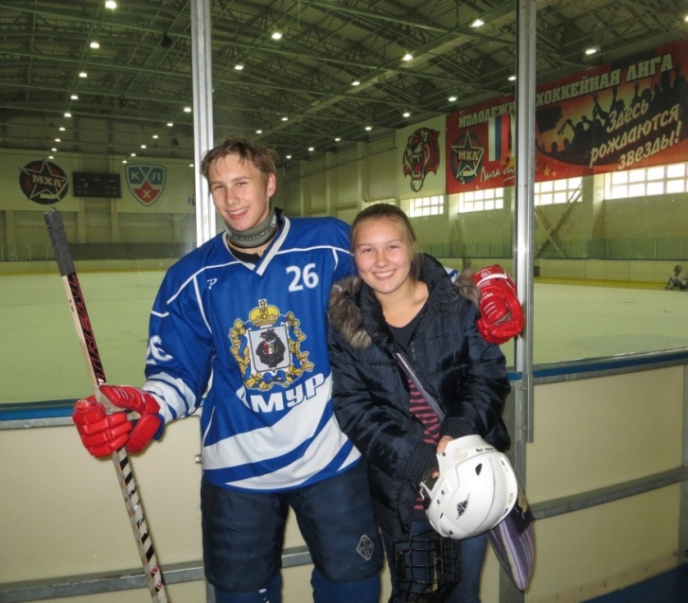
Next morning we spent watching Vanya’s training at The Arena. I had never thought that it could be so exciting. On the way back home my grandma and I left the car in the centre of the city for shopping. It was the best shopping in my life! We dropped into all shops on our way and I was allowed to buy everything I wanted. I bought loads of trendy clothes and cool sunglasses. So, we returned back by bus, happy and eating ice cream.

A few days later, my aunt, her husband and their youngest son went to the camp on the seaside, where Matvey had already been staying for two weeks. Grandma, my eldest cousin Vanya and I had to keep an eye on the house. Moreover, we had to look after animals. To be honest, I had never approached a cow before.
We woke up early in the morning. Vanya milked the cow. At first he couldn’t do it properly, but then he brought three liters of milk every morning and evening. At first grandma tried to milk too, but she had to give it up because she had sore arms.
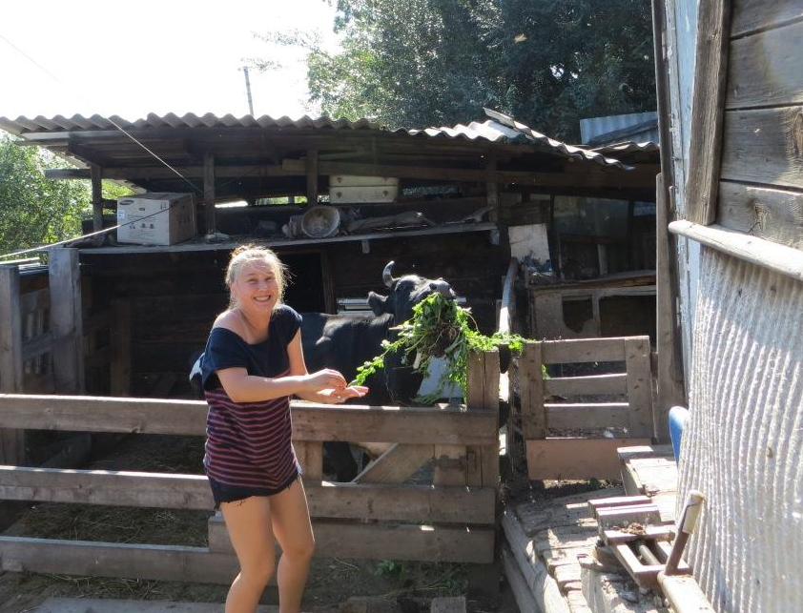
Do you want to ask me why I didn’t try to milk the cow myself? Oh, I’ll tell you. Once I decided to feed and flatter the cow. When I came to her with an armful of grass, she grasped the grass and almost bit off my hand! It was horrible and I was really frightened! So granny decided it would be better if I did other chores.

Every morning I had to cook breakfast, while they were feeding animals. Then Vanya went for his training, grandma was busy cleaning cages and I did housework. After dinner we went shopping to the city. Two weeks later my aunt, her husband and my other cousins came back. They were happy and suntanned.
I made friends with Matvey: he showed me different exercises to keep fit, gave me music he listened to and always made me smile.
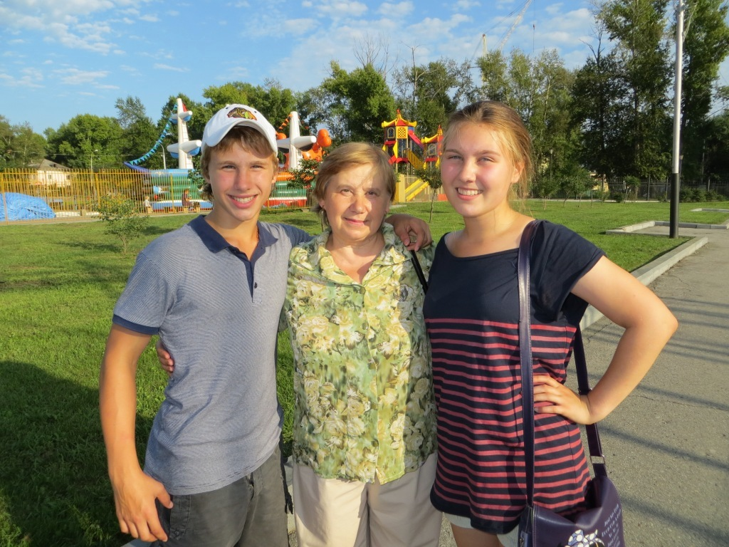

Some days before my flight back, my aunt’s husband, Zhenya, brought tickets for a hockey match between Amur (Khabarovsk hockey team) and a team from Japan. I was happy. I adore hockey. Besides, I like Japanese culture and I have been studying Japanese for five years. I didn’t want any team to lose.
The match started at the Platinum Arena at seven p.m. We had come there on time. The match grabbed my attention completely. Both teams were eager to win, but Amur scored more and all the spectators cheered them with clapping and shouting. It was really exciting.

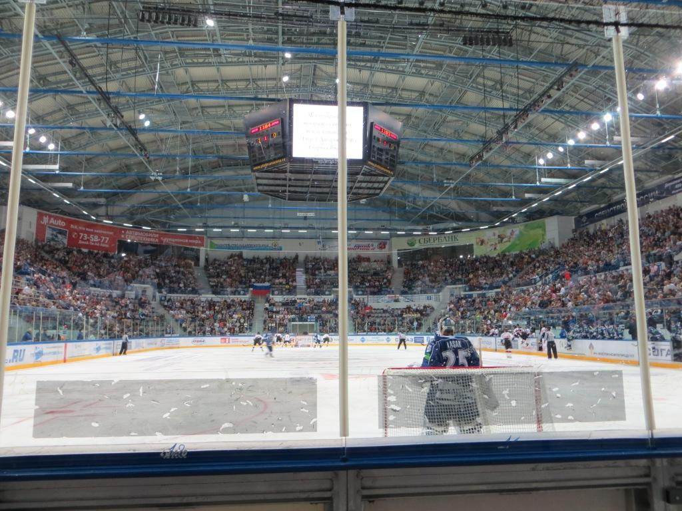

The next day I had to fly back. The whole family saw me off at the airport. They didn’t look happy and I was sad, too. It was an unforgettable holiday. I had a wonderful time and got wonderful experience of living in a village, dealing with boys and relatives and reasonable shopping! I look forward to going to Khabarovsk again!
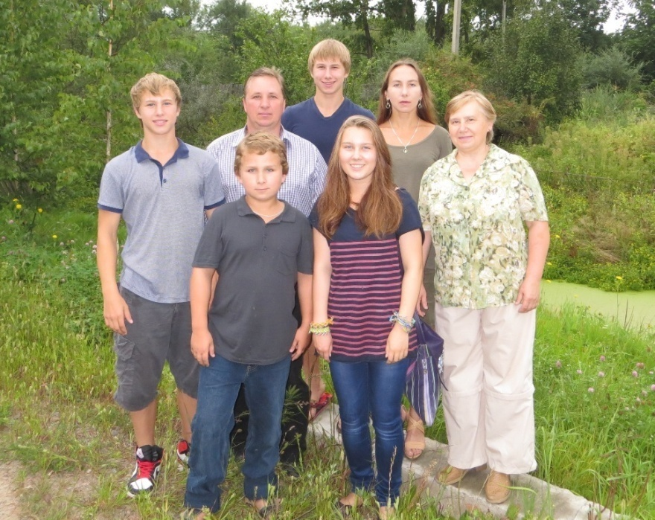

The End
Фотографии из семейного архива Фоменковых-Гребенщиковых использованы с разрешения родителей участника конкурса.

