“My Summer Adventure”

Автор: ученица 10 «А» класса Анохина Александра.
Учитель: Ваулина Ольга Михайловна
Школа: МБОУ Средняя общеобразовательная школа № 1
Населенный пункт: г. Биробиджан
Регион: Еврейская Автономная Область

Oh, summer!!! In my opinion, summer is the greenest, sunniest and hottest season! I like summer, because the sun always shines, the sky is always blue. The city is always green. The weather is simply great!
My holidays began and it’s not necessary to wake up early and go to school. In June this year I spent my time with my friends. We walked, talked and simply had fun.

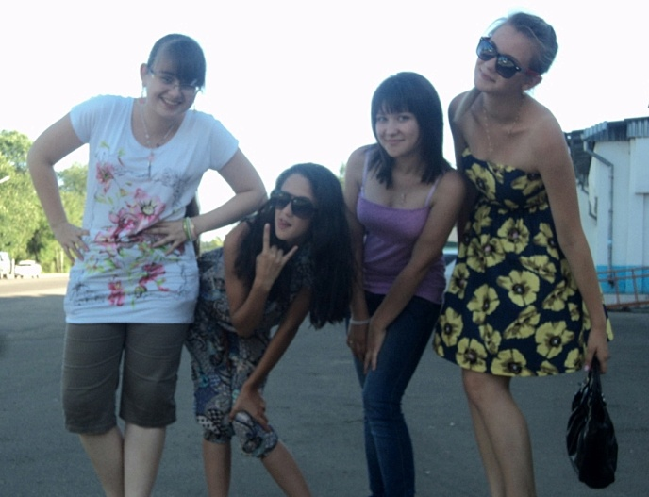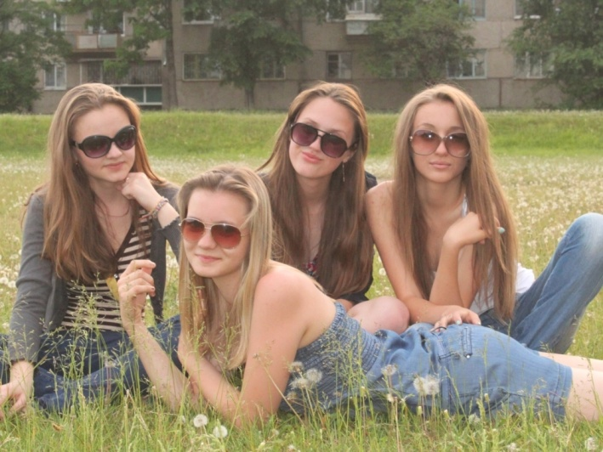
It is me and my friends
In July I studied English language in summer «Access» camp. In camp I was full of impressions. I learned about famous American people, famous places and landmarks. Also we sang songs, danced and enjoyed our meeting.
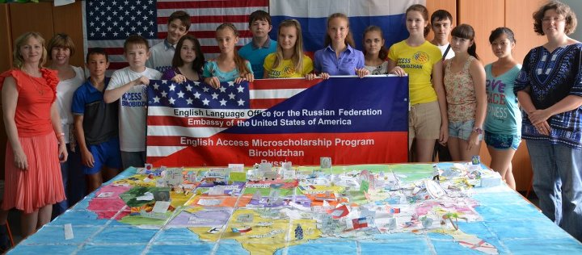
My group in camp.

Kory Gleason visited our camp on the 3rd week. Kory came from Moscow. She is the director of American Embassy in Moscow, Russia. She taught us to play baseball. It’s a very exciting American game. In the end of the camp I got a T-shirt “Access”.
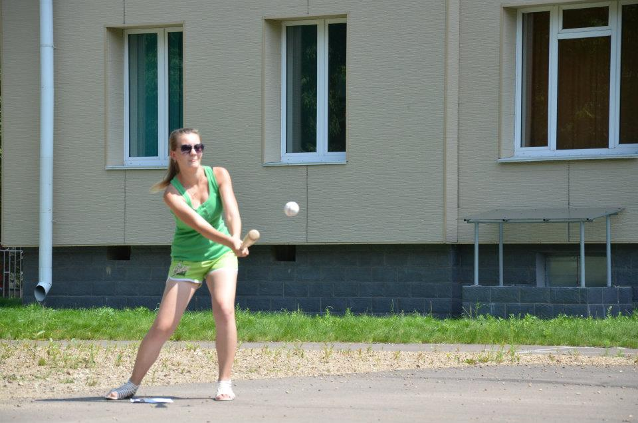
I’m playing Baseball. It’s very cool!

In August I spent very interesting time in summer camp “Scarlet Sails”. I found new friends. We played volleyball, sang songs, danced a lot. One dance, which we danced, was “Cats”. 3 girls and I danced as cats. And also a boy danced with us. He was a cat. Everyone liked our performance. It was a very cool and fun dance.
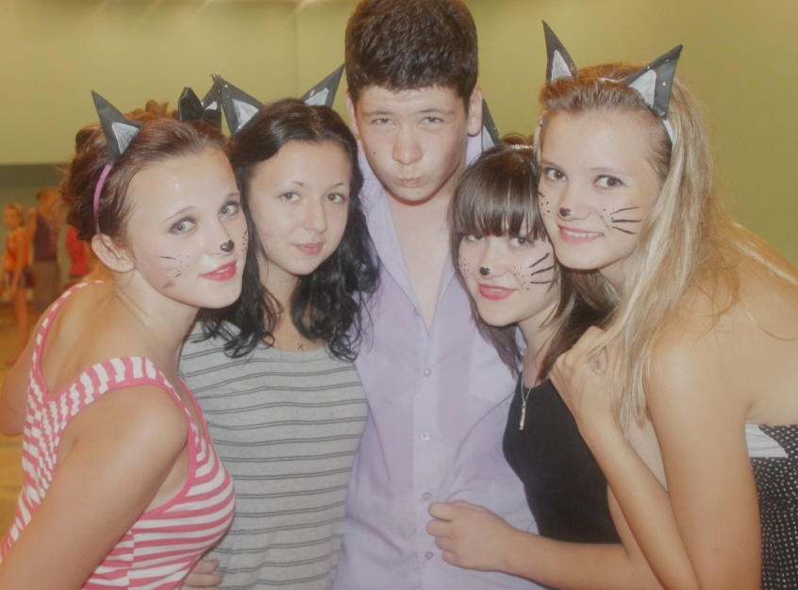
3 cats and 1 cat.
In the camp I celebrated my birthday. It was a great day! My counselors and my group painted “Sashylya, Happy birthday to you! on the pavement. “ I was happy! My group presented me a lot of flowers and chocolate. My friends presented me a small toy dog.
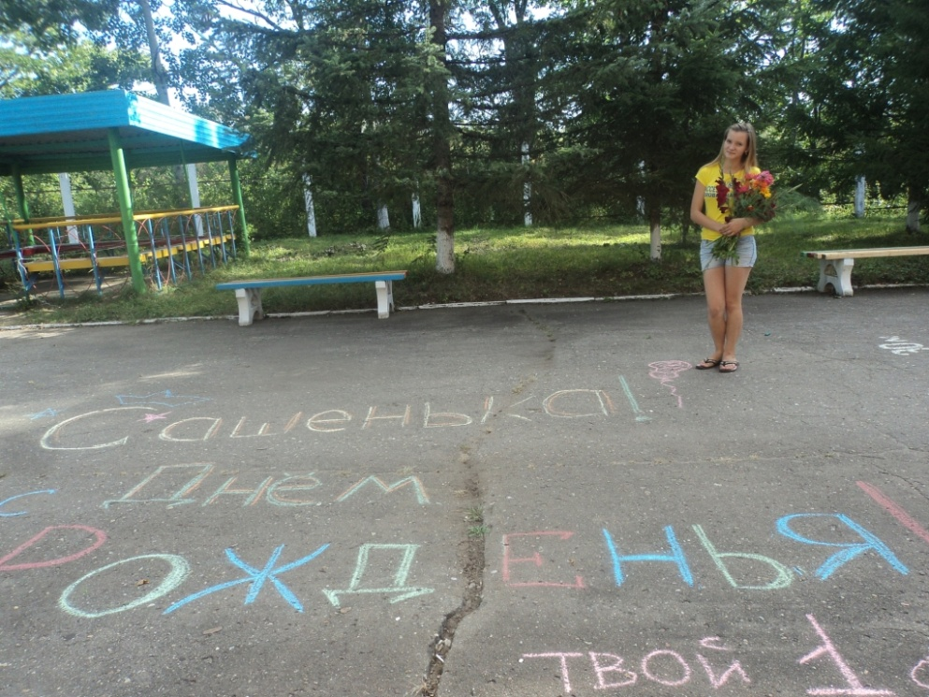

I think that my summer was great! I had an enjoyable time and I was full of impressions.
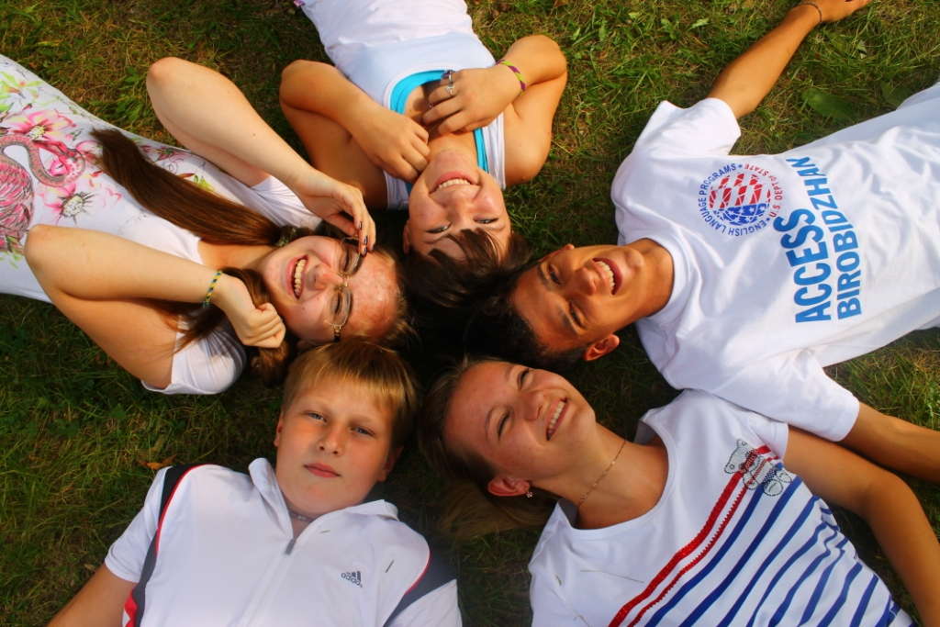
Использованы фотографии из семейного архива Анохиных. Представленные в работе фотографии разрешены родителями для публикации.

