“My Summer Adventure”

Автор: ученица 8 «А» класса Решетникова Влада.
Учитель: Рыжикова Евгения Николаевна
Школа: МБОУ Средняя общеобразовательная школа № 1
Населенный пункт: г. Биробиджан
Регион: Еврейская Автономная Область

Summer is a small life!
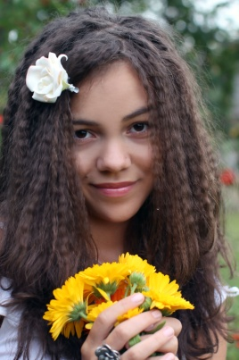
Summer 2012 was a very eventful. I went with my family in the west of our great country. Firstly, we went to Sochi, where we had a rest in the sanatorium "Aurora". The Black Sea was really the warm. Also, we visited the wonderful country Abkhazia, Krasnaya Polyana, which is called the Russian Switzerland, 33 waterfalls and many exciting excursions. I had a great chance to see the performance of ballet "TODES" and listened to music at the open jazz festival. So we had a great time but this was only the beginning of our journey...
Then we went to my dad's parents. Grandparents live in the village Moseevo. The forgotten village where there is not any signs of civilization. But there I spent a wonderful time too. There was my birthday.
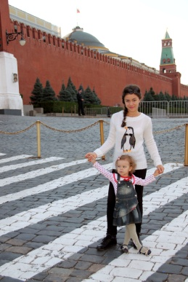
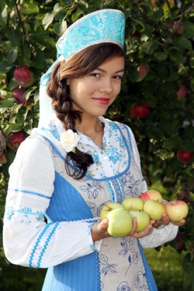
Then we flew to the ancient and beautiful city Suzdal. There we visited a lot of churches. We lived with relatives.
I have not seen as September 1 has passed and all the children except me went to learn. But with my little sister Lisa we clearly had fun.
Finally we visited our capital Moscow. Moscow is an extraordinary beautiful city. We visited several theaters, Tretyakov Gallery, the Red Square and lots of shops. We were delighted by this wonderful city!
That's how I spent my summer. It was great holiday, great opportunity to know more about my favourite country and spend time with my family.

Использованы фотографии из семейного архива Решетниковых. Представленные в работе фотографии разрешены родителями для публикации.

