“My Summer Adventure”

Автор: ученица 7 «А» класса Поповская Мария.
Учитель: Рыжикова Евгения Николаевна
Школа: МБОУ Средняя общеобразовательная школа № 1
Населенный пункт: г. Биробиджан
Регион: Еврейская Автономная Область

Summer in Bulgaria.
This summer I was in Bulgaria. It is very beautiful. People are very nice. Many people speak inEnglish and there are some who speak in Russian.
In Bulgaria there is the Black Sea. It is very warm and beautiful. Often there were big waves. We go swimming every morning. The sea was blue.
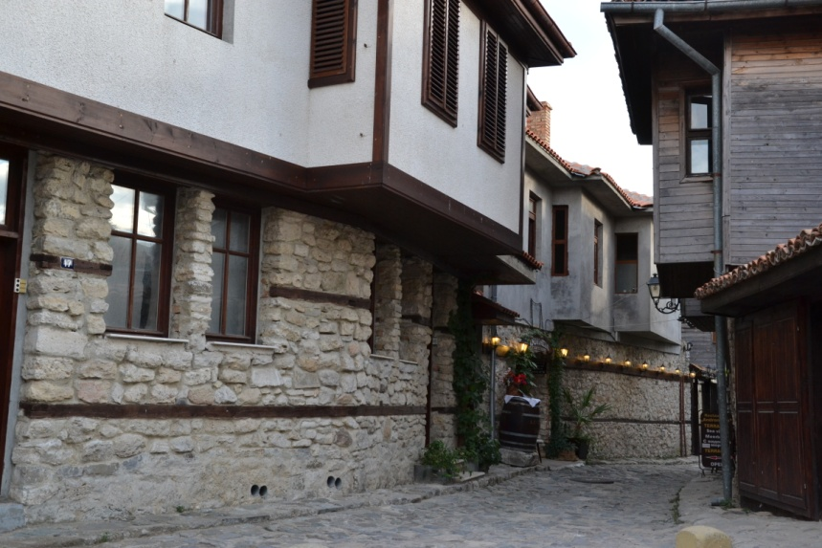
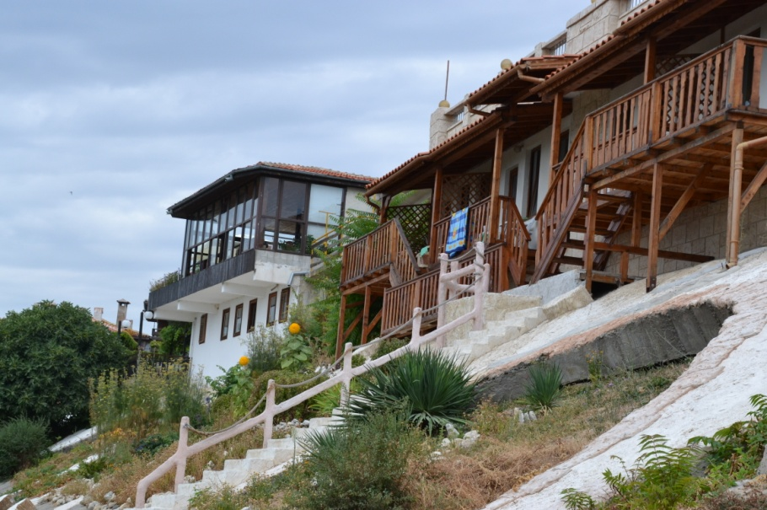
We visited the old town of Nessebar. It was more than 1000 years. There are beautiful houses in the streets.

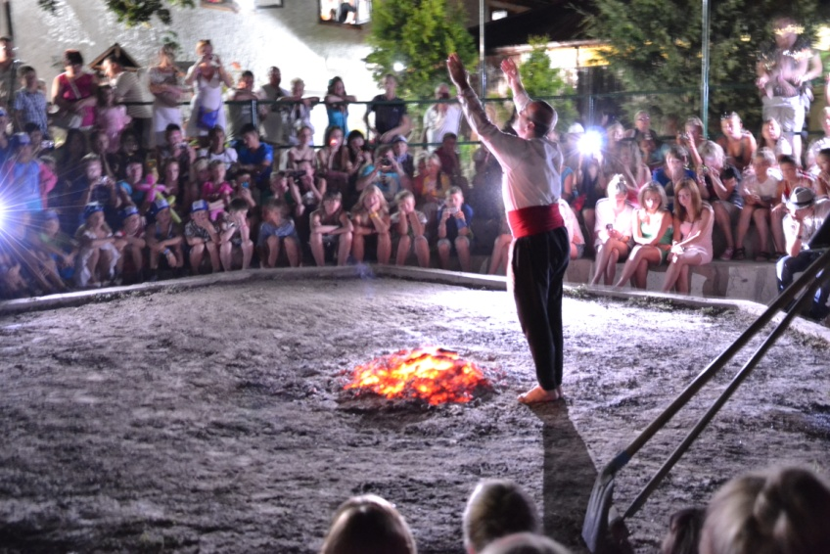
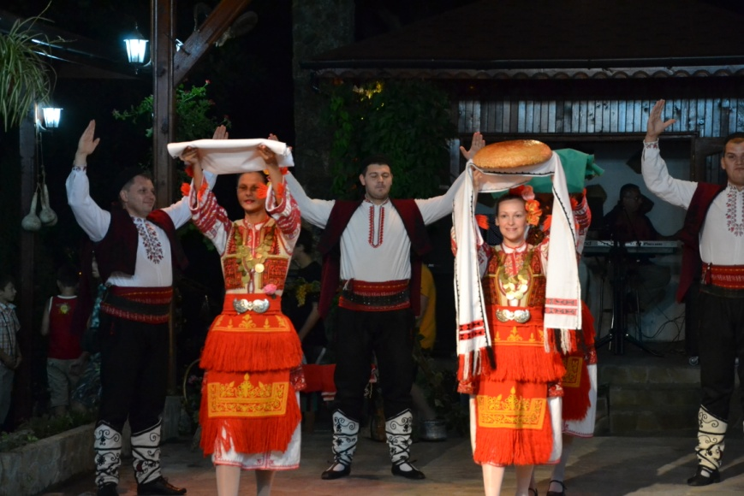
We were in the Bulgarian village. We saw the Bulgarian dances and then a man walked on the coals. I tasted Bulgarian food. It was very delocious.

We also visited the aqua park. It was funny and interesting. We rode the roller coaster and swam in the pool.
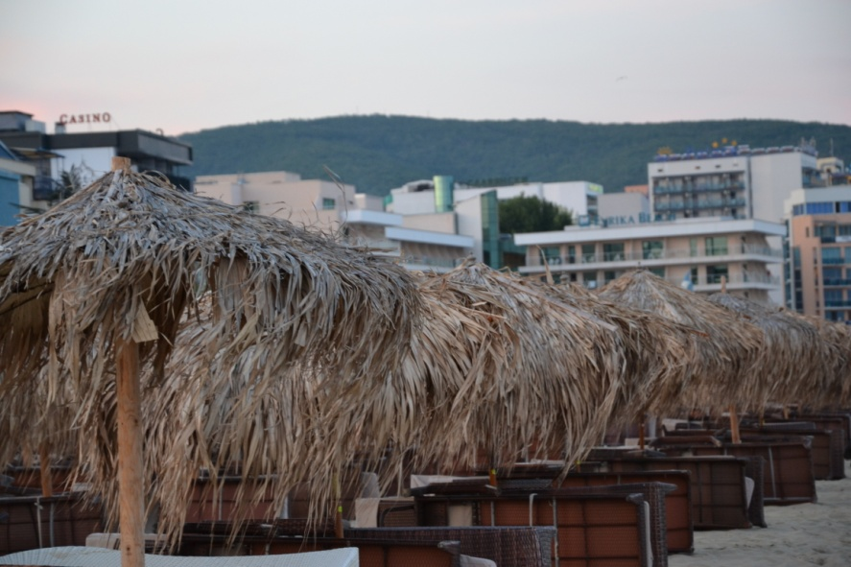
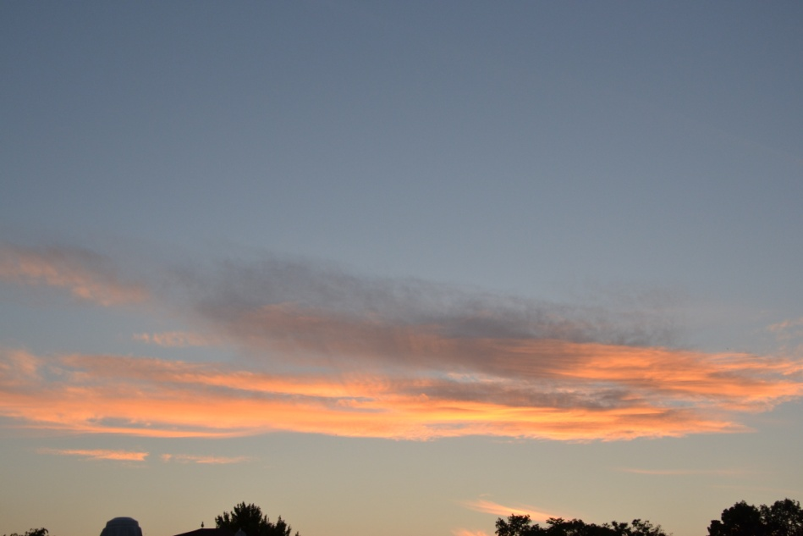
It is very beautiful in Bulgaria. There are beautiful flowers and tasty fruits.

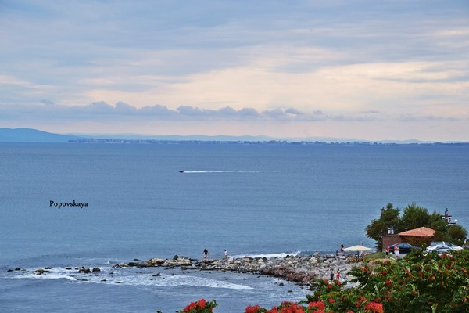
In the last days of our rest we went to the sea. We swam and sunbathed. The sun was very hot. And the sand was very hot. Sometimes on the shore lay a lot of algae.

On the very last day, we went to the city of Bourgas. In Burgas we went shopping. We bought a lot of things and souvenirs.

Bulgaria is a country of roses. Much makeup is made with oil rose. We bought soap with rose oil. It smells delicious. We also bought a lot of cream.
I hope I will go there yet.

Использованы фотографии из семейного архива Пововских. Представленные в работе фотографии разрешены родителями для публикации.

