“MY SUMMER ADVENTURE”

Автор: ученица 7 класса «б» Монашова Екатерина.
Учитель: Холодова Екатерина Юрьевна.
Школа: МБОУ «СОШ № 8»
Населенный пункт: г. Муром
Регион: Владимирская область

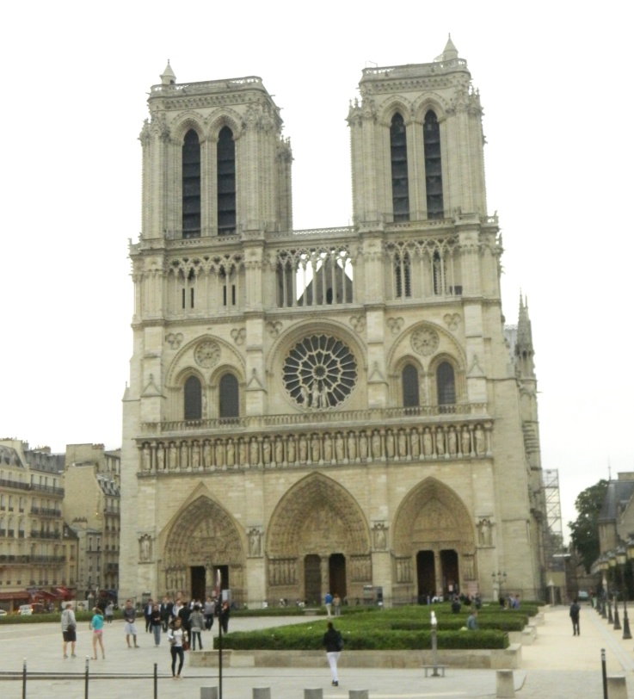

Summer… It’s the most wonderful season for children. Last summer was very exciting and special for me. They say people have got their own dreams, sometimes crazy and very often unrealizable. But my dream realized – I made a trip to Europe. I visited different museums in Germany, went boating in Holland, saw funny statues in Belgium, and went on rides in France…
Well, we thought of our trip beforehand. When my mother showed tickets I was full of emotions that I could cry. I couldn’t believe that my dream was not so far!
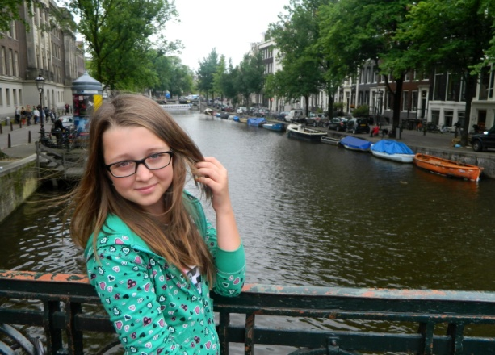
Our trip lasted 11 days. We travelled by bus. I learnt a lot. In Berlin I liked one of the most famous parks – Treptower Park, we saw the Soviet War Memorial there. Canals of Amsterdam were so wonderful and beautiful! Also I laughed when I saw Manneken Pis, this funny 61 cm bronze statue was made in 1619.
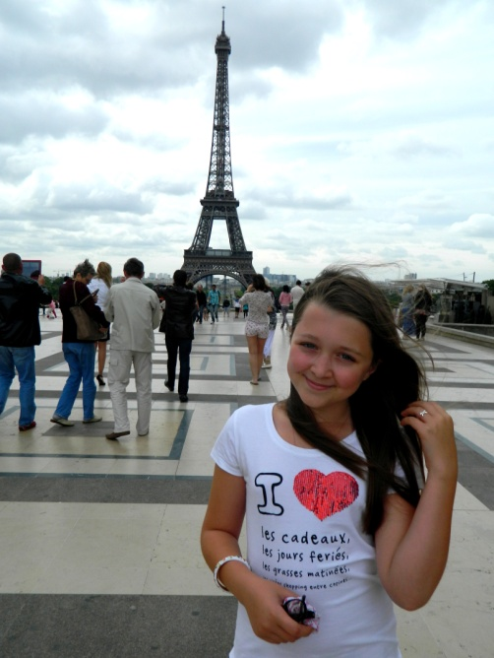
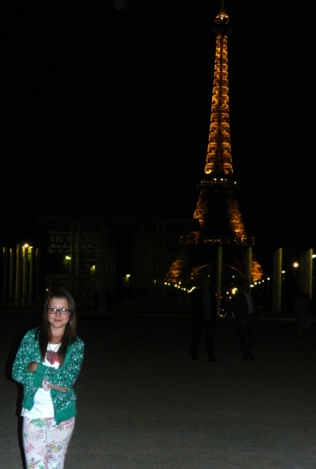
And at last… France! Now I can say I liked everything there. Visiting France has always been my dream. Besides I began to study French 2 years ago. France was so charming; there were a lot of nice cafes, restaurants. I had never eaten such delicious fruit-cakes and sponge-cakes before. I bought different souvenirs and gifts for my best friends. The weather was fine, so I took a lot of fantastic photos. I visited the Louvre, Notre Dame Cathedral and many other interesting places. I will never forget when I saw the Eiffel Tower for the first time. Every day at 11 p.m. the Tower was twinkling like a Christmas tree. Unfortunately it lasted only 5 minutes, but it was fantastic.
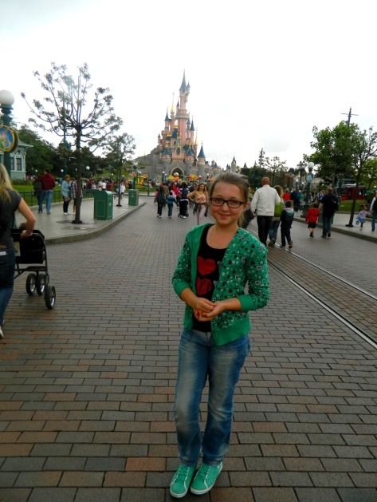
Frankly speaking the most unforgettable moment was our visiting Disneyland Paris. Oh, it was so cool! It’s too large, it’s impossible to walk round it. We went on rides a lot. But I enjoyed the Astro Orbitor’s rotating planets most of all. It was the most terrifying ride in this park for me.
I liked this summer very much, I had the most wonderful summer adventure in my life.
Now we are going to make a trip to Italy next year. I want to dream again. I hope we will be able to do it. So I’d like to say that there is nothing impossible. People should believe, we cannot live without it!

Все фото из личного архива семьи Монашовых.
Публикуются с разрешения родителей.

