“My Summer Adventure”

Автор: ученица 8 Б класса Лаврова Ольга
Учитель: Булаева Марина Александровна
Школа: Муниципальное бюджетное образовательное учреждение Спасская гимназия
Населенный пункт: г. Спасск-Рязанский
Регион: Рязанская область

MY SUMMER ADVENTURE
(or THE AMAZING MEETING)
By Olga Lavrova

Last summer I spent my holiday in my birthplace Spassk-Ryazansky, where everything has been familiar to me since my early childhood: every path and every birch... Someone may think: «It’s very boring to have summer vacation in a small native town. A trip abroad and a visit to a summer camp are much more exciting». But I think differently. A real adventure is the fascinating event which changes you for the better. As for me, this summer can be called a great adventure. And I’d like to tell you about one day of my holiday.
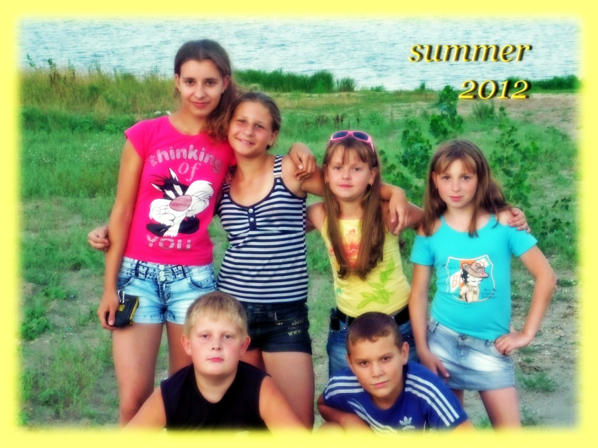
It was a warm, sunny morning when my friends and I went on a trip to the river Oka. We had been looking forward to it for the whole week. So we had arranged everything in advance. The boys had prepared the tent, charcoal and fishing rods. The girls had bought food and dishes. That morning we got up very early, packed up our things and got together in the appointed place. At 10 o'clock we went hiking. All the friends were walking happily in the forest, telling stories and laughing. In an hour we safely reached the river. It was a beautiful, picturesque place. There was the Oka nearby. In a distance we saw a majestic forest where the birds were singing. The sun was shining brightly, but we could hide from the sunrays under the branchy trees. The narrow descent led to the river. We went down and began making a camp.
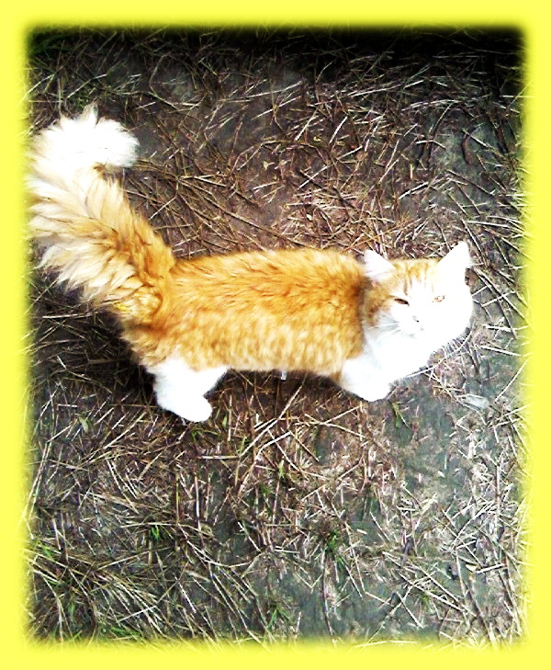
Soon after, everything was ready. The tent was put up. The boys set the rods and threw fishing tackles. After a while, the guys pulled out the first fish. There were cries of joy, which were interrupted by someone's mewing. We turned around and… saw a cat there! Yes, that was just a mere cat! He was walking along the river bank and was mewing. Perhaps, someone had left it. The cat was surprisingly well-groomed and fluffy. He had white hair with bright red spots. Paws were very large and soft, and the tail was similar to a red pipe. As soon as I gave him a fish, the cat sniffed at it and walked away. All the time, while we were fishing, the cat didn’t leave us. When we caught enough fish and decided to cook soup, “our pet” followed us to the tent. While the girls were scaling the fish, the cat was still walking around us.
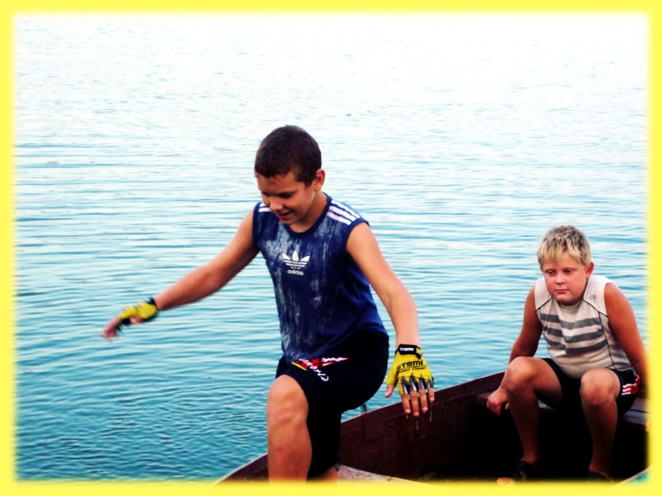
Suddenly, he disappeared. Exploring the surroundings, the boys found the cat watching the gulls. He was sitting in an ambush and wagging his tail. His eyes were shining. Five minutes later, he decided to attack. Having caught one bird, the cat dragged it into the bushes. There was a squeak, and the gull ran out of the bushes. The cat rushed forward, but he did not catch it up. It became clear that the cat wasn’t a hunter. He was simply a household pet.
Later, we swam in the river, gathered strawberries and ate fish soup. After having lunch, we began playing badminton. Meanwhile, the cat was pitifully mewing and was hanging about the tent. One of the boys poured the fish soup into the bowl and came up to him with the tasty treat. The cat ate it greedily. After the meal, he ran up to us and started chasing the shuttlecock. We had a lot of fun watching the cat. We gave him a nickname - Acrobat, he was so energetic and cheerful. It was late in the afternoon. The sun was going beyond the horizon, and the bright red glow lit up the river. We were sorry to leave Acrobat alone, and we decided to take it with us. The cat was also not against it. Half an hour later, everyone was ready to go home. Finally, we set out.
So, our wonderful adventure came to its end. My girlfriend dreamed of having a pet, and we gave her the cat. The forest cat has recently turned into a loyal pet. And up to this day, we play badminton together with him. Our summer adventure is unforgettable because we have admired the beauty of our nature, have had a lot of fun and have made a furry friend.

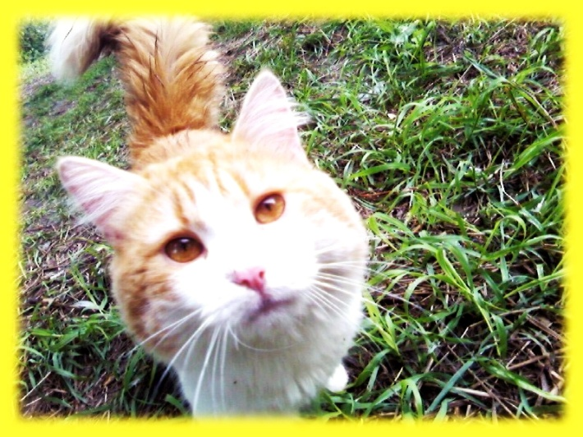

Фотографии из личного архива семьи Лавровых и использованы с разрешения родителей ученицы.

