My summer adventure
Автор: ученица 7к класса Климагина Ирина
Учитель: Ахмадеева Анна Петровна
Школа: МБОУ «Столбищенская СОШ»
Населённый пункт: село Столбище
Лаишевский район
Регион: Татарстан

My dear friend, I am sorry that you could not come to visit me during my summer holidays. We would have a great time with you. But do not worry, I'll try to describe you my summer adventures. I'll be your guide. You will not notice how you will turn up in the journey called "summer".
So, our first station is the camp "Star Troopers." This camp is located in Laishevsky area in the White Mountains (I was there with my friends). 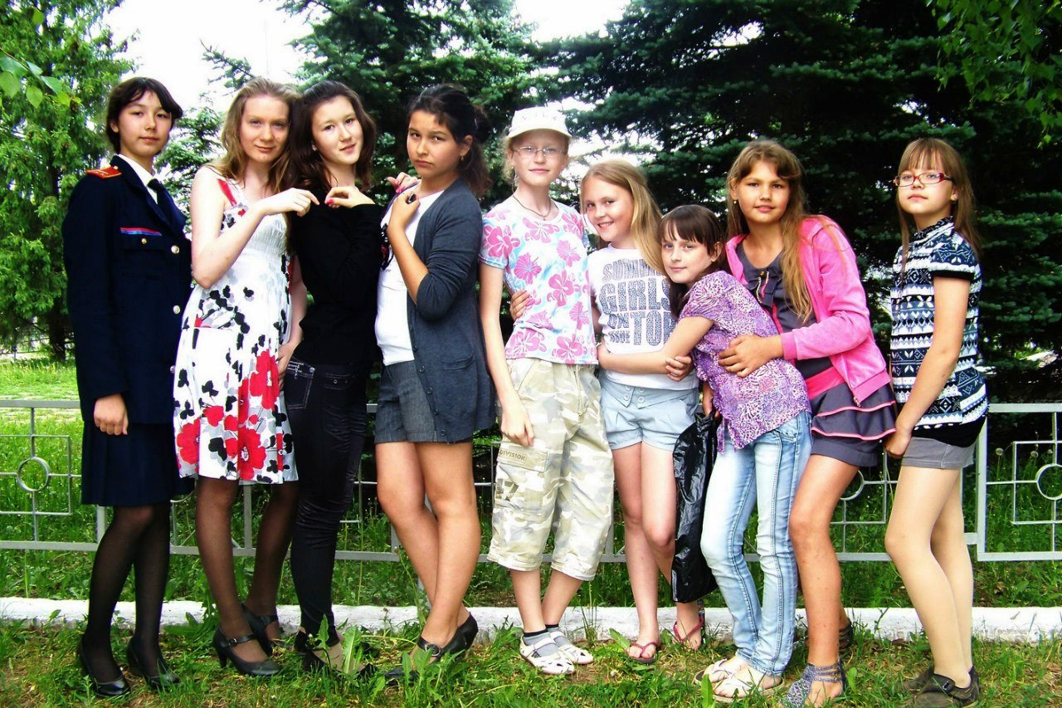
There have been a lot of fun (I'm sure you'd like it). Every day there were interesting competitions and events. KVN was where we just could not stop laughing at different kinds of jokes. Then there was a sports day (I know, you'd be thrilled); I was so tired that when I touched the head with a pillow I fell asleep. Neptune was also the day where we poured water from the river Kama on each other and threw water bombs. And then it little mushroom rained (it was bright sun), and we began to dance under the rain. As a result, in the sky there was a rainbow, my hair was ruined (I had to be seen at this moment), but I was satisfied and happy. In the camp we sang songs, assembled and disassembled machines (guns), made shows. At the disco there was great music, and we danced till we dropped. In the "Star", we always helped to cook: peeled potatoes, garlic, cut cabbage. But the most interesting thing was to go to the spring to fetch water. How beauty was there! Imagined the beautiful river Kama, its waves caressing the rocky shore, small but luxurious mountain of white clay (from there its name), like the wise old man towering over you. Clean, cool water flows out of the spring. 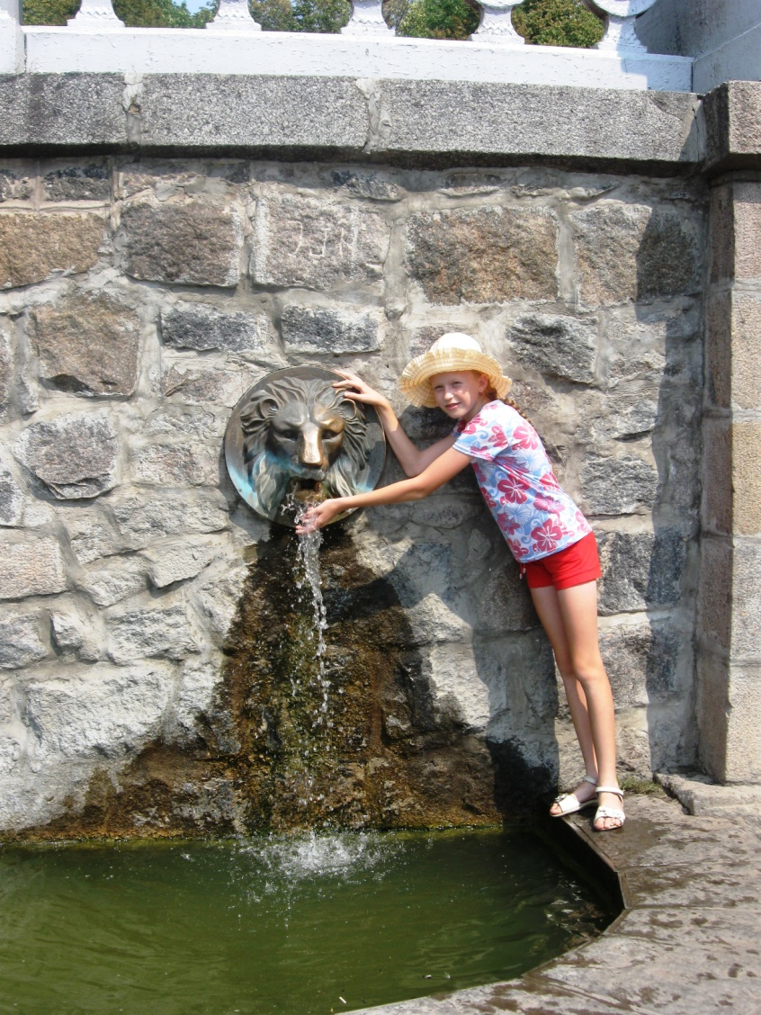
The beauty of beauty, but the descent was very steep. And I got sore knees. In the camp we went to the swimming pool where I learned to swim.
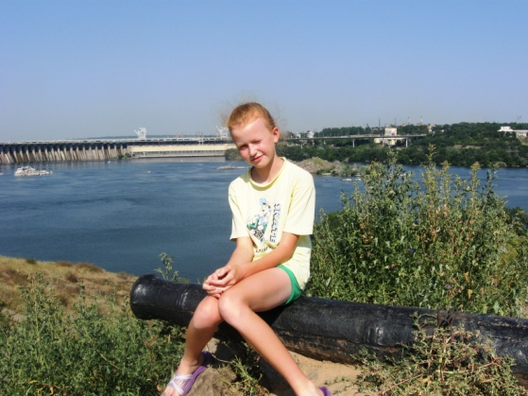
On the last day the disco was longer than usual. Then there was a fire and we sang songs with guitar and shared our impressions. Later the “royal night” (it's the last night in the camp, during which all children smear each other toothpaste). My friend and I promised that we would not sleep through the night. We woke up, of course, "on time." The whole camp was already up, and our arms, legs and face were in toothpaste (you can be happy that you were not with us at that moment).
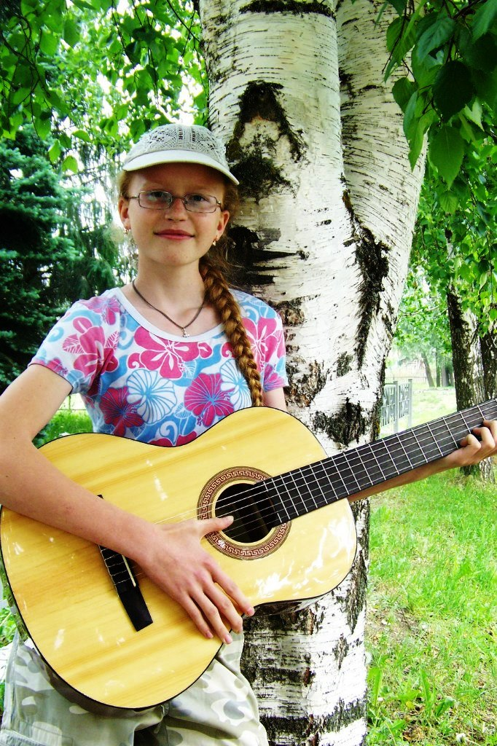
A few hours later my family patiently listened to me talking about my adventures in the camp. It was great! I found a lot of friends and learned a lot. It is a pity that the camp was only for a week.
How do you think about it? Do you like our journey? I hope so! So, our next stop, "St Sophia’s cathedral" in city Laishevo.
There was a festival of church music. My grandma and I went there. Oh, I'll never forget this day! Paintings in the church were very interesting. The icons were painted in the way that if you stand in different places of the church you can feel the views of holies. Even in ancient Russia was accepted to paint icons by this way. First it was held church public worship. All the people were praying, and that was as good and pure spirit in the temple! I've never been so relaxed. There was a feeling that all the problems and failures of life was there, at the door of the cathedral (you just imagine how beautiful it was!). Later the concert began. Choruses from all over Russia sang there. It was great (I was sorry that you did not hear it)!
And then, when we were driving home, my grandmother and others women in the bus sang Russian folk songs. I will always remember it.
Let's move on! I do not even know how to call the station. All I know is that here you have to meet my best friend Dasha (I'm sure you'll get along with her). The next part of the summer I spent with her.
I actually have a lot of friends. But my best and closest friend is Dasha. We made a lot of things together! We went fishing in the lake. We caught a few fish, but the cat was pleased. We went swimming, went to the movies, taught a language for deaf-and-dumb people, shot our own film, cycled, walked in the woods, draw, went on a flash-mob of zombies, went hiking, and even wrote a letter to the future.
And our next station is "Horse riding". We were there with my mother.
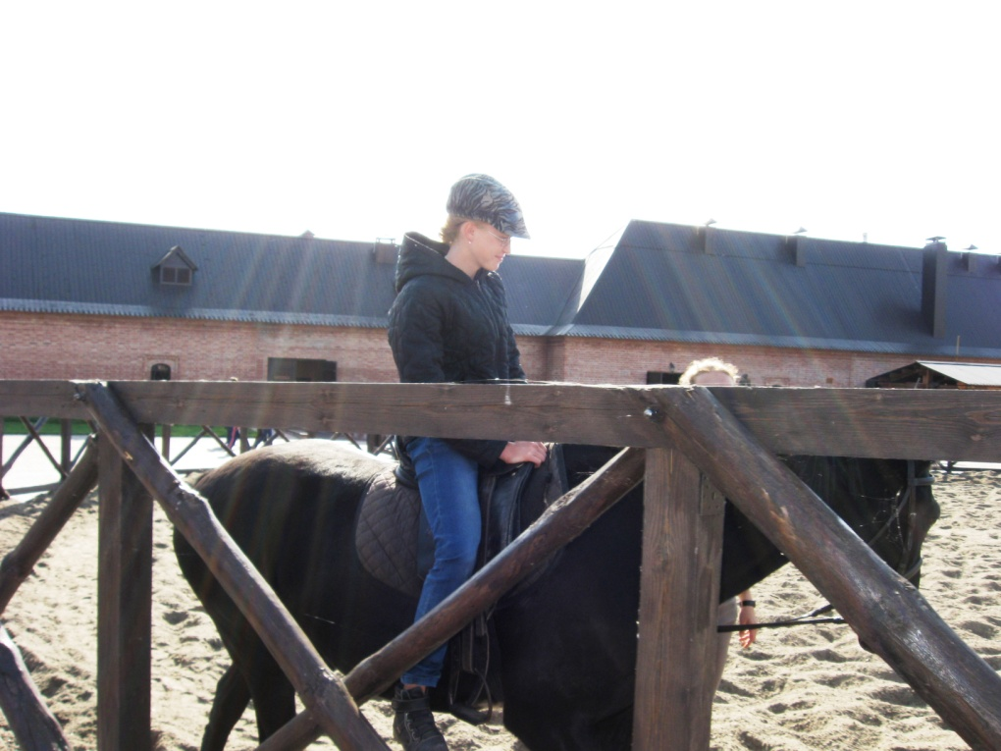
The first time I sat on the horse I was very scary but then I used to. My horse Thunder was very lively, and always pestered to the other horses. First, the road was wide but when we went down it was the path between the rocks and the canyons. But it was very beautiful. Just imagine rocks, huge trees, valley filled with water, a lot of strong and muscular horses! Once my horse suddenly ran, I felt myself like the "Great rider." We returned safely. I really enjoyed the trip!
We finish your way in the station, "The Forest". I went to the forest to pick mushrooms with my family. There were many mushrooms and we did not notice how we entered into the wilderness and found ourselves in the windbreak. It was really scary, we did not know the back way, and had to climb over fallen trees. We thought that we would never get out, but fortunately nothing happened, and we barely got out of there. We returned home with baskets full of mushrooms.
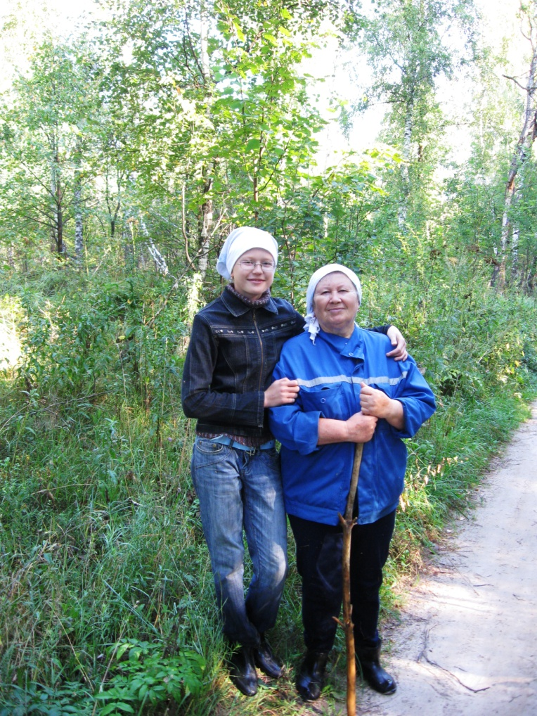
Well, our journey is over. Summer is a little life! I lived it well. I hope you enjoyed our journey.
Фотографии взяты из личного архива автора Климагиной Ирины с разрешения её родителей.

