« My Summer Adventure»
Автор: ученица 9а класса
Николаева Екатерина

Учитель: Тарасова Марина Владимировна

Школа: МБОУ СОШ с углубленным изучением отдельных предметов №2

Населенный пункт: г. Волжский

Регион: Волгоградская область

My name is Kate. I’m 15. No doubt all teenagers are fond of summer and adventure. I’m not an exception. I’d like to tell you about my summer adventure.
What a busy holiday I had! I was glad to be free from school, to have an opportunity to work and earn some money. So in June I deliver newspapers. July was quieter. I spent hours reading books, watching my favorites TV programs, swimming in the river. But in August I had a real adventure.
Our family has friends in London. So they invited my mother and me to spend a week there. We were going to stay at the hotel as we didn’t want to crowd the Swans. On August 7th we were on the board of a plane.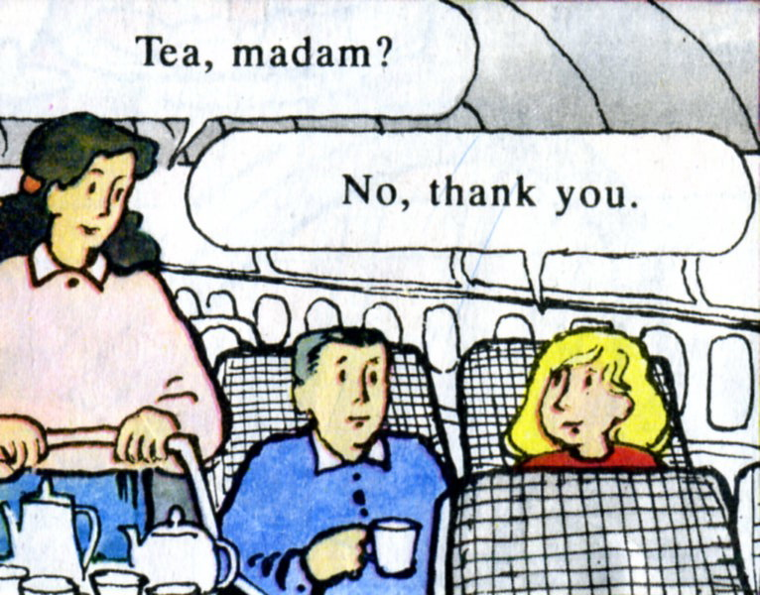
It’s the fastest way. It took us only three and a half hours to get to London. But it was expensive and Iwas proud that my salary came into useful.
Mr. Swan and his wife Susan met us in the airport and accompanied to the hotel. We left our luggage in the room, had some rest and went to the Swans. There I understood that everything was different from Russia!
The first surprise was in the bathroom. I saw two taps there, one for cold water and one for hot water. To wash my hands I had to mix the water in the basin. As for English food I didn’t really like it .Englishmen eat bread only with soup and never with meat and vegetables. They drink a lot of tea and have too much cheese during a day. Nevertheless it was interesting to learn about their traditions and culture.
Next day we went sightseeing.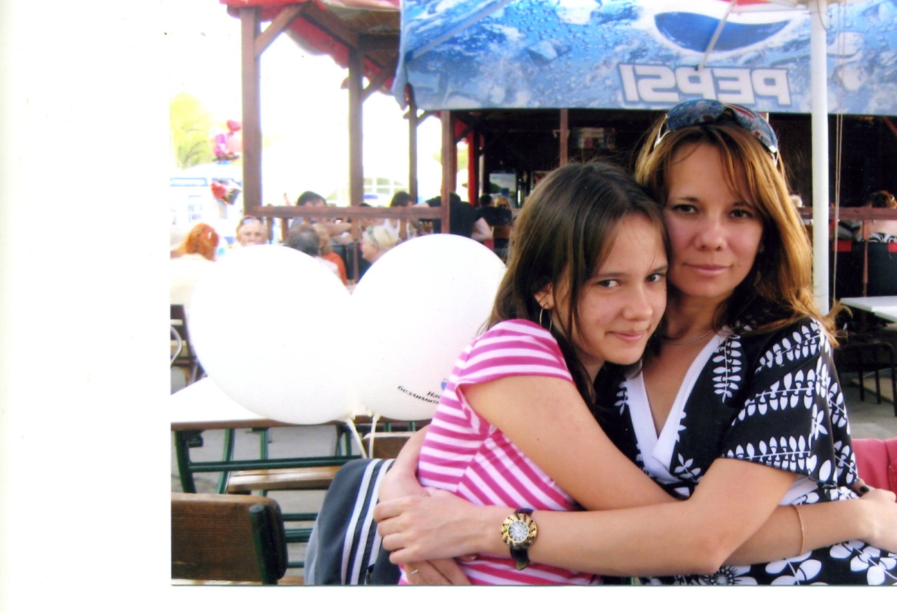
My mother and I were impressed by the most famous old buildings including Buckingham Palace, the Houses of Parliament, Westminster Abbey and the Tower of London.
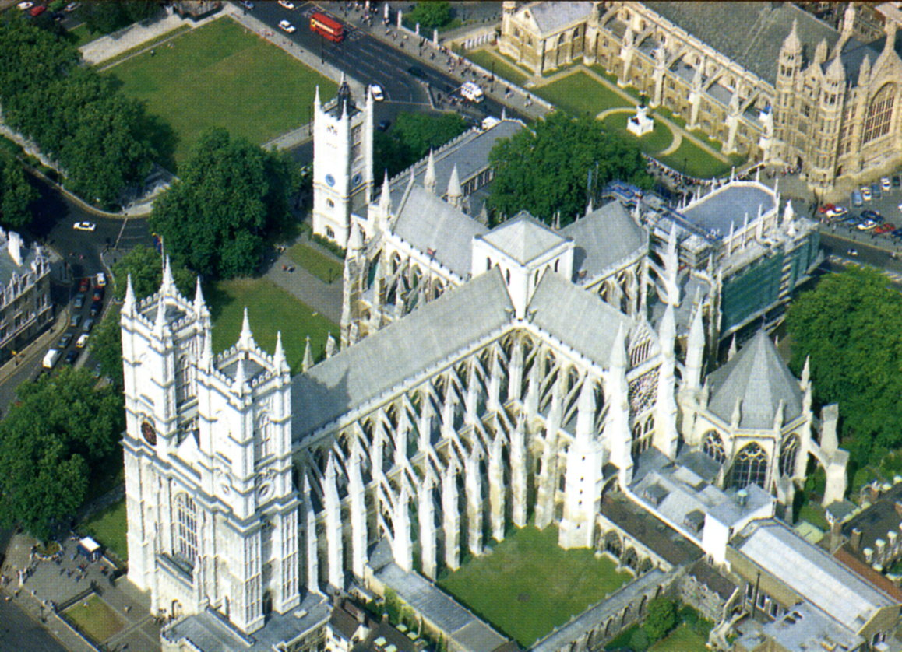
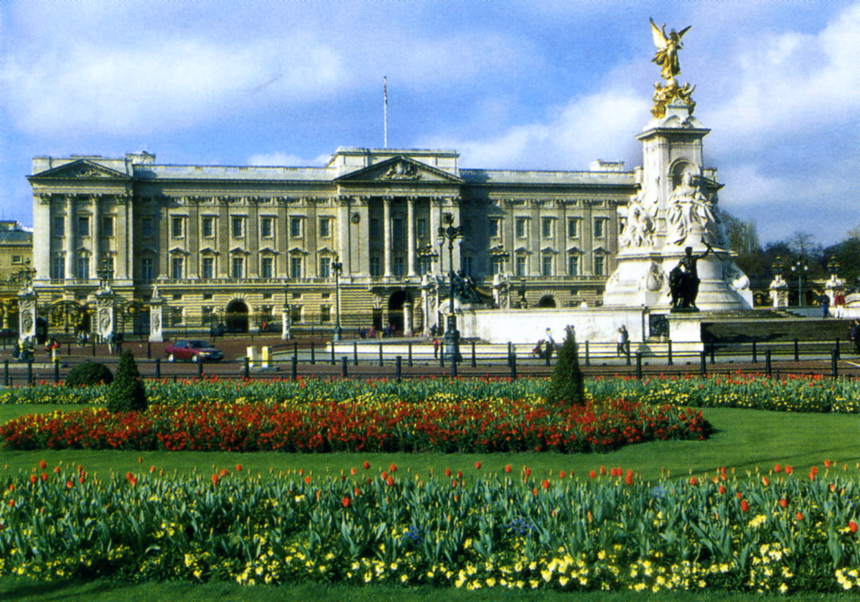
It was not a simple thing for us to cross the street, because the cars keep to the left not to the right as in Russia. Englishmen are naturally polite. They are never tired of saying «Thank you» and «I’m sorry». They wait quietly in lines and do not rush for seats in buses and trains.
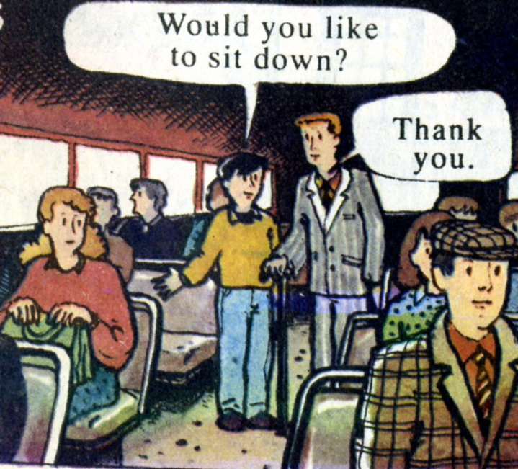
In the evening we returned to the hotel. There was one more surprise for us. The administrator invited my mum and me to the restaurant. There we saw a lot of guests who greeted us, gave some flowers and presents. The hall was decorated with balloons and posters.
.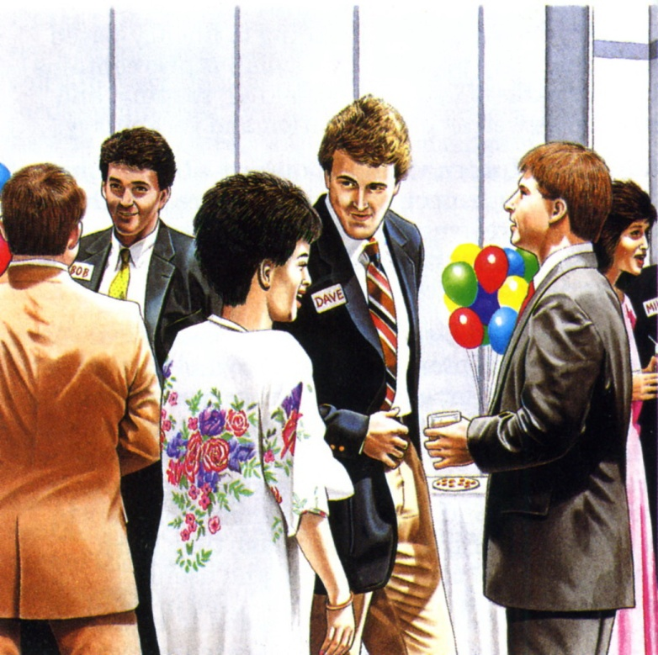
We couldn’t understand anything. But everything became clear in some minutes. Two women entered the restaurant. They looked like us, they were our twins! The guests sat in amazement. My mother and I were not the real authors of the celebration. The party was held for those young women from Italy. We were invited for that party again. Every day we met our twins, walked together and had a talk. Veronica and Sophia invited us to Italy next summer. It would be interesting to learn about Italian culture and their world famous cuisine.
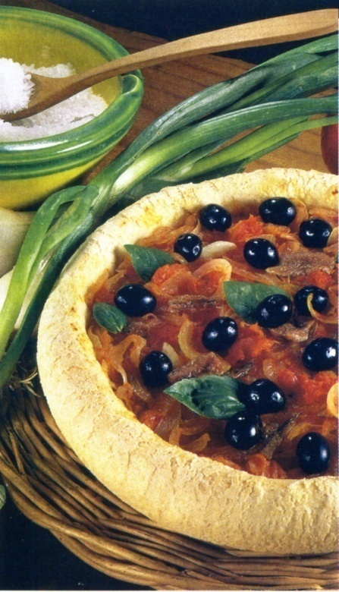
I’m sure that my summer adventure was unforgettable and fantastic. I’m looking forward to my next summer holidays.

В работе использованы фотографии из семейного архива Николаевых, размещаются с разрешения родителей участника конкурса, иллюстрации из учебника «Счастливый английский» Т.Б. Клементьева , Б.Монк, Москва, Просвещение 1994,из учебника «Interchange» Jack C. Richards,Cambridge University Press 1991

