“My Summer Adventure”

Автор: Терентьев Денис, ученик 9 класса
Учитель:Войцеховская Наталья Владимировна
Образовательное учреждение: МБОУ ДОД Североморский Дом детского творчества
Населенный пункт:г.Североморск
Регион: Мурманская область

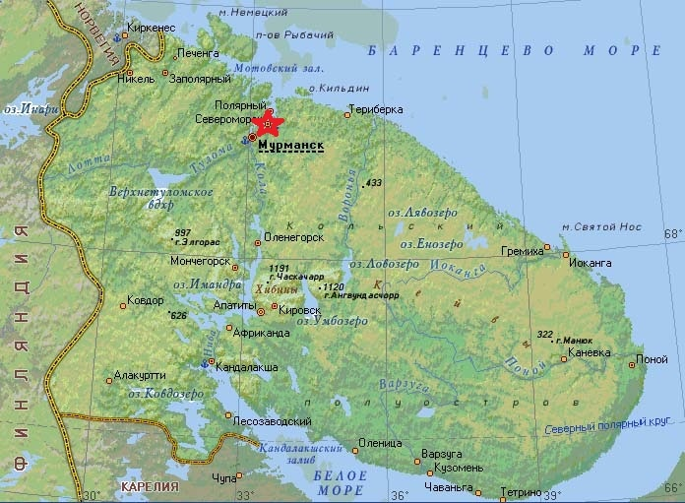

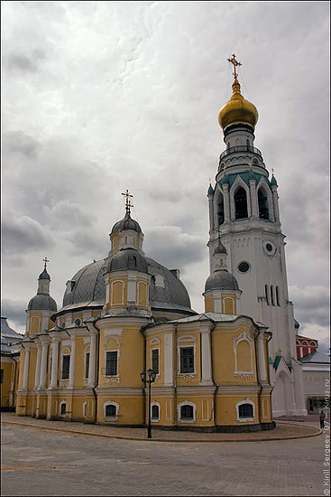
Many people go abroad or to the seaside on summer holidays. The place my family spend summer in is Vologda as my grandparents live in it.
Vologda is a very old city located on the Vologda River. There are a lot of attractions and each of them has its own history. My brother and I get acquainted with the most interesting ones every time we are in the city. The museum of local lore was the first place visited by us last summer. It is situated in Sophia Cathedral. I was greatly impressed by its big collection of stuffed animals and birds which live in this region while my brother was interested in ancient arms. A lot of beautiful icons and a big Vologda lace collection also attracted our attention. I was lucky to view the city from the biggest belfry and it was rather exciting. I will remember it forever, nothing can be compared with what I felt at that moment.
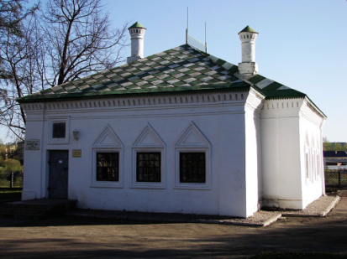
It’s the first time we have been to the House of Peter the Great which stands on the bank of the Vologda River. From the guide’s story we learned a lot about the city of that period.
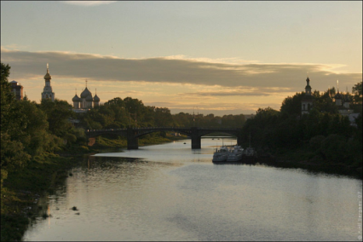
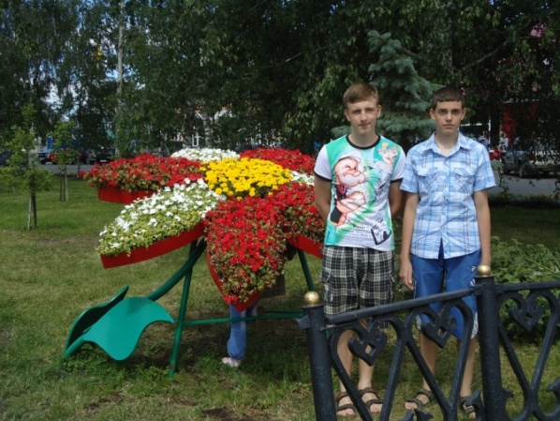
My family went on a boat trip along the river with great pleasure, and we enjoyed the beauty of coastal landscapes.
In modern world people often are in a hurry and do not have enough time to spend with their relatives that’s why there is misunderstanding between children and their parents. Poor relationship leads to problems in the family. Summer holidays give us a good opportunity to spend more time with our nearest and dearest, to share our interests and learn each other better. So, this summer we rather often went to the cinema together, ate delicious ice cream in a cafe, walked in different parks. It was pleasant to walk around the city as it was decorated with beds of flowers of different shapes. We could see a big ladybird, swans or many other things made from flowers! While having a walk we learned that some famous Russian writers and poets were born and worked in this beautiful city. One of them was Nikolay Rubtsov whose monument we visited.
My brother and I go in for basketball. We want to be healthy and strong. In summer we spent much time playing basketball with our new friends. It was very interesting and useful for us. Our basketball matches made my holidays unforgettable.
It goes without saying that we had to help our grandparents about the house and garden. We did it with pleasure because we knew that they needed our help. They were happy to watch us working in their garden.
Summer is over and we have come back to the town of Severomorsk. I miss my grandparents and friends. I am looking forward to next summer and I am sure next summer holidays will be as interesting and impressive as these ones.

Использовалась информация: http://www.kirus.ru/images/photography/places/vologda/vologda_church_5.jpg
http://ru.wikipedia.org/wiki/Файл:Domick_Petra_I_(Vologda).JPG
http://www.kirus.ru/images/photography/places/vologda/vologda_church_1.jpg
http://www.murmanskobl.ru/images/karta(6).jpg
Фото из личного архива. Фото детей размещены с согласия родителей.

