My Summer Adventures

Автор: ученица 9 класса Кабаргина Виктория
Учитель: Калинина Марина Валерьевна
Школа: МБОУ СОШ №5
Населенный пункт: г. Шахты
Регион: Ростовская область

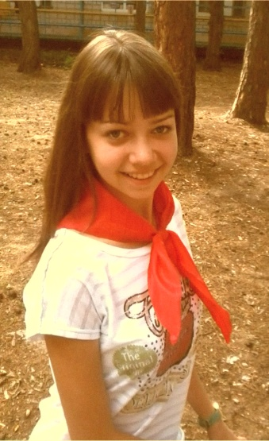
Hello! I am Vika Kabargina. And I am very glad I have a chance to tell you about my wonderful summer holidays.
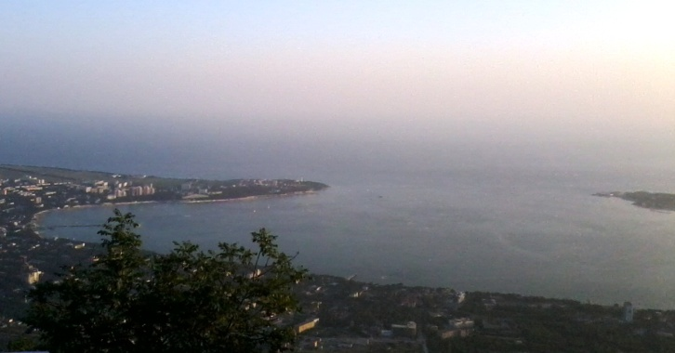
This summer my best friend and I went to a summer camp which is situated on the shore of the Black Sea. It was a great time! The weather was amazing. When we arrived, all children were divided into squads. We appeared to be in the largest one. We made friends with our squadmates very easily and quickly and met our squad leaders. They all turned out to be friendly, positive and cheerful people. Our life in the camp was great, full of interesting events, exciting competitions and entertainments. We were never bored. Every day we went to the beach to have a swim. Our leaders were very invetive and offered us contests, games and festivals which the squad won more often than others. And of course every day we had dances with cool music. So we had a wonderful time but there was one night I will never forget.
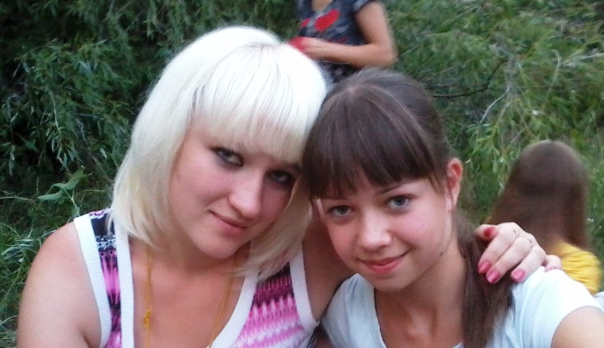
One day we came to our leaders and told them we wanted to go to the beach at night. They told us it was forbidden and they would never let us go there. We were disappointed but could not object to the rules. Several days later the leaders decided to surprise us. When the dances were over and we were about to go to bed, they came to our room and told us to get ready. “Where to?” we asked. “To the beach,” they whispered. “But keep quiet,” warned the leaders. “Nobody should know about it.”
We were so excited that it was almost impossible to stay calm. Soon they peeped into our room and told us that the only way out was through the window as the guard in the hall was on duty. Our room was on the ground floor, so for us it was not a problem. When we were outside we saw other guys of the squad. Some minutes later we were on the beach! We had such a great time there! We swam, had fun, sang song by the bonfire and admired the moonpath on the sea. It was very romantic! But then the leaders called us to come back to the camp because it was 4 a.m. already!
We returned the same way we had gone out. In spite of being rather tired by impressions, nobody went to sleep that night. We were chatting about those unforgettable hours on the sea shore.
That was the most exciting adventure of my life! I will never forget our camp and this summer!

В работе использованы фотографии из архива семьи Кабаргиных. Фотографии несовершеннолетнего публикуются с разрешения родителей.

