“My Summer Adventure”
Автор: ученица 8 класса Усманова Диляра.
Учитель: Укулекова Татьяна Рахимовна.
Школа: МБОУ СОШ №27
Населённый пункт: г.Астрахань.
Регион: Астраханская область.

“My Summer Adventure”
I want to tell you how I spent the summer .My name i s Dilyara.
I'll remember this summer for a long time. From my child hood I wanted to visit St. Petersburg, the second capital of our country Russia and my parents decided to send me to camp "Scarlet Sails" in St. Petersburg.
I don’t like travelling, but this trip liked very much, because I visited many interesting places, parks, museums and saw many sights of city.
When we arrived in St. Petersburg, where it was pretty cool, as compared with the Astrakhan climate. On the first day we were settled in our room and started to settle.
The next day we met with the teachers and children with our floor. From the first day I had a friend his name is Vyacheslav he has dark hair, brown eyes and a strong character. He has a sister, her name is Lily. The most interesting thing is they are twins, they are very similar in appearance. But they are quite different in nature. For example, he is mysterious boy, calm, friendly, smart and beautiful ,but I can not say about Lily. Although, of course she is also smart, beautiful, friendly, but unlike her brother, she is more optimistic.
The next day we made friends with neighbors on the floor and we went to inspect the camp. While we looked around the camp, we met a lot of nice and friendly children. I met many children from different cities and different ages of ten and sixteen.
During breakfast, the dining room was like an anthill ,because it was crowd and noisy .Children spoken ,laughed loudly and discussed their problems.
I liked dishes in this camp: specially soft rolls. What I was very surprised.
After breakfast we go for a walk in the garden.
There are many children in the playground of different ages. Someone was playing with a ball, someone was playing hopscotch, and teens were in a small group and discussed their arrival at the camp.

Then we returned to our room to preparing for a trip to the park, we visited a beautiful park,the most interesting is that there were beautiful flowers I had never seen in our Astrakhan. There we had a lot of fun time walking in the park. We took photos . After, we went back to camp. All the way, we had fun and bullies in the bus, and when we returned to the building, we were so tired and went to sleep. In the evening, we got up and went to canteen; as usual there were lots of people.
The next day we visited the Museum of Zoology. Museum collection is constantly updated with exhibits representing expeditions. The total exhibition area of more than 6 thousand square meters.
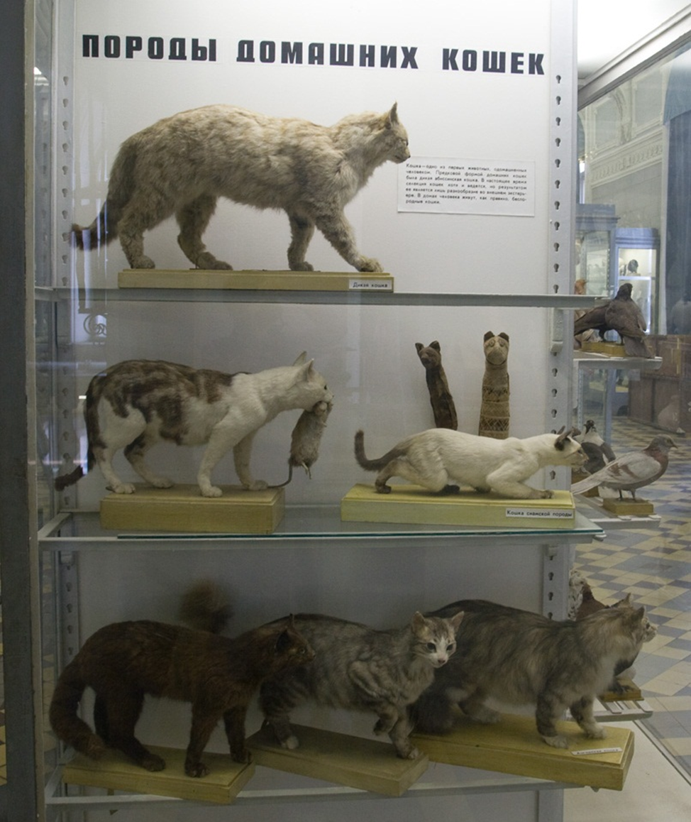
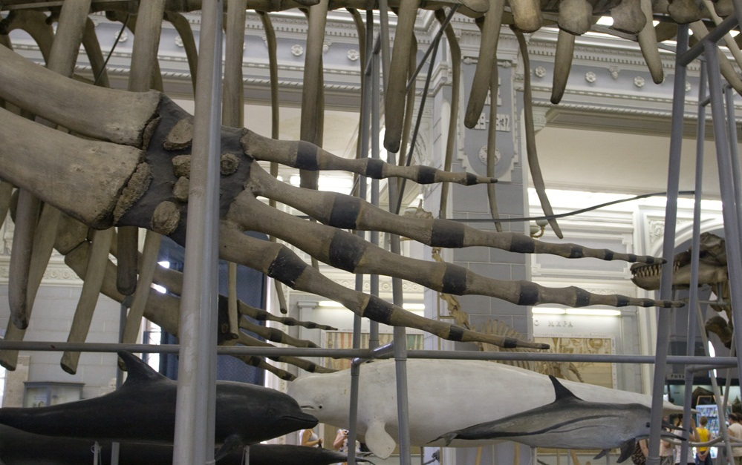
Now on display exhibits more than 30 thousand species of animals.
In addition, the fund’s total about 15 million copies of the fauna. The exhibition is organized in a systematic way. Here you can see all kinds of animals - from the simplest to the primates. There are exhibits represent the theory of Darwinian evolution.
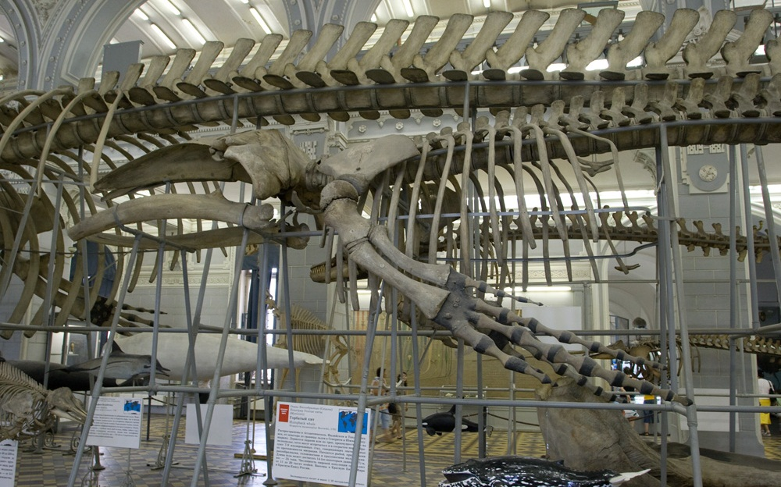
When we came from tour, we were under the impression of what happened. We loved this museum, there are a lot of unusual items, and some items even frightened me.
The days passed quickly, so the teacher decided to make us a fun day. We acted out scenes from the movie "Enchanted." I played the role of an enchanted princess, and Lily played the role of the magician. The most interesting part and the most interesting costume had Slava, he was knight who saved me. I loved this day. Scene was small, but a lot of emotion and excitement!

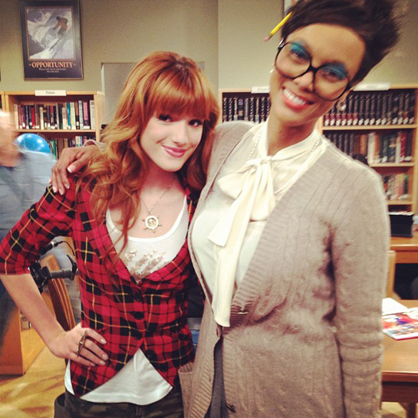

I would like to tell you about the monument, which heard all the Monument to Peter-I-"The Bronze Horseman."
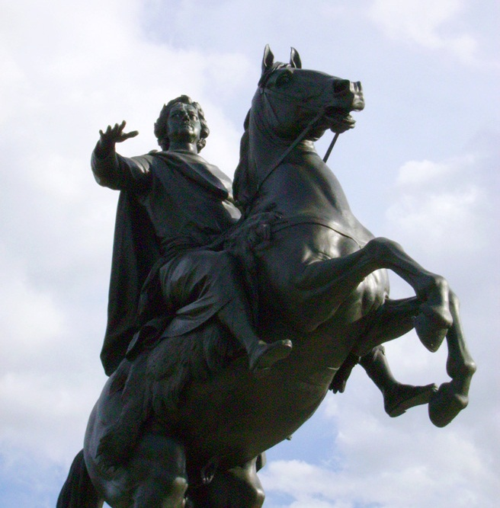

This monument is located on the Senate Square. This monument was great and even a bit frightened me.
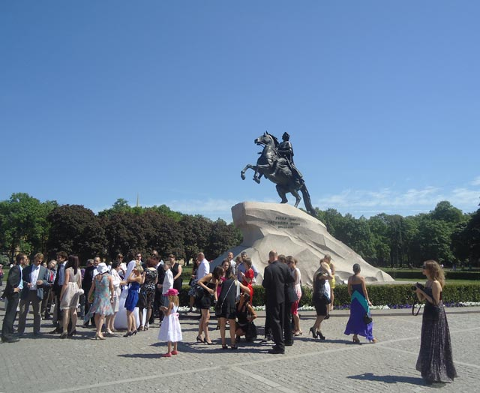
The area was quite large; it was for so many people, the outskirts of the square decorated with green bushes in the form of a low wall. A little walked and played on the square, we headed back to camp.
The next day we went to the Mariinsky Theatre. Mariinsky Theatre specializes in classical art - ballet and opera. In this theater of St. Petersburg associated with the names of outstanding ballerina Maya Plisetskaya (and now teaches) and conductor Valery Gergiev (gives concerts and now). Performances are held in two buildings. The seats on the balconies, especially on the third level, are wooden benches with numbers that are painted with oil paint on the back.

The next day we visited the Palace Bridge - adjustable cast-iron bridge over the Grand River Neva in St. Petersburg. Connects the central part of the city (Admiralty Island) and Vasilievsky Island. Named in honor of the Winter Palace of the Russian emperors. Everyone knows that in St. Petersburg White Nights. When we returned in the evening with Excursions, it was already 7:00 pm, and there was light, as four in the afternoon.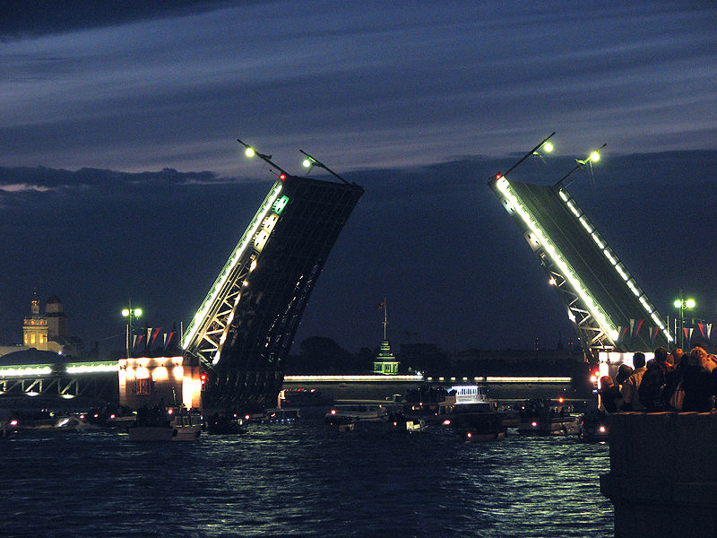
The next day we went to the Hermitage is one of the most famous museums not only in St. Petersburg, but also throughout the world. Currently, the museum has a collection of more than 3 million items. This is primarily paintings and sculpture, applied art, and other works of art. If we consider every item one minute, it would take eight years to see the whole collection. For inspection of all exposures to walk 20 miles.

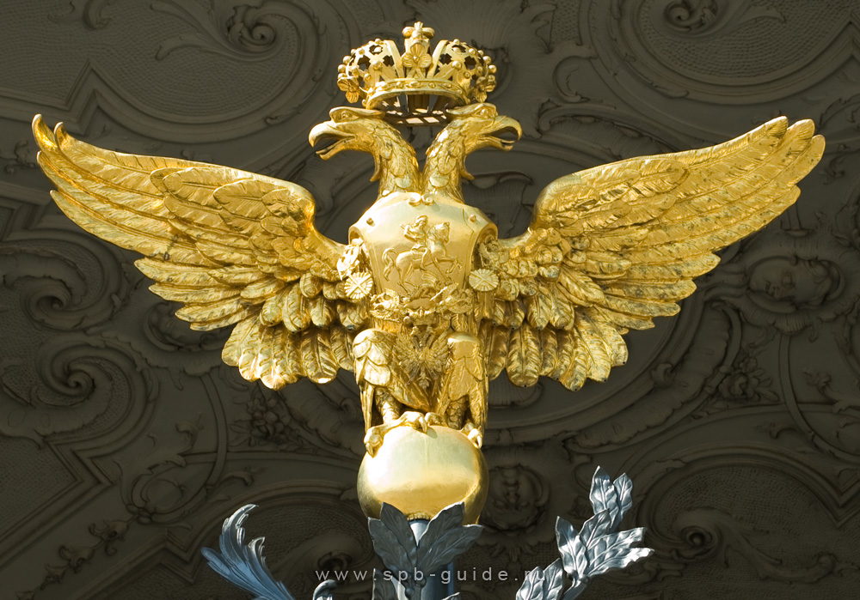

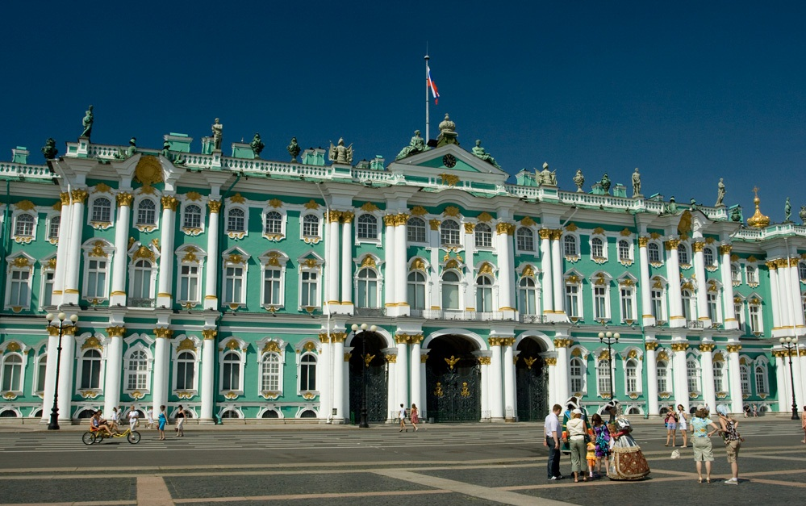

It is so interesting we had our fun, carefree and exciting days. Most do not like the fact that the children in the camp were friendly and kind. I enjoyed the evening, when we were watching TV and playing different games. Of all the sites I liked more the Hermitage. Next summer I'd like to spend in the camp "Scarlet Sails" with Lily and Vyacheslav.

Ресурсы
Фотографии из личного архива семьи Усмановых.
Фотографии несовершеннолетнего публикуются с согласия родителей.

