My summer adventure
Автор: ученица 8а класса Кабаева Марина
Учитель: Певнева Лариса Николаевна
Школа: МБОУ «СОШ №2»
Населённый пункт: поселок Чернянка
Регион: Белгородская область

Hi, my name is Marina Kabaeva . Summer is my favourite season. Every child could say this. It’s time for adventure, travelling and rest. I have my secret diary where I write about all events in my life. If you read it you’ll know about all my summer adventures in this year.
Saturday June 2, 2012
My mother, my father and I went to my granny to the country. I had a lot of friends there. I’m looking forward to meeting with them. My granny made a strawberry pie. It was very delicious. We had tea, talked a lot and I went to see my friends.
Friday June 8, 2012
My friends and I decided to go to the river. It was fantastic. We swam and sunbathed. The water was warm. Then we rode a bike, play volleyball, went to the Kholky underground monastery and caves .Its history comes back to the 11th century. They say that some monks made some caves in the chalk hill not far from our town. They lived there and prayed. It’s a Saint place. A guide made an excursion for us. It was interesting and informative for me because I like History. It’s my favourite school subject. I’m very proud of this historic place.
Wednesday June 26, 2012
Today I helped my granny and grandpa about the house. We planted flowers, watered them, weeded the garden, mowed the long grass. It was a hard work, but the flowerbeds became wonderful and splendid. We were glad to see the result of our work.
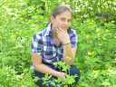
Friday July 6, 2012
My parents took a month’s holiday and we went to have a rest to the South together. We went to the Crimea. Black sea! How I liked it! It was the most unforgettable moment of my holidays. This day we went to the sea by car. I liked to travel by car. We could see different places through the window. We could stop at any time and had a little picnic, took some photos.
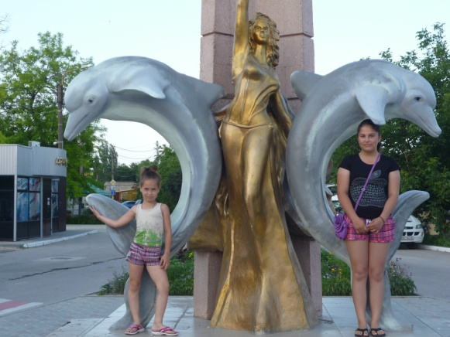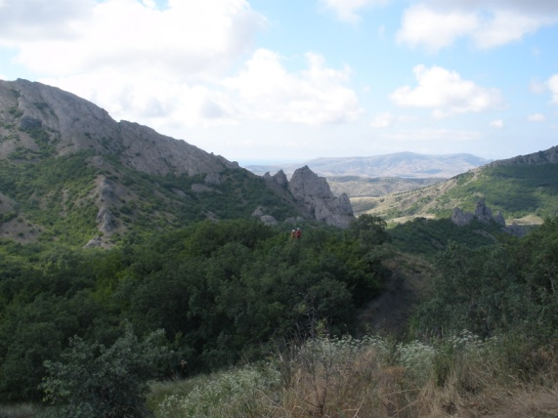
Saturday July 7, 2012.
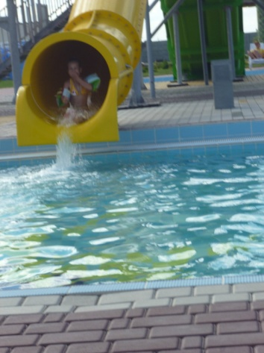
We arrived. We lived in a little hotel on the beach of the Black sea. We swam, sunbathed, rode a catamaran, a motorbike. After lunch we went to the aqua park. There were many attractions there. I adore attractions. We had a good time. The day was full of impressions.

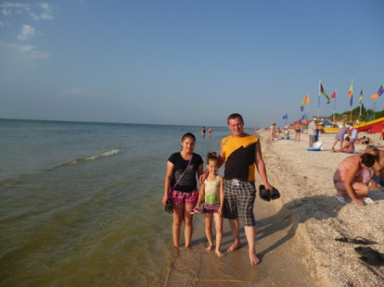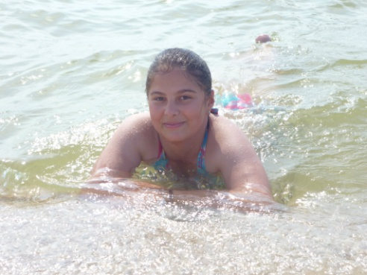
Tuesday July 10, 2012
Today we went to excursion. It was named the Golden ring of the Crimea. We visited the Crimea for the second time and this place impressed me very much because every town or village is connected with the history of our two countries: Russia and the Ukraine. We visited well-known church in Faros,powerfull waterfall “Ou-Chan-Su” ,the splendid sea-front inYalta, and the famous Russian tsar residence “Massandra Palace”. We could see so many places in one day!
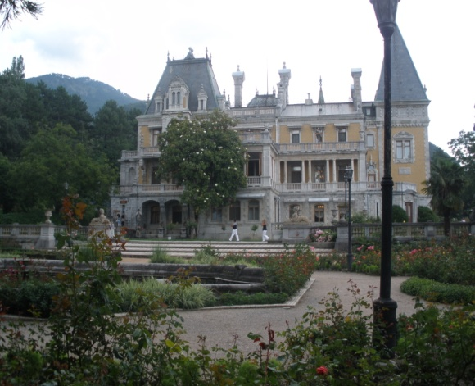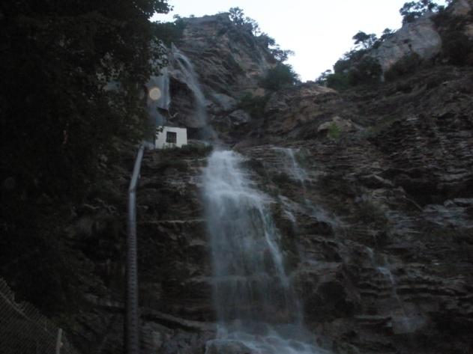
We were tired a little but enjoyed.
Sunday July 15,2012
We went home. Our travelling was finished. But I was not sad because I had missed my home, my grandparents, and my friends.
August, 2012
I spent last month of my holidays at home. I read books, play with my friends and prepared for school.
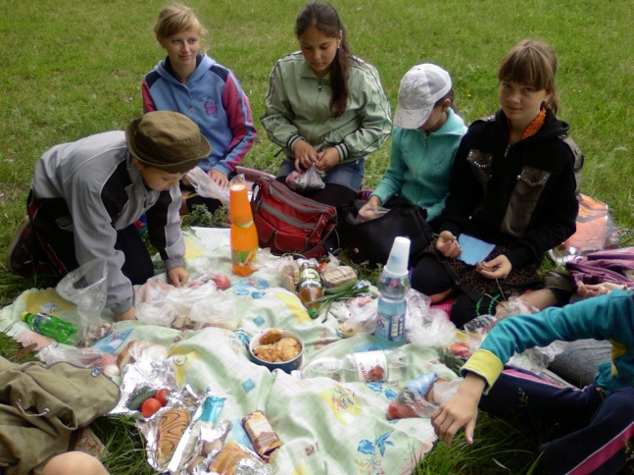
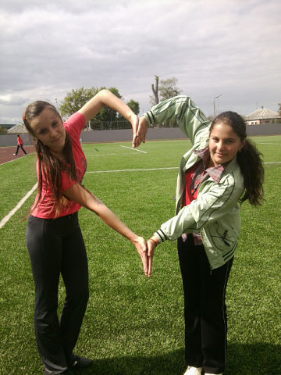
On Sundays we went on a picnic. It was fun to make a fire and cook meals near the river. We took long walks. We watched insects, birds’ nests, picked flowers and gathered mushrooms. It was great. So, I spent my holidays very well and had a good rest!

Фотографии взяты из личного архива автора Кабаевой Марины с согласия родителей.

