“My Summer Adventure”

Автор: ученица 11 «б» класса Комарова Елена
Учитель: Минайченко Мария Сергеевна
Школа: МБОУ СОШ №6
Населенный пункт: городской округ Красноуральск
Регион: Свердловская область

2012

A

lot of people think that the most pleasant season is summer, because it is the best time for travelling. I think so too. I always look forward to my summer holidays, and I am sure, travelling is the best way to spend your free time. It is always interesting to discover new things, different ways of life, to try different food, to make new friends. Every trip is a small adventure.
This summer I was lucky to take part in the international project "We are children of one planet". The main aim of this project was to develop the communication between two countries: Germany and Russia! Last year our German friends visited us! This summer we went abroad!
They met us at the airport in Berlin with love and warmth! It seemed to me there was no the year dividing us. At the beginning of our trip we stayed in a hotel but in three days we were invited to live in German families.
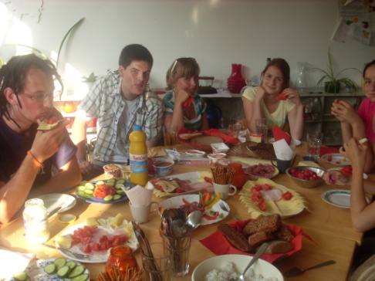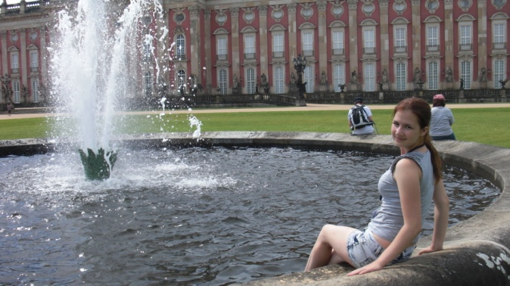
Our "mother‘s" name was Andrea. When I saw her it seemed to me that we were familiar for a long time. Her husband was very hospitable and friendly. They had a daughter Torah and a son Pete, but he spent his holidays in the camp and was not at home at that moment.
On the one hand it was wonderful to make new friends, but on the other hand there were some problems with understanding each other. For the most part we spoke English. But sometimes we tried to chat Russian and German. Our excursions were also conducted in three languages.
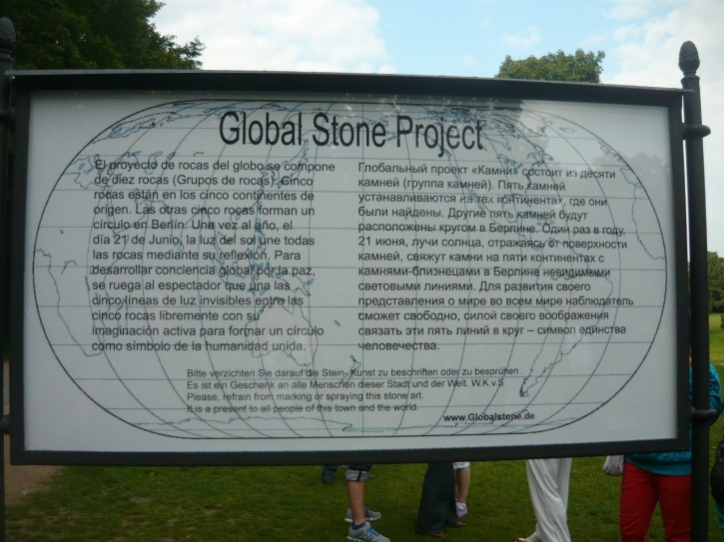

We visited Tiergarten - the Berlin zoo and the largest park and a variety of public monuments, the Brandenburg Gate - a symbol of reunion of the country and the part of Berlin Wall, the huge Victory Column.
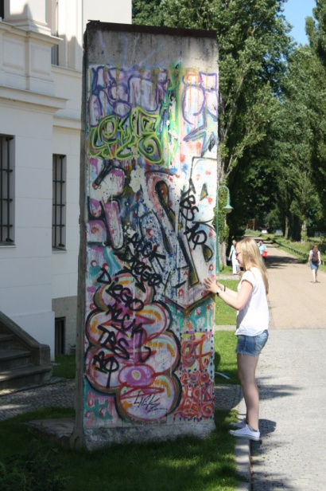
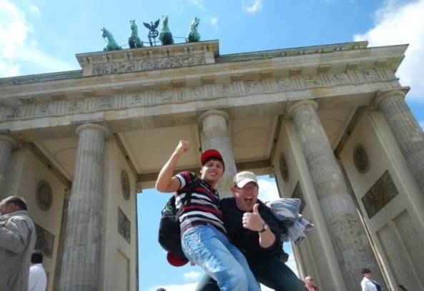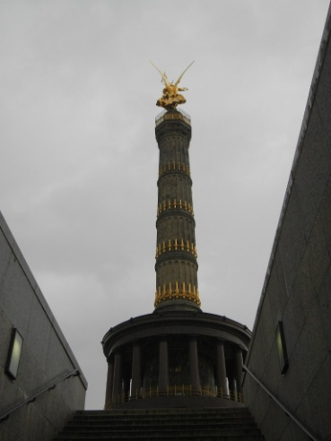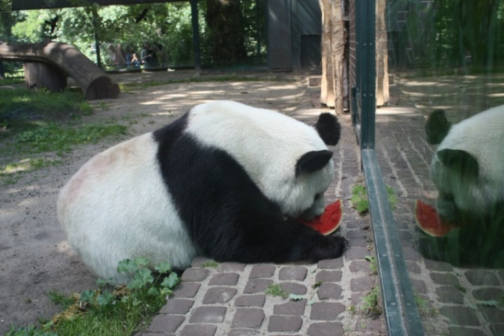

In the evenings we enjoyed walking along the streets. I noticed that the people living there do not pay attention how they look like, they do not care for fashion. Once we were at station waiting for a bus, it rained and a car sprinkled me. I was dumbfounded but Robert, my new German friend, said:"Oh, it is the Berlin fashion".
Our next destination was Potsdam, where we were lucky to visit Palace San Sushi and admire its beautiful sculptures, fountains and parks.
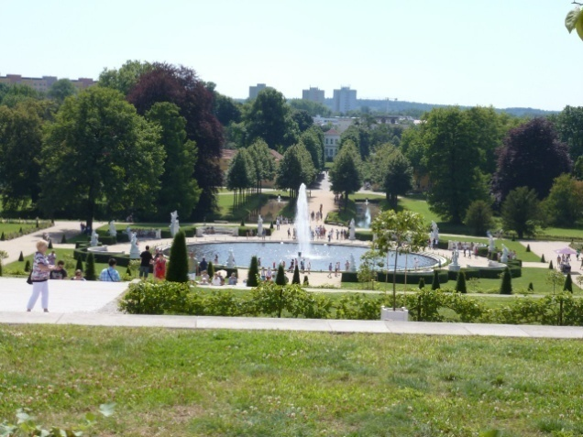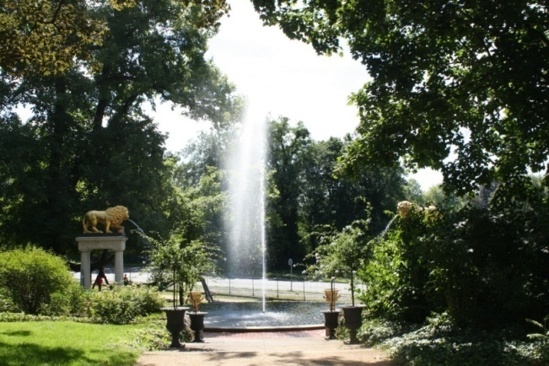
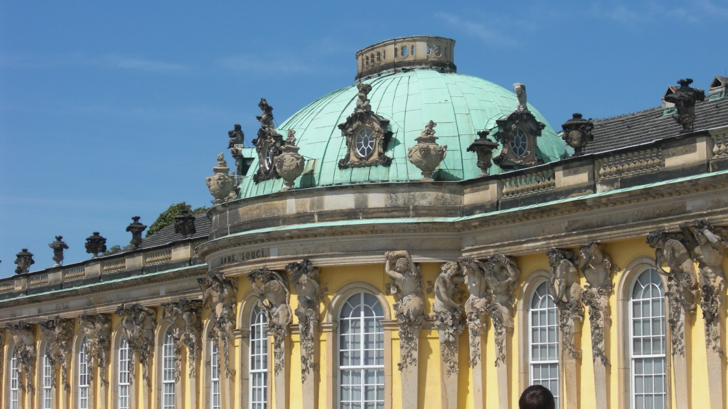

This summer was the best in my life! For the first time in my life I travelled by the plane! For the first time I went abroad! I learned a lot of words and expressions and tried to communicate with Torah in German.
I understood there: it does not matter how you look like, personal characteristics are of great importance. This summer trip was a real and unforgettable adventure in my life and I hope we will meet with our new friends next year again.

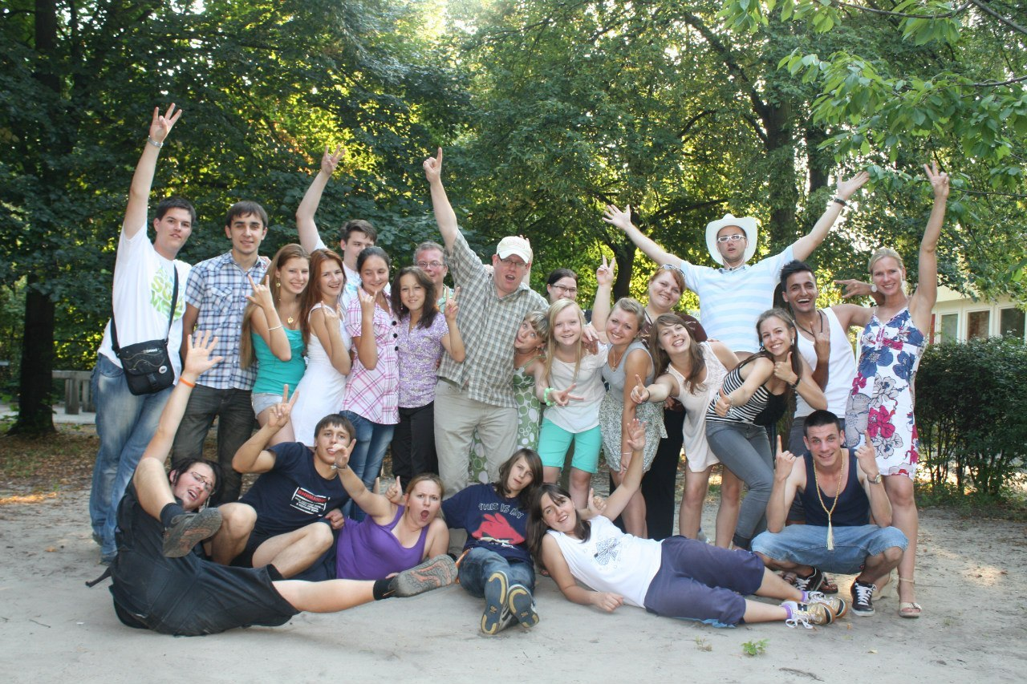

The end.

В работе использованы фотографии из личного архива семьи Комаровых.
Фотографии несовершеннолетней размещаются с разрешения родителей.

