My summer adventure

Автор: ученик 7-а класса: Дмитриев Илья

Учитель: Никифорова Елена Борисовна

Школа: МОУ АСОШ №2

г. Андреаполь

Тверская область

My Summer Adventure
Oh, summer… I love you. It is the best season I know. It gives me a chance to have a lot of fun.
This summer I had many adventures. But I want to tell everybody about an incident we can’t forget and often remember about it even now.

It happened when my cousins as usual came to stay with us in July. They come to see us every summer to take a breath of fresh air, to run along the streets, to play around with a ball. Things that for us living in small provincial towns or in the countryside seem ordinary are new and interesting for those who live in big cities. City dwellers often can’t afford doing such things as catching up with each other, rolling about in the grass fancying they are fighters or just playing outdoor games.

It was a usual summer day. My brothers and I thought of what to do that afternoon. So we decided to go to the yard to play hide – and – seek. A city child certainly hasn’t got so many places to hide in the apartment that’s why it is a very important and pleasant occupation for children in the country.

Our family lives in a cottage, big and cosy. Around the cottage you can see a garden with fruit trees and flowers, a kitchen garden and of course there is a lot of place where it is possible to play hi de –and- seek.
We chose a “water” and scattered in all directions trying to find a secure place. I found a nice place to hide. It was just behind a big bush growing in the backyard. I sat down and prepared to stay there for a long time as I was sure nobody could find me.
And suddenly …in the grass behind me someone rustled and started to move. I was terribly frightened and ran away home with wild shouts . At home I began to tell about a
monster that was over there just behind the bush.

I was sure it was a real monster. One of those I often see in the cartoons. Everybody got interested in my story. But I think they didn’t believe me.
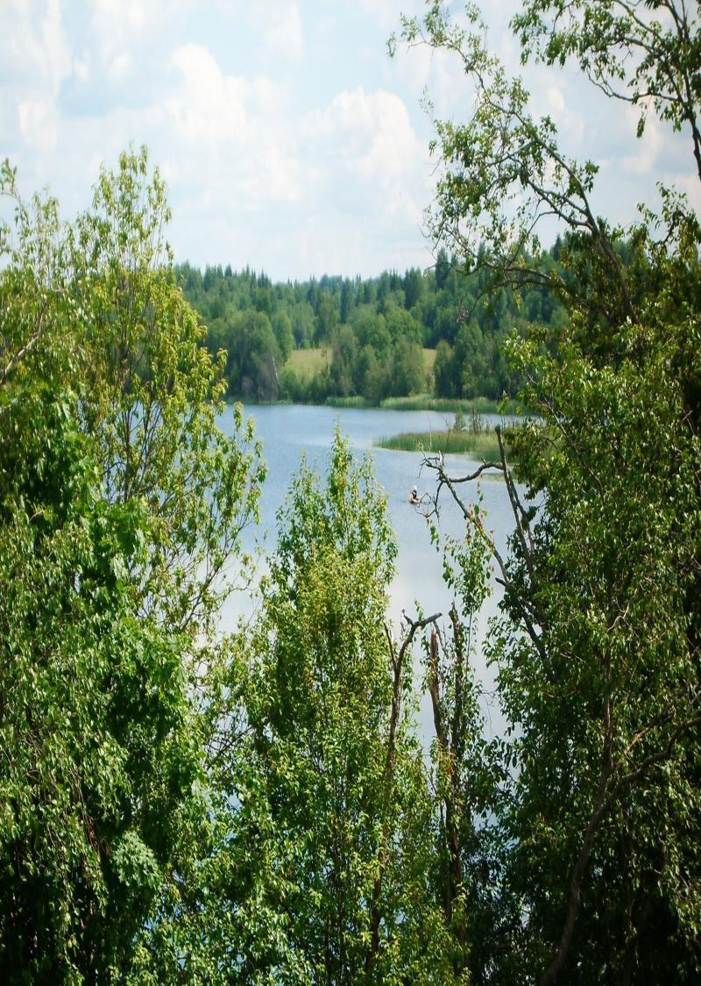
Next day we went to that place to find out how the monster looked like. We took Jack with us. Jack is my shaggy friend. It often gives me a helping hand. Jack jumped up and then aside, he smelt for a moment and began to bark loudly. When we pulled the grass apart, we saw …oh, my God… the most ordinary hedgehog!
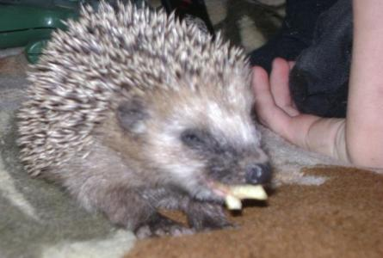
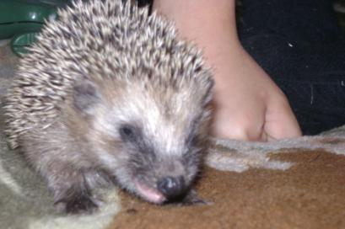
The hedgehog didn’t ran away. It turned out to be brave and sniffed all the time. At first it turned into a ball. But animals can feel danger. The hedgehog understood that we didn’t mean to hurt it. It showed us its paws and even allowed to stroke.
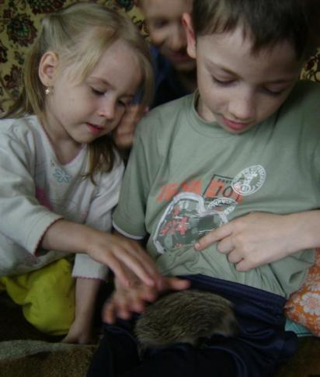
I saw a real hedgehog for the first time in my life. I was amazed at its paws. They are very strong, with big claws and very- very warm. Its small eyes looked like small buttons. They watched us with curiosity and apparently smiled. I was surprised at its nose. It was like plush toys had, but only real, very soft and warm. We began to watch the hedgehog. We put it on the ground and saw where it would run.
It was a female hedgehog with 6 baby animals. They followed their mother and it was very funny . We fed them for a long time and watched them growing. We poured some milk into the saucer and they drank it with pleasure.
It is great that animals are not afraid to live next to a person.
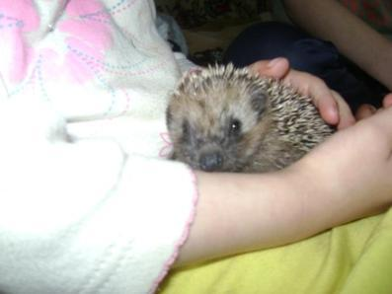

Фото из личного архива семьи Дмитриевых. Публикуются с разрешения родителей несовершеннолетнего

