“My Summer Adventure”

Автор: ученик 9-А класса Хохлов Кирилл
Учитель: Логвинова Кристина Александровна
Школа: МБОУ СОШ №1 города Дятьково, Брянской области
Населенный пункт: город Дятьково
Регион: Брянская область

My summer adventure
In our time life is not so interesting and exciting as it can be. My parents go to work 5 times a week. I go to school. A lot of time we lead in our city. Every year I wait for summer holidays with impatience! I always hope that I will have interesting adventures.
This summer I have spent unusually. In June my class- mates and I helped to repair our school. We brought out chairs, tables, played football at school, ate in our canteen. Canteen’s food was tasty. We had fruits every day! It’s cool to be with friends so long time and without homework.
My really adventures began in July. My parents have bought a sanatorium voucher to Turkey. The lack of our family is to do everything at the last moment! We packed our suitcases last day and left my diving mask at home. I was angry. At last we were in the airport. When I travel by plane, I don’t spent a lot of time going from one place to another. It’s very comfortable. After 3 hours our family was in Turkey. Our bus to our hotel was with minicomputers in the sits. It was great!

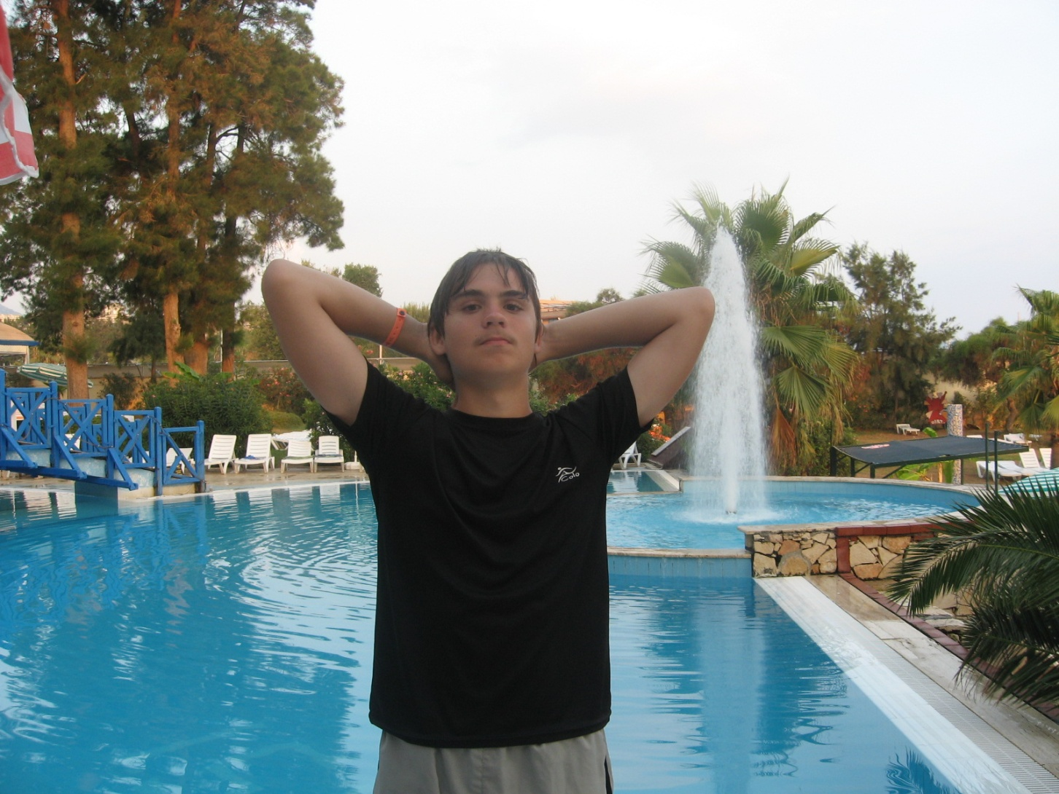

Our hotel worked according to the system of “all inclusive”. The most important thing was smorgasbord. It was an occasion for my stomach: bottles of Fanta and Cola, ice –creams, sweets. To my mind sea was clean and warm. It was pleasant to watch the waves. The fishes swam through my feet and I caught them with a plastic bag. I liked to ride the water slides. Our hotel had three big water slides. The sunrise and the sunset were unforgettable. In Turkey we visited a wine factory ( My parents tasted wine and I tasted pomegranate juice) and textile mill. But the most interesting trip was in Constantinople.
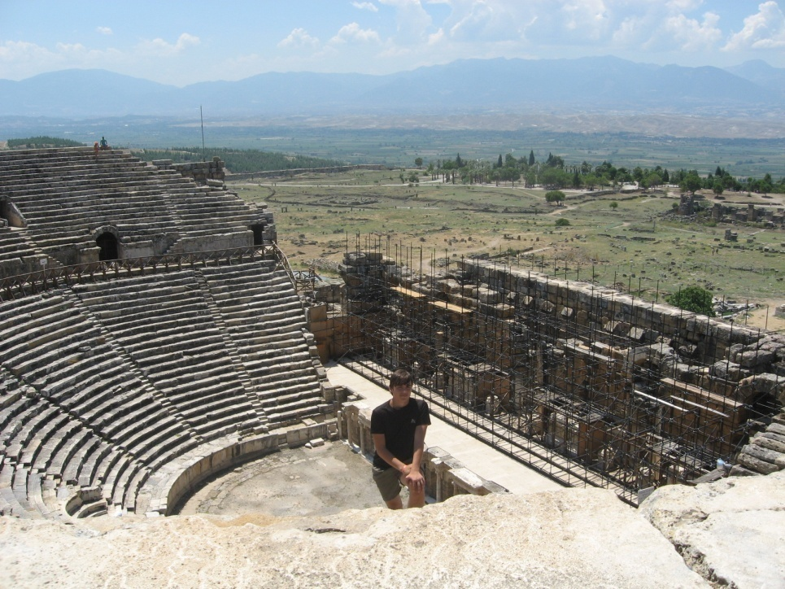

I was in the amphitheatre.
There was Pamukkale not far from Constantinople. It is a natural monument of calcium mountains. I ventured to take a bath in calcium lakes. It was exciting! The temperature was 40 degrees above zero. It was usual for Turks, but wasn’t for me!
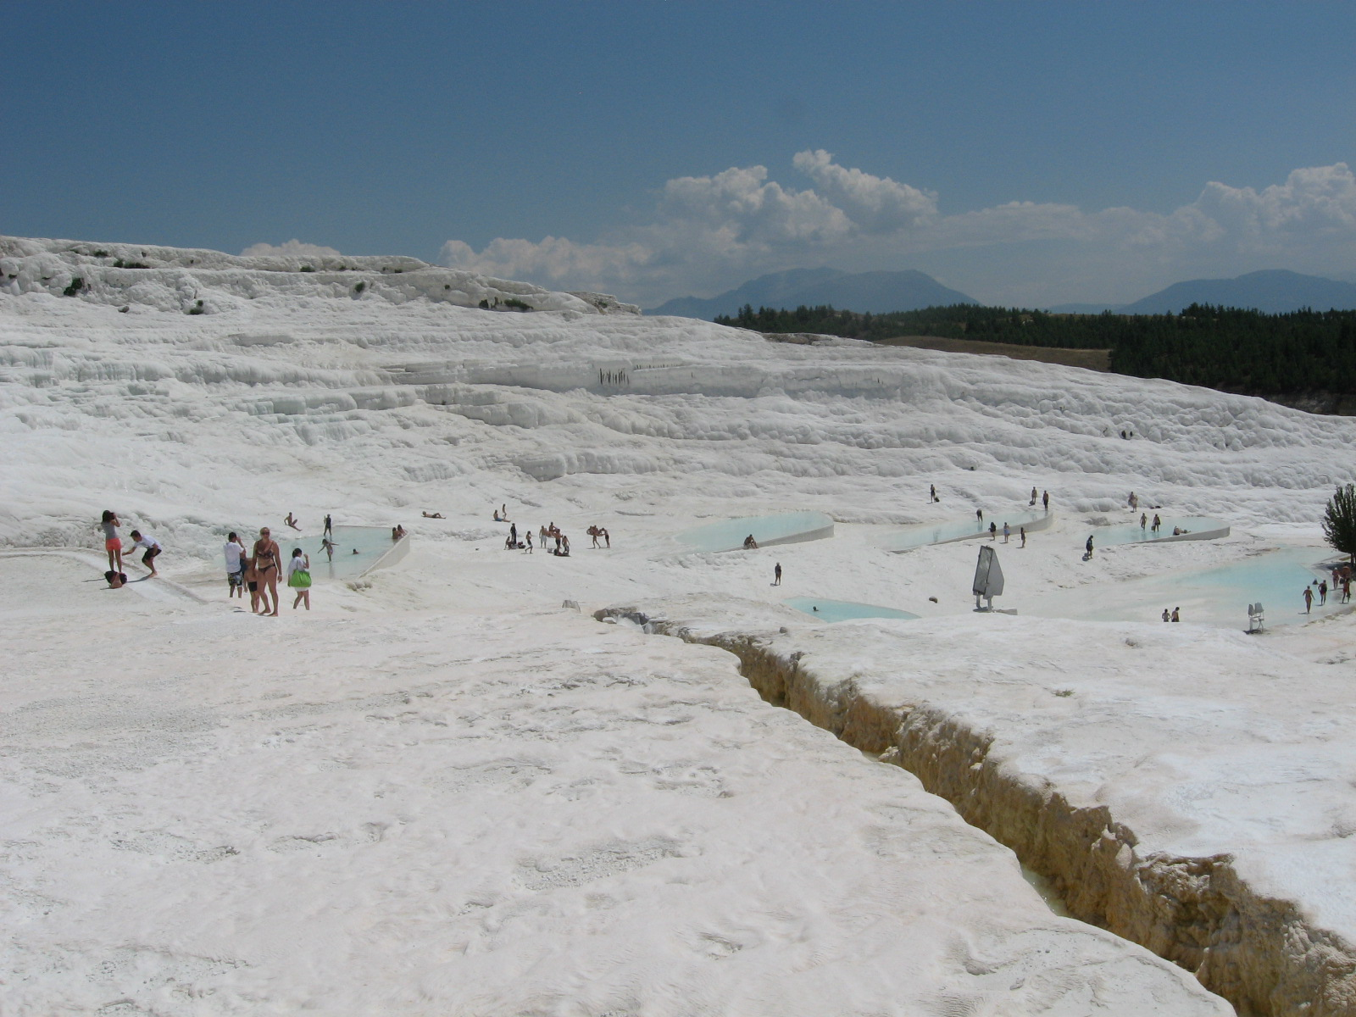

From Turkey I came back happy, sunburnt and with a lot of photos.
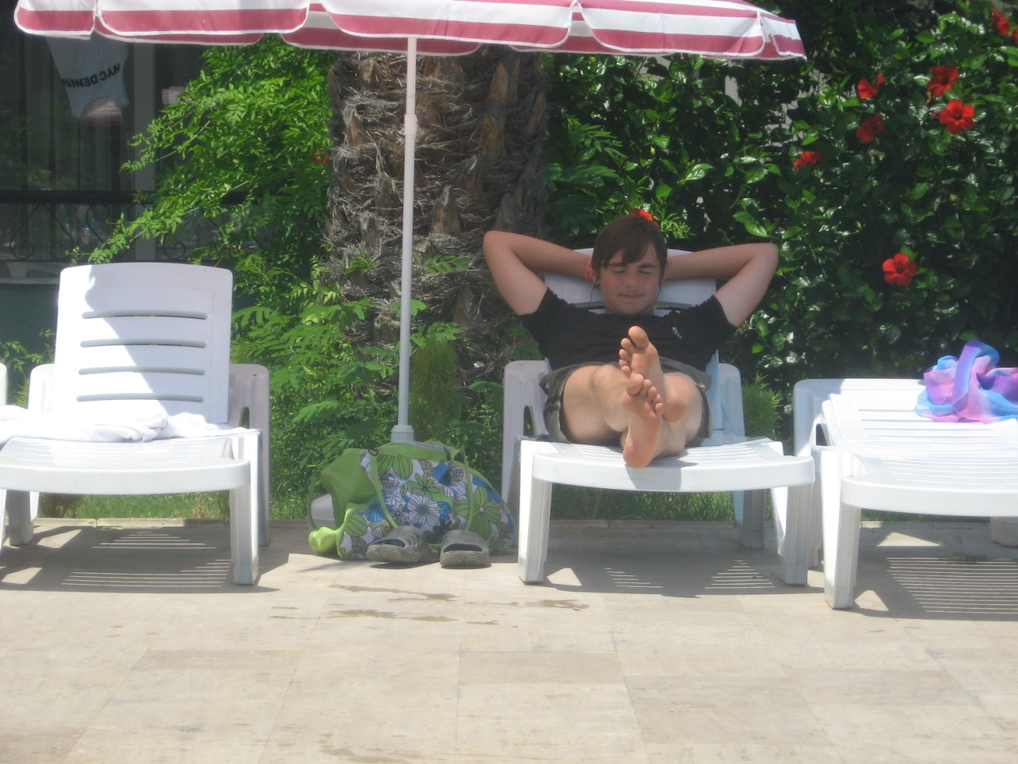
In August I slept and played computer games, went to the river. On the 27th of August I dug potatoes by my granny and went fishing with my father. My take was a big carp.
I had a rest and am ready to go to school now!

Все фотографии взяты из личного архива семьи Хохловых. Фотографии несовершеннолетнего публикуются с согласия родителей.

