“My Summer Adventure”

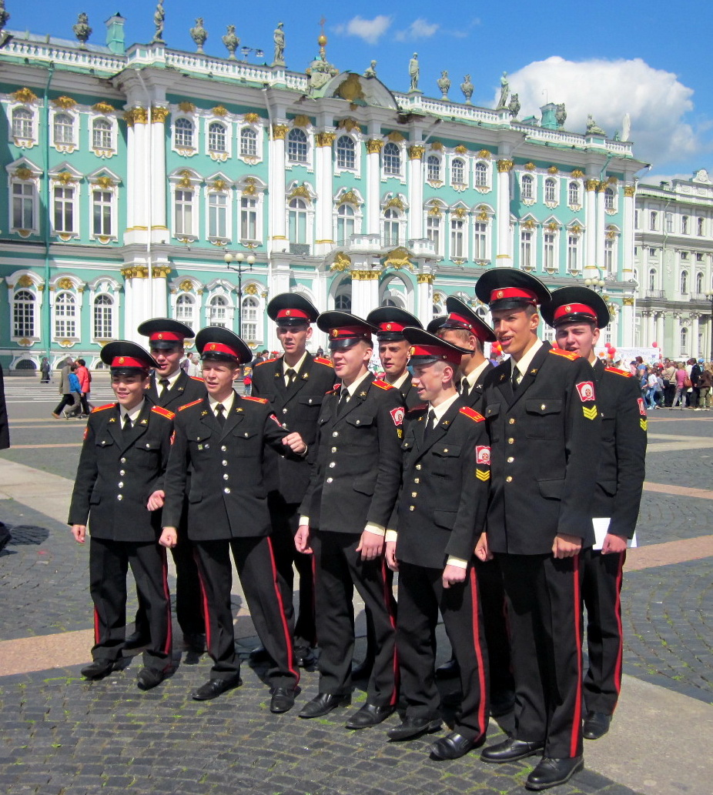

Автор: ученик 11 класса Дмитрий Романовский
Учитель: Наумова Татьяна Владимировна
Школа: Санкт-Петербургский кадетский корпус МО РФ
Населенный пункт: г.Санкт-Петербург

I will never forget this summer. I spent much time in the State Hermitage. The history guards keep their secrets there. This summer they revealed their secrets to me. It was a real adventure.
I study at the Saint-Petersburg cadet corps, which is located in Petergof. Every year cadets of the tenth form attend summer school groups. There were twenty summer school projects for us this year. Each cadet could choose one of the groups to join. The groups studied various subjects and had their own plans. It was not easy for me to make a choice. I wanted to gain experience that would help me in the future to overcome difficulties in my big adventure called life. At last my choice fell on the group «Cadets at the Hermitage volunteer service». I had never been a volunteer before. It seemed to be interesting.

The State Hermitage is one of the greatest museums in the world. Its collection is numbering about 3,000,000 items. They are pieces of art and culture of Antiquity, Western Europe, Oriental countries and Russia. The museum occupies five buildings. The most famous of them is the Winter Palace, built by the architect Rastrelli in the eighteenth century. It was there that our summer school took place.
Summer School 2012 Integrated Project
"Cadets at the Hermitage Volunteer Service "

Summer School 2012 Integrated Project
"Cadets at the Hermitage Volunteer Service "

Summer School 2012 Integrated Project
"Cadets at the Hermitage Volunteer Service "

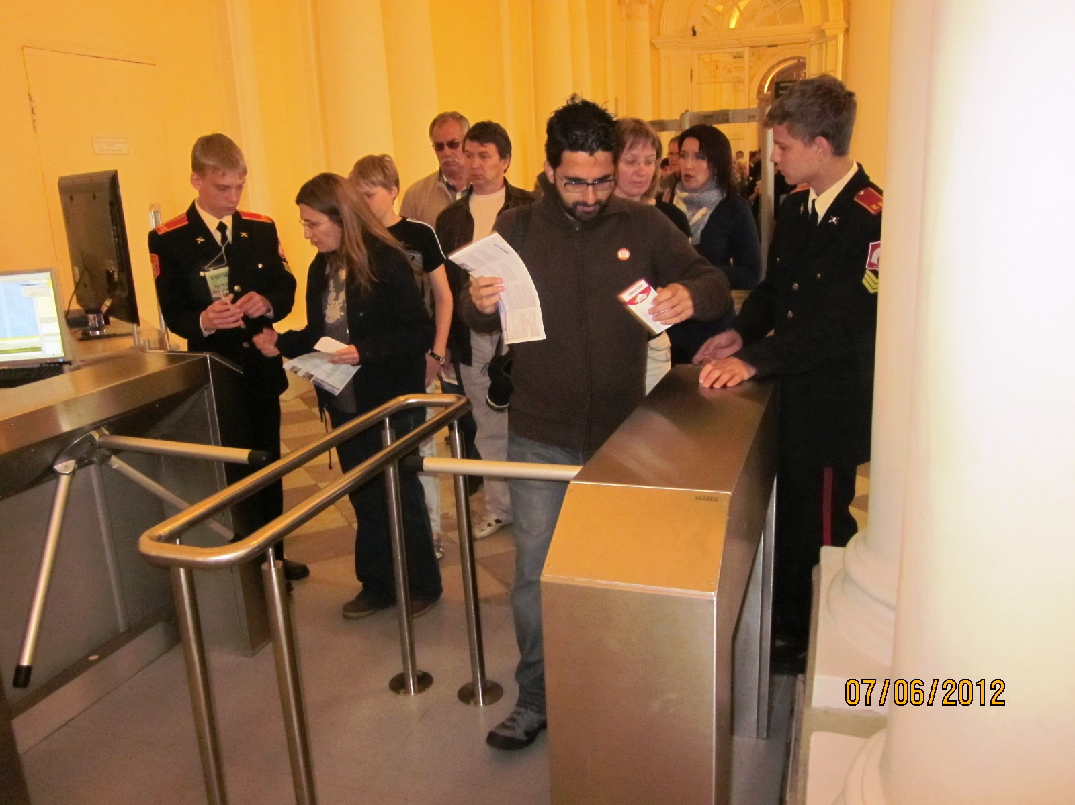
I admired the Winter Palace state rooms decorated with the massive columns and gold-plated pedestals, ceilings with skillful carving and pictures of nymphs. I saw a lot of various statues and vases in the halls. It seemed to me that I could look at them for hours. My favourite place in the Hermitage was the Military Gallery of 1812 – the memorial to the military glory of Russia. I peered into the faces of the heroes on the portraits.

During the summer practice I managed to visit the State Hermitage Depository “Staraya Derevnya” equipped with the latest technology. The depository had been opened for visitors in 2004. I saw a collection of furniture, collection of carriages and other exhibits which had been unavailable to the public for a long time. There I took part in the international conference «Virtual Museums». The language of the conference was English. How did it happen that I took part in the conference? I was one of the volunteers at the State Hermitage volunteer service.

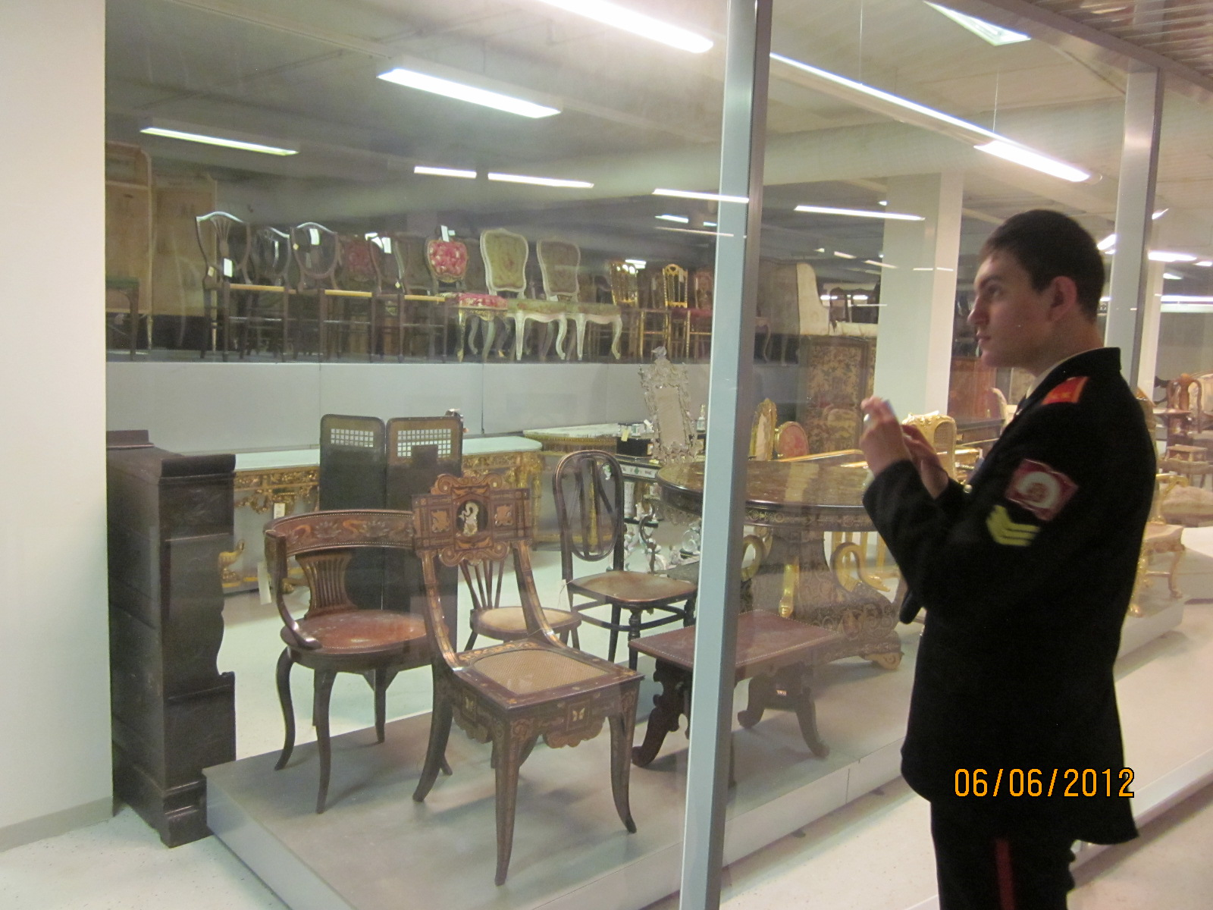

I had never heard about such service before. It turned to be very useful. Volunteer Service is free voluntary activities for the benefit of society. The principle mission of the Volunteer Service in the State Hermitage is to acquaint people with the cultural heritage of the Hermitage’s international collections. We greeted visitors of the museum in the entrance hall. Here we explained the rules of the museum to the quests as well as provided information about the museum’s collection and temporary exhibitions. Our task was welcoming and checking tickets, assisting Hermitage visitors to the cloakrooms and helping visitors with limited abilities. There are special wheelchairs for disabled persons in the Main Vestibule.

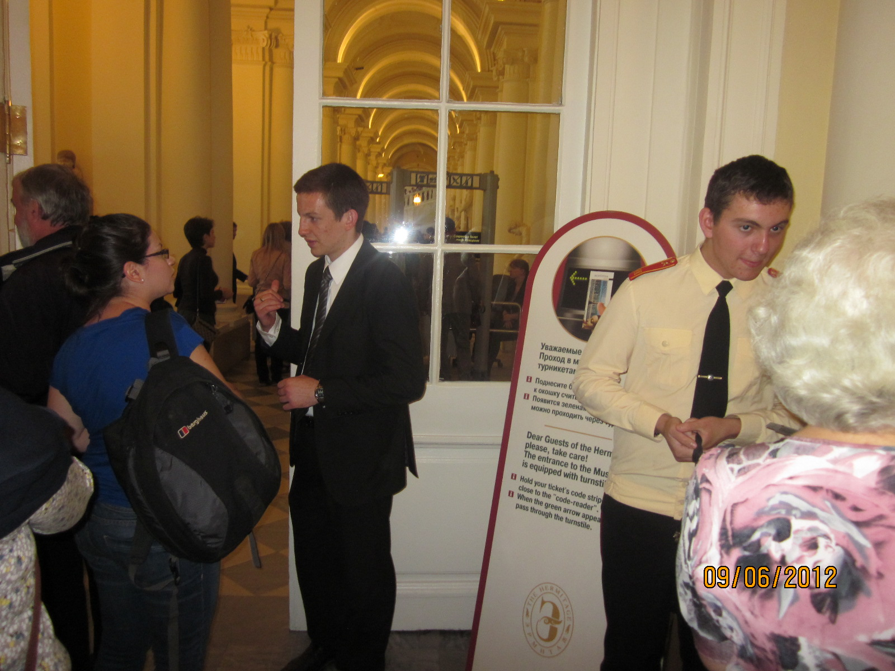

Volunteers, working at the Hermitage, were from different countries, such as Germany, France, the USA, Italy and Finland. All of them spoke English as a second language. Most of the volunteers didn’t understand Russian. We worked in a team and had to communicate. It was not easy for me to overcome the language barrier but I did it. I understood that it was very useful to master my English not only at the lessons at school but talking to the English-speaking people. I had a chance to practice the English language answering the questions of many quests of our city. I realized that English was the language of international communication. People all over the world speak English.

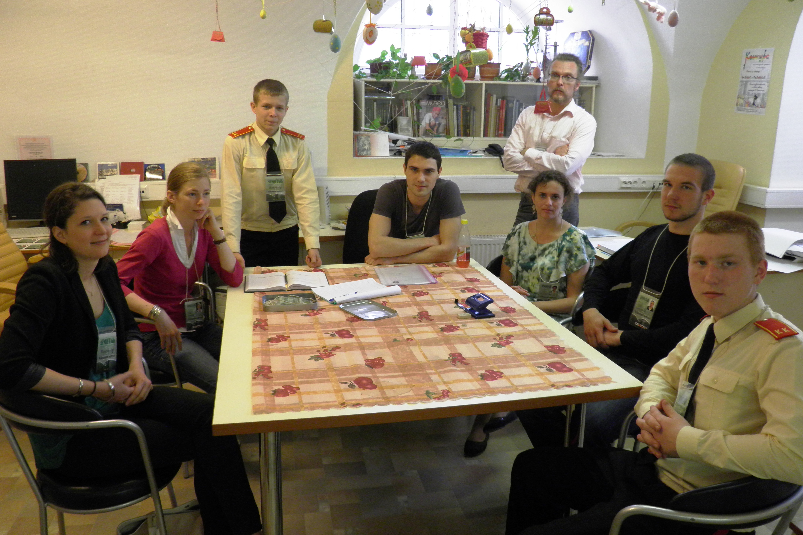

The summer school was a real adventure for me. I learnt a lot about the world and the city in which I live. I met many interesting people. I made friends with students from different countries. I mastered my English and my cultural level. I managed to get rid of complexes and shyness. I would like to continue the volunteer service in the future.

Все фотографии из личного архива Наумовой Т.В.

