“My Summer Adventure”

Автор: ученик(ца) 6² класса Тюрина Александра
Учитель: Борбат Лада Владимировна
Школа: МАОУ ЛМИ (Лицей Математики и информатики)
Населенный пункт: _г. Саратов
Регион: Саратовская область

2012
Автор: Тюрина Александра 6 «2» класс Школа: МАОУ ЛМИ
Учитель: Борбат Лада Владимировна
Город: Саратов Регион: Саратовская область

My Summer Adventure
After my hard and busy school year my summer holidays began. I felt happy when my school year finished. I started to plan a lot of wonderful things. I was dreaming about visiting other countries. I wanted to spend summer with my family. Now I’ll tell you about my summer adventures.
In July we traveled to Turkey. We stayed at a wonderful hotel. In a very cosy double room. The weather was hot but not stuffy. Every day we went to the seaside to swim and to get a sun bath.
One day we went on an excursion to a carpet factory. We had an opportunity to take part in making a carpet. It was great! We were shown a lot of carpets of different sizes and colors. Also workers of this factory let us walk on all carpets that we wanted. They were so soft. We were shown the process of making thread by bugs. It is very interesting. Then we got into a very comfortable bus and went to Myra. There we saw an old great church. Many years ago it fell into the earth and later it was found in the mountain. Yes, it was exactly in the mountain!
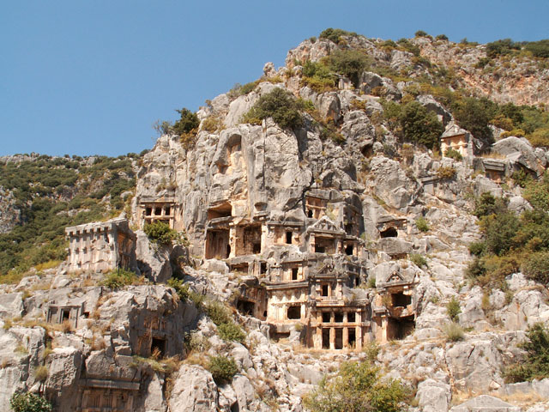

There was a Greek amphitheater near it which was made by people from Greece. I like it too.
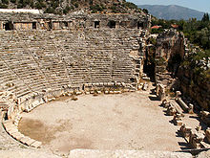

Then we visited St. Nicolas church. It was very old and a monument to Saint Nicolas is in front of it. We went inside and saw a lot of candles
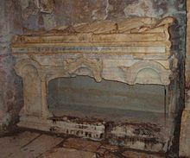
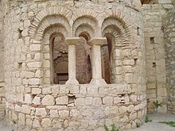
I was tired and sat on a column lying on its side. Suddenly I saw somebody lying on the earth behind me. I was frightened and cried! My father ran up to me and ...... laughed at me, because it was only a sleeping dog.
Then we returned to our hotel. We got there very fast. It was time for supper. We were hungry! After supper we went to the sea. It was warm and calm. It was wonderful to look at the dark blue sky full of stars! What an amazing sight!
The next day we had an excursion to the Travertine. The Travertine is the White Mountains. They are full of not deep natural reservoirs. I had a bath in a little one near the main mountain. The Travertine is situated near an old ruined town Hierapolis. People destroyed it so much that only an old cathedral remained.
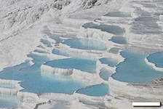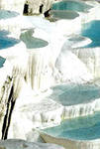

The next day we planned to visit “Sank Town”. We went to the harbour. We got on the ship Titanic – 2 and went to “Sank Town”. When we arrived the huge windows in the lower deck were opened. We saw a lot of old things which people used in their life many centuries ago. Near a small island we had a stop to swim in the sea. I like it very much because I swim very well. After swimming we ate sea ddelicacies. They were made from little fish which were caught during our stop.
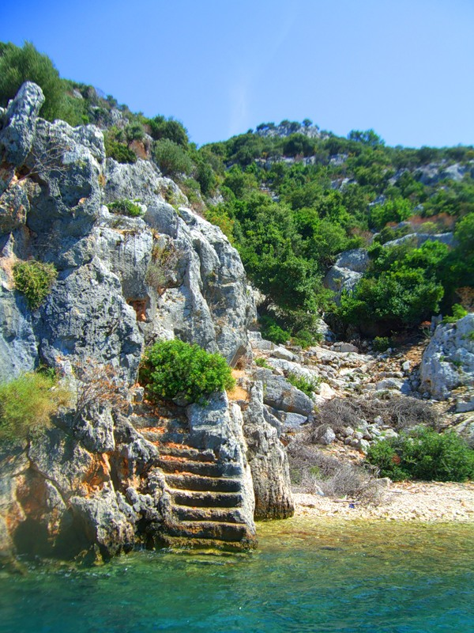
On board the ship there was a photographer. He made photos of passengers and used these photos in making souvenirs plates. I had this plate too. On our way back a lot of people asked to stop near a big shopping centre. It was called “White House” and there were three floors in it. People did the shopping and returned to our bus. On our way to the hotel we were shown a film “Adventures of Odyssey, the king of Ithaca”. And I thought that this summer I had a lot of adventures too!
After supper I ran to our room to change my clothes. It was time for famous “Turkey night”. It is a concert devoted to Turkey, its customs and traditions. The concert was wonderful! The stage was decorated with balloons, lights and flags of Turkey.
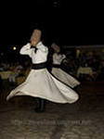

On the next day I was on the beach with my family. We were swimming and sunning ourselves. I remember that I ate the famous Turkish ice-cream the first time. It was not very expensive but unusual and very tasty. On the beach I found a lot of shells and nice little stones. After dinner we went to the seaside again. My father offered to parachute. I was very glad to do it! We flew the Mountains. They were green and beautiful. It was misty on their tops. Suddenly I looked at the sea. It was like another world.
It was great! On the next day I had a big adventure too. We got on a sea motorbike! The wind was blowing into our faces and it seemed to us that we were flying. That day I got a lot of impressions.
To the end of our trip we had only 4 days. But I still had enough to be with my new friends. It was a pity that our rest was over but I was happy that my parents went with me to Turkey. I love my parents very much!
These holidays were extremely amazing and wonderful. I want all the holidays to be the same!

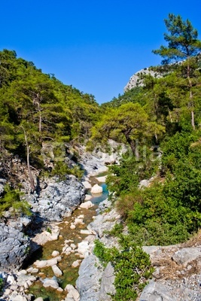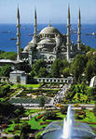

Фото из личного архива автора. Все фотографии несовершеннолетних опубликованы с согласием их родителей.

