“My Summer Adventure”

Автор: ученица 10 класса Талипова Лейсан
Учитель: Вальгер Ольга Вячеславовна
Школа: МБОУ СОШ №38
Населенный пункт: город Абдулино
Регион: Оренбургская область

Summer is the most gorgeous season! It is the time of resort, long-awaited holidays, and long summer vacations.
Summer vacations are three wonderful months which you can spend as you wish.
It is possible to meet friends, to read favorite books, and certainly to travel.
Russia is a vast country. Its landscapes are very colorful and different. Summer months are characterized by favorable climate and weather conditions that give you a chance to go wherever you want.
Many people go abroad without paying attention to the beauties of our country. There is hardly such a country that does not possess its individuality. I also have a temptation to visit Paris, America, Spain, India, and the United Arab Emirates. But it is impossible not to notice the beauty of our country. Russia is a country of fields, woods, rivers, lakes, mountain ranges! It is a country having all the natural riches.
This summer started with a trip to the Republic of Bashkortostan, the city of Ufa. This city has practically become native to me because since my childhood I visit it. In my childhood I certainly didn't notice beauty of buildings, monuments, nature. But maturing you start to examine what surrounds you. In the city of Ufa there are a lot of monuments of culture, architectural buildings. For example, the most known monument – a monument to Salavat Yulaev. Salavat Yulaev is the national hero of the Bashkir people, a symbol of modern Bashkortostan. The surroundings, the city, streets, cultural and educational establishments are named after him. I like very much to be there.
Other trip was to the Republic of Bashkortostan, the village Nugush. In Russia they say «Nugush is a South Urals pearl». Nugush is a resort. It is a wonderful place! The sizes of its reservoir are vast and huge. The water world is various too.
I was struck by beauty of these places. I couldn't imagine that such a beauty is not far from us. Its beauty can be compared with the beauty of the Caucasus.
There are beautiful high mountains. In Nugush all conditions for a human life are created. We slept in tents. In this territory little tables and benches are equipped.
The bank of a reservoir is from stones. Water is very clean. It is such a pleasure to swim in the lake. Water is warm even at night.
Different entertainments are offered for visitors: hydrocycles, boats, motor ships, buns, tablets, bananas.
We used "banana" to get to a river mouth. I had no idea that the lake is so big. The beauty of these places struck me. There we spent two nights and three days. It was unforgettable! It is impossible to write words to express emotions that I had in my soul after this trip.
When I came back home, I was looking forward to one more trip. The trip to Ponomarevka famous for its grey –hydrogen lake .This lake is supposed to have a medical power. And it is true. Water temperature is +4 degrees during a whole year. When we swam there water was very cold but we got some kind of adrenaline.
There we made masks from blue medical clay.
Such a short-term trip happened in my life. So short but so unforgettable.
The nature of Russia is so various and unique. Sometimes we don't notice what is around us. There is a beauty in all that surrounds us, even in a small stone that also has its own history.
Appreciate what is around you! Sometimes it is enough to bend and to enjoy the uniqueness of small and simple things.
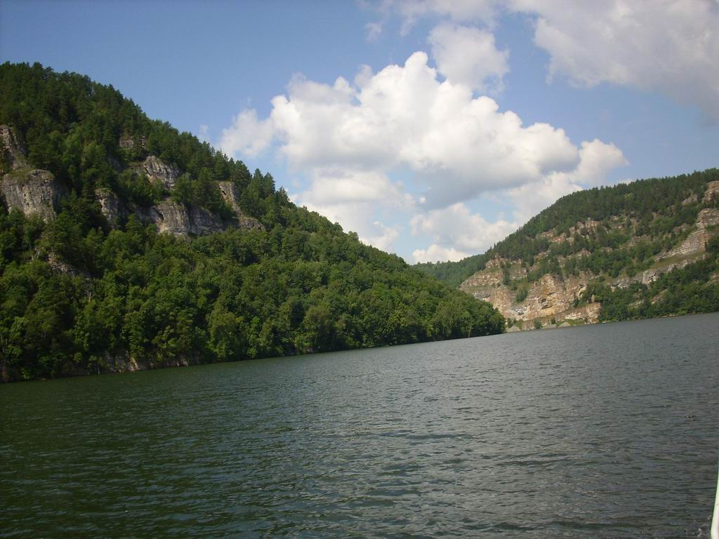
NUGUSH
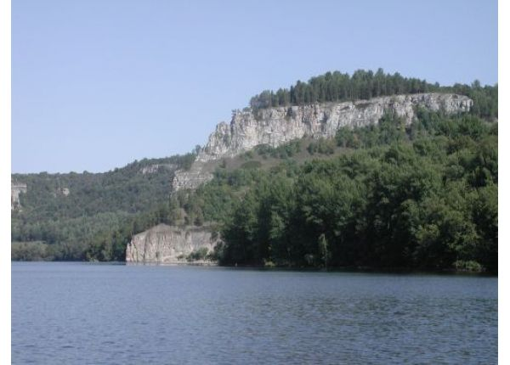
NUGUSH

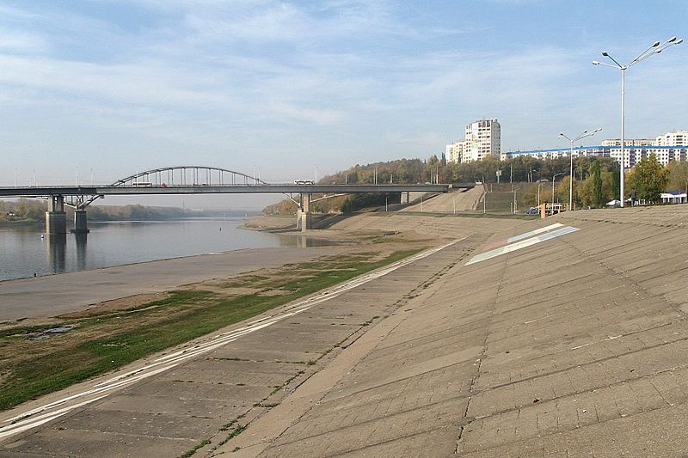
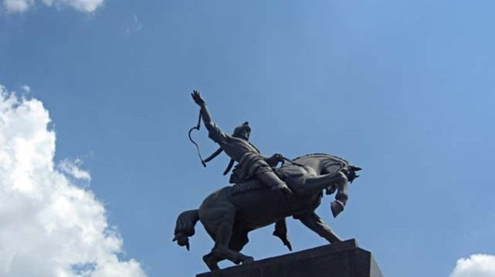
THE CITY OF UFA
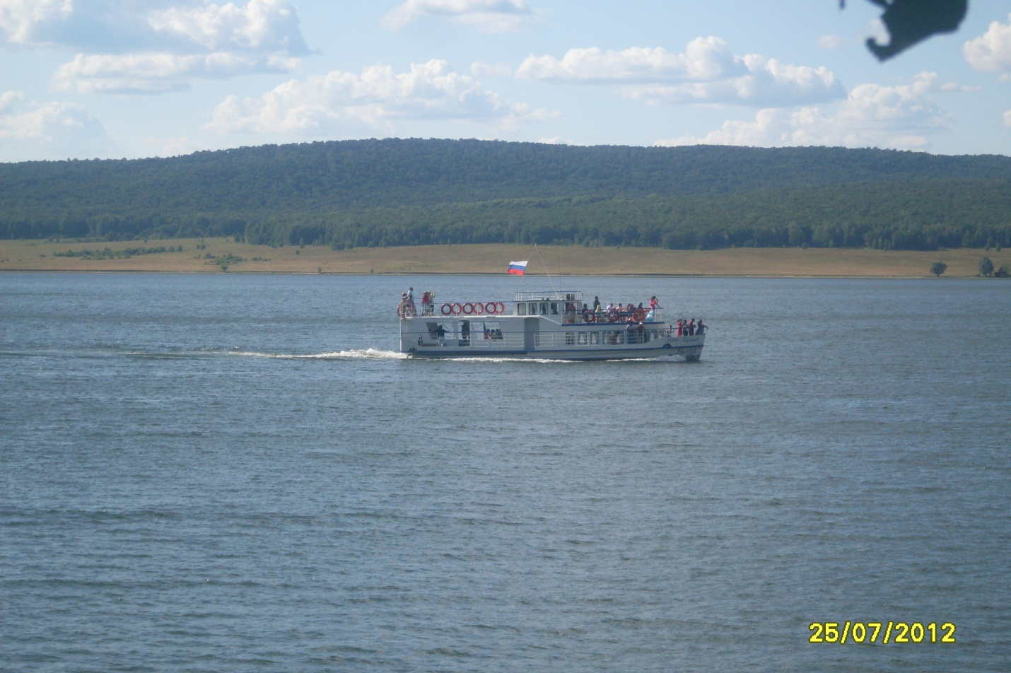
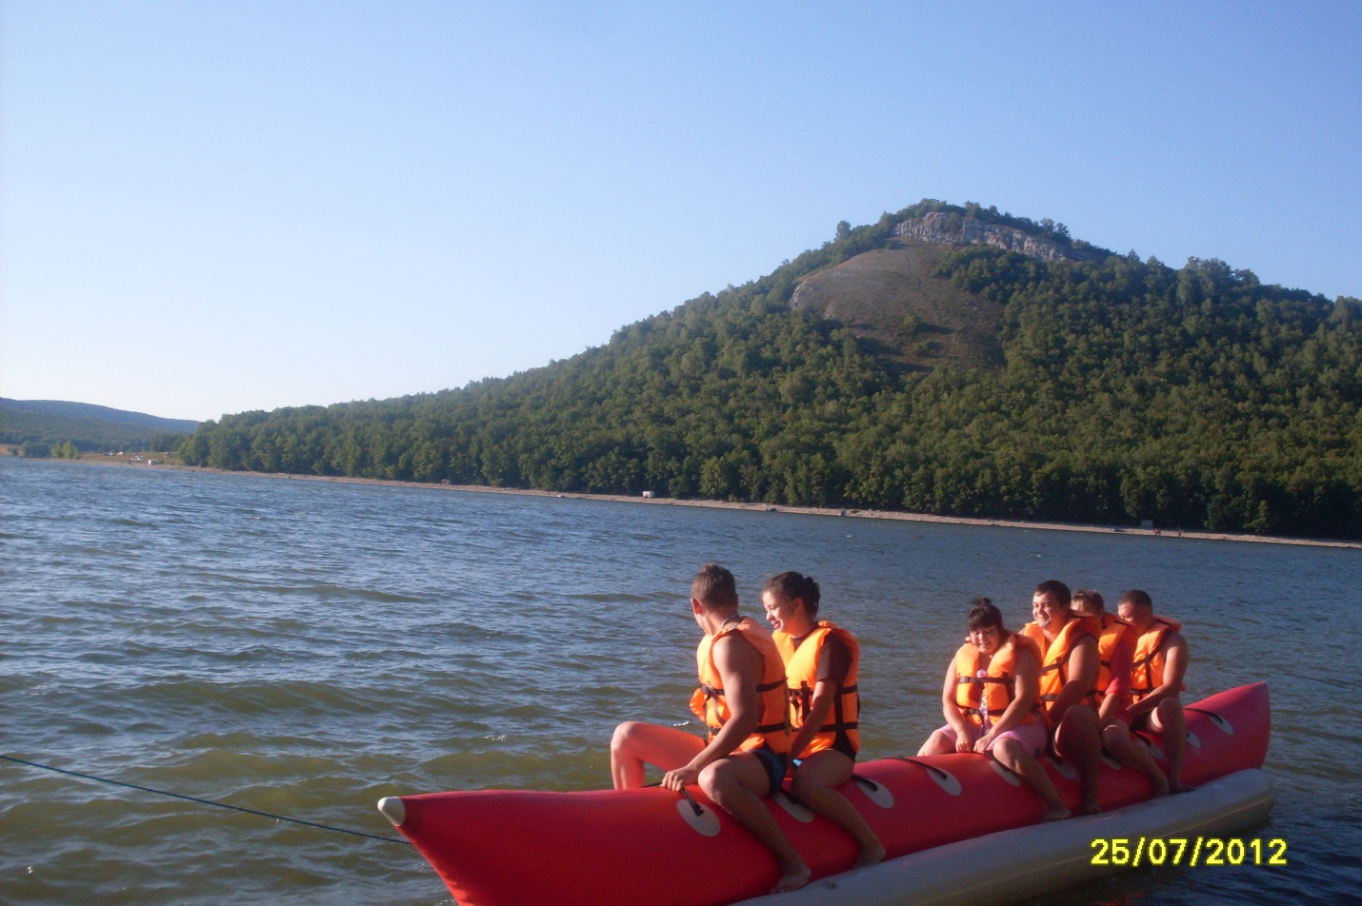
NUGUSH

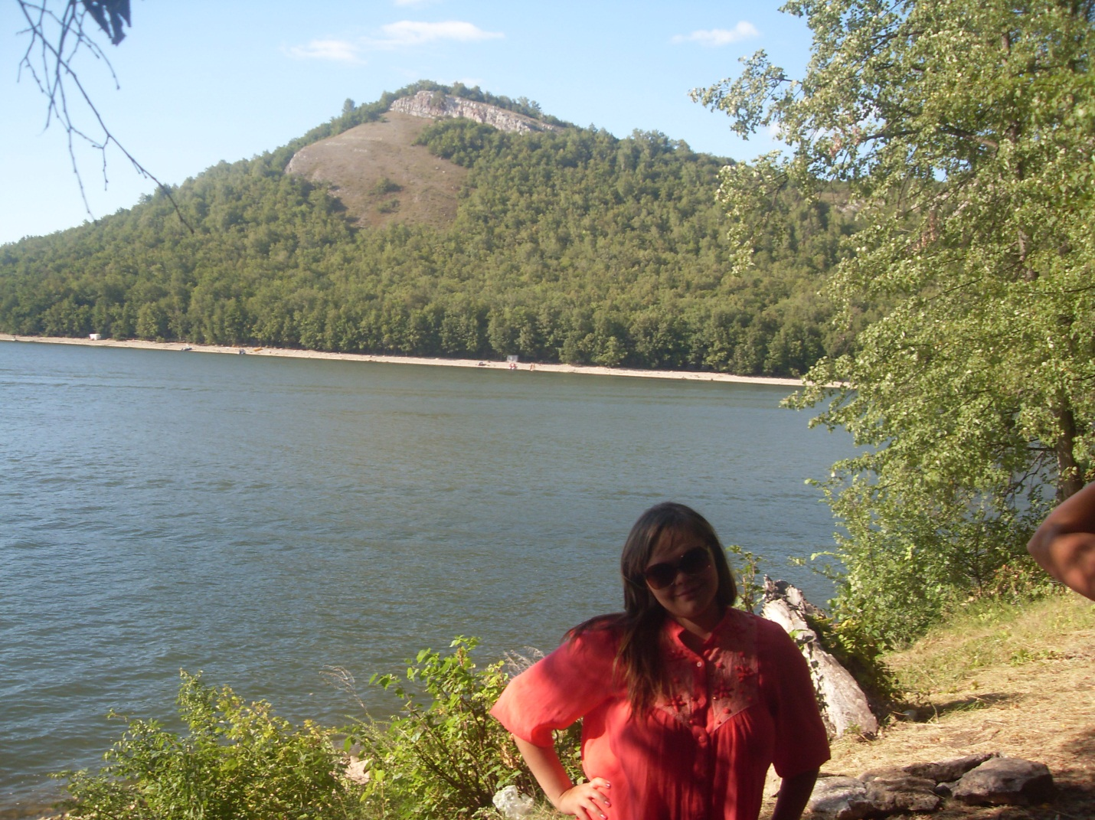
IT IS ME IN NUGUSH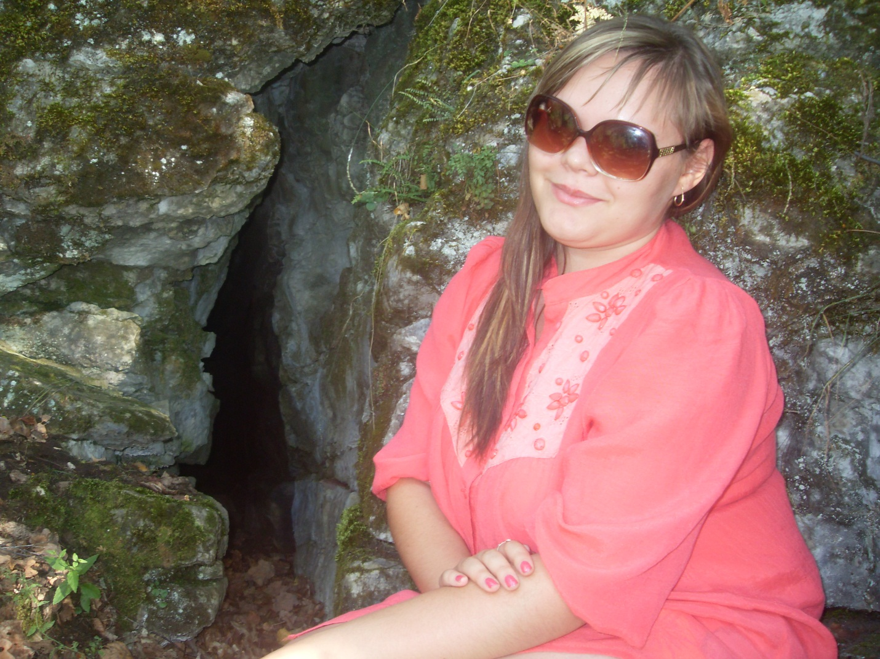
PONOMAREVKA

ФОТОГРАФИИ ВЗЯТЫ ИЗ СЕМЕЙНОГО АРХИВА СЕМЬИ ТАЛИПОВЫХ И РАЗМЕЩЕНЫ С РАЗРЕШЕНИЯ РОДИТЕЛЕЙ

