My summer adventure
Автор: ученица 9 «в» класса Белоус Елена
Учитель: Костылева Елена Васильевна
Школа: МБОУ СОШ №6
Населённый пункт: город Красноуральск
Регион: Свердловская область

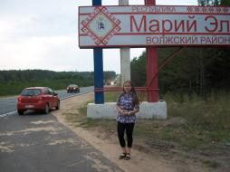
This summer my dad and I decided to travel around our country to see our motherland. We travelled by car. Our destination was St. Petersburg. We rode through many regions and republics. We slept in our car. It was scary and cold at night. Trees looked like monsters when it got dark. We took a navigator for the trip. Everything was perfect at the beginning but then we got lost. The navigator showed us the wrong way. It took us three days to arrive in St. Petersburg.
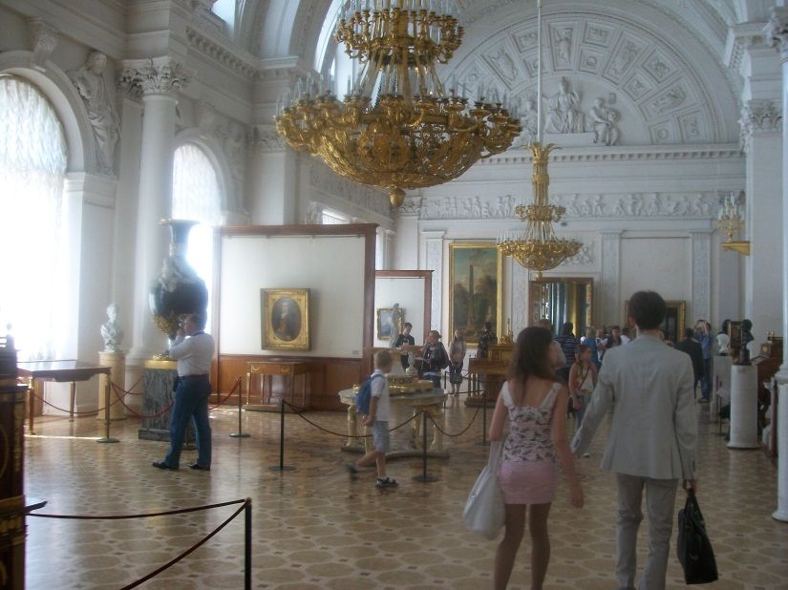
It was my old dream to visit St. Petersburg. I wanted to see its popular sights. Our first excursion was to the Hermitage. It was impossible to look at all exhibits during a few hours. There are thousands of beautiful paintings, wonderful sculptures of famous artists and sculptors from all over the world. I liked most of them.

In the Hermitage we met a foreigner. His name was Marshall. I took my chance to speak English with him. I learned that he was 40 and he was fond of music. I found out that we both liked the same singer Eminem. I told Marshall about myself too. I was happy to talk to him.
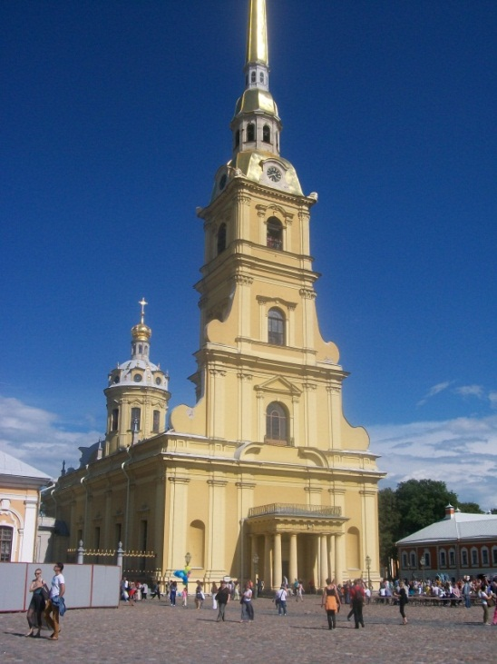
The next day we visited Petropavlovskaya fortress. It’s very large and impressive. Every day at noon hundreds of tourists come here to listen to ringing of the bells and shooting of the fortress cannon. I was making a video when the cannon fired and I nearly dropped my camera because the sound was very loud and unexpectable. Tourists were delighted. There are also different museums in the fortress. I went to all of them. The Torture chamber was especially interesting for me to visit.
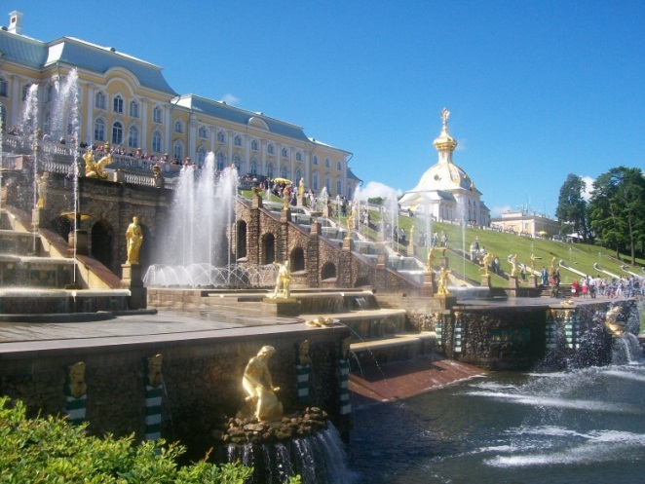
On the last day of our stay in St. Petersburg we went to Peterhof. There are many fantastic fountains there. While we were enjoying them we were poured over with cold water from head to feet. One of them turned out to be a special fountain for entertainment.

We spent a lot of time in Petergof, took pictures and admired its palaces, parks, fountains and beautiful flowerbeds.
In the evenings we had dinner in McDonald’s and walked along the streets of this magnificent city. We enjoyed its beauty and greatness, its gorgeous bridges, majestic monuments and buildings.
We returned home full of impressions. It was my summer adventure.
I’ll never forget my trip to this great city!
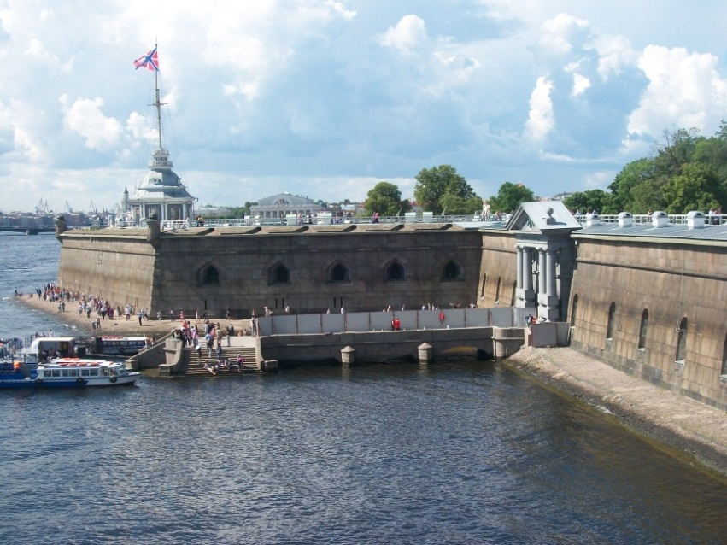

Фотографии из личного архива семьи Белоус.
Фотографии использованы с разрешения родителей несовершеннолетнего.

