Автор: ученица Савина Алина 5в класса
Учитель: Пожидаева Надежда Владимировна
Школа: МБОУ СОШ №2 с углублённым изучением отдельных предметов.
Населенный пункт: г. Волжский
Регион: Волгоградская обл.

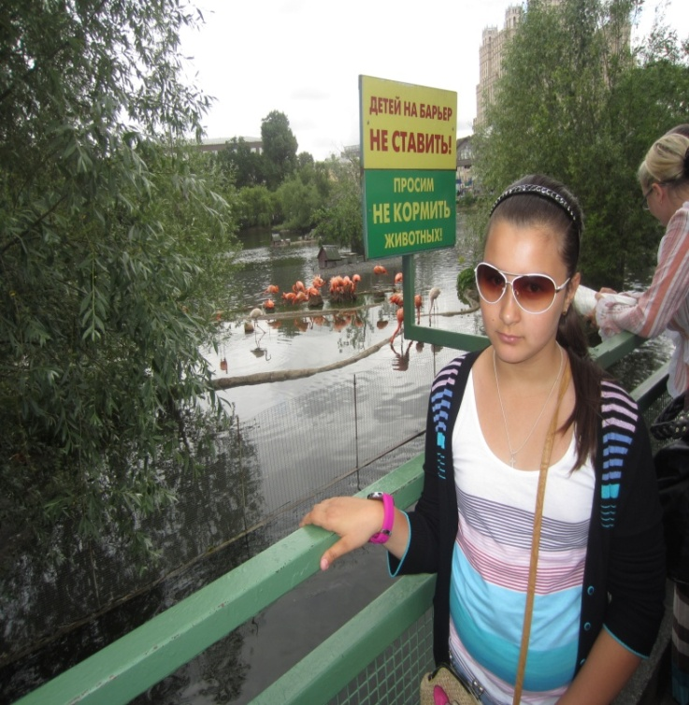
In June I was in Moscow. I went to the Zoo, the Central park and to McDonald’s. I saw TV Centre and the 1st Channel Studio there. We swam on a boat in the river.

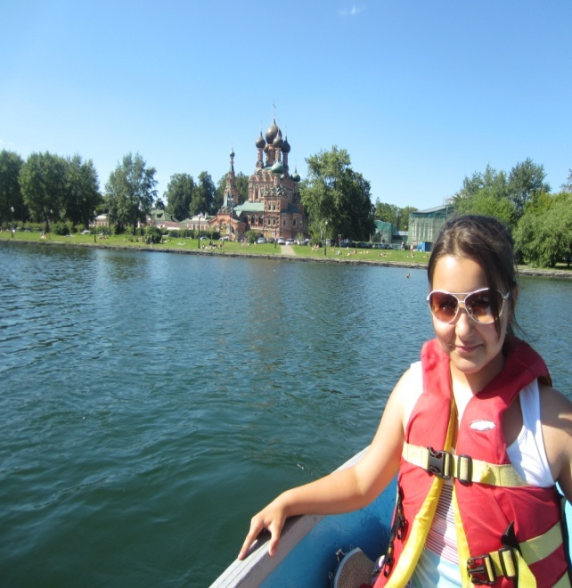
The weather was fine and I enjoyed my trip along the river. We saw many beautiful sights.

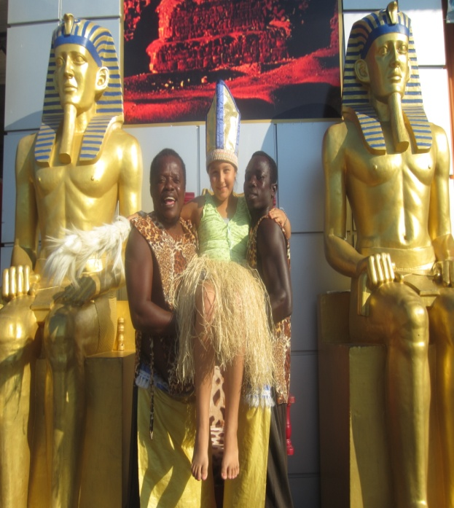
In July I went to the sea by plane. I lived at my relatives. We visited Aqua park. I rode the camels. We also went to the beach and we sunbathed there. There were also many beautiful churches and museums in the city. My family and I had an amazing time there!

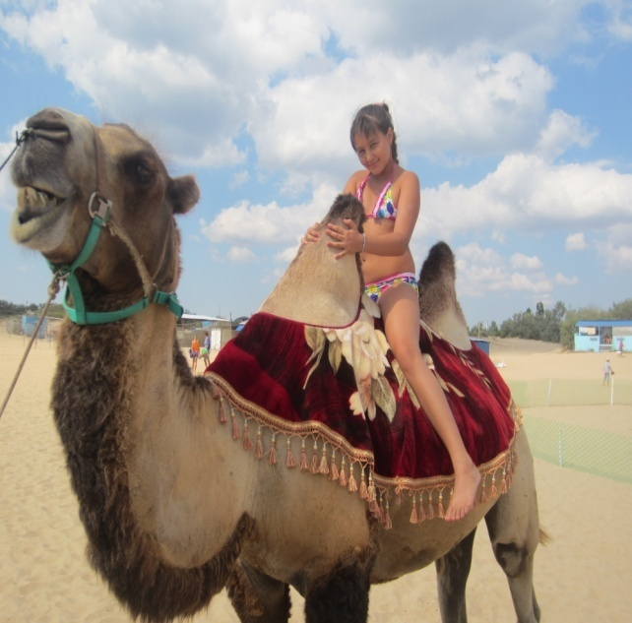
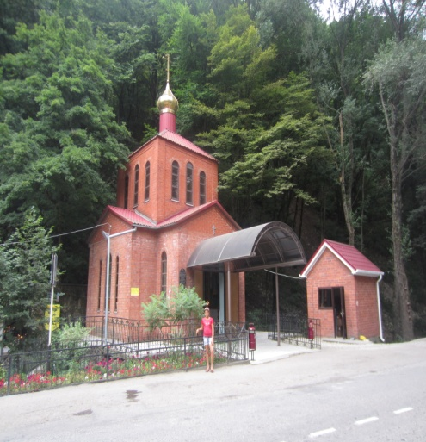

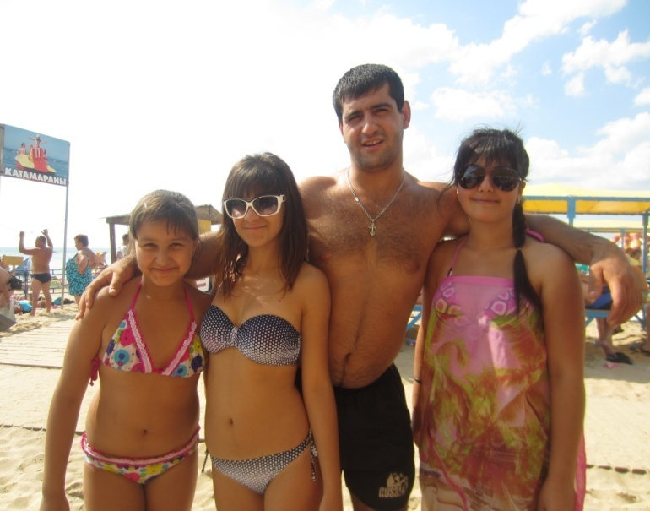
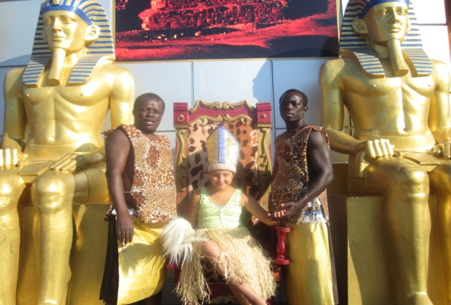

In August I lived in dacha not far from the town. I rode the bike and went to the river. My grandmother grew beautiful flowers and different vegetables.
My grandmother has many rabbits. They are white and black. My sister and I helped our grandmother to take care of them.
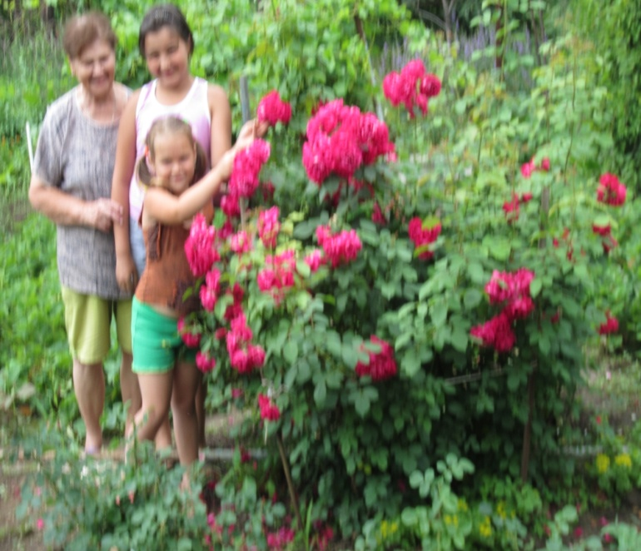
My favourite rabbit is white. Its name is Rodger.
It was my best summer holidays, I enjoyed them very much!
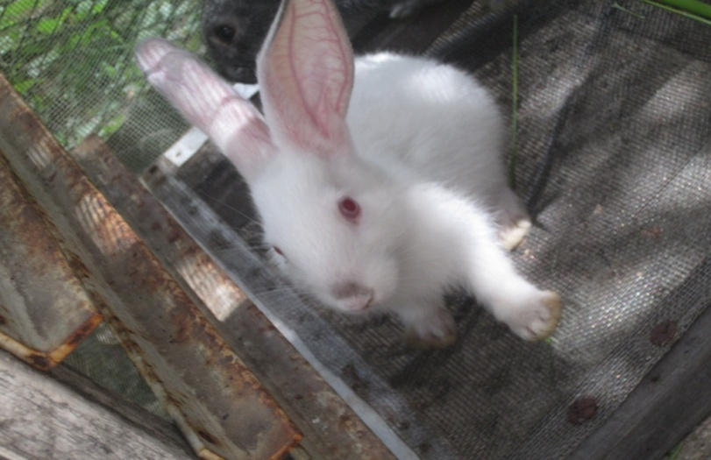

Фотографии из личного архива Савиной Алины. Размещены с разрешения родителей.

