“My Summer Adventure”

Автор: ученица 8 класса Гималова Алина.
Учитель: Галеева Римма Ануровна.
Школа: МОБУ СОШ села Новое Барятино
Населенный пункт: Село Новое Барятино, Стерлитамакский район
Регион: Республика Башкортостан

Let me introduce myself, my name is Alina. I am a good pupil. I do well in all subjects. I'm very sociable. I have many friends, most of them are my class-mates. But most of all I like my family. We all are great friends. Our family is big. There are seven of us: mother, father, little brother, three little sisters and me.
I would like to tell you about my summer holiday. I love holidays because during my holidays I can relax and have fun. I can do whatever I like, I don’t have to get up too early, and do my homework. I get enough time to travel, play my favorite sports and practice my hobbies. Most of all I like summer holidays because they are the longest ones. I think summer is the best season of all because it is warm, the nature is beautiful and we have great opportunities for rest.
My family likes to travel in summer. We like to travel by car. It's interesting too, because we can see many things in a short time. When we go by car, we don't take tickets. We put all things we need in a car. We don't carry them.
I am from Bashkortostan. Our climate and geography are amazingly good. Last summer our family was in Nugush. Nugush is a big reservoir. Nugush is one of the most wonderful places, which attracts people in Bashkortostan. It's interesting for me to swim all day. We swam, lay in the sun, played different games and had a wonderful time. We carry a camera with us and take pictures of everything that interests us — forests, trees, mountains. Perhaps years later, we will be reminded by the photos of the happy times we have had. As a rule I make new friends there. I never feel bored. Time passes quickly and soon we have to make our way back. When it was time to go home, we were sorry to leave Nugush. The days were amazing and unforgettable.
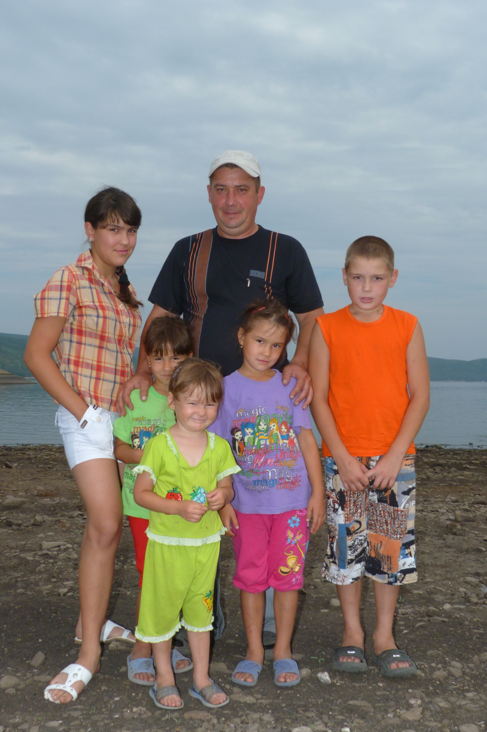
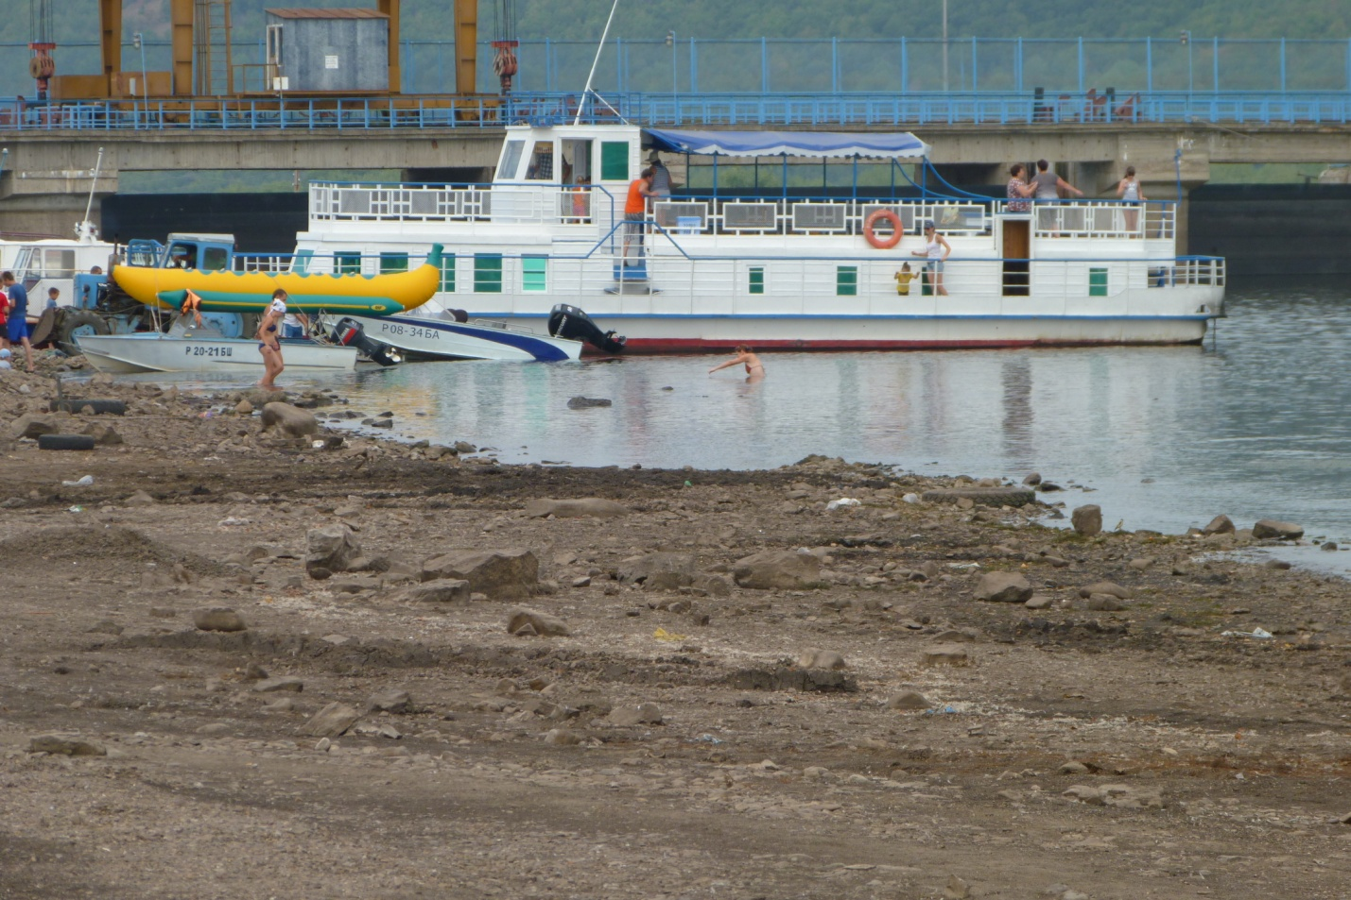
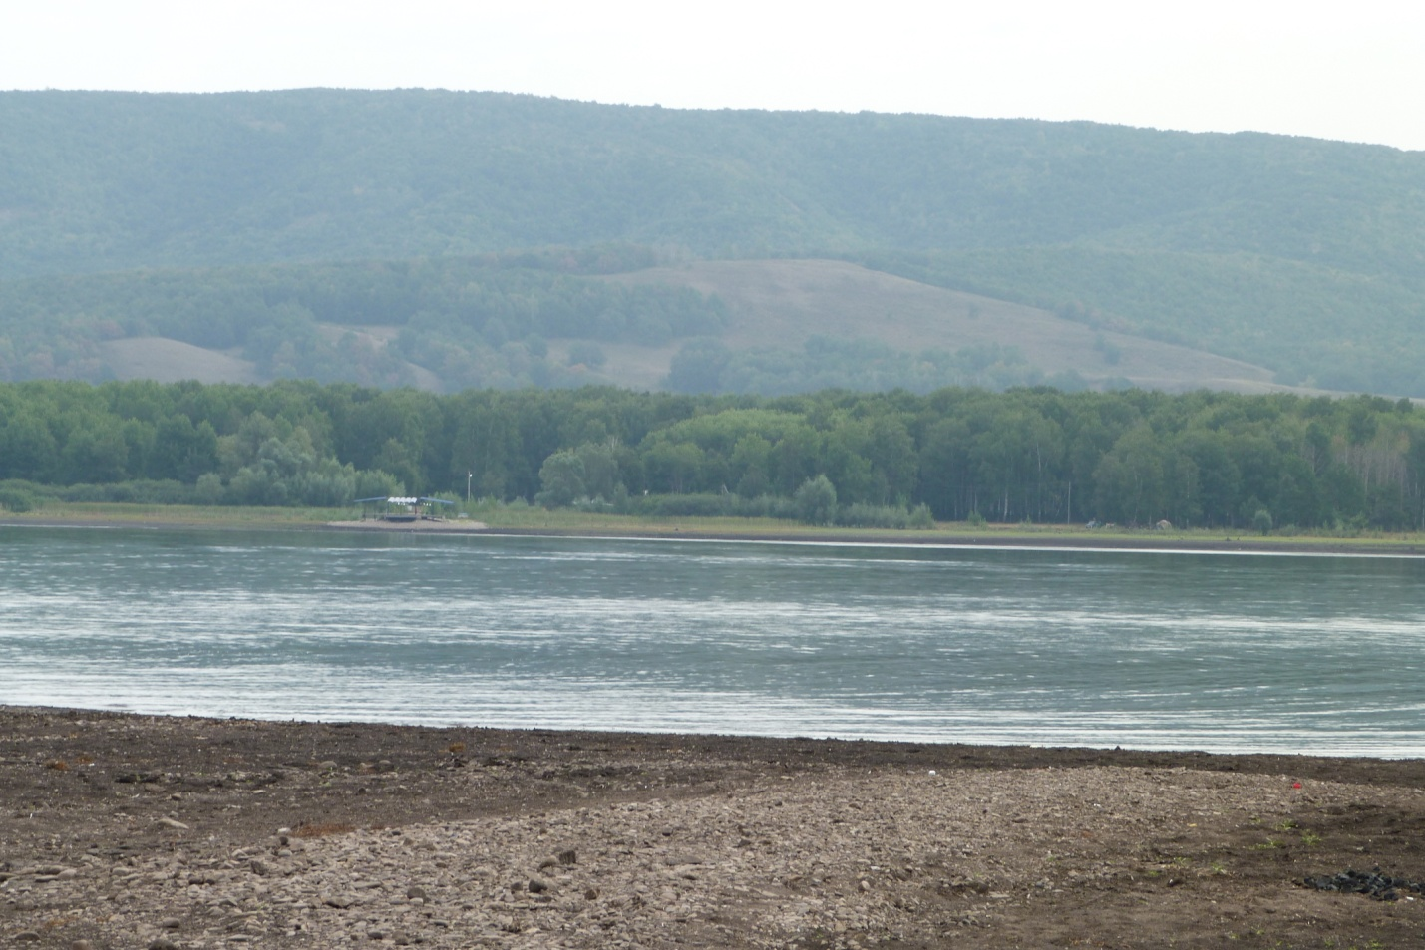
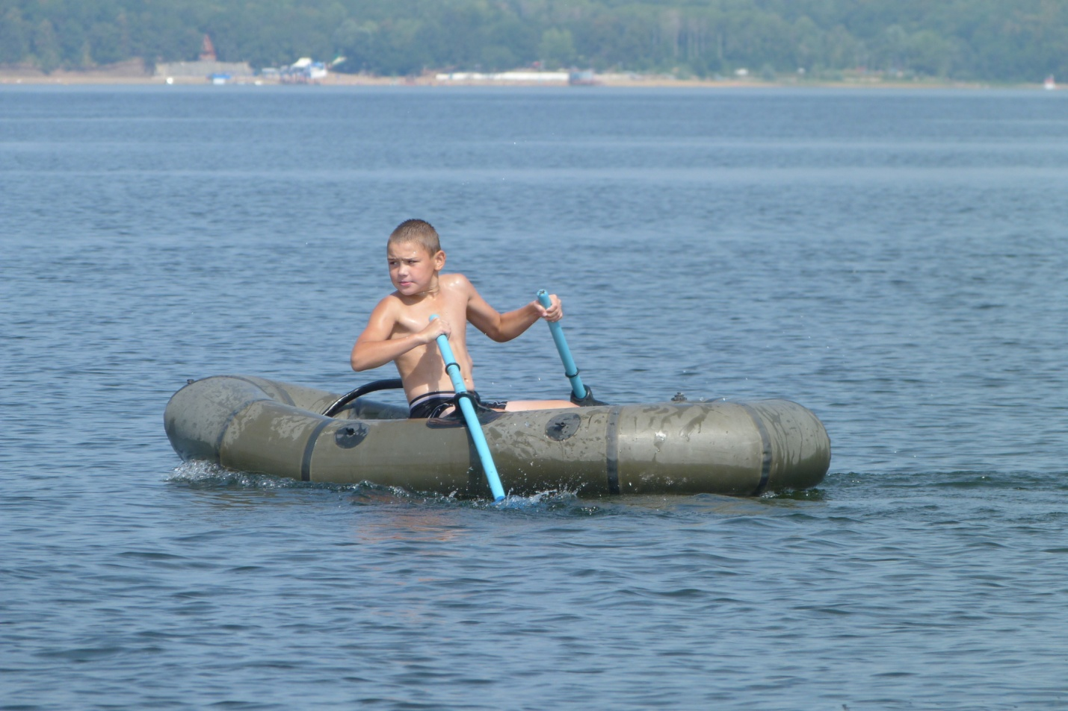
Фото из личного архива семьи Гималовых. Опубликовано с согласия родителей Гималовой Алины.

