“My Summer Adventure”

Автор: ученица 5 класса Яковенко Татьяна .
Учитель: Еретниченко Елена Александровна
Школа: МБОУ СОШ № 4
Населенный пункт: г.Батайск
Регион: Ростовская область

В работе использованы фото из личного архива семьи Яковенко, публикуются с разрешения родителей несовершеннолетнего

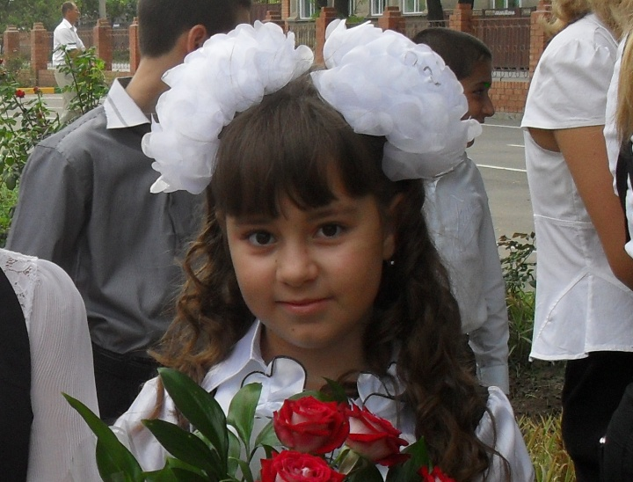
“ My summer adventure’’
My name is Tanya. My surname Yakovenko. I’m eleven. I live in Bataysk.
I study at school number four.
School year is over, elementary school is in the past. Four years flew as one instant. We absolutely don’t want to say goodbye to our first teacher. New teachers, new subjects wait for us in future, but now summer is the most important thing! My plans for summer? Rest, rest and rest ones more!

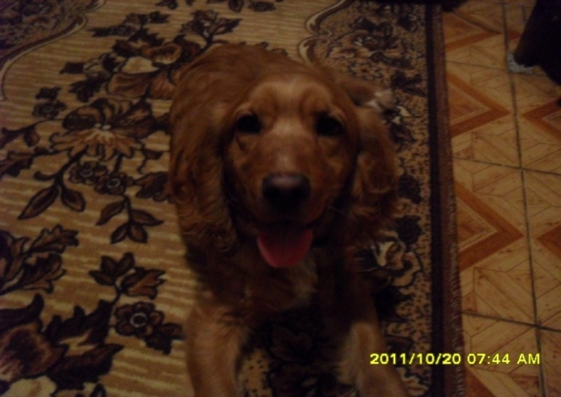
When my summer holidays started, I fall ill and was treated for a long time. As I finished my school year with good marks my grandmother bought me roller skates , it was my dream. In the evenings my brother Nazar , my dog Jack and I went to the sport ground. We roller-skated, then we played with our loving dog Jack. Everyday walks with the dog and roller-skating help you to be nice and slim. I recommend!

Well, now I’ll tell you about fishing.
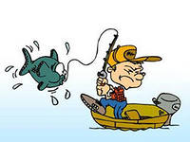
Several times my grandfather, my brothers Nazar, Roma, Maksim and I went fishing .We got up at five o’clock ,took warms, food, fishing-roads and went to the river. When we came to the river my brothers and I wanted to eat. But my grandfather said “Let’s catch a fish first, then we’ll have breakfast”. So, our fishing started. We went to grandpa turn by turn and asked him to help us with warms. He was angry. He said: “You are bad fishermen”. But he helped us. When we caught the first fish we started our breakfast. We laid our food on the blanket, filled our cups with hot tea, watched sunrise and ate. When the water in the river became warm, we started to swim in it, and hampered grandfather’s fishing. When we came home we were very tired, but happy. Grandfather gave fish to grandmother. Grandmother scaled and roasted it. And said: “ What good fishermen!”
Also I went to the river with my parents and we took my dog Jack. It was awful, lucky grandfather, he wasn’t there! A few times Jack knotted fishing lines. The dog hampered us and we gave him a little fish, Jack ate it at once . When we were going to go home, father didn’t want take Jack in the car because he had dirty paws. Mother laid a shawl and took Jack on her knees . My loving dog was so happy and tired, that he slept all the road . At home we washed and combed him. The rest of the day he slept.
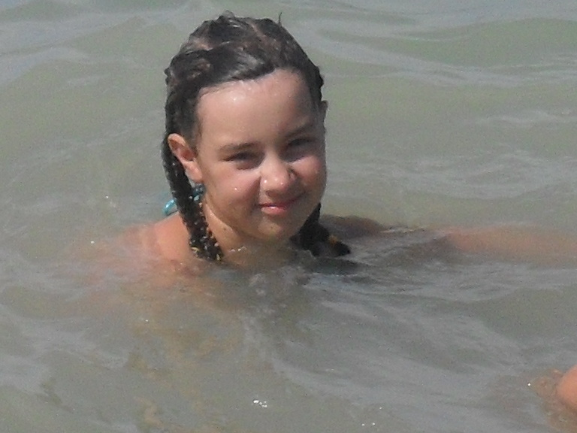
At the end of July my parents had holidays and we went to The Black Sea. We had one big problem: our pets. I have a parrot, a cat, an aquarium, and of course Jack. We asked grandmother to look after them for a few days. The fish, the parrot and the cat didn’t worry me very much, but Jack! He has a habit to walk every day, I thought: “ He will miss us and disturb grandmother and neighbours with barking”. We told grandmother how to look after our pets and gave her the recipe of Jack’s porridge . The road to the seaside was long and interesting. At ten o’clock we came to the small village of Dederkoy . The weather was wonderful. Parents found a very comfortable house for us not far from the sea.

The sea was wonderful, the water was very warm, we swam for a very long time.
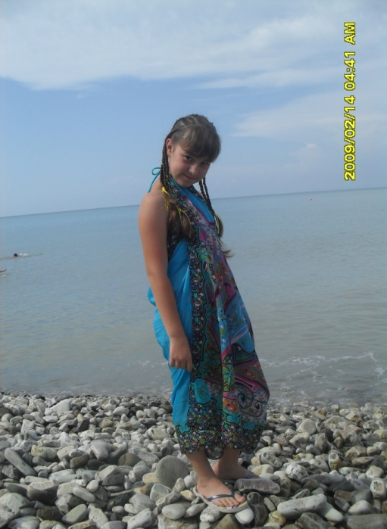

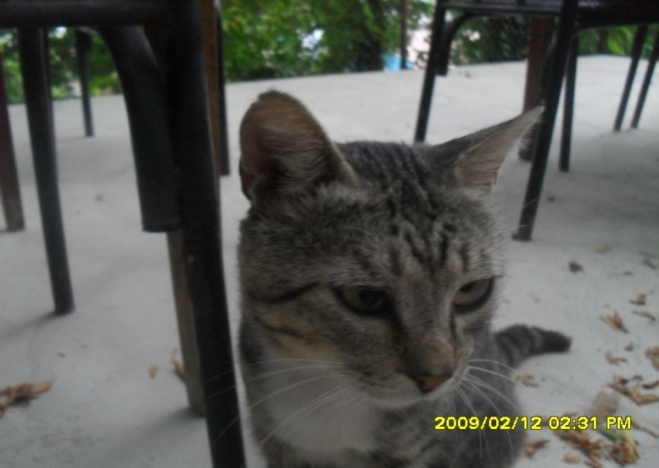
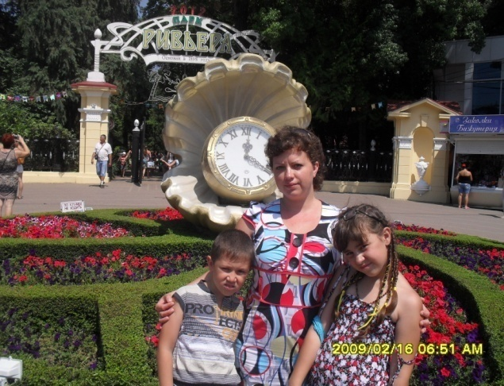
In the evening we made shashlik and a local cat smelt it , after that this cat came every evening for supper. Every day I called grandmother to concern about my pets. Grandmothers said that Jack looked at the door and waited for me and missed very much. On the fourth day of our rest we went to Sochi to visit the Riviera Park and to walk around town. I liked the trip very much I saw many plants and places.

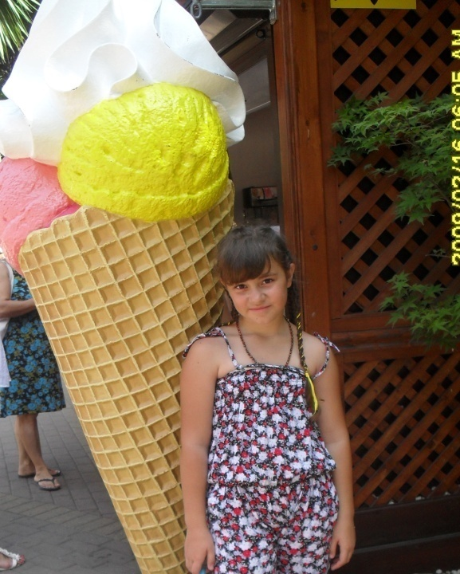

We took a lot of photos , ate ice-cream and had fun . Also we went to the planetarium, my brother liked it very much.
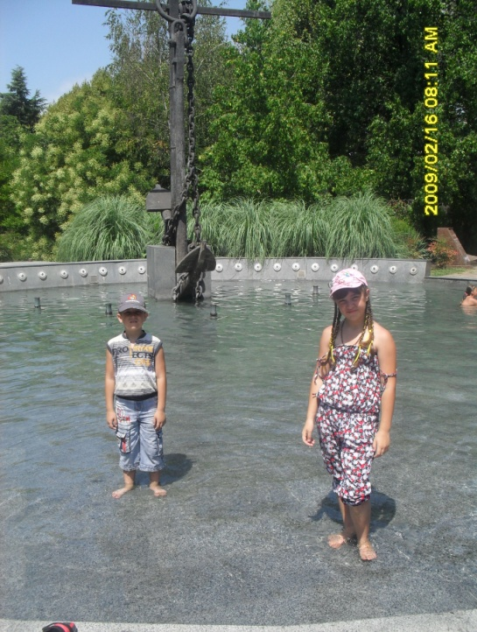
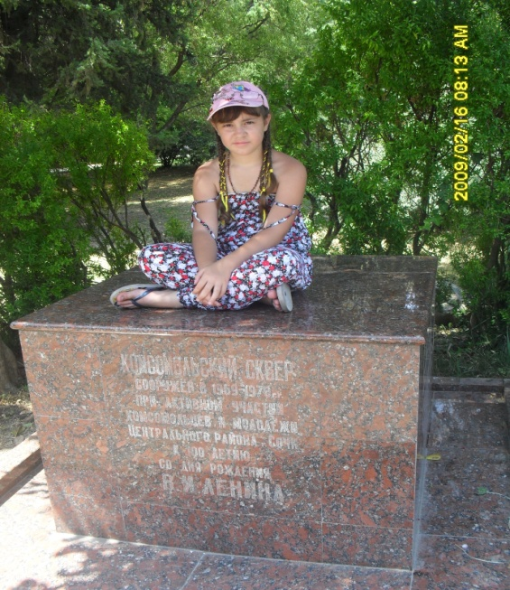
We came to Dederkoy in the evening we went to the sea and swam.
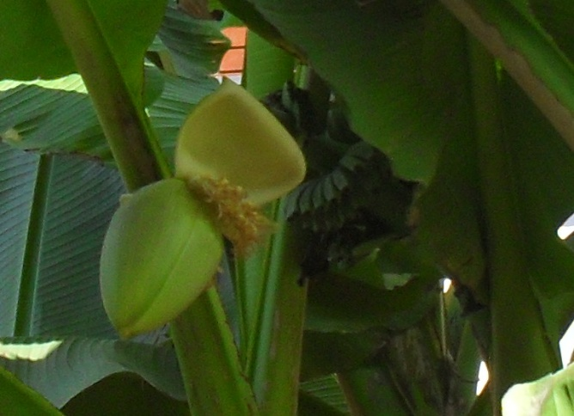
I also want to tell you about a palm tree with little bananas I saw it by the road to the sea, and my mother took photos of it.
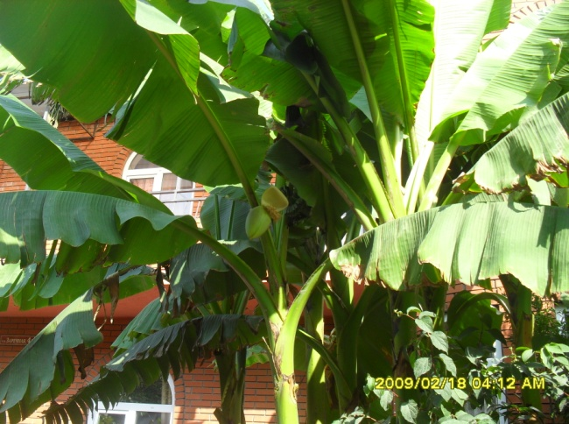
Seven days went away it was time to go home.
On our way home we saw a lake with lotuses, it was very beautiful and unusual.
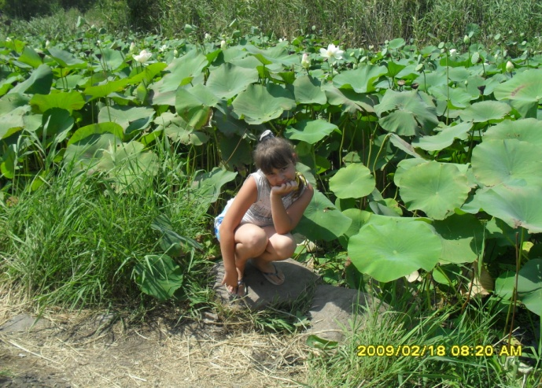
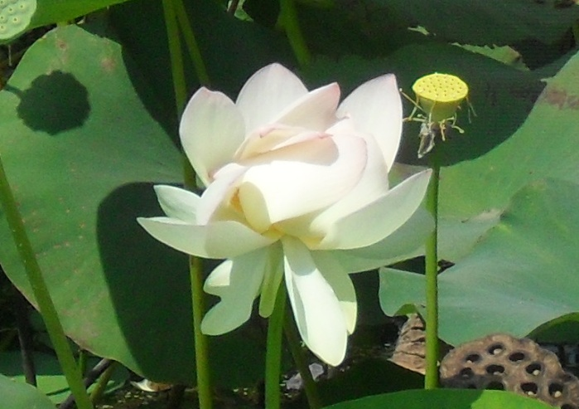

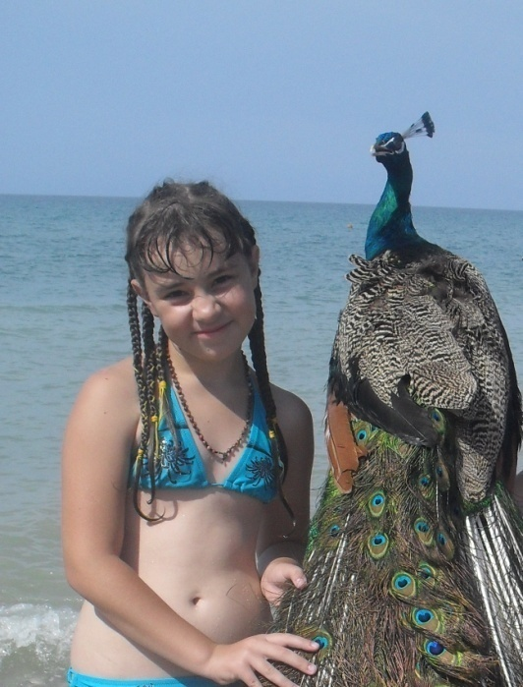
When we came home, we open the door quietly, to see Jack’s reaction , he barked loudly and jumped with joy. We all brought a lot of presents to all the relatives and many impressions.
Then we prepared for a new school year: uniform, copybooks and so on.
Here is new school year, my friends, I missed all of them.
I will tell them about my summer adventures!

